121/1 MATHS PAPER 1 MARKING SCHEME DECEMBER EXAM 2021
1. | Numerator:$\frac{7}{9}+\frac{2}{18}=\frac{8}{9}$  Denominator:$\frac{2}{5}×\frac{10}{3}×\frac{3}{1}=4$  $$\frac{8}{9}×\frac{1}{4}=\frac{2}{9}$$ | M1  M1  A1 | Numerator  Denominator
 |  | 03
2. | N;($3x-2y)(4x-y)$  D;$2x\left(3x-2y\right)\left(3x+2y\right)$  $$\frac{\left(3x-2y\right)(4x-y)}{2x\left(3x-2y\right)(3x+2y)}$$  $$\frac{4x-y}{2x(3x+2y)}$$ | M1  M1  A1 | Numerator  denominator
 |  | 03
3. | UK $£9600=Sh 125.30×9600$  = $Sh 1 202 880$  $$\frac{95}{100}×1 202 880=Sh 1142736$$  $$\frac{1}{4}×1142 736=285 684$$  $$\frac{285684}{63.20}=4520.32$$  $$=\$4520$$ | M1  M1  A1 | Expression  Expression  CAO
 |  | 03
4. | $$4^{x}\left(8^{x-1}\right)=1$$  $$8^{x-1}=\frac{1}{4^{x}}$$  $$2^{3(x-1)}=\frac{1}{2^{2x}}$$  $$2^{3x-3}=2^{-2x}$$  $$3x-3=-2x$$  $$x=\frac{3}{5}$$ | M1  M1  A1 | Comparing powers
 |  | 03
5. | $$\frac{90(2n-4)}{{90}^{0}(2n)}=\frac{3}{4}$$  $$\frac{(2n-4)}{2n}=\frac{3}{4}$$  $$8n-16=6n$$  $$n=8$$  $${90}^{0}\left(2 x 8-4\right)$$  $${1080}^{0}$$ | M1  M1  A1 | Equation  Expression
 |  | 03
6. | No. Log  2 0.3010  0.324 +  1.7642 0.2465 x 2 0.4930 -  5.42 0.7340 + 1.2270  0.4428 | M1  M1  A1 | All logs correct  Attempt to divide
 |  | 03
7. | 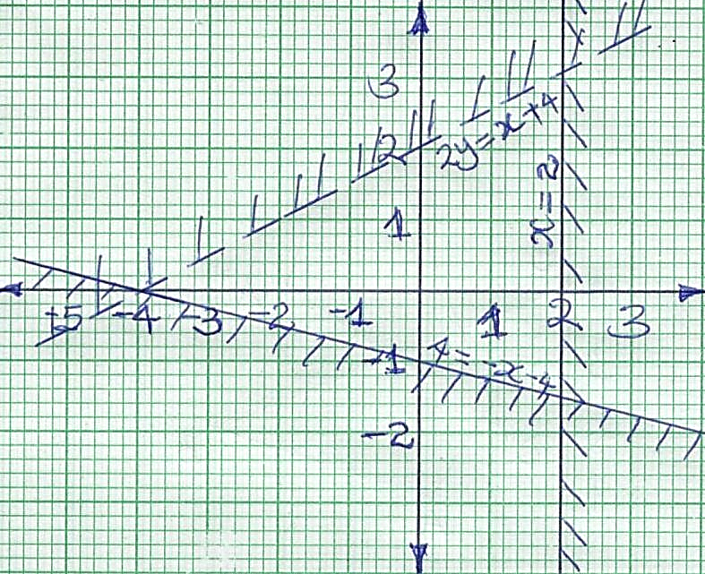 | B1  B1  B1 | 2y<x +4  4y ≥ - x- 4  x≤2
 |  | 03
8. | Midpoint ($\frac{6+-2}{2},\frac{5+3}{2})$  $$\left(2,4\right)$$  $$m1=\frac{3-5}{-2-6}=\frac{1}{4}$$  $$m2=-4$$  $$\frac{y-4}{x-2}=-4$$  $$y=-4x+12$$ | M1  M1  A1
 |  | 03
9. | $$GCD=6=2 x 3$$  LCM = 900 = 2² x 3² x 5²  36 = 2² x 3²  60 = 2² x 3 x 5  Least possible number = 2 x 3 x 5² = 150 | B1  B1  B1 | GCD/LCM  36/60
 |  | 03
10. | $$0.2×10×\frac{1}{3.75}-10×\frac{1}{1.406}×\frac{1}{1000}$$  $$0.2×10×0.2667-10×0.7114×0.001$$  $$0.5334-0.007114$$  $$0.526286$$ | M1  M1  A1
 |  | 03
11. | $$4x+3y=475$$  $$5y+2x=325$$  $$x=\frac{325-5y}{2}$$  $$4\left(\frac{325-5x}{2}\right)+3y=475$$  $$-7y=-175$$  $$7y=175$$  $$y=25$$  $$x=\frac{325-5(25)}{2}$$  $$x=100$$ | M1  M1  A1 | Substitution  For both
 |  | 03
12. | (a) 5 Tan θ = $\frac{4}{3}$  4  3  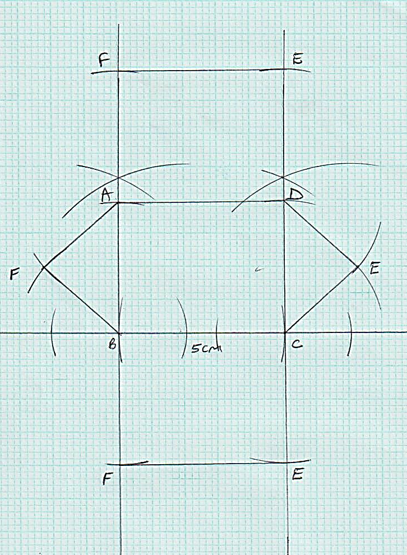  (b) Cos (180 – θ) = - $\frac{3}{5}$ | B1  B1  B1
 |  | 03
13. |  | B1  B1  B1 | Complete net, well labelled
 |  | 03
14. | $$V.s.f=960:1500$$  $$=8:125$$  $$L.s.f=2:5$$  $$A.s.f=4:25$$  $$Surface area of the larger can=\frac{144×25}{4}$$  $$={900cm}^{2}$$ | M1  M1  A1
 |  | 03
15. | (i)$Let <AOD=y, <AOB=2y$  <BOD = 2 <DAB = 2 x 87 = 174⁰  $$y+2y+174={360}^{0}$$  $$y={62}^{0}$$  $$<AOB=2×62={124}^{0}$$  $$sum of angle at a point add up to {360}^{0}$$  (ii) $<ADT=<ABD=28+3= {31}^{0}$  $$angles in alternate segment are equal$$ | B1  B1  B1  B1 | <AOB  Property  <ADT  Property
16. | (i) $\frac{θ}{360}×2πR=2πr$  $$\frac{{120}^{0}}{{360}^{0}}×2×π×42=2πr$$  $$r=\frac{120×42}{36}$$  $$=14cm$$  (ii)$h=\sqrt{{42}^{2}-{14}^{2}}$  $$=39.6cm$$ | M1  M1  A1  B1
 |  | 04
17. | (a) Distance after 30mins  $$Bus→100×\frac{1}{2}=50km$$  $$Nissan→120×\frac{1}{2}=60km$$  $$Distance covered by bus in 1hr$$  $$50km+50km=100km$$  Relative $Distance =100-60$  $=40km$  $$Relative speed=120-100$$  = 20km/hr  $$=Time taken to catch up=\frac{40}{20}$$  = $2hrs$  $$Distance from Nrb=60+\left(120×2\right)$$  $$60+240=300km$$  (b)$7.00am+1hr+2hrs$  $$=10.00am$$  (c) $time=\frac{340}{100}=3.4hrs→3hrs 24mins$  $$Arrival time=7.00am+3hrs 24mins$$  $$=10:24am$$ | M1  M1  M1  M1  A1  M1  A1  M1  M1  A1 | For both distance  Relative distance  Relative speed  Relative time
 |  | 10
18. | - OP = a + $\frac{2}{3}$ (b – a)  = $\frac{1}{3}$ a + $\frac{2}{3}$ b  BQ = $\frac{1}{3}$ a – b  - (i) OC = h$\left(\frac{1}{3} a+ \frac{2}{3} b\right)$  = $\frac{1}{3}ha+ \frac{2}{3}hb$  OC = b + k $\left(1/3 a – b\right)$  = $\frac{1}{3}$ ka + (1 – k)b  $\frac{1}{3}$ h = $\frac{1}{3}k$  h = k  $\frac{2}{3}$h = 1 – k  $\frac{2}{3}$ k = 1 – k  2k = 3 – 3k  5k = 3  k = h = $\frac{3}{5}$  (ii) OC = $\left(\frac{1}{3}\right)\left(\frac{3}{5}\right)a+ \left(\frac{2}{3}\right)\left(\frac{3}{5}\right)b$  = $\frac{1}{5} a+ \frac{2}{5} b$  (iii) BC: CQ = $\frac{3}{5}$: $\frac{2}{5}$  BC:CQ = 3:2 | B1  B1  M1  M1  M1  M1  A1  M1  A1  B1
 |  | 10
19. | $$x$$ $$fx$$ fd  9.5 19 0.2  24.5 539 1.1  44.5 2225 2.5  69.5 1668 0.8  89.5 179 0.2  $$∑fx=4630$$  $$mean=\frac{∑fx}{∑f}=\frac{4630}{100}=46.3$$  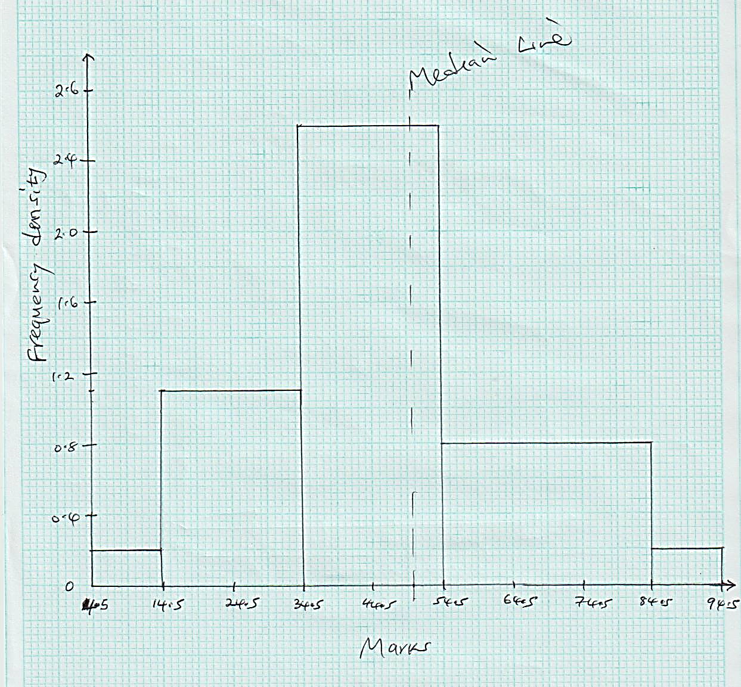  Total area = 2 + 22 + 50 + 24 + 2 = 100  50 – (2 + 22) = 26+26 = 2.5 x y, y = 10.4  Median = 34.5 + 10.4  = 44.9 | B1  M1  A1  B1  S1  B1  B1  B1  B1  A1 | fx  f.d  scale  For median line
 |  | 10
20. | a)  x -4 -3 -2 -1 0 1 2 3  y 30 13 2 -3 -2 5 18 37  b)  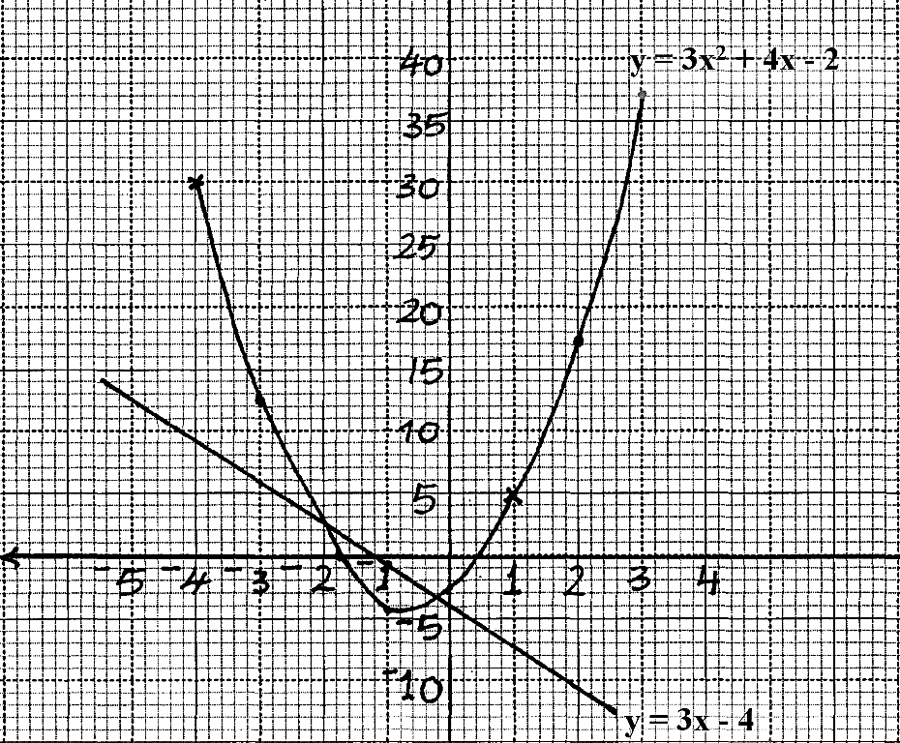  c) i) x = + 0.4  x = -1.7 + 0.1  ii) y = 3x² + 4x – 2  0 = 3x² + 7x + 2  y = -3x – 4  x = -2 or x = -0.4 + 0.1 | B2  B1  B1  B1  B1  L1  B1 | All  at least 6  For equation of line  For line drawn
 |  | 10
21. | 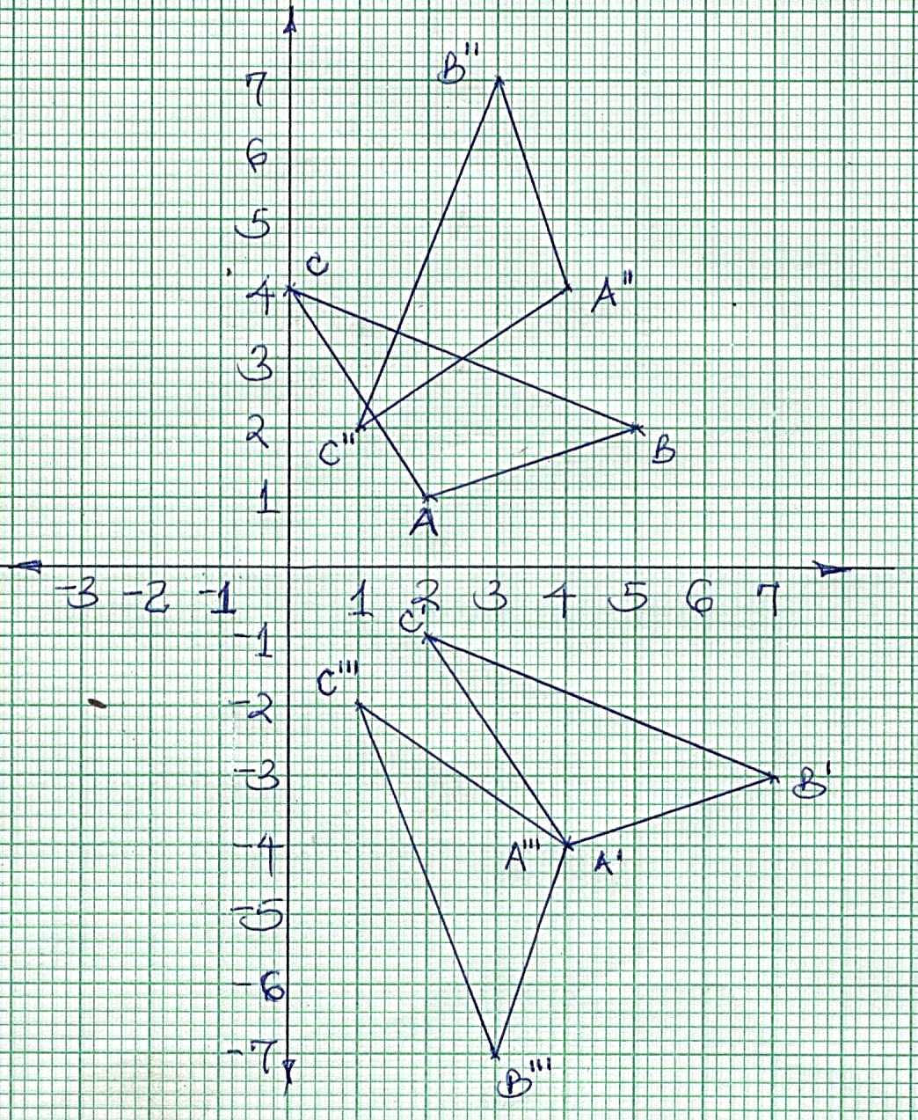  (b) A¹(4,-4) B¹(7,-3) C¹(2,-1)  (c) A¹¹(4,4) B¹¹(3,7) C¹¹(1,2)  (d) A¹¹¹(4,-4) B¹¹¹(3,-7) C¹¹¹(1,-2) | B1  B1  B1  B1  B1  B1  B1  B1  B1  B1 | For plotting  For ∆ABC  For ∆A¹B¹C¹  For construction or otherwise  For ∆A¹¹B¹¹C¹¹  For construction or otherwise  For ∆A¹¹¹B¹¹¹C¹¹¹
 |  | 10
22. | a)  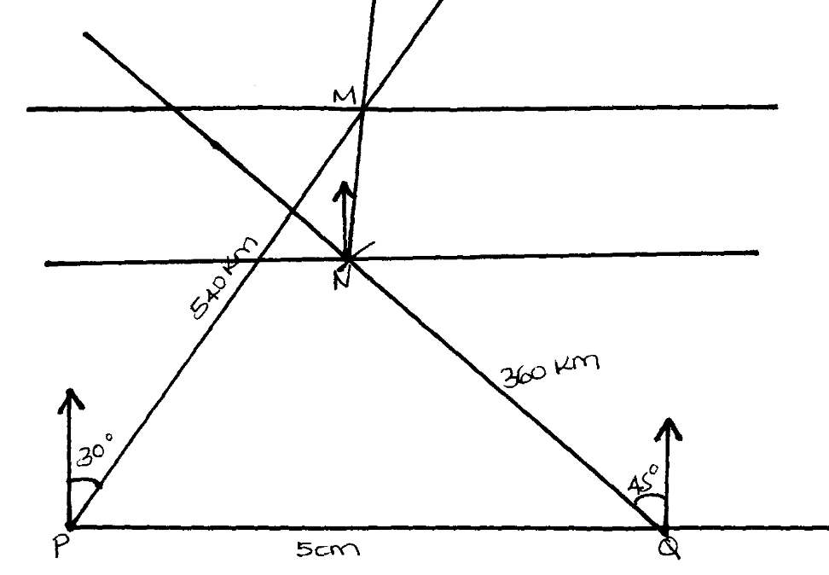  b) 2.1 + 0.1cm  200km, 210km, 220km  c) i) Bearing of M from N = 010⁰ + 1⁰  ii) Bearing of N from M = 190⁰ + 1⁰ | S1  B1  B1  B1  B2  M1  A1  B1  B1 | 1cm rep.100km  <30⁰ at P  <45⁰ at Q  positions of PQM and N  labelling 540km, 360km, 500km all
 |  | 10
23. | $$\left(a\right)\frac{1}{3}×4×4×10=53\frac{1}{3}{cm}^{2}$$  (b)$\frac{4.243}{2.828}=\frac{10+H}{10}$  $$42.43=28.28+2.828H$$  $$H=\frac{14.15}{2.828}=5.004$$  (ii) Volume of frustum  $$\frac{1}{3}×12×12×15.004-\frac{1}{3}×4×4×10$$  $$720.192-53.33$$  $$666.86{cm}^{3}$$  - $\frac{2}{3}×\frac{22}{7}×r^{3}=53\frac{1}{3}$  $$r^{3}=\frac{159}{3}×\frac{7}{22}×\frac{3}{2}$$  $$=25.30$$  $$r=2.935cm$$ | M1  A1  M1  M1  A1  M1  M1  A1
 |  | 10
24. | $$V=\frac{dh}{dt}=-6t^{2}+3t+3$$  $$a=\frac{dv}{dt}=-12t+3$$  $$at t=0, a=-12\left(0\right)+3$$  $$3{m/s}^{2}$$  (i)$-6t^{2}+3t+3=0→2t^{2}-t-1=0$  $$2t\left(t-1\right)+1\left(t-1\right)=0$$  $$\left(2t+1\right)\left(t-1\right)=0$$  $$t=1 or-0.5$$  $$time=1sec$$  (ii)$h=-2{\left(1\right)}^{3}+\frac{3}{2}{\left(1\right)}^{2}+3\left(1\right)$  $$=2.5m$$  (c)$at maximum speed, \frac{dv}{dt}=0$  $$-12t+3=0$$  $$t=\frac{1}{4}$$  Maximum speed, $-6({\frac{1}{4})}^{2}+3(\frac{1}{4})+3$  $$3.375m/s$$ | M1  M1  A1  M1  A1  B1  M1  A1  M1  A1  M1  A1 | For both
 |  | 10

