Name: …………………………………………………………………………….. Class: ………… Adm.No……………
Index No……………………………..
School: …………………………………………………………………………… Date: ………………………………………
Sign:………………………………………..
121/2
MATHEMATICS
PAPER 2
TIME: 2 ½ HOURS

ACK MOCK EXAMINATION – 2022 AUGUST/SEPT
Kenya Certificate to Secondary Education

Instructions
- Write your name, class, admission number, school, date and signature in spaces provided above.
- The paper contains two sections A and B.
- Answer all questions in section A and any five questions from section B in the spaces provided below each question.
- Show all the steps in your calculations giving your answers at each stage in the spaces below each question.
- Non-programmable silent electronic calculator and mathematical tables may be used except where stated otherwise.

For Examiner’s Use Only
1 | 2 | 3 | 4 | 5 | 6 | 7 | 8 | 9 | 10 | 11 | 12 | 13 | 14 | 15 | 16 | TOTAL
SECTION A

SECTION B

17 | 18 | 19 | 20 | 21 | 22 | 23 | 24 | TOTAL  PERCENTAGE  SCORE

SECTION A (50 MARKS)

(Answer all questions in this section in the spaces provided)
- Use logarithm table to evaluate. (4mks)

- Three sisters, Ann, Beatrice and Caroline together invested Ksh. 48,000 as capital and started a small business. If the share of profit is Ksh. 2,300, Ksh. 1,700 and Ksh. 800 respectively, shared proportionally. Find the capital invested by each of them. (3mks)

- Make t the subject of formula in $x=({\frac{p+t}{t})}^{\frac{1}{3}}$ (3mks)

- Without using a calculator or mathematical tables, express in surd form and simplify. (3mks)

- Expand and simplify ${\left(3x-y\right)}^{4}$ hence use the first three terms of the expansion to approximate the value of ${\left(6-0.2\right)}^{4}$. (4mks)

- Find x without using tables if 3 + $\log_{2}{3}$ + $\log_{2}{x}$ = $\log_{2}{5}$ +2 (3mks)

- Find the value of m for which the matrix transforms an object into a straight line. (3mks)
$$\left(\begin{aligned}m^{2} 1 \\ 2m-1 1\end{aligned}\right)$$

- In the figure below PT is a tangent to the circle at T, PQ = 9cm, SA = 6cm, AT = 8cm and AR = 3cm. Calculate the length of;
S
R

A
Q

P

T

(a) AQ (2mks)

(b) PT (1mk)

- A right angled triangle has a base of 15.3 cm and height 7.2 cm, each measured to the nearest 3 mm. Determine the percentage error in finding the area of the triangle, giving your answer to 2 decimal places. (3mks)

- Given that sin x=0.8, without using a mathematical table and calculator find tan(90-x) (3mks)

- The point B(3,2) maps onto B¹(7,1) under a translation T₁. Find T₁ (2mks)

- Using a ruler and a pair of compasses only, construct triangle ABC in which BC=6cm, AB= 8.8cm and angle ABC= 22.5⁰. (3mks)

- Two grades of tea A and B, costing sh 100 and 150 per kg respectively are mixed in the ratio 3:5 by mass. The mixture is then sold at sh 160 per kg. Find the percentage profit on the cost price.
(3mks)

- The first, the third and the ninth term of an increasing AP, makes, the first three terms of a G.P. If the first term of the AP is 3, find the difference of the AP and common ratio of GP. (4mks)

- The matrix M=$\left(\begin{matrix}3 & -2 \\ -5 & y\end{matrix}\right)$ maps a triangular object of area 7 square units onto one with area of 35 square units. Find the value of x. (4mks)

- The equation of a circle is given by x²+4x+y²-2y-4=0. Determine the centre and radius of the circle (3mks)

SECTION B (50 MARKS)
(Answer any five questions in this section)

- A bag contains 3 black balls and 6 white balls. If two balls are drawn from the bag one at a time, find the:
- Probability of drawing two white balls:
- With replacement (2mks)

- Without replacement (2mks)

- Probability of drawing a black ball and white ball:
- With replacement (3mks)

- Without replacement. (3mks)

- In the triangle below P and Q are points on OA and OB respectively such that
OP:PA = 3 : 2 and OQ : QB = 1 : 2. AQ and PQ intersect at T. Given that OA = a and OB = b.

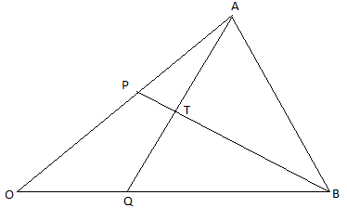

(a) Express AQ and PQ in terms of a and b. (2mks)

(b) Taking $BT=kBP$ and $AT=hAQ$ where h and k are real numbers.
(i) Find two expressions for OT in terms of a and b. (2mks)

(ii) Use the expression in b(i) above to find the values of h and k.
(4mks)

(c) Give the ratio $BT:TP$. (2mks)

- Complete the table below for the functions y=3cosx-2 for 0⁰≤x≤360⁰ (2mks)
x | 0 | 30 | 60 | 90 | 120 | 150 | 180 | 210 | 240 | 270 | 300 | 330 | 360
y=3cosx-2
- Plot the graph of y=3cosx-2 in the graph provided below. (3mks)

- From the graph
- Find the amplitude of the wave. (2mks)

- The period of the wave. (1mk)

- Find the solution to 3cosx=2 (2mks)

- A plane leaves an airport A (41.5⁰N, 36.4⁰W) at 9:00am and flies due north to airport B on latitude 53.2⁰N. Taking π as $\frac{22}{7}$ and the radius of the earth as 6370Km,
- Calculate the distance covered by the plane in km (4mks)

- The plane stopped for 30minutes to refuel at B and flew due east to C, 2500km from B. Calculate:
- position of C (3mks)

- The time the plane lands at C if its speed is 500km/h (3mks)

- The curve given by the equation $y=x^{2}+1$ is defined by the values in the table below.
(a) Complete the table by filling in the missing values. (2mks)
X | 0 | 0.5 | 1.0 | 1.5 | 2.0 | 2.5 | 3.0 | 3.5 | 4.0 | 4.5 | 5.0 | 5.5 | 6.0
Y | 1.0 |  | 2.0 |  | 5.0 |  | 10.0 |  | 17.0 |  | 26.0 |  | 37.0

(b) Sketch the curve for $y=x^{2}+1$ for $0≤x≤6$ (2mks)

(c) Use the mid-ordinate rule with 5 ordinates to estimate the area of the region bounded by the curve $y=x^{2}+1$, the x-axis, the lines x = 0 and x = 6. (2mks)

(d) Use method of integration to find the exact value of the area of the region in (c) above. (2mks)

(e) Calculate the percentage error involved in using the mid-ordinate rule to find the area. (2mks)

- (a) Using a ruler and pair of compasses only construct triangle PQR in which
$PQ = 7.5cm$ $QR= 6.0cm$ and angle $PQR = {60}^{0}$. Measure PR (3mks)
- On same side of PQ as R
- Determine the locus of a point T such that angle $PTQ = {60}^{0}$ (3mks)
- Construct the locus of M such that $PM = 3.5cm.$ (2mks)
(iii)Identify the region W such that $PR≥3$ and angle $PTQ≥{60}^{0}$ by shading the unwanted part. (2mks)

- OABCD is a right pyramid on a rectangular base with AB = 8 cm, BC = 6 cm,
OA = OB = OC = OD = 13 cm. Calculate;

(a) the height of the pyramid. (3mks)

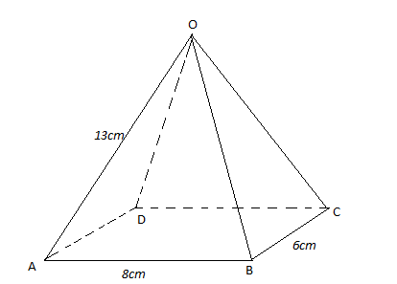
(b) the inclination of OBC to the horizontal. (2mks)

(c) the angle between;
(i) OB and DC (3mks)

(ii) the planes OBC and OAD (2mks)

- The games master wishes to hire two matatus for a trip. The operators have a Toyota which carries 10 passengers and a Kombi which carries 20 passengers. Altogether 120 people have to travel. The operators have only 20litres of fuel and the Toyota consumes 4 litres on each round trip and the Kombi 1 litre on each round trip. If the Toyota makes x round trips and the kombi y round trips;
  - write down four inequalities in x and y which must be satisfied . (2mks)

(b)Represent the inequalities graphically on the grid provided. (3mks)
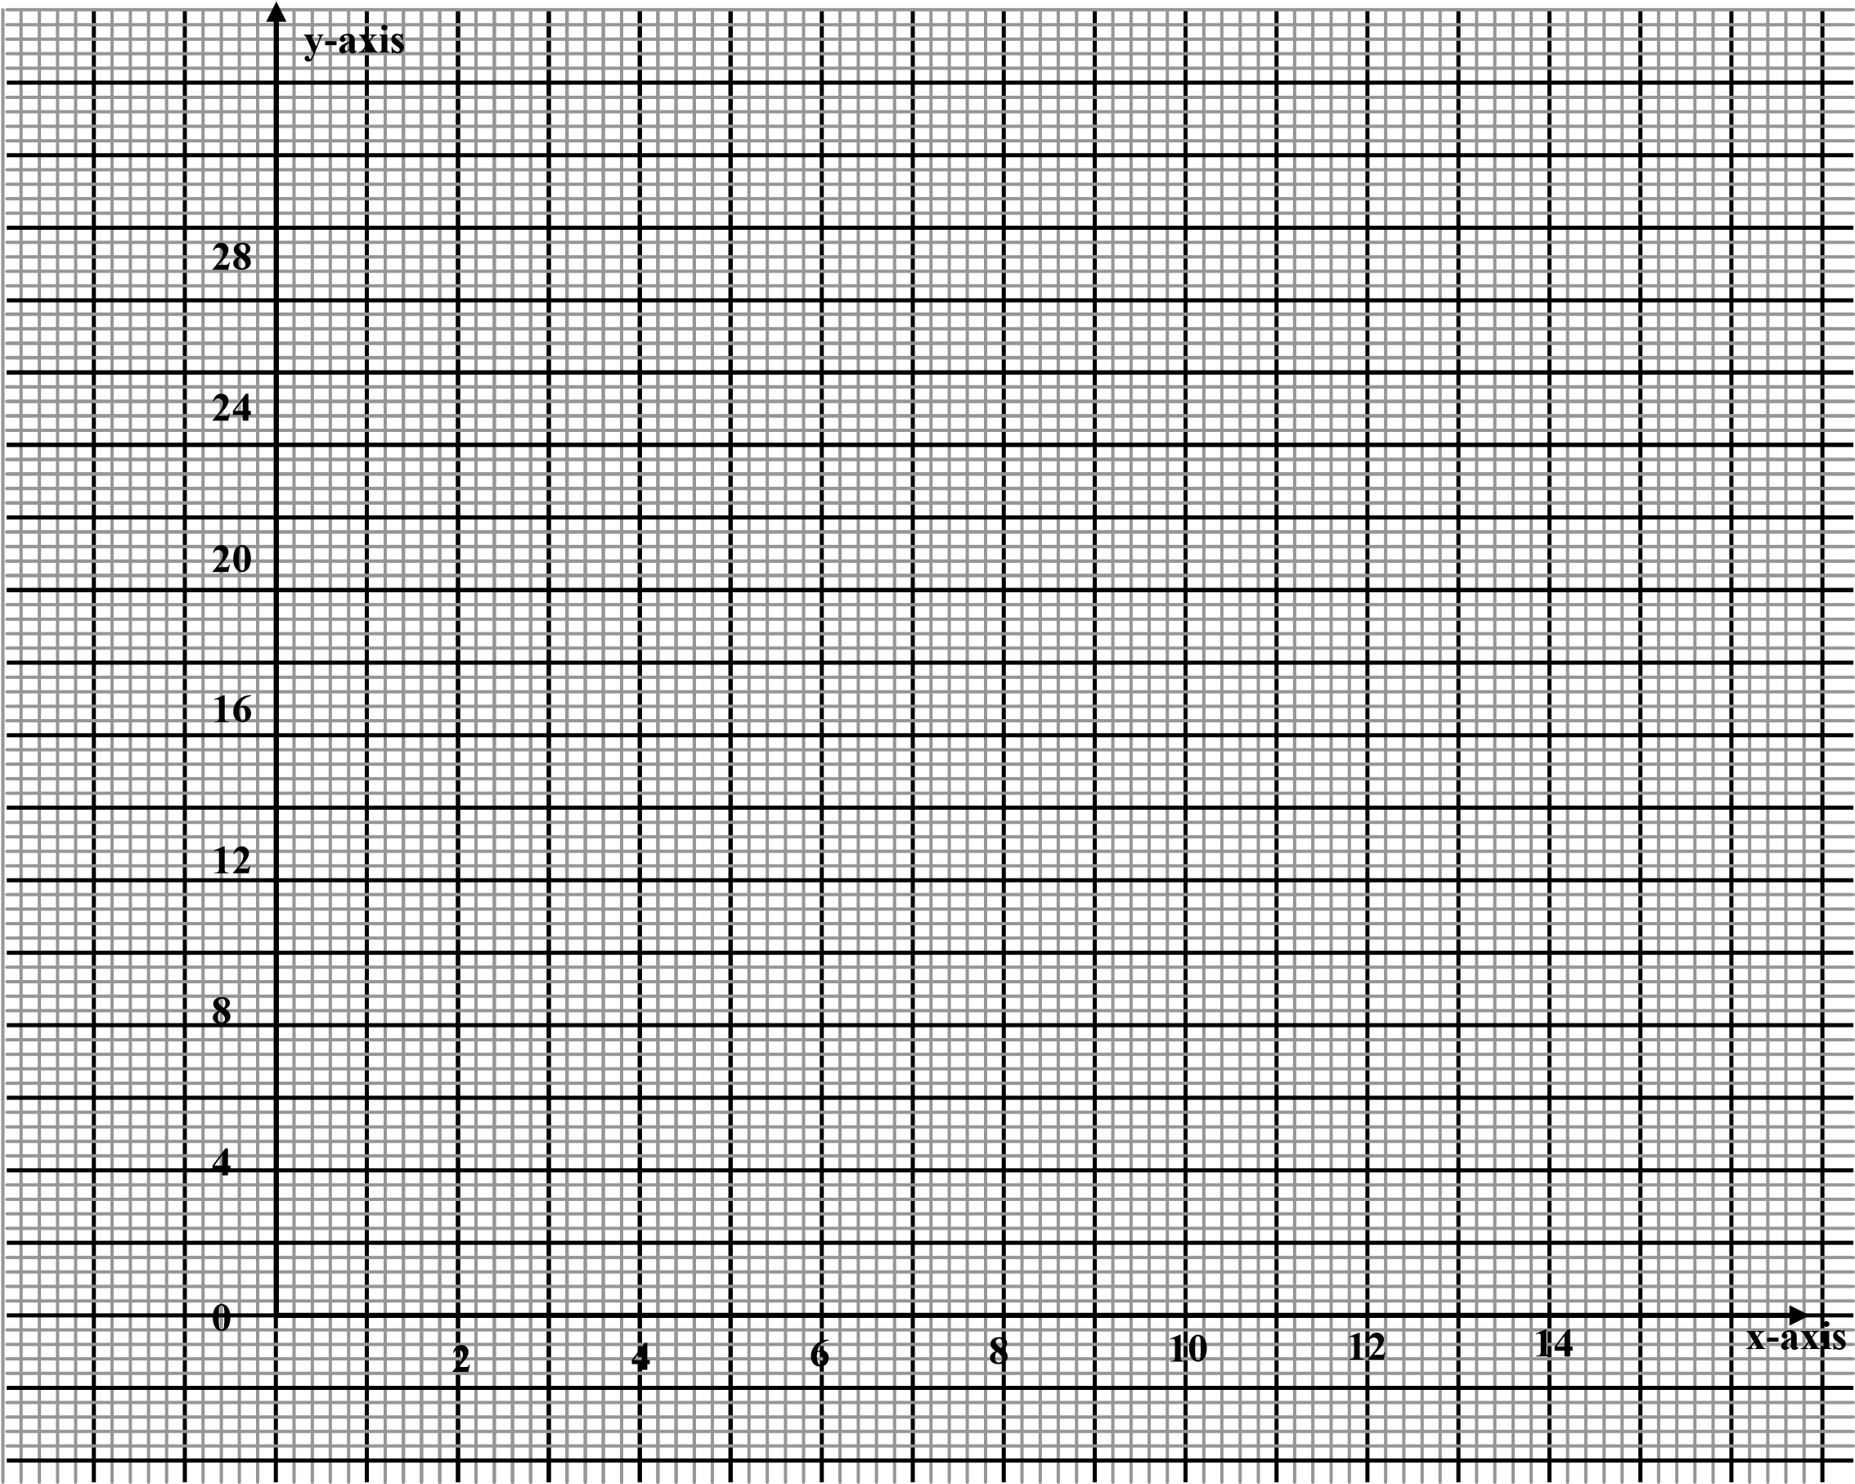
(c) The operators charge shs.100 for each round trip in the Toyota and shs.300 for each
round trip in the kombi;
- determine the number of trips made by each vehicle so as to make the total cost a minimum. (4mks)

- find the minimum cost. (1mk)

