MARKING SCHEME - MATHEMATICS ALT A - 121/2
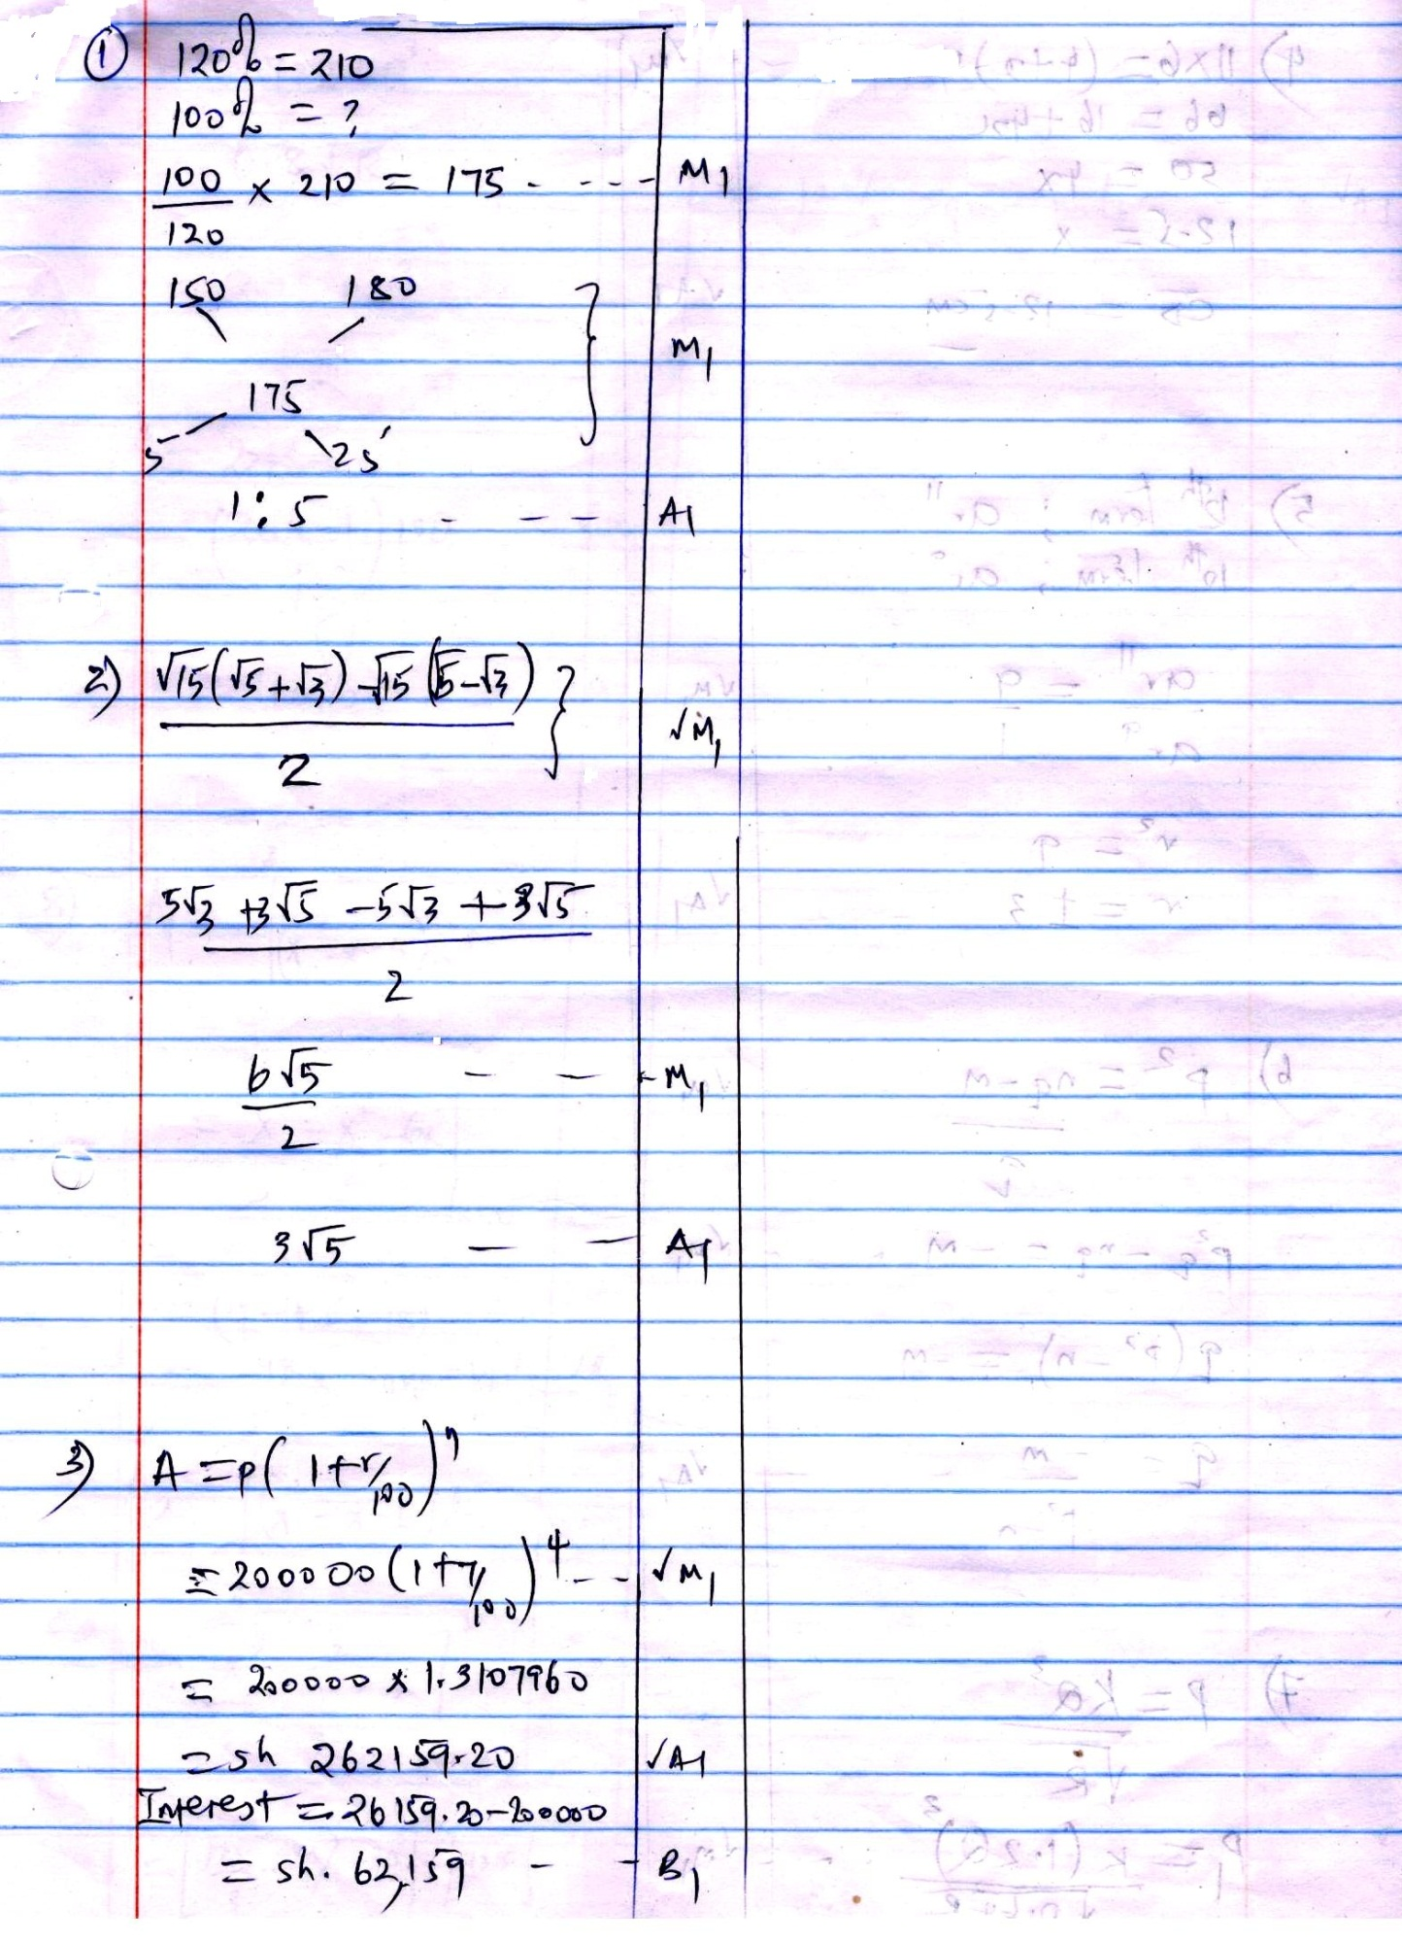
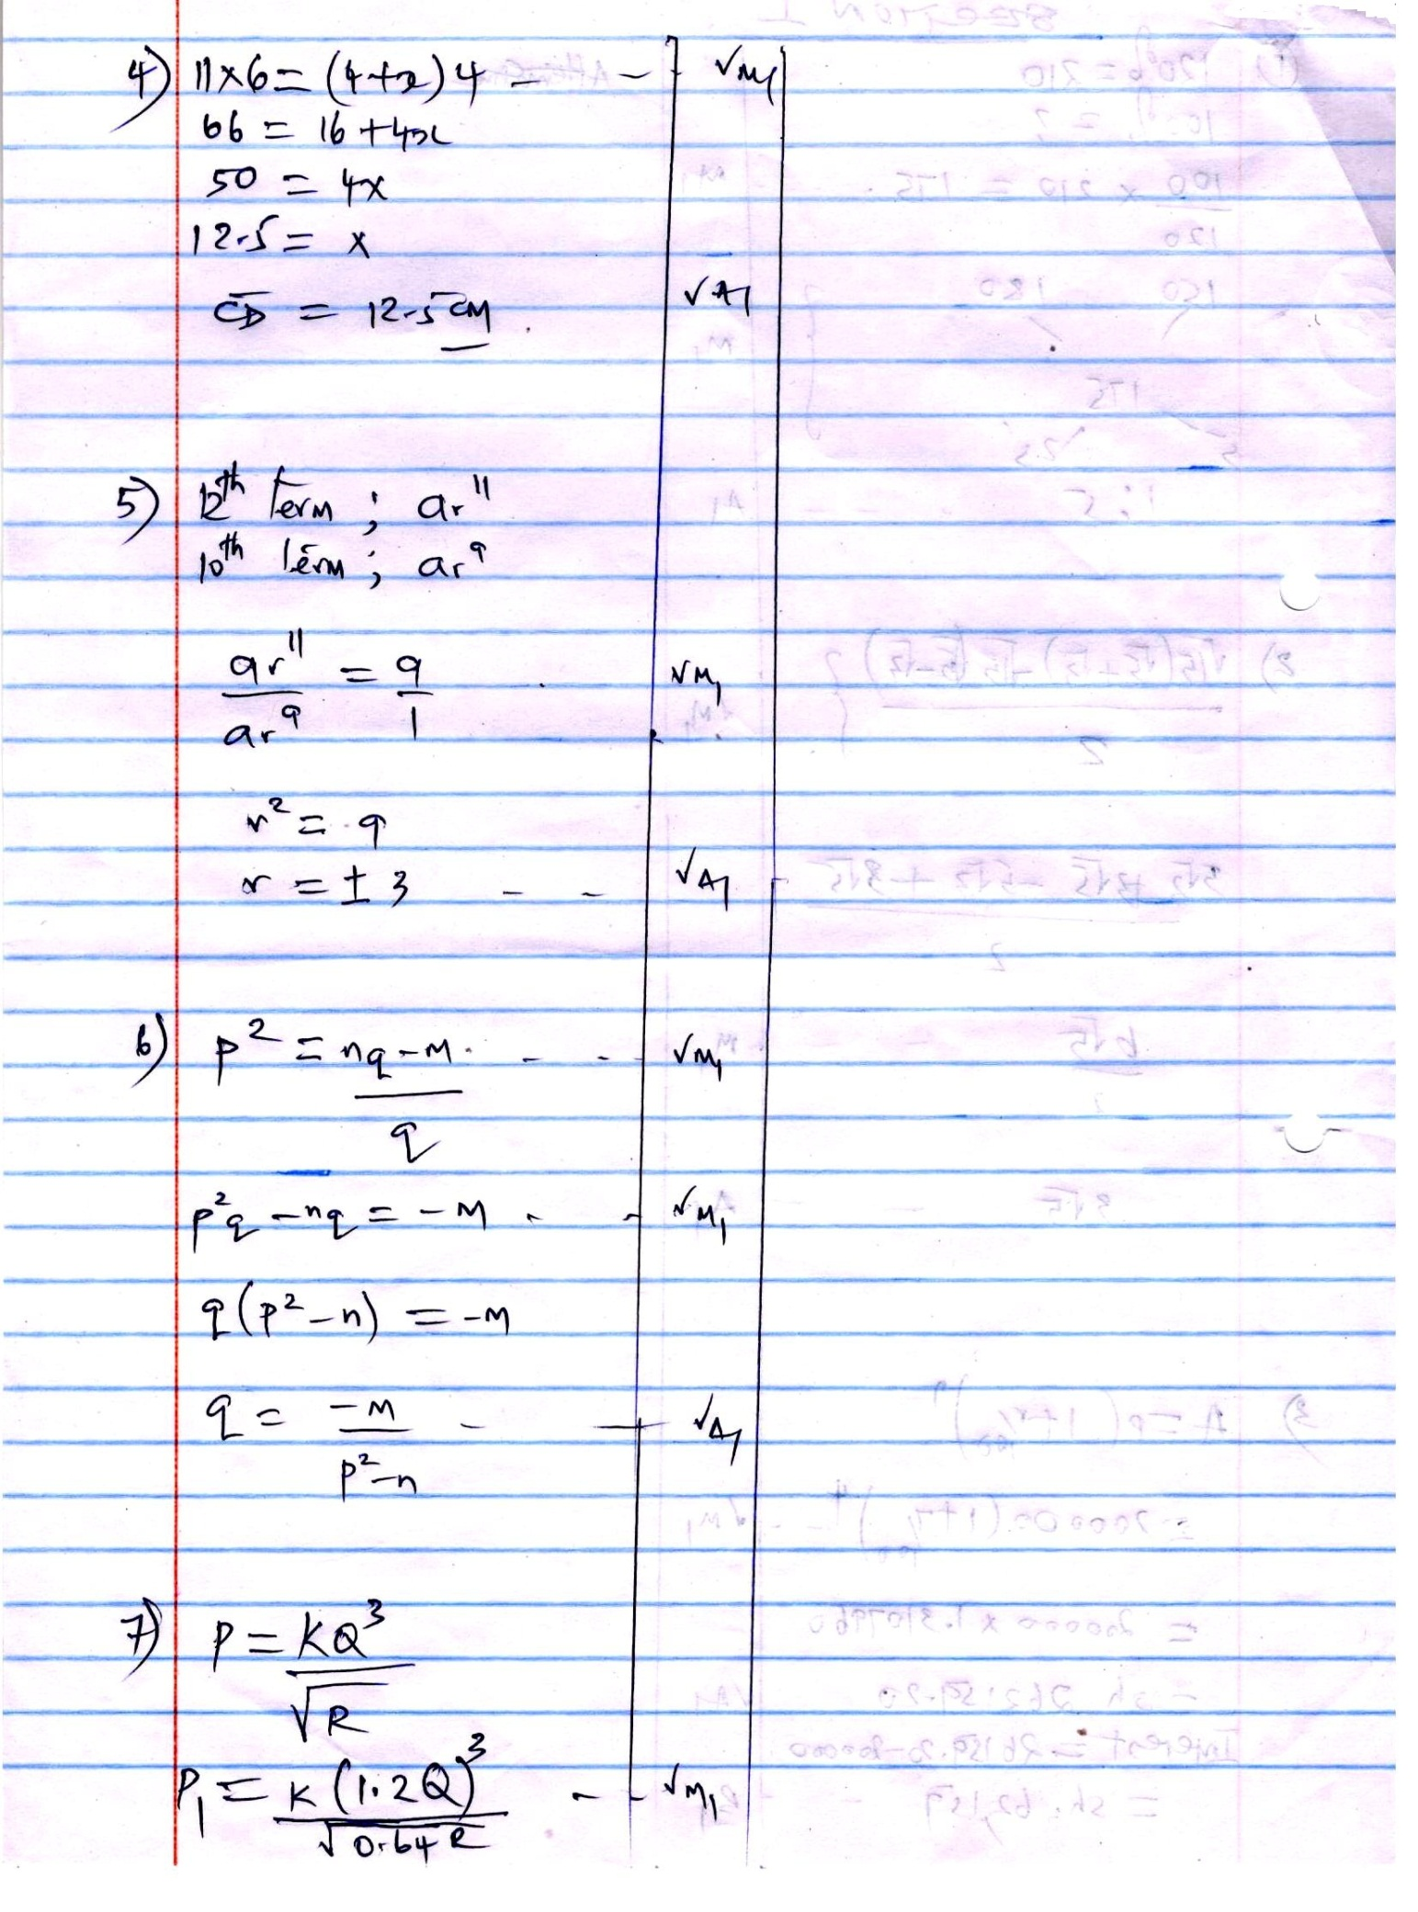
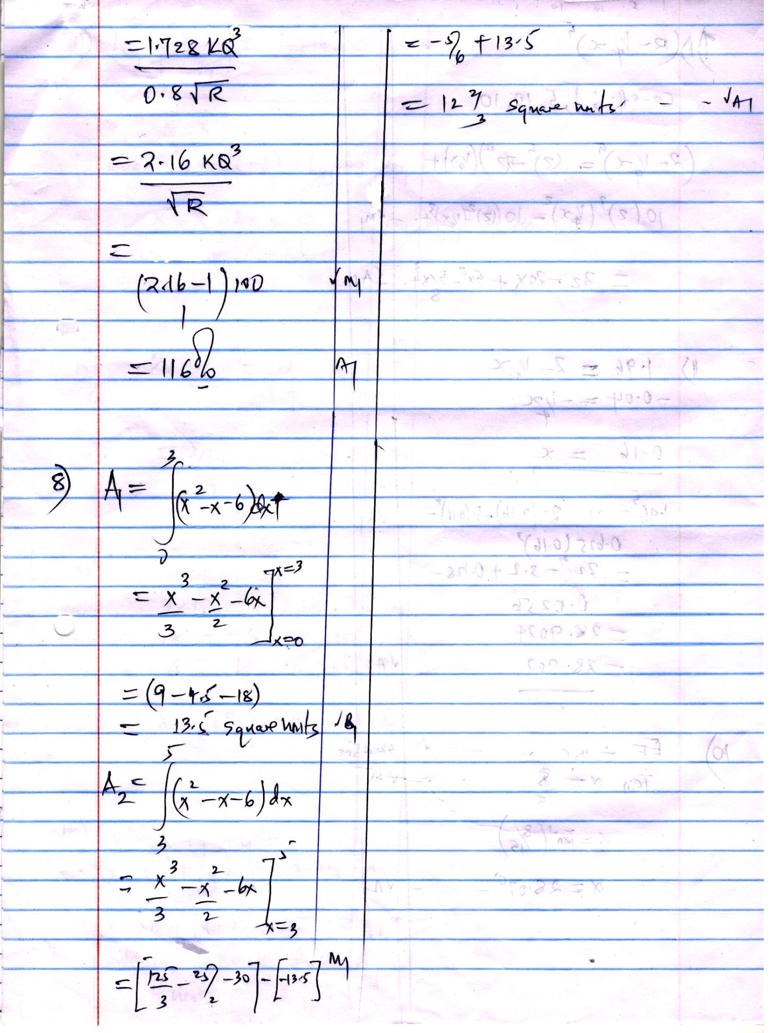
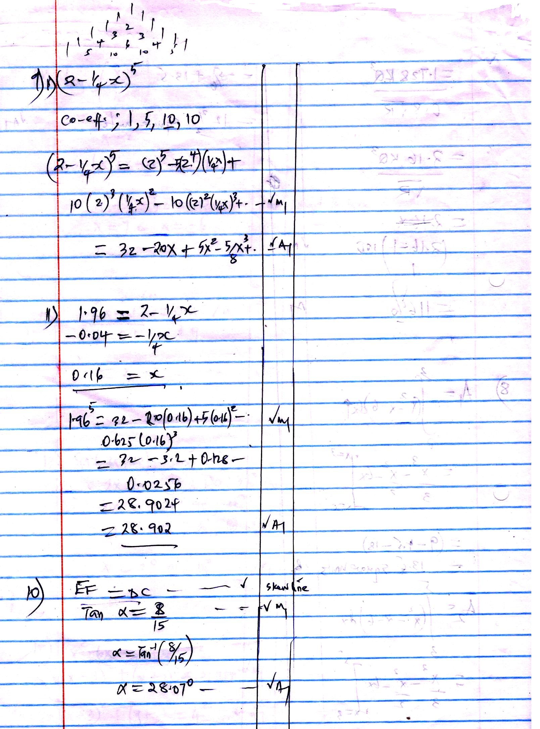

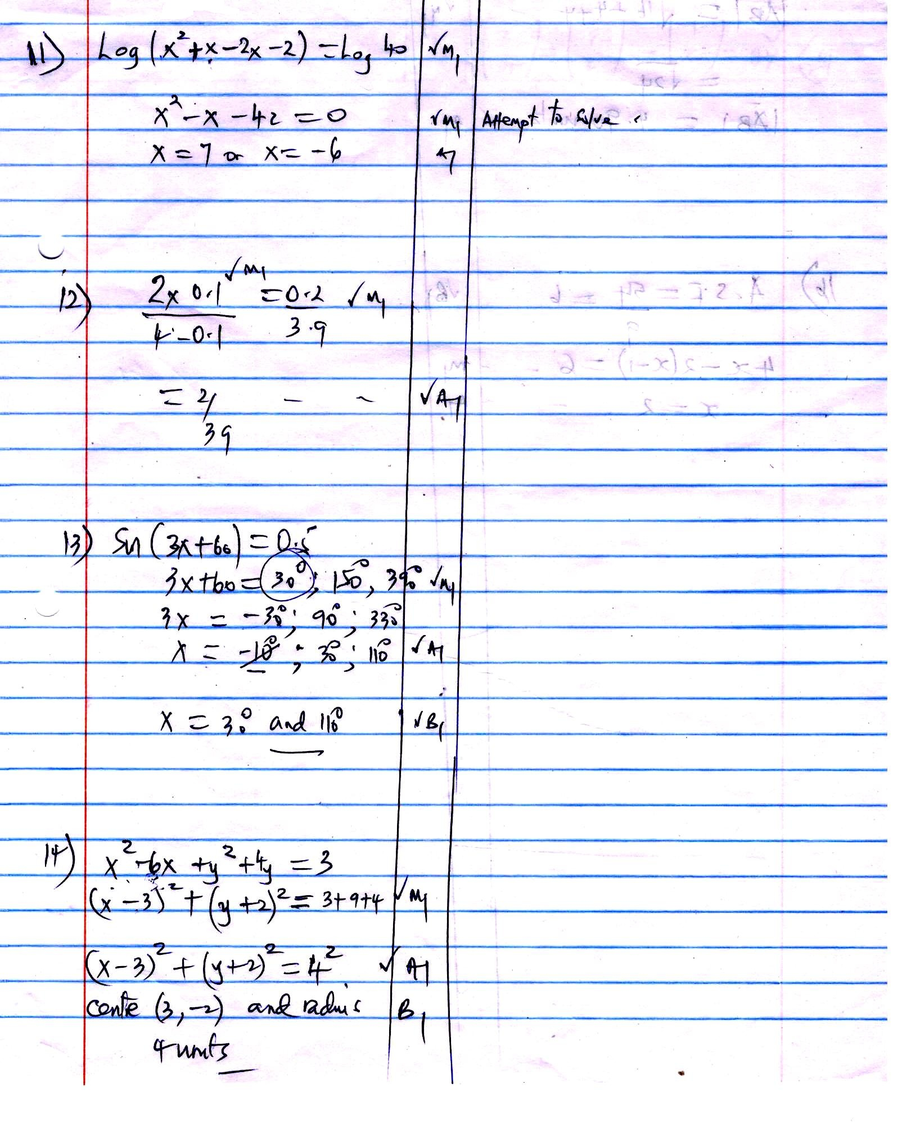
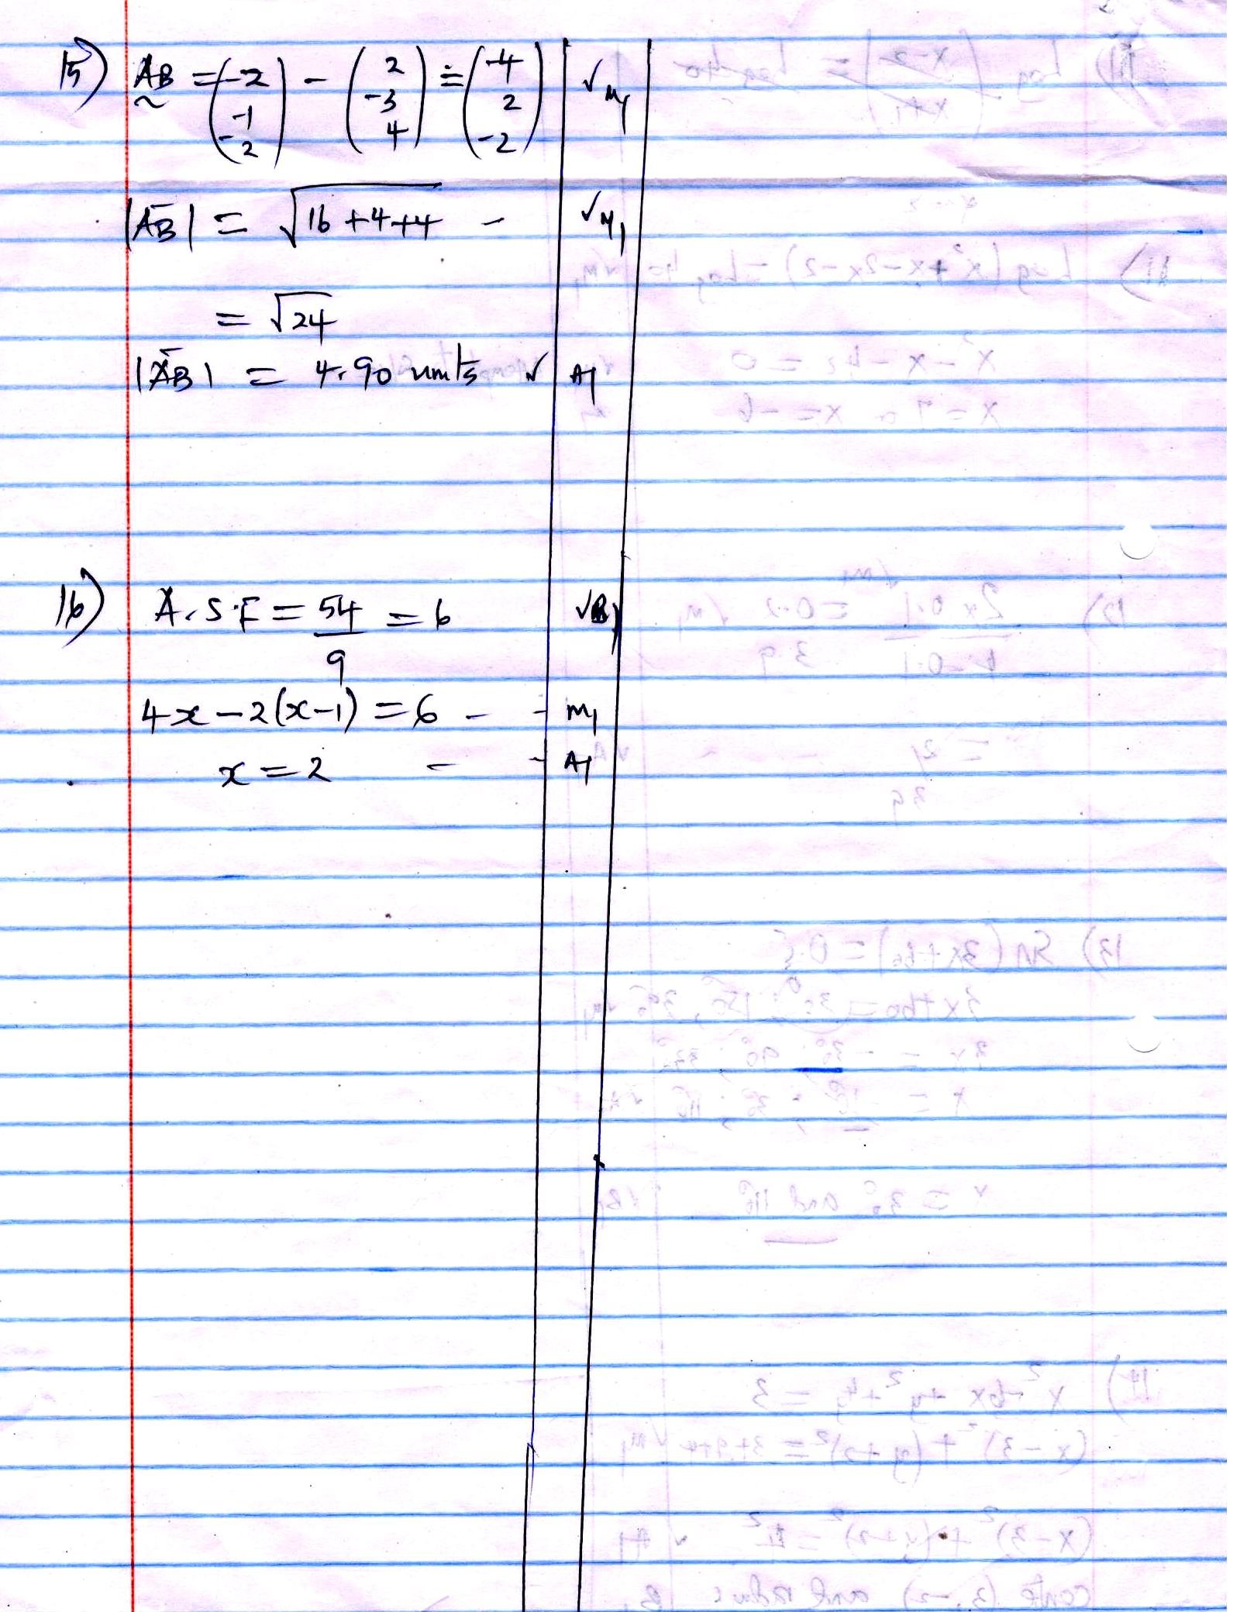

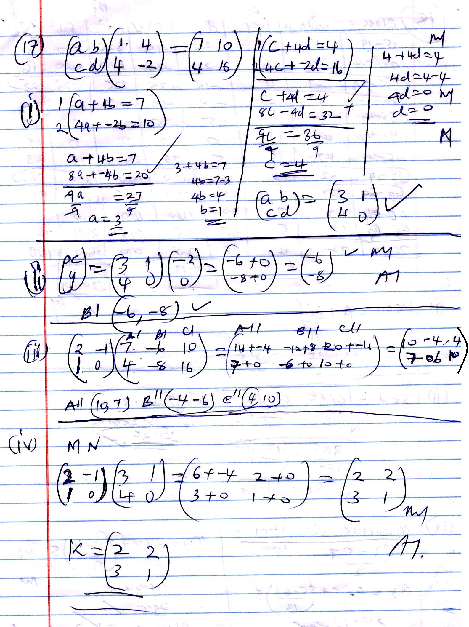
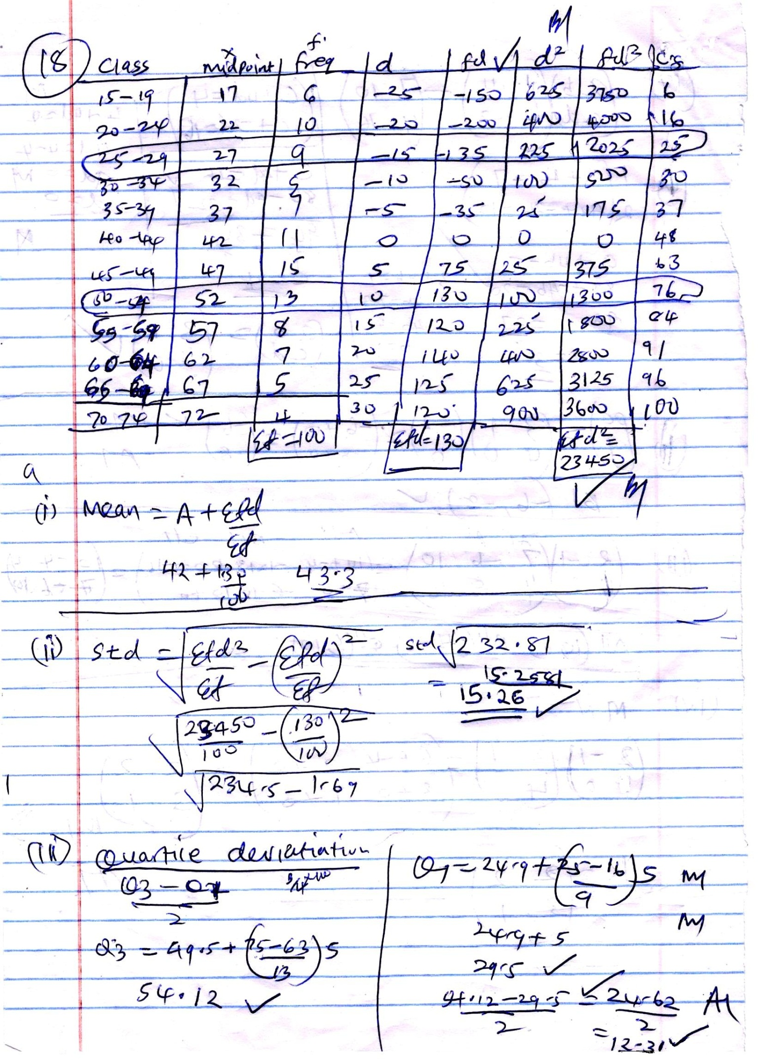
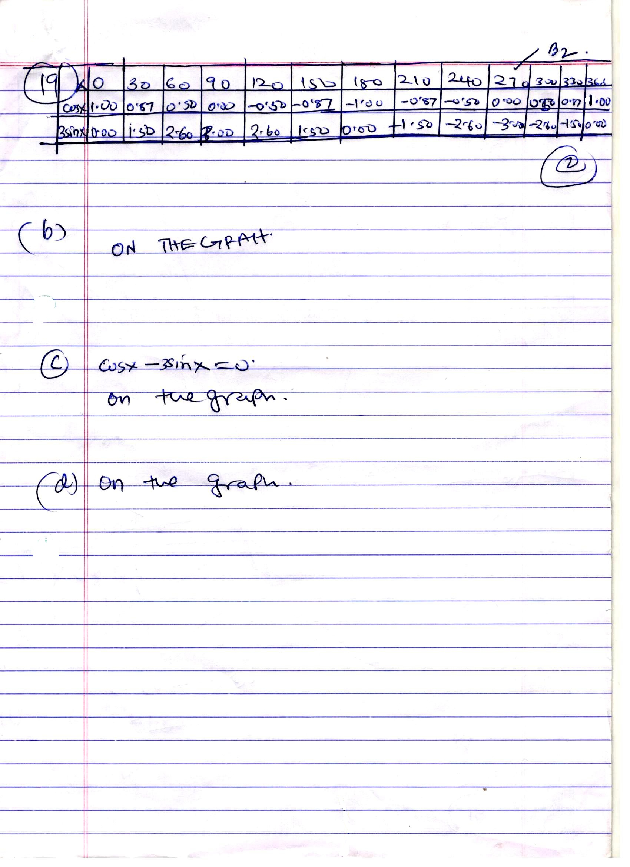
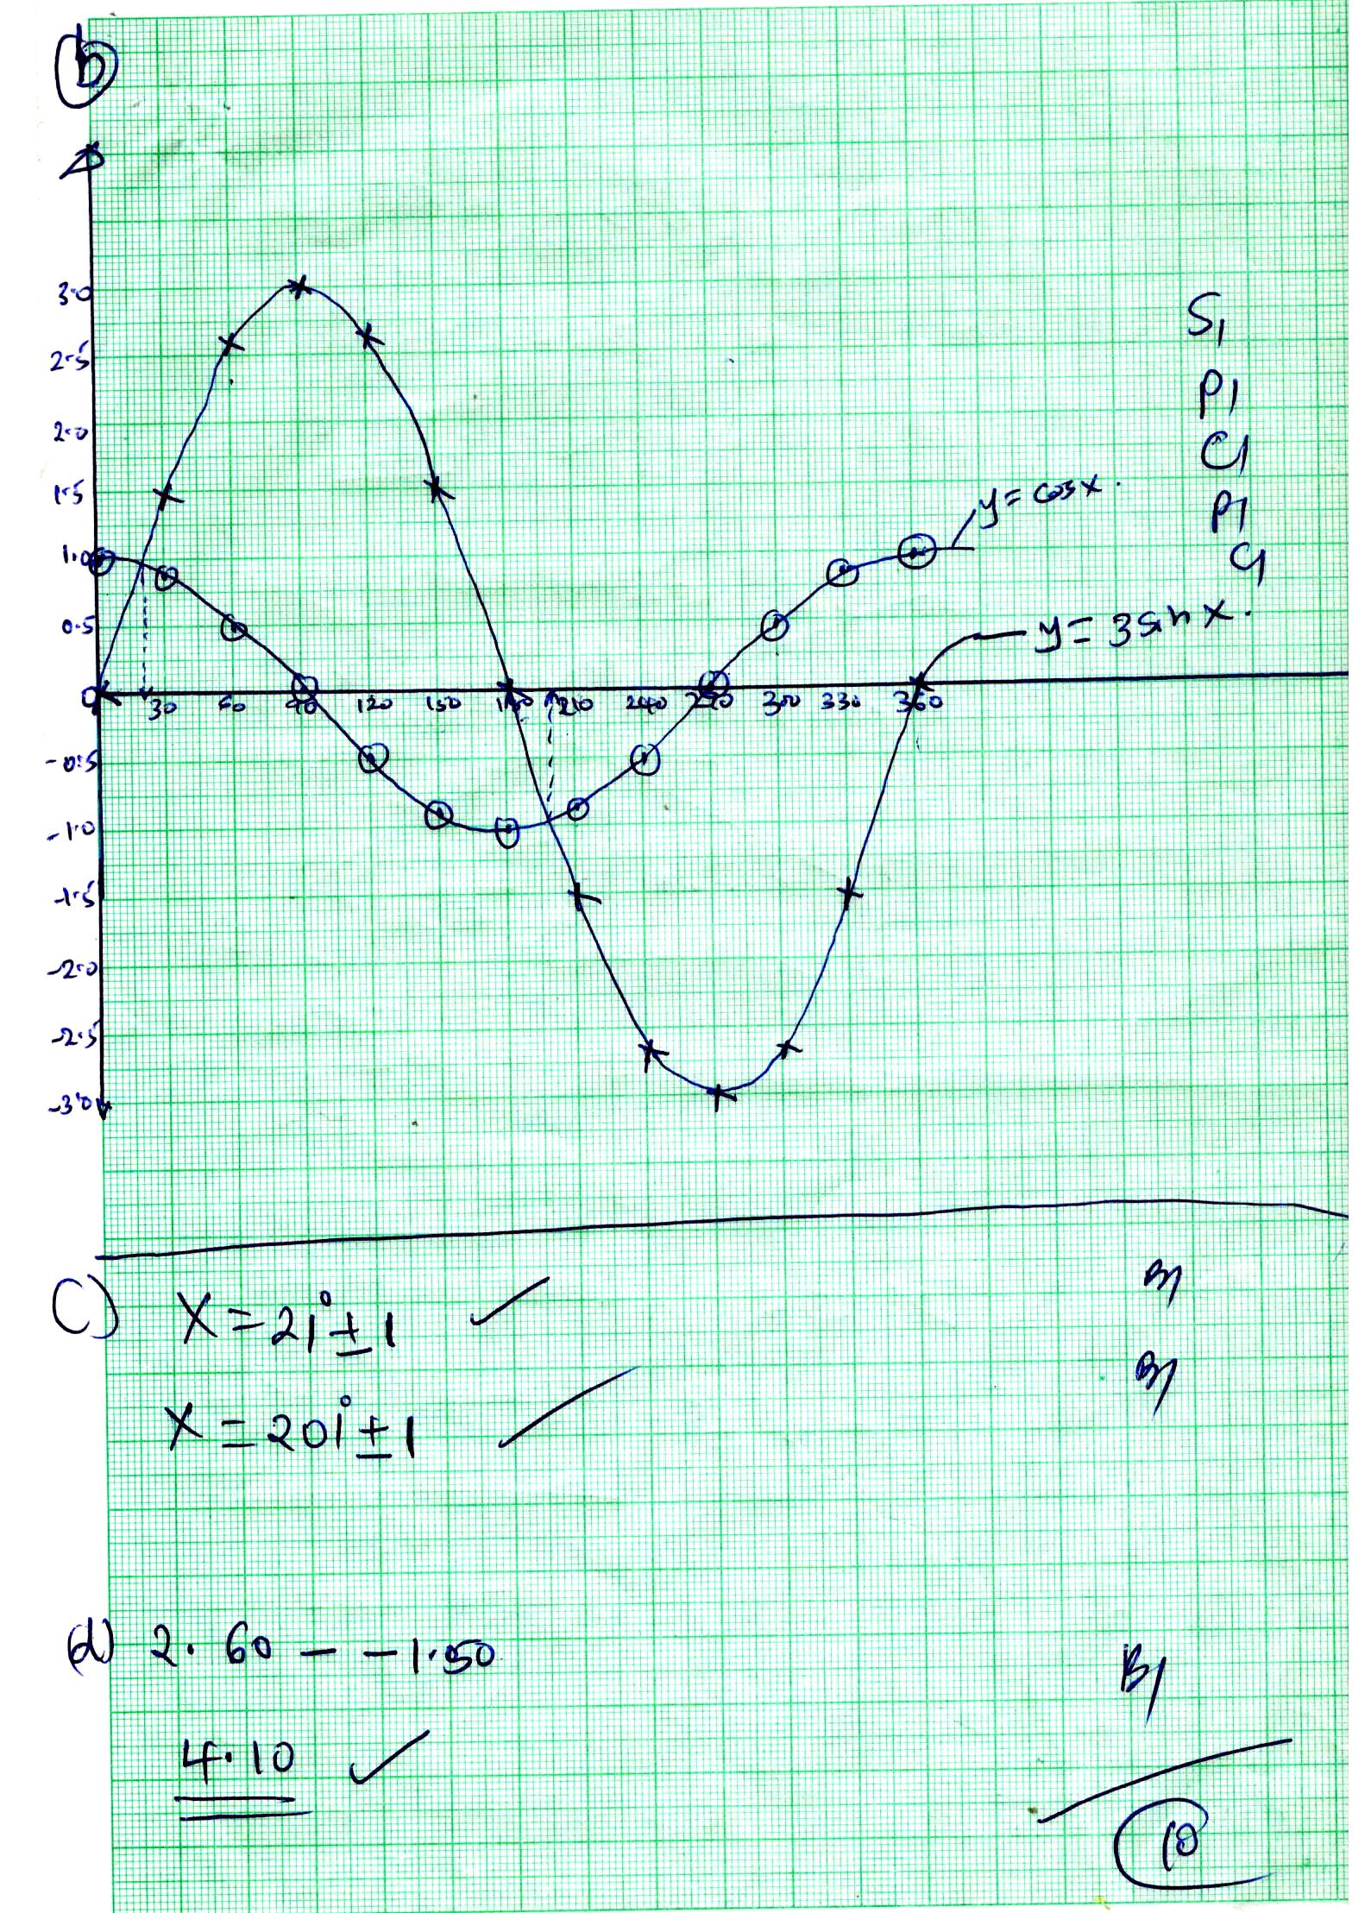
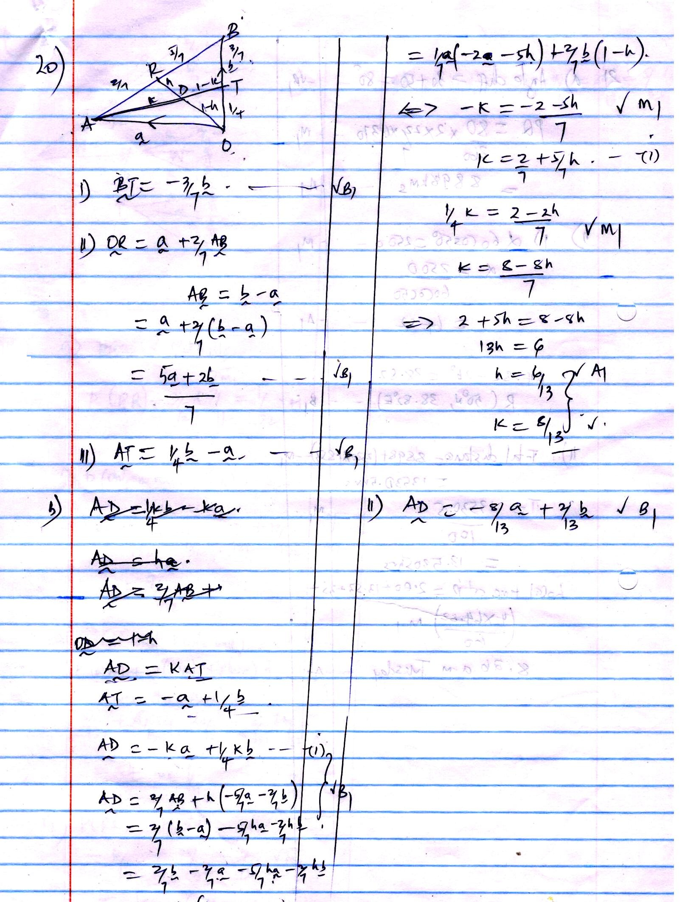

21. (a) 3000 = $\frac{4}{360}$ x 2 x $\frac{22}{7}$ x 6370 cos 30º M1
$∝$= 31.15º $√$A1
(b) (i). . dist = speed x time
= 600 x 5 $√$M1
= 5000 nm
3000 = 60$∝$ cos 60º $√$M1
$∝$ = $\frac{3000}{60\cos{{60}^{o}}}$
$∝$= 100º
K = 100 - 45 = 55ºE$√$ A1
Q (60º, 55ºE)
(ii). longitude diff = 55 + 45
= 100º
Time = 100 x 4 min
= 6 hrs 40 mins
Time at Q = 10.45 – 6.40
= 4.05 am
Arrival at Q = 4.05 + 5.00
= 9.05 am
c).Q = 180º – 2 (30)º
= 120º
Distance = 60Q
= 60 x 120
= 7200nm
OR in KM
= $\frac{120}{360}$ x 2 x $\frac{22}{7}$ x 6370
= 13,346.67KM
