Name _________________________________________ Index No______________________
School ____________________________ Candidate’s Signature ___________________
Adm.No ___________________________ Date __________________________
121/2
MATHEMATICS
PAPER 121/2
2 ½ hours
AUGUST/SEPTEMBER, 2022
TIME: 2 ½ Hours

ARISE AND SHINE TRIAL EXAMINATIONS
Kenya Certificate of Secondary Education (KCSE)

Instructions to Candidates
- Write your name and index number in the space provided above.
- This paper consists of TWO sections: section I and section II.
- Answer all the questions in section I and only five questions from section II.
- All workings and answers must be written on the question paper in the spaced provided below each question.
- Non-programmable silent electronic scientific calculators and KNEC Mathematical tables may be used EXCEPT where stated otherwise
- The paper consists of 13 printed pages.
- Candidates should check carefully to ascertain that all the pages are printed and no questions are missing.

For Examiner’s Use Only
Section I
Question | 1 | 2 | 3 | 4 | 5 | 6 | 7 | 8 | 9 | 10 | 11 | 12 | 13 | 14 | 15 | 16 | Total
Candidate’s Score
Section II Grand Total

Question | 17 | 18 | 19 | 20 | 21 | 22 | 23 | 24 | Total
Candidate’s Score
SECTION I: 50 MARKS
- 1kg of brown sugar cost sh.150 while that of white sugar cost sh180. In what ratio by mass should be mixed so as to realize a profit of 20% by selling 1kg of the mixture at sh.210. (3 marks)

- Simplify $\frac{\sqrt{15}}{\sqrt{5}- \sqrt{3}}$ - $\frac{\sqrt{15}}{\sqrt{5}+ \sqrt{3}}$ (3 marks)

- Find the compound interest on Sh.200,000 for 2 years at 14% p.a. compounded semi-annually (3 marks)

- Chord AB and CD in the figure below intersect externally at Q. If AB = 5cm and BQ =6cm and DQ=4cm, Calculate the length chord CD. (2 marks)
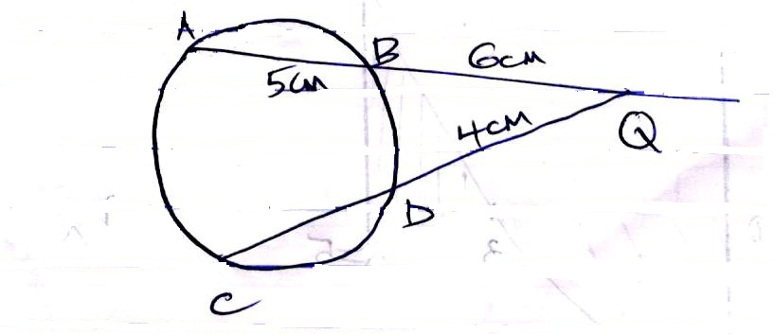

- The ratio of 12th to 10th term in geometric series is 9:1. Find the common ratio (2 marks)

- Make q the subject of the formula. (3 marks)
P = $\frac{\sqrt{nq-M}}{q}$

- P varies as the cube of Q and inversely as the square root of R. If Q is increased by 20% and R decreased by 36%, find percentage change in P. (3 marks)

- The Sketch below represents the graph of y = x² - x - 6. Find the area bounded by the curve, X-axis and the line X=5 (3 marks)
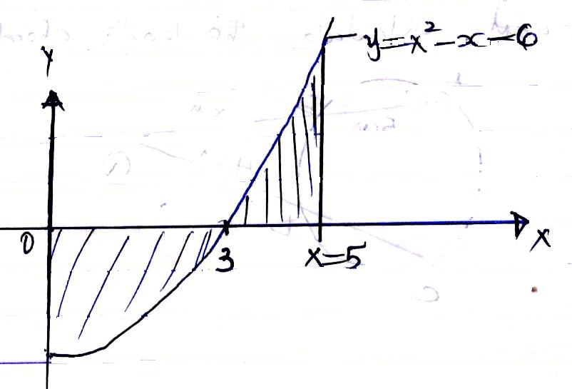

- Expand upto the term X³ (i) (2 -$\frac{1}{4}x$)⁵ (2 marks)

(ii) Use your expansion to find the value of (1.96)⁵ correct to 3 decimal places. (2 marks).

- The figure below shows a cuboid labeled ABCDEFGH point O is the mid-point of BD, AB=15cm, BC = 8cm and CF = 5cm.
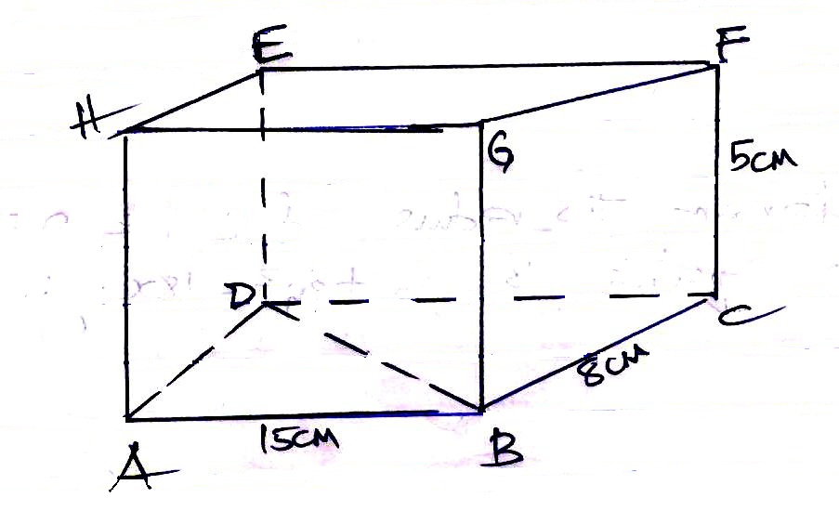
Calculate the angle between the lines BD and EF (3 marks)

- Find the value of X in log (X - 2) + log (X + 1) = 1 + log 4 (3 marks)

- Given that 2 ≤ A ≤ 4 and 0.1 ≤ B ≤ 0.2. Find the minimum value of $\frac{AB}{A-B}$ (3 marks)

- Solve the equation: 2 sin (3x+60) = 1 for 0°≤ x ≤ 180° (3 marks)

- Determine the radius and centre of a circle whose equation is 3x² + 3y² - 18x + 12y - 9 = 0 (3 marks)

- The position vector of A and B are given as a = 2i – 3j +4k and b = -2i – j + 2k respectively. Find to two decimal places the length of AB (3 marks).

- In a transformation, an object with area 9cm² is mapped onto an image whose area
is 54cm². Given that the matrix of transformation is $\left({x \atop 2}{x-1 \atop 4}\right)$Find the value
of X (3 marks)

SECTION II (50MARKS)
Choose Five Questions in this Section

- The Points A (1, 4), B (-2, 0) and C (4,-2) of a triangle are mapped onto A¹ (7, 4), B1(X, Y) and C¹ (10, 16) by a transformation N = $\left({a \atop c}{b \atop d}\right)$
Find;
- Matrix N of the transformation. (4 marks)

- Co-ordinates of B¹ (2 marks)

- A"B"C" are the image of A¹ B¹ C¹ under transformation represented by matrix
M = $\left({2 \atop 1}{-1 \atop 0}\right)$ write down the coordinate of A"B"C" (2 marks)

- A transformation N followed by M can be represented by a single transformation K. Determine K. (2 marks)

- The table below shows a sample of 100 bulbs, the time taken for each bulb to burn was recorded. The table below shows the results of the measurement.
Time in Hrs | 15-19 | 20-24 | 25-29 | 30-34 | 35-39 | 40-44 | 45-49 | 50-54 | 55-59 | 60-64 | 65-69 | 70-74
Number of Bulbs | 6 | 10 | 9 | 5 | 7 | 11 | 15 | 13 | 8 | 7 | 5 | 4
- Using an assumed mean of 42, Calculate;
- The actual mean of distribution. (4 marks)

- The Standard deviation of the distribution (3 marks)

- Calculate the quartile deviation. (3 marks)

- (a) Complete the table below by filling in the blank spaces. (2 marks)
X | 0 | 30 | 60 | 90 | 120 | 150 | 180 | 210 | 240 | 270 | 300 | 330 | 360
y = cos x | 1.00 | 0.87 |  | 0.00 |  | -0.87 |  | -0.87 |  |  |  | 0.87
y = 3 sin x | 0.00 |  |  | 3.00 |  |  |  |  |  |  |  | -1.50 | 0.00
- Using the scale 1cm to represent 30° on the X-axis and 2cm to represent 1 unit on the vertical axis, draw on the graph y = cos x and y = 3 sin x (5 marks)
- Use your graph to solve the equation cosx - 3 sin x = 0 (2 marks)

- What is the difference in the value of y = cox x and y = 3 sin x at x=120° (1 mark)

- The figure below is a triangle OAB, where OA = a andOB=b. A point R divides AB in the ratio 2:5 and a point T divides 0B in the ratio 1:3. OR and AT intersect at D.
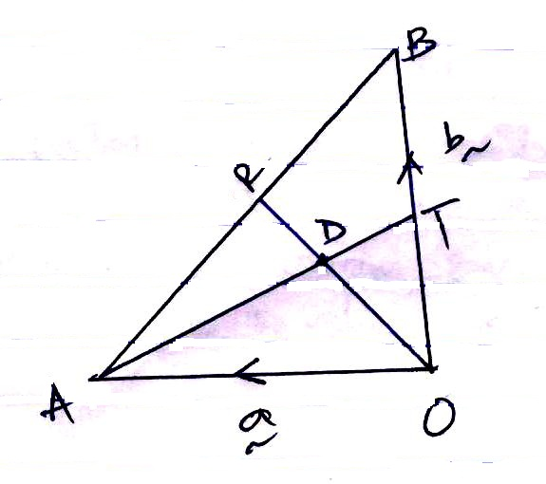
- Find in terms of a and b
- BT (1 mark)

- OR (1 mark)

- AT (1 mark)

- Given that AD =kAT and RD = hRO where k and h are scalars.
- Find the values of h and k. (4 marks)

- Hence AD in terms of a and b (1 mark)

- (a) Two towns on latitude 30°N are 3000km apart. Find the longitude difference of the two towns (Take π =²²/₇ , and radius of earth to be 6370km) (2 marks)

- The position of airport P and Q are P(60°N, 45°W) and Q (60°N, k°E). It takes a plane 5 hours to travel due East from P to Q at average speed of 600 knots.
- Calculate the value of k (3 marks)

- The Local time at P is 10:45am when it is the local time at Q when the plane reached there? (3 marks)

- Calculate the shortest distance between A( 30°S, 36°E) and B (30°S, 144°W) (2 marks)

- A bag contains 3 red, 5 white and 4 blue balls. Two balls are picked without replacement. Determine the probability of picking.
(a) 2 red balls (2 marks)

(b) Only one red ball (2 marks)

(c) At least a white ball (2 marks)

(d) Balls of same colour. (2 marks)

(e) Two white balls (2 marks)

- The ministry of health made an order of both Astrazenica and Johnson and Johnsons vaccines for a health centre. The total number of both vaccines should be more than 600 boxes. The number of boxes of Johnson and Johnson should be less than 500 boxes and more or equal to twice the number of Astrazenica. Letting x to represent the number of Johnson and Johnson boxes and y. to represent the number of boxes of Astrazenica,
(a) i) Form all the inequalities in x and y to represent the above information. (3 marks)

ii) Represent the inequalities on a graph (4 marks)
(b) If the cost of importing 1 box of Johnson and Johnson is sh1000 and astrazenica is shs.800. Find maximum cost of importing the vaccines. (3 marks)
- A particle moves in such a way that its velocity V at any given time is v = 10t – ½t² - 15 m/s.
- Calculate its initial velocity (1 mark)

- Calculate the velocity when the time t = 3s

- Find the displacement during the 5th second (4 marks)

- Calculate the maximum velocity attained. (3 marks)

