**Name……………………………………………………Adm.No……………………….**

**SCHOOL…………………………………Signature……………………Date………………**

**121/1**

**MATHEMATICS PAPER 1**

**Term 1 , 2022**

**2 ½ HRS**

**MUMIAS WEST JOINT EVALUATION TEST**

**TERM 1 – JUNE 2022**

**FORM 4 – MATHEMATICS PAPER 1**

**INSTRUCTIONS TO CANDIDATES**

* Write your name and your class in spaces provide
* The paper contains **two** sections. Section **I** and Section **II**
* Answer all the questions in section **I** and any **five** questions from **section II**.
* Show all the steps in your calculations, giving your answers at each stage in the spaces below each question.
* Marks may be given for correct working even if the answer is wrong.
* Non-programmable silent electronic calculators and KNEC Mathematical tables may be used except where stated otherwise.
* This paper consists of 16 printed pages

**FOR EXAMINERS USE ONLY.**

|  |  |  |  |  |  |  |  |  |  |  |  |  |  |  |  |  |  |
| --- | --- | --- | --- | --- | --- | --- | --- | --- | --- | --- | --- | --- | --- | --- | --- | --- | --- |
| Question | 1 | 2 | 3 | 4 | 5 | 6 | 7 | 8 | 9 | 10 | 11 | 12 | 13 | 14 | 15 | 16 | TOTAL |
| Marks |  |  |  |  |  |  |  |  |  |  |  |  |  |  |  |  |  |

GRAND TOTAL

|  |  |  |  |  |  |  |  |  |  |
| --- | --- | --- | --- | --- | --- | --- | --- | --- | --- |
| Question | 17 | 18 | 19 | 20 | 21 | 22 | 23 | 24 | TOTAL |
| Marks |  |  |  |  |  |  |  |  |  |

**SECTION A (50 marks)**

Answer **all** questions in this section in the spaces provided.

1. Without using a calculator evaluate

5x6 + (-76) $÷$ 4+27 $÷$ 3

(-5) $÷$ 3 x (-4) (3mks)

2. ( a) Express 2268 in terms of its prime factors (1mk)

(b) Hence determine the smallest positive number x such that 2268x is a perfect square. (2mks)

3. Elvis arrived in Kenya with 5000 sterling pound, he exchanged it to Kenya Shilling and spent sh. 267 100. Before jetting out of the country, he exchanged the balance into Euros. Using the exchange rates below, calculate the amount he obtained in Euros in Kenya shillings. (3mks)

**Currency Buying Selling**

1 Sterling pound 114.20 114.50

1Euro 101.20 101.30

4. Simplify the expression (3mks)

2x2+3x-2

x3- 4x

5. When two wires of length 179m and 234m are divided into pieces of equal lengths a

remainder of 3m is left in each case. Find the least number of pieces that can be obtained.

(3mks)

6. Without using calculator, solve for n in the equation 1 - = (3mks)

7. Solve for y in the equation - = (3mks)

8. Two similar solids have surface area of 48cm2 and 108cm2 respectively. Find the volume of the smaller solid if the bigger solid has a volume of 162 cm3  (3 mks)

9. Use reciprocal table only to evaluate $\frac{1}{0.325}$ (3mks)

Hence, evaluate to 1.d.p

10. A plot measuring 1.2m by 19.1 m is surrounded by a path 0.5m wide. Find the area of the

path in square metres. (3mks)

11. The interior angle of a regular polygon is 600 more than its exterior angle, find the number of sides of the polygon. (3mks)

12. Complete the following solid given that ABC is its cross-section (3mks)

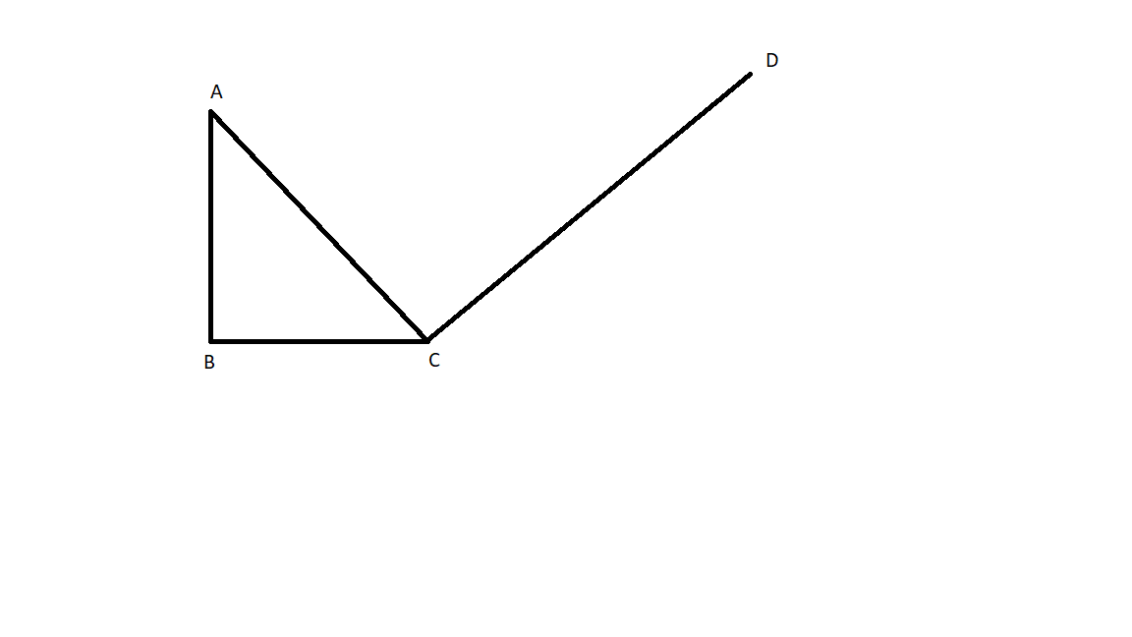

13. If tan x = $\frac{1}{√3}$ find without using tables or calculator the value of

Sin (90-x)+ cos (90-x) leaving your answer in simplified surd form (3mks)

14. A line perpendicular to the line 3y-2x=2 passes through the point (-3,2). Determine the

equation of the line and write it in the form ax +by = c where a, b, and c are constant.

(3mks)

15. Given that **A** = and **C** = $\left(\begin{matrix}3 & 7 \\ -1 & -2\end{matrix}\right)$ (4mks)

Find **B** such that **A2** + **B** = **C-1**

16. Ali travelled a distance of 5km from village A to village B in direction of N600E. He then

changed direction and travelled a distance of 4km in the direction of 1350 to village C.

1. Using a scale of 1cm to represent 1.0 km represent the information on an accurate diagram.

(2mks)

1. Using scale drawing (a) above determine
2. distance between A and C (1mk
3. bearing of A from C (1mk)

**SECTION I (50 MARKS):**

**Answer all the questions in this section in the spaces provided.**

1. The figure below shows a frustrum. The top and bottom radii are 5cm and 10cm respectively, while the vertical height of the frustrum is 12cm.

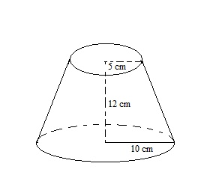

Find the:-

a) Slant height of the frustum. (3marks)

b) Curved area of the frustum. (3marks)

c) Volume of the frustum. (4marks)

1. Bumala is a market centre 600km from Kisumu town.A bus starts from Kisumu for Bumala at 7.00am at an average speed of 80 km/h. At 8.30 am a car started from Kisumu to Bumala and moved at an average speed of 120 km/hr. Calculate

i) The distance bus covered before the car started moving. (3marks)

ii) The relative speed for the two vehicles. (2marks)

iii) The time the car overtook the bus. (1 mark)

iv) Distance covered by the car before overtaking the bus. (2marks)

v) Distance from Bumala to the car at the time the car was overtaking the bus. (2marks)

1. The height of 36 students in a class was recorded to the nearest centimeter as follows:-

148 159 158 163 166 155 155 179 158

161 160 157 165 165 175 173 172 178

147 168 157 172 165 154 170 157 167

155 159 173 171 168 160 172 156 167

1. Make a frequency distribution table using a class interval of 5 and starting with the class

145 – 149. (2marks)

b) From the table above

i) Calculate the mean mark (3marks)

ii) Calculate the median (3marks)

1. Draw a frequency polygon using the table in (a) above. (2 marks)



1. Bujumba Boys Secondary School. Intends to buy a certain number of chairs For Ksh. 16,200. The supplier agreed to offer a discount of Ksh. 60 per chair which will enable the school to get 3 chairs more.

Taking *y* as the originally intended number of chairs:-

1. Write an expression in terms of *y* for

i) Original price per chair. (1mark)

ii) Price per chair after discount. (1mark)

1. Determine

i) The number of chair the school originally intended to buy. (4marks)

ii) Price per chair after discount. (2marks)

iii) The amount of money the school would have saved per chair of it got the intended number of chairs at a discount of 15%. (2marks)

1. a) Without using a protractor, construct triangle ABC such that angle ABC = 600, BC = 8cm and AC = 9cm.Measure AB. (3marks)

b) Drop a perpendicular from A to BC and measure its length. (2marks)

1. Hence calculate the area of triangle ABC. (2marks)
2. Locate a point D on BC such that the area of triangle ABC is three times that of triangle ABD. (3marks)
3. In triangle ABC, shown below, AB = a AC = b point M lies on AB such that AM: MB = 2:3 and point N lies on AC such that AN: NC = 5:1 line BN intersects line MC at X.

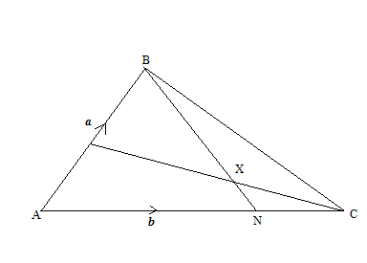

M

1. Express the following in terms of ***a*** and ***b***

i) **BN** (1 mark)

ii) **CM** (1 mark)

1. Given that **BX** = k**BN** and **CX** = r**CM** where k and r are scalars

i)Write two different expressions for **AX** in term of a, b, k and r (4marks)

ii) Find the values of k and r (4 marks)

1. A triangle ABC has vertices A(2,1), B(5,2) and C(0,4).

  (a)On the grid provided plot the triangle ABC. (2 marks)

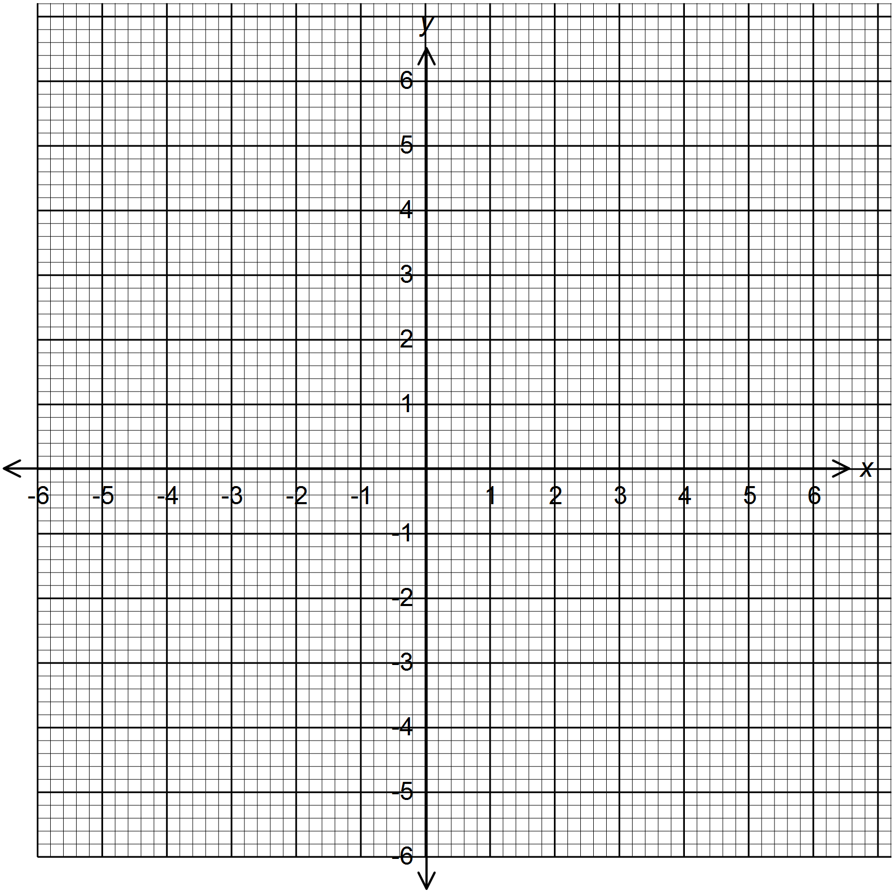

(b) A1B1C1 is the image of ABC under a translation . Plot A1B1C1 and state its coordinates. (2 marks)

(c) Plot A11B11C11 the image of A1B1C1 after a rotation about the origin through a negative quarter turn. State its coordinates. (3 marks)

(d) A111B111C111 is the image of A11B11C11 after a reflection on the line y = 0.

Plot A111B111C111 and state its coordinates.

(3 marks)

24.The table below shows income tax for a certain year

|  |  |
| --- | --- |
| Monthly Income in Kenya Shillings (Ksh) | Tax Rate |
| 0 - 10164 | 10% |
| 10165 - 19740 | 15% |
| 19741 - 29316 | 20% |
| 29317 - 38892 | 25% |
| Over 38892 | 30% |

A tax relief of Ksh 1162 per month was allowed. In a certain month of the year, an employee’s taxable income in the fifth band was Ksh.2108.

1. Calculate
2. Employees total taxable income in that month (2 Marks)
3. The tax payable by the employee in that month (5 Marks)
4. The employee’s income include a house allowance of Ksh 15,000 per month. The employee contributed of the 5% basic salary to a co-operative society. Calculate the employee’s net pay for that month (3 Marks