MATHEMATICS ACTIVITIES - CBC GRADE 2 MID TERM 1 EXAMS 2023

QUESTIONS
- Match the objects with equal group
For question 1 - 3
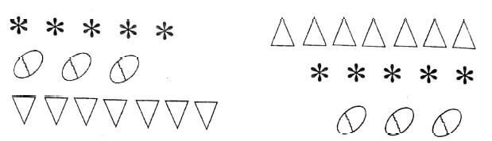

- Addition; 5 + 3 + 5 =
- Add using number line.
8 + 4 =
- Subtract:
60 - 10 =
- Subtract by use of numberline
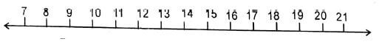
16 - 5 =
- Two girls have how many legs =
- Add:
34 + 5 =
- Write the missing numbers
  - 4, 6, 8, ............, 12
  - 30, 40, 50, ..........., 70, ...........
- Add:
  - 50 + 30 =
  - 32 + 4 =
- Match the numbers with their names.
a | 8 | seven
b | 10 | nine
c | 7 | ten
d | 9 | eight
- Count 3 steps from 32:
32 + 3 =
- What is 12 take away 4?
- Write the place value of these numbers
87 = ...............tens .............ones
04 = ............ tens .............. ones
- Fill in the missing number
  - 5 + ................ = 10
  - 14 - .............. = 7
- Add 7 + 4 + 5 =
- Fill in the days of the week
Number | Days
1 | Sunday
2 | Monday
3
4 | Wednesday
5 | Thursday
6
7 | Saturday

