MATHEMATICS ACTIVITIES - GRADE 3 MID TERM 1 EXAM 2023
Write the following in words.
- 19....................................
- 20....................................
- A class has 29 pupils. Out of these, 17 are boys. How many girls are there?
........................................................................
Write the shaded fractions.
- 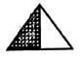
- A mother had 7 baskets. Each basket had 4 mangoes. How many mangoes were there altogether?
........................................................................
- A teacher had 25 exercise books. She shared them equally artong 5 learner groups. How many books did each group receive?
........................................................................
- Subtract 48 from 99.
....................................
Write the number of days in each of the following months.
- Apri....................................
- February.....................................
- December....................................
- Our lunch is commonly served in the....................................
(morning, afternoon, evening)
- Tick a shorter rod.
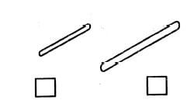
- Colour a longer ruler.
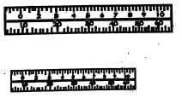
- How many are the same?
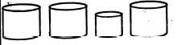
- Which container has less water?
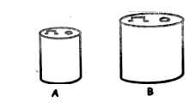
- ....................................is the day just before Monday.
(Tuesday, Sunday, Saturday)
- Colour a need.

Marking Scheme
- ninteen
- twenty
- 12 / twelve
- 1/2 / a half
- 1/4 / a quater
- 28
- 5
- 51
- 30
- 28/29
- 31
- afternoon
- the one on the left
- the ruler on top
- 3 of the 4
- container A
- Sunday
- the banana

