MATHEMATICS - GRADE 7 TERM 1 EXAMS 2023
- Rearrange the digits in the number 64809725 to form the smallest eight digit number and write it in words (2mks)
- A member of county assembly donated 24036 tree seedlings to be shared equally among 12 schools in a certain education zone. How many seedlings did each school get?. (1 mk)
- In a certain farm ¹/₁₂ of the animals are donkeys, ¹/₃ are goats, ¹/₈ are camels, ⁵/₂₄ cows and the rest are sheep. Arrange the fractions representing each type of the animal in descending order. (2mk)
- The volume of a rectangular container with a square base is 1152cm'. If the height is 8 cm, what is the length of each side of the base? (3mks)
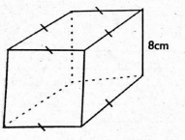
- What is the inequality ²/₃ k − 6<24 expressed in its simplest form? (2mks)
- Wanjiku bought three trays of eggs each sh. 400. On her way home, ¹/₃ of eggs in one tray got broken. She sold the remaining eggs at sh. 20. How much profit or loss did she make? (3mks)
- In the figure below line ABC is straight. Angle CBD Angle DBE. Angle ABF = 48°. (4mks)
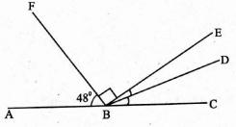
What is the size of angle DBE?
- What is the area of the shaded part in the figure below? (3mks)
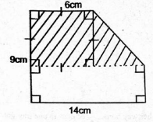
- Asha went in a supermarket and bought two dresses at sh.1200 per dress. She also bought a pair of shoes at sh. 800. She also paid sh. 512 as VAT. If she paid using four sh. 1000 notes, how much balance did she get? (4mks)
- The area of a square farm is 14400m². What is its perimeter? (3mks)
- Grade 7 learners wanted to make a model of a 3-D shape. They first made the net below
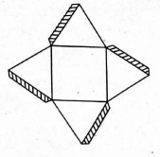
What 3-D shape were they likely to make? (2mks)
- A motorist left home for Mombasa city in the morning. He reached Mombasa at 36 minutes past midnight. Write his arrival time in 24hour clock system. (2mks)
- A circular flower garden has a radius of 28m. What is its circumference? (2mks)
- What is the value of 144 ÷ 36 x 11 + 4 − 11? (2mks)
- Grade 7 learners filled a cubical container of sides 20cm long with water. How much water was this in litres? (3mks)
- What is the LCM of 28, 42 and 84? (1mk)
- The population of a country is 36978302. What is the population rounded off to the nearest tens of millions? (2mks)
- The data below shows ages of 24 children playing hide and seek game in a village.
7,8,6,8,6,7,8,6,7,9,6,8
9,7,8,6,6,7,8,7,8,7,9,5
Represent the data in the frequency table below. (5mks)
Age (years) | Tally | Frequency
5
6
7
8
9

MARKING SCHEME
- 20456789 - Twenty million four hundred and fifty six thousand, seven hundred and eighty nine.
- 2003
- ¹/₃, ¼, ⁵/₂₄, ¹/₈, ¹/₁₂
- 12cm
- k < 45
- Sh. 400
- 21°
- 60cm²
- Sh. 288
- 480m
- Square based pyramid
- 0036hrs
- 176m
- 37
- 8 litres
- 84
- 40000000

Age (years) | Tally | Frequency
5 | l
6 | llll l
7 | llll ll
8 | llll ll
9 | lll

