MATHEMATICAL ACTIVITIES - CBC GRADE 2 TERM 1 2023
- Take away:
Use a number line to subtract. For example 18 - 4 = 14
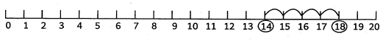
  - 19-4 =
  - 15- 2 =
  - 16-3 =
  - 16- 6 =
  - 17- 3 =
- Subtract the multiples of 10:
  - 50
- 30
  - 40
- 20
  - 70
- 40
  - 60
- 20
  - 80
- 50
- Use a number line to add: For example 3 + 2 + 1 = 6
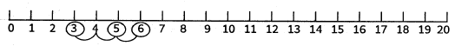
  - 3 + 4 + 2 =
  - 7+ 2 + 1 =
  - 4 + 3 + 3 =
  - 2 + 3 + 1 =
  - 6 + 2 + 1 =
- Write the number of objects in each group.
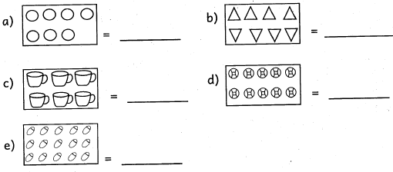
- Write the missing numbers
  - 15, 16, 17, ____, 19
  - 10, 9, 8,_ ,6
  - 6,5, 4, ___, 2
  - 20, 21, 22, __, 24
  - 30, 25, 20, _ , 10
- Match the numbers in symbols and in words.
10 two
8 ten
5 six
2 eight
6 five
- Subtract
  - 86-3 =
  - 76 - 31 =
  - 48 - 85
  - 69-6 =
- A storybook has 54 pages. Sheila read 6 pages. How many pages are remaining for her to read? (1mk)
- One year has ......................... months.
- Name the days of the week
  - ___________________________________
  - ___________________________________
  - ___________________________________
  - ___________________________________
  - ___________________________________

- Which one costs more
  - pen book
Sh 40 Sh 50______________________
  - Ball Orange
Sh 74 Sh 24______________________
- Work out
  - 24 = 18 + ____ + ____
  - 32 = 30 + ____
  - 40 = 20 + 20 + ____
  - 18 = 4 + ____ + ____
  - 60 = 50 + ____ + ____

