KPSEA- CREATIVE ARTS & SOCIAL STUDIES - GRADE 6 EXAMS TERM 1 2023
QUESTIONS
- Which of the following is an upper case letter?
  - a
  - b
  - H
  - g
- A person who manipulates and control puppet is called:-
  - marionette
  - puppeteer
  - magician
  - acrobat
- Which of the following is not a principal of art?
  - Balance
  - Tonal value
  - Proportion
  - Overlapping
- The following materials are used in painting except:-
  - Pencil
  - Crayon
  - Thread
  - Brush
- The process of joining these two pieces of leather is called:
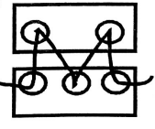
  - beading
  - etching
  - thonging
  - hemming
- Three of the following are benefits of songs except. Songs ________________________ people.
  - educate
  - entertain
  - console
  - accuse
- Erick used the printed fabric shown below to decorate a book cover. How many motif have been used?
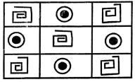
  - Three
  - Two
  - Nine
  - Six
- Sarah, a grade five leamer drew a hut on a hard carton. She then applied glue and mounted rice on the drawing. Sarah was making a
  - mosaic
  - motif
  - collage
  - montage
- Which colour do you get when you mix red and yellow?
  - Green
  - Violet
  - Orange
  - White
- The pattern below is used in weaving. It is called:-
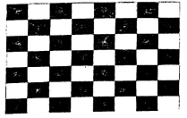
  - twinning
  - splitting
  - plaiting
  - plain weaving
- The pattern above can be used to decorate a
  - mat
  - pot
  - sufuria
  - T.V
- Wind instruments are played by:-
  - plucking
  - blowing
  - hitting
  - shaking
- Special clothes that are worn when performing folk songs are called:-
  - uniform
  - costumes
  - adornment
  - decoration
- Which community uses the instrument below?
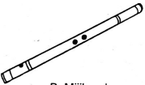
  - Kalenjin
  - Mijikenda
  - Akamba
  - Teso
- Which of the following types of song is correctly matched with the community it comes from?
  - Ramogi - Akamba
  - Isikuti - Luo
  - Mwomboko - Agikuyu
  - Kilumi - Luhya
- Which of the following materials can be used to make a dancing skirt?
  - Clay soil
  - Tree leaves
  - Manilla paper
  - Sisal fibres
- What is the use of adhesives when mounting an artwork?
  - Decoration.
  - Exhibition.
  - Sticking.
  - Cutting.
- The speed of a song is called:-
  - tempo
  - pitch
  - rhythm
  - volume
- "Natujenge taifa letu". This statement is found in the:-
  - East Africa Anthem
  - Sacred song
  - Topical song
  - Kenya National Anthem
- A piece of song performed by two people is called:-
  - duet
  - solo
  - choral
  - trio

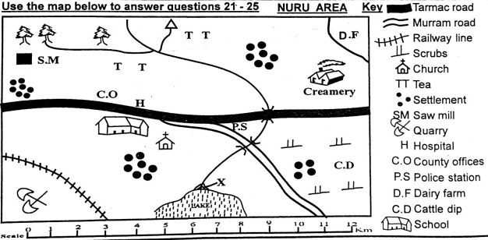
- Which pattern is formed by the population | 25 distribution in Nuru Area?
  - nucleated
  - sparse
  - dense
  - linear
- Nuru area is headed by:-
  - Assistant County Commissioner
  - Deputy County Commissioner
  - Governor
  - Chief
- The climate experienced in the Northern part of Nuru area is :-
  - cool and wet
  - hot and wet
  - cool and dry
  - hot and dry
- The feature marked x is called:-
  - estuary
  - delta
  - confluence
  - tributary
- Which economic activity is not carried out in Nuru Area?
  - Lumbering
  - Farming
  - Tourism
  - Mining
- Which of the following groups consists of the plain nilotes in Kenya?
  - Agikuyu, Dawida, Abakuria
  - Maasai, Samburu, Turkana
  - Somali, Boran, Rendille
  - Arabs, Nubians, Indians
- A school routine is normally shown on
  - a timetable.
  - an exercise book cover.
  - the school uniform.
  - the school gate.
- Equatorial climate is always:-
  - hot and wet
  - hot and dry
  - cool and wet
  - cool and dry
- On 12th December, Kenyans celebrate:-
  - Madaraka day
  - Labour day
  - Jamhuri day
  - Mashujaa day
- Which of the following minerals is correctly matched with the place it is found?
  - Soda ash - Magadi
  - Diatomite - Malindi
  - Salt - Kariandusi
  - Oil - Nakuru
- One of the crops below is grown in the subsistence farms. Which is it?
  - Tea
  - Flowers
  - Kales
  - Coffee
- Which of the following is a quality of a good leader?
  - Dishonest
  - Caring
  - Cruel
  - Unjust
- Chege a grade five pupil has been employed in a hotel. The hotel owner is practising:-
  - Child labour
  - Early marriage
  - Good citizenship
  - Child right
- Who among the following traditional leaders practised long distance trade?
  - Mekatilili wa menza
  - Njuri Ncheke
  - Oloibon Lenana
  - Chief Kivoi Mwendwa
- Which of the following economic activities is correctly matched with the symbol it represents?
  - Saw mill-fishing
  - Tea- transport
  - Quarry - mining
  - Road - farming
- Identify a historic built environment in Kenya.
  - Wilson airport
  - River Tana
  - Mount Kenya
  - Fort Jesus
- Which is the largest country in Eastern Africa?
  - Tanzania
  - Sudan
  - Somalia
  - Djibouti
Use the diagram below to answer questions 38 and 39
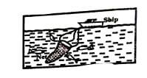
- The fishing method illustrated above is
  - trawling.
  - net drifting.
  - harpooning.
  - purse-seining.
- The fishing method above is used where
  - water is flowing fast.
  - there are few fish.
  - a river is shallow.
  - the sea is deep.
- How many basketfuls of food were left after Jesus fed the multitude?
  - 24
  - 10
  - 3
  - 12
- Which is the correct way of using social media?
  - Accusing others
  - Watching nakedness
  - Sending greetings to friends
  - posting immoral pictures
- Otieno wakes up very early every Sunday to arrange chairs in their church. Otieno demonstrates:-
  - responsibility
  - courage
  - holiness
  - loneliness
- Who raised the Jairus daughter from death?
  - Peter
  - Jesus
  - Elisha
  - Paul
- Which of the following is not one of the books in the Bible?
  - Genesis
  - Exodus
  - Gideon
  - Samuel
- Who among the following grade six learners used his/her free time well during the December holiday?
  - Ken- went to steal fruits from a nearby farm
  - Eliud - went to fetch water for an old lady
  - Tom was given a ride by a stranger
  - Betty-talking with her friends about others
- One of the Ten commandments tells us to honour our parents because:-
  - they give us food
  - we can live long on earth
  - we can avoid being cursed
  - they may refuse to pay our school fees
- "Do not accuse anyone falsely". Which lesson do Christians learn from this statement?The importance of being:-
  - obedient
  - kind
  - loving
  - truthful
- Eve was created by God as a ___________________________ of Adam.
  - servant
  - caretaker
  - helper
  - enemy
- Which of the following prophets challenged the prophet of Baal at Mt. Carmel by bringing fire from heaven?
  - Jeremiah
  - Daniel
  - Elijah
  - Isaiah
- Which of the following prophets challenged the prophet of Baal at Mt. Carmel by bringing fire from heaven?
  - Jeremiah
  - Daniel
  - Elijah
  - Isaiah

MARKING SCHEME
- C
- B
- D
- C
- C
- D
- B
- A
- C
- D
- A
- B
- C
- B
- C
- D
- B
- A
- D
- A
- A
- C
- A
- B
- C
- B
- A
- A
- C
- A
- C
- B
- A
- D
- C
- D
- B
- D
- B
- A
- A
- C
- A
- B
- C
- B
- B
- D
- C
- C

