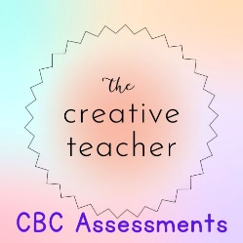

NAME………………………………… ADM.NO…………………… DATE……………..

MID TERM ONE EXAMINATION
INTEGRATED SCIENCE

Instructions to learners
- Answer all questions in the spaces provided
- The paper consists of 4 printed pages. Check to ascertain that all the pages are printed.

FOR OFFICIAL USE ONLY
 | Exceeding expectation  25-30 | Meeting expectation  20 - 24 | Approaching expectation  11 - 19 | Below expectation  0 - 10
Learner’s Score
Performance level

- State three components of integrated science. (3mks)

- Studying integrated science equips learners with several skills. List three of these skills (3mks)

- Which of the following pathways in senior school is related to Integrated Science? (1mk)
- Art and spot science B) Science, Technology Engineering and Mathematics C) Social sciences

- a) Define the term career (2mks)

b) State any three careers related to integrated science (3mks)

- Explain how integrated science helps in the following
- Poverty eradication (2mks)

- Promoting healthy living (2mks)

- Understanding our bodies (2mks)

- a) What is a laboratory? (2mks)

b) State the causes of the following common accidents in the laboratory (4mks)

Common accident | Cause
Burns
Scalds
Poisoning
Electric shock
- a) What is a hazard? (1mk)

- Identify the meaning of each of the following hazard signs (3mks)

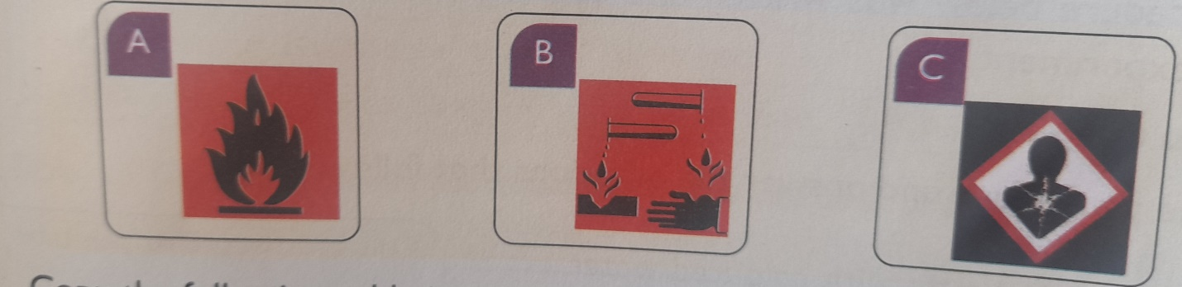

8) List any two items found in a first aid kit (2mks)

