Integrated Learning Activities - CBC Grade 2 Term 1 Exams 2023
ENVIRONMENTAL
Use the weather chart to answer the questions
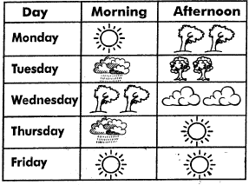
- The weather on Monday morning was?
- Which day was the weather sunny throughout the day ?
- Name the days of the week which the weather was sunny
- On Tuesday afternoon the weather was
- Name three domestic animals (lion, zebra, donkey,monkey,sheep,cow)
- Draw the sources of light
  - bulb
  - sun
  - candle
- Name the things used to store water (pipe, bucket, pot, jerrycan, cup)
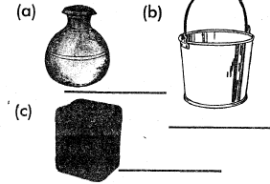
- Name parts of a plant(stem, fruit, flower, leaf,roots)
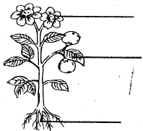
- We go to______ to learn (hospital, school)
- ______teaches pupils at school. (doctor, teacher)
HYGIENE AND NUTRITION
- The first food we eat in the morning is called? (lunch, breakfast)
- Breakfast provide us with (food, energy)
- We should brush our teeth______times a day to keep them clean, (4,3,1)
- Name the personal items (handkerchief, mask, toothbrush, comb)
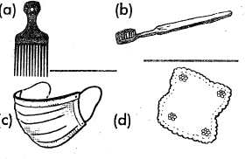
- Write "good habit" or poor habit" for our teeth
  - Sucking your finger______
  - Eating healthy food______
  - Biting your nails______
  - Use toothpicks______
- A______is a doctor who treats our teeth (nurse,dentist)
- A new born baby has ______teeth(1,32,0)
- Name the food we eat(maize, carrot, pineapple,fish)
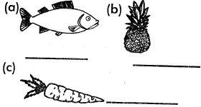
- We sleep on a______
- Name the utensils below(plate, pot, folk, sufuria)
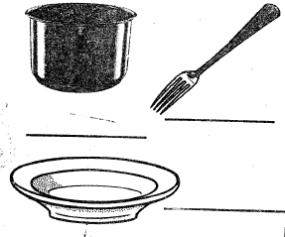

C.R.E Activities
- The bible is divided into two parts, the _____ and _____ (new and old,black and red)
- Psalms 139:13 "You created every part of me: You put me together in my mother's _____(mouth, womb, eye)
- Jesus was born in _____
- The mother of Jesus was called _____while the father was _____
- Name the three members of extended family
- _____saw a burning bush. (David, Moses)
I.R.E
- Muslims follow the teachings of _____(Quran, gospel sheitwan)
- According to Surah Al-fatiha, Allah is the master of _____(Yaumul-Oyama. Yaumul Eid)
- The prophet (SAW) was born in the month of _____
- I do _____ when I visit the toilet. (Istijmar, Istinjai,ta-yammum)
- We should not enter the toilet with _____(Qurai,water, clothes)
- Draw a mosque
- Name three of Allah's creation

MARKING SCHEME
ENVIRONMENTAL
- sunny
- Friday

  - Monday
  - Thursday
  - Friday
- calm

  - Donkey
  - sheep
  - cow

  - pot
  - bucket
  - jerrycan
- flower
leaf
root
- school
- teacher
HYGIENE AND NUTRITION
- breakfast
- energy
- 3

  - comb
  - toothbrush
  - mask
  - handkerchief

  - bad habit
  - good habit
  - bad habit
  - good habit
- dentist
- 0

  - fish
  - pineapple
  - carrot
- bed
- pot
fork
plate
C.R.E ACTIVITIES
- new and old
- womb
- Bethlehem
- Mary, Joseph

  - uncle
  - aunt
  - cousin
(any other)
- a Church
- Moses

