INTEGRATED SCIENCE - GRADE 7 TERM 1 EXAMS 2023
QUESTIONS
- Grade 7 learners visited a resource person. They asked him to explain careers that are related to skills and knowledge acquired from studying Integrated Science. Name five careers he was likely.to explain. (5mks)
- Mercy, a grade 7 learner was asked to name three components of Integrated Science as a field of study. Which ones was she likely to name?. (3mks)
- Grade 7 learners of Promise Academy visited a County Director of Education. They went to enquire about pathways that are related to Integrated Science at Senior school. Identify three pathways related to Science, Technology, Engineering and Mathematics that they learnt. (3mks)
- Explain four reasons why it is important to study Integrated Science in our daily life. (4mks)
- Tom visited a laboratory and observed the symbols in the box below. Identify the meaning of them symbols. (5mks)
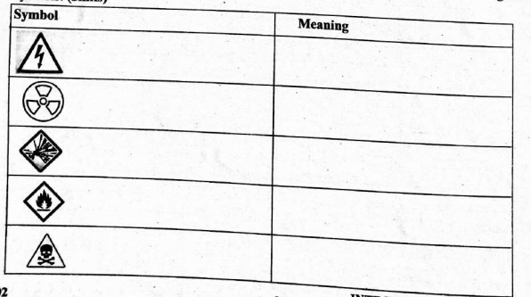
- Wanyoike was asked to list common accidents likely to occur in a laboratory. She listed the following. Write the likely cause of each accident she listed. (4mks)
  - Scalds
  - Suffocation
  - Burns
  - Electric shock
- While doing an experiment in a laboratory using some chemicals, a chemical accidentally dropped in Kimutai's eyes. State three first aid steps you would follow to help him. (3mks)
- Identify three examples of basic skills in science. (3mks)
- Four grade 7 learners were asked to find out and explain why it is important to observe safety measures while in a laboratory. State three methods they would use to explain their findings. (3mks)
- Grade 7 learners visited a laboratory technician in a neighbouring secondary school. The technician taught them about the International System of Units (SI units) used to measure certain quantities. Identify the SI units they learnt that are used to measure the quantities listed below. (5mks)
  - Temperature
  - Density
  - Electric current
  - Volume
  - Area
- Grade 7 learners set-up an experiment as illustrated below and observed after sometime.
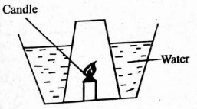
What was their conclusion after the experiment? (1mk)
- Grade 7 learners visited a laboratory to learn about laboratory apparatus and instruments and their uses. They observed the apparatus shown below. Write their names and uses. (6mks)
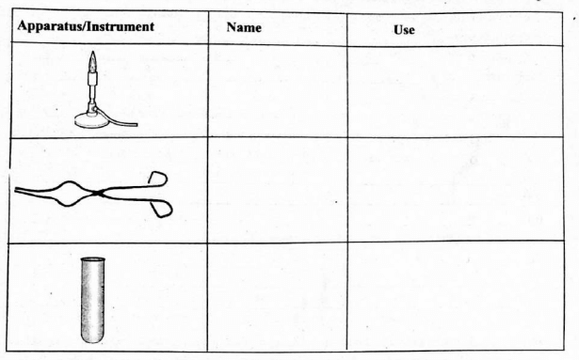
- Jemimah, a grade 6 learner, decided to sensitize the community on ways of conserving water in the community. She made a poster. Write three ways of using water sparingly that she wrote on the poster. (3mks)
- Otieno went to hospital to check his blood type because he wanted to donate blood to a patient. After test the doctor told him that he could donate blood to all other blood groups. Which blood group did Otieno have? (1mk)

MARKING SCHEME

  - Teaching
  - Medicine and surgery
  - Nursing
  - Scientific research
  - Electrical and civil engineering. analytical chemistry.

  - Biology
  - Chemistry
  - Physics

  - Pure science
  - Appled science
  - Technical and engineering

  - Helps in solving environmental problems
  - Helps in eradicating poverty
  - Helps in understanding how systems of our bodies work.
  - Promotes heathy living.
  - Helps us loin nature.

  - Electric shock
  - Radioactive
  - Explosive
  - Flammable
  - Toxic

  - Hot liquids
  - Inhaling poisonous gases
  - Open flames, es
  - Open electric sockets

  - Take him to a station with clean water
  - Wash his eyes with the clean water in plenty
  - Report to the teacher or laboratory technician.

  - Manipulative skills / measurable skills
  - Observation skills / prediction skills
  - Classification skills/ communication skills.

  - Drawing graphs, charts or tables
  - Writing a report
  - Publishing books or journals.

  - Kelvin (k)
  - Kilogram per cubic metres (kg/m³)
  - Ampere (A)
  - Cubic metre (m³)
  - Square metre (m²)
- Oxygen is present in air

Name | Use
Bunsen burner | Source of heat in the laboratory
Tongs | Holding solid substances being heated
Boiling tube | Holding solid and liquids when heating.

  - Using water saving shower.
  - Using watering can to water crops in the farm
  - Turning off water taps when not in use
  - Repairing leaking water pipes or taps
- Place where a fertilized egg develops into a baby.
- Blood group 0.

