INTEGRATED LEARNING AREAS - CBC GRADE 3 MID TERM 1 EXAMS 2023
HYGIENE AND NUTRITITON ACTIVITIES
- Name these food that show balanced diet (3mks)
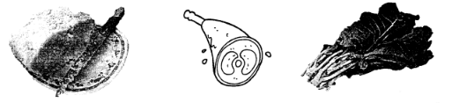
__________________________ ____________________ _____________________________
- We get the adverisement of food from.
r___dio and t_____levision.
- The food we take in the morning is called __________________________. (supper, lunch, breakfast)
- Name these foods we take for breakfast (5mks)
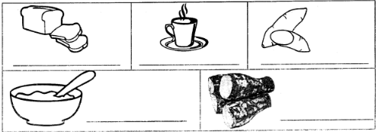
- Match the items with the room (4 marks)
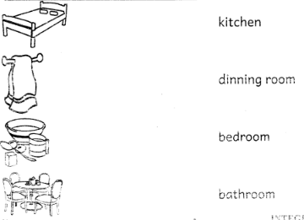
ENVIRONMENTAL ACTIVITIES. (15mks)
- We protect crops by _______________________________(cutting, fencing, burning)
- Plants need _____________________________to grow. (water, milk, soil)
- We keep plants free from pests by ___________________________________ them. (cutting, washing, spraying)
- We remove ____________________________ so that plants can grow well. (plants, weeds, water)
- We should __________________________________ ourselves when cleaning animal houses. (wash, expose, protect)
- A dirty school can make us ____________________________________________ (well, sick, fine)
CRE ACTIVITIES. (13mks)
- When I am given something I should be ______________________________ (sorry, thankful, happy)
- Which son asked for his share of the property? ____________________________ (Younger, Older, Bigger)
- What do we learn from the story of the prodigal son? That we should ________________________others. (hate, abuse, forgive)
- Name these items that we carry to school for learning. (5mks)
________________ ________________ __________________ _____________________
- We should ______________________________ of the items we carry to school. (take care, cut, throw)
- Samuel was called _________________________ times. (2, 3, 4)
- Who built an ark? ____________________________________(Moses, Noah, John)
- Name the three sons of Noah? (3mks)
_____________________________
_____________________________
_____________________________
ARTS AND CRAFT
- What is the colour of charcoal?
___________________________________
- Draw and colour a ball.
- Name one item used when painting.
___________________________________
- Plastacine is used to ___________________________________
- What can you use to make a simple painting brush?
___________________________________

MARKING SCHEME
HYGIENE AND NUTRITION ACTIVITIES
- Ugali, meat, vegetables
- radio and television
- breakfast
- bread, tea, sweet potatoes, porridge, arrow roots
- bedroom
bathroom
kitchen
dinning room
ENVIRONMENTAL ACTIVITIES
- Fencing
- water
- Spraying
- weeds
- protect
- sick
CRE ACTIVITIES
- Thankful
- Younger
- forgive
- eraser, pencil, sharpener,bag
- take care
- 3
- Noah
- Seth, Ham and Japheth

ARTS AND CRAFT
- Black
- Student should draw figure as instructed
- brush/ paint/ canvas
- model/ craft
- stick, hairs/fur,

