INTEGRATED LEARNING AREAS - CBC GRADE 3 END TERM 1 EXAMS 2023

QUESTIONS

ART & CRAFT
- We do not need ............................. to make a kite
(nails, glue, papers)
- Tick an item that can be used for painting.
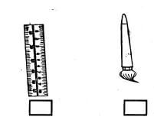
- A necklace and a bracelet are both .............................
(tools, ornaments, toys)
- A grade two boy made a toy like the one shown below.
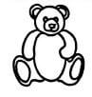
The material he used was likely to be.............................
(sand, sticks, clothes)
- Look at the item draw below.
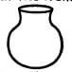
The item above can be made using .............................technique
(folding, weaving, pinch)
- Madam Husna was seen using a dowel loom. Madam Husna was practising .............................
(painting, drawing, weaving)
Name the following lines.
- 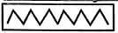
- 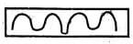
- A drowning swimmer can be rescued using a .............................
(pool, sinker, floater)
- Horizontal float is a sports activity to be practised in the .............................
(field, classroom, pool)
- The picture below show a girl facing direction E.
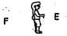
If she turns and faces direction F, the turn is called a .............................turn.
(half, quarter, complete )
- We use our ............................. for leaping.
(shoulders, hands, legs)
- Study the diagram below.
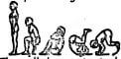
The roll demonstrated above is called ............................. roll.
(forward, egg, backward)
- Pulling and pushing are locomotor skills.
True or false? .............................

MUSIC
Identify the instruments drawn below.
Drum Whistle Horn
- Wind instruments are played by .............................
(blowing, hitting, shaking)
- May we dwell in unity is a line in the .............................verse of the Kenya National Anthem
(third, second, first)
- Name the wind instrument drawn below.
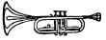
(Guitar, Piano, Trumpet)
- A performance by a group of people is called a ............................. performance.
(solo, choral, crowd)

MARKING SCHEME
- nails
- item 2 / the brush
- ornaments
- clothes
- pinch
- weaving
- zigzag
- wavy
- floater
- pool
- half
- legs
- backward
- false
- whistle
- drum
- blowing
- first
- trumphet
- choral

