INTEGRATED LEARNING ACTIVITIES - CBC GRADE 2 TERM 1 EXAMS 2023
HYGIENE AND NUTRITION ACTIVITIES (15mks)
- Mary ate an egg in the morning. Which bird laid the egg?(1mk)
- Match the following foods with the name. (5mks)
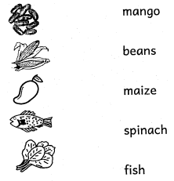
- Tick the foods that are bad for our teeth. (2mks)
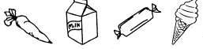
- The food I ate for lunch was smelling nice. Which part of the body did I use to smell? (1mk)
- We should before eating. (wash, boil, cook) (1mk)
- Food gives me work. (energy, disease, water)
Write 'true' or 'false' (4mks)
- Eating dirty fruits is good
- Always wash your hands after visiting the toilet
- Girls use urinals
- We can eat food when we are in a latrine

ENVIRONMENTAL ACTIVITIES.(15mks)
- Name these items that produce sound when hit, blown or plucked., (3mks)
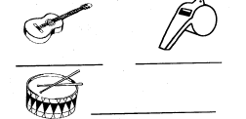
- Match the pictures with the sound that alert us on danger (5mks)
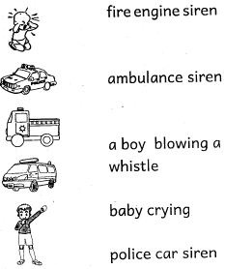
- Draw and colour these things found at home. (4mks)
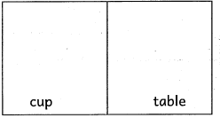
- Name these basic needs. (3mks)
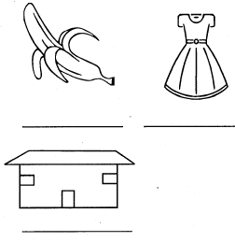
CRE ACTIVITIES. (10mks)
- Draw and colour the coat that Jacob gave to his son Joseph. (5mks)
- Who were the parents of Jesus? and (2mks)
- Who baptised Jesus? (Peter, John, Judas) (1mk)
- The shepherds went to to see baby Jesus. (Nazareth, Bethlehem, church) (1mk)
- We remember the birth of Jesus during (1mk) (Easter, Christmas, Sunday)
IRE ACTIVITIES. (10mks)
- The second pillar of Iman is to believe in the (books, angels)
- The first woman to be created was
- The name of Allah Al-Razaq means the (creator, provider)
- Adam was created from
- Allah created Hawa from a (clay, rib)
Match the angels with their duties.
- Mikail Paradise
- Jibril Rain
- Ridhwan Trumphet
- Israfil Wahy
- Muslims pray times a day. (five, four)

MARKING SCHEME
HYGIENE AND NUTRITION ACTIVITIES
- Chicken/Hen

- Nose
- wash
- energy
- false
- true
- false
- false
ENVIRONMENTAL ACTIVITIES
- Guitar
Whistle
Drum

- (Mark drawing)
- Food
Clothing/Clothes
Shelter
CRE ACTIVITIES
- (Mark drawing)
- Mary & Joseph
- John
- Bethlehem
- Christmas
IRE ACTIVITIES
- Angels
- Eve
- Provider
- Soil
- Rib
- Mikail - Rain
- Jibril - Wahy
- Ridhwan - Paradise
- Israfil - Trumpet
- five

