Hygiene and Nutrition - Grade 2 Term 1 Exam 2023
- Tick (✓) the dangerous chemical.
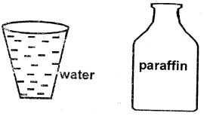
- _______________ can cause accidents in the kitchen (knife, plate)
Name 3 common accidents at home.
- _______________________
- _______________________
- _______________________
Match the senses and sense organs.
- Touching nose
- Smelling eyes
- Seeing ears
- Tasting hands
- Hearing tongue
- We __________________ fruits before eating them (bite, wash)
- Teeth that we remove are called _______________ (milkteeth, bad teeth)
- We should not ___________________ personal items (use, share)
Write 2 uses of water.
- ________________________
- ________________________
Match the following foods with where we buy them
- 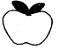 shop
- 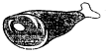 fishmongers
- 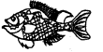 market
- 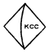 butchery
- We should eat food with our mouths _________________ (open, closed)
- Talking while eating can cause ___________________ (drown, choke).
Write three foods we can eat for supper.
- ______________________________
- ______________________________
- ______________________________
- Food we eat in the morning is called _______________________. (supper, breakfast)
- Boys use _______________________ to pass urine at school. (urinals, bathrooms)
Write 'True' or 'False'.
- We should not play with sharp objects. __________________.
- Fire can cause burns. _______________________.
- It is a good habit to run as you eat. ______________________
- Hot liquid cannot burn us. ______________________
- Chew food well before swallowing. _______________________
Name two foods we get from animal sources
- _______________________________
- ______________________________
Name the forms of medicines below.
- 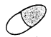
__________________________
- 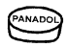
__________________________
- 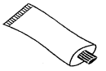
___________________________
- 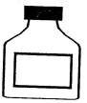
___________________________
(Ointment, tablet, capsules, syrup)
- After using the toilet we should ___________________it. (knock, flush)
- This is a ___________________ (toilet, latrine)
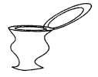
Draw and colour
- Banana
- Orange
- Foods like________________ and
- _______________ are not good for our teeth.
(carrots, biscuits, sweets, milk)
- A ripe mango taste ____________________.
(bitter, sweet)
Draw the sharp objects that can cause accident at home.
- Scissors
- Knife
- Razor blade
- A hot jiko can cause a ____________________ (burn, cut)
- We should put waste in a ______________________ (dustbin, pocket)
- DrinKing water should be _____________________ (cooked, boiled)

