Name: ……………………………………………………… ADM No: …………………

BUNAMFAN CLUSTER EXAMINATION
JUNE 2022
441/1
HOME SCIENCE
PAPER 1 (Theory)
2½ Hours
MARKING SCHEME

INSTRUCTIONS TO CANDIDATES:
Write your name and index number in the spaces provided above.
This paper consists of three Sections: A, B and C
Answer all the questions in Sections A and B.
Answer any two questions from Section C
All answers must be written in ENGLISH

FOR EXAMINER’S USE ONLY

Section | Question | Maximum | Score
A | 1-21 | 40
B | 22 | 20
C | 23 | 20
 | 24 | 20
 | 25 | 20
 | Total score | 100

This paper consists of 10 printed Pages
Candidates should check the question paper to ensure that all the pages are printed as indicated and no questions are missing
SECTION A – 40 MARKS
INSTRUCTIONS: Answer ALL the questions in the spaces provided

- Outline two ways in which a cook can infect food with germs. 3mks
- Handling cooked food with bare hands/ dirty hands
- Could be a heavy carrier of infectious disease.
- May hold cooked food in cracked and chipped containers
- May store cooked food in dirty place
- May use contaminated water

- State two points to note when using paraffin as a fuel. 2mks
- Avoid storing in a soda bottle.
- The lid of the container should fit strongly
- Store away from food stuffs
- The containers should be clearly labeled
- Keep away from open fires

- Mention two ways of providing variety in meal planning and management. 2mks
- Variety in colour – choose interesting colour combination.
- Variety in texture- choose a variety such as crispy, crunching and tender
- Variety in flavor- chooses salty, sweet, plain, flat and aromatic

- Analyze two effect of heat on vitamin C. 2mks
- Vitamin C is water soluble and is destroyed (lost) during preparation and cooking.
Food rich in vitamin C should be cooked quickly and served immediately to avoid reheating.
- vitamin C is ready oxidized hence vegetables should be cooked with the lid on to minimize oxidation. Serve vegetables and fruits raw where possible

- Identify two ways of controlling bed bugs in a home. 1mk
- Airing of beddings and bed
- Keep beddings and bed clean
- Avoid cracks on the walls
- Use pesticides

- Differentiate between active immunizations and passive immunization. 2mks
Active immunization is a use of a vaccine (1/2) containing bacteria and the body is induced (1/2) to start the production of antibiotics whereas passive immunization is the use of serum (1/2) already containing disease ½ fighting antibodies.
- State two factors that determine the type of media to use when advertising. 2mks
- Nature of commodity
- Attend to the market to be covered
- Cost of advertisement
- Type of consumer the advertisement is meant to reach

- List any two ways of finishing wood 2mks
- Staining
- polishing
- varnishing
- laminating

- Name two stain removal agents used in removing a banana sap stain from your t-shirt
2mks
- Paraffin
- Turpentine

- Mention two possible causes of stitches looping when sewing with a sewing machine
2mks
- Incorrect threading
- Upper and lower tension too loose

- Give two examples of stitches used to neaten raw edges 1mk
- Overcasting
- Loop stitch
- Suggest two ways of managing foreign body in the ear 2mks
- Gently flush out with warm water or vegetable oil
- In case of an insect turn the head such that the ear is facing the ground for the insect to crawl out
- Don’t use a finger to remove the object as it may push it further.
- Mention two dangers that arise from misuse of cosmetics 2mks
- Bleaching
- Causes skin irritation
- Cosmetics with mercury and hydroquinone can damage the user’s internal organs

- Mention two disadvantages of steaming food 2mks
- Requires much attention during cooking
- It’s dangerous as the steamer can cause scalds if carelessly handled.
- Not a suitable method for cooking tough foods.

- Mention two points on prevention and control of round worms 2mks
- Thorough washing of fruits and vegetables before use.
- Proper disposal of human faeces.
- Proper hygiene practices such as washing hands.
- Deworming.
- Define the term consumer Education 1mk
This is information that makes people aware of the goods and services available and their rights as consumers to avoid being exploited.
- State two factors that affect a budget 2mks
- Loss of income
- Increase in income
- Change in personal or family goals
- Lack of commitment in following a budget
- Inflation

- Mention two points to observe when using disinfectants during laundry. 2mks
  - Manufacturer’s instructions should be followed
- Wear protective clothing to avoid infection
- Required amount of disinfectant can be added to water during soaking or rinsing
- Kept away from children
- Completely rinsed out of clothes before drying
- Fasteners are mainly functional on garments. Give two examples 1mk
- Buttons
- Zips
- Hook and eyes
- Press-studs
- Velcro tapes
- Loops with chords
- Ties

- State two qualities of a well-made seam 2mks
- Strongly stitched to last longer.
- Accurately stitched to maintain a good line
- Neatly stitched to enhance appearance.
- Well pressed and flat
- Matched where they cross or meet each other.
- Be of appropriate width and equal in all parts of the garment

- State three disadvantages of cash buying 3mks
- One cannot obtain an item unless they can fully pay for the item
- For large items such as a car it is not safe to carry large amounts of money
- It is difficult or takes too long to buy some items such as a house

SECTION B – 20 MARKS
INSTRUCTIONS: This question is compulsory. Write your answers in the spaces provided after the question

- Your parents are recovering from an attack of covid 19 and you are assisting them with house chores
(a) Explain the procedure for thorough cleaning a neglected and blocked stainless steel kitchen sink. 8mks

- Using hands fitted with gloves (½) remove the solid wastes (½) blocking the sink.
- If the sink cannot unblock, use a plunger (½) to push the water through the drain pipe to allow water to move.
- Open (½) the eye and clean (½) the bend.
- Pour in very hot (½) water to remove grease and oil stains and to kill germs.
- Scour ( ½ ) with a scouring powder ( ½ ) and scouring pad / sisal fibres (½) with warm ( ½ ) water, (OR scouring pad ( ½ ) and warm ( ½ ) soapy ( ½ ) water) with disinfectant ( ½ )
- Rinse (½) thoroughly with warm (½) water. Pour cold (½) water in sink to fill U/S bend.
- Dry sink with a dry (½) cloth and buff with soft non-fluffy (½) cloth.

b) Outline the method you will use to clean a white washable cotton mask you had used the previous day. 7mks
- Soak (½) in cold water into which a disinfectant (½) has been added to loosen the dirt and kill germs
- Rinse out of the soaking water. (½)
- Wash by friction method (½) in warm soapy (½) water to remove fixed dirt
- Rinse in warm clean water (½) to remove soap and dirt.
- Final rinse in cold water (½) to freshen.
- Wring out excess water (½) to facilitate quick drying
- Dry on a clothesline (½) in the sun (½) secured with pegs (½) to remove moisture and prevent falling.
- Iron using a hot iron (½) to remove creases
- Air to dry completely (½)
- Fold and store (½) appropriately

c) Describe the procedure of cleaning a kitchen counter made of plain wood 5mks
- Collect the equipment and materials (½)
- Dust using a dry duster (½) to remove loose dirt.
- Clean using warm soapy (½) water and a scrubbing brush (½).
- Scrub in the direction of the grain (½), this prevents roughening of the surface and dirt is removed.
- Rinse using a cloth wrung from warm water (½) to remove soap and dirt.
- Finally rinse off using a clean cloth wrung out of cold water (½) this freshens the wood and helps to preserve its color.
- Dry (½) with a piece of cloth (½) to remove moisture.
- Clean the equipment and store appropriately (½).

SECTION C– 40 MARKS
INSTRUCTIONS: Answer any TWO questions from this section. Write your answers in the spaces provided after the questions

- a) Discuss five reasons for sufficient ventilation in a sickroom 10mks
- To prevent humidity which describes the high concentration of moisture in the air.
- To get rid of surplus heat this makes the atmosphere uncomfortable.
- To increase the free circulation of air thus reducing the spread of airborne diseases.
- To remove any odors which develop when people crowd together.
- To get rid of air pollutants in a room e.g. aerosols
b) Give four uses of eggs in cookery 4mks
- As a main dish
- As a raising agent in flour mixtures.
- As a glazing agent.
- As a binding agent.
- As a coating agent.
- For garnishing
- Emulsifying agent in cakes and mayonnaise
.
c) Briefly explain six points to consider when choosing an ironing board. 6mks
- Should have a heatproof mat at the end for placing the hot iron.
- Should be well hinged to prevent accidents when ironing.
- Should taper off on one side for ease of ironing of hidden corners of garments.
- Should be foldable for ease of storage.
- Its height should be adjustable to avoid tiring the user.
- Should stand firmly and freely to avoid accidents when ironing.
- Should have a loose cover that can be washed to avoid dirtifying the work

- a) Explain three ways of avoiding food wastage in the kitchen. 6mks

- Cook just enough to avoid unnecessary left over’s
- Food should be prepared correctly to avoid wastages.
- Use felt over wisely which may escape through
- Avoid buying perishable food in bulk if there is no paper storage to avoid spoilage
- Foods should be stored properly to avoid wastage

b) State four ways of preventing cholera outbreak 4mks
- Proper disposal of human faeces to prevent water contamination.
- Pit latrines should be dug deep and away from water source.
- Water for domestic use should be treated before use.
- Infected persons should be isolated
- Personal items of the infected should be isolated sterilized.
- Infected persons should undergo treatment.

c) Explain four ways of fulfilling the physical needs of an expectant mothers 8mks
- Getting adequate sleep and taking a nap at least one hour a day
- Working normally but avoiding lifting loads or suffering fatigues
- Doing exercises ie walking, swimming
- Wearing loosely fitting clothing and fitting low heeled shoes for comfort
- Maintaining high standards of hygiene ie bathing daily, brushing teeth
- Sometimes she needs to rest her feet on a low stool or a foot rest to prevent them from swelling
d) Differentiate between print and electronic media advertising 2mks
- Print media – Passes information to the consumers in print form e.g. newspapers, posters etc.
- Electronic media – Information is passed to the consumers using electronic media
e.g T.Vs, radios
25. a) Briefly explain five points to consider when planning and serving meals for children
5mks
- The diet should be balanced
- Provide variety of foods which the child can choose.
- Meals should have crunchy and crispy foods that require plenty of chewing necessary for growth of strong teeth
- Serve food in small quantities to encourage second helping ,serve in correct serving plates or bowls
- Food should be presented attractive to encourage enjoyment
- Food served at regular intervals and punctually
- Give fluids such as clean boiled water and fresh juices to aid digestion and replace fluid lose during play.
b) Explain the procedure of working gathers by hand on the waist of a skirt. Use well labelled diagrams to illustrate. 10mks
- Begin by a firm knot (½) to secure the thread then work the first row (½) of running stitches (½) 6 mm (½) above the fitting line throughout the width or area to be gathered (½).
- Leave the thread hanging at the end of the row of running stitches (½). Work the second row of running stitches (½) 6 mm below the fitting line (½) and leave the thread hanging at the end (½).
- Pull both thread ends together (½) to draw up the fabric until the required size is achieved. (½)
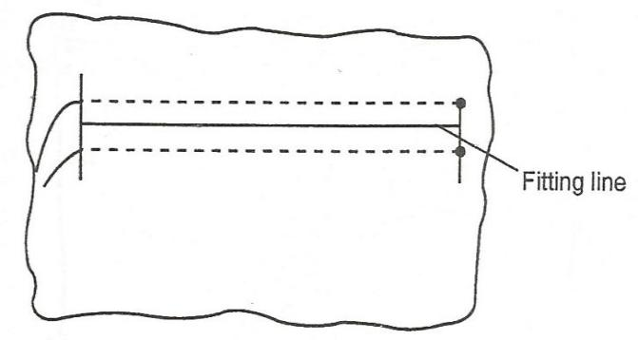
- Wind the hanging threads (½) round a pin (½), forming a figure 8 (½) to secure the gathers.

1mk

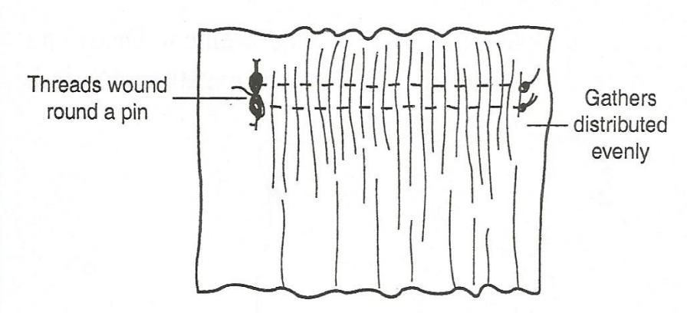

1mk
- Join to the waistband (1)

c) Briefly explain five reasons for using soft furnishings in the home 5mks
- For decoration
If the colours of soft furnishings are well chosen to blend with the colour scheme of a room, the appearance of the room will be greatly enhanced.
- For privacy
Curtains, for example, are used for screening windows at night or during daytime.
- For comfort
Cushions and pillows are for supporting the body when sitting or sleeping; carpets provide warmth to the feet
- For protection
Loose chair covers and bedcovers are used to protect expensive upholstery and bedding from wear, tear and dirt. They are also easy to launder and can improve the appearance of the room, if well-chosen.
- For easy maintenance
Loose covers are cheaper to launder than dry-cleaning upholstery.
- For improving the appearance of an unattractive furniture
Loose covers can be used to cover and enhance the appearance of a room.
- For filtering excessive light
Curtains control the amount of the light coming into a room. This is important, especially during daytime.
- For warmth and reduction of noise
Carpets reduce noise and add Warmth to a room.

