Student Name…………………………………………Adm No…………………………………………..
School………………………………………………Class………………………Date……………………
HOME SCIENCE
441/2
PAPER 2
PRACTICAL
TIME: 2 ½ Hours
CEKENAS END OF TERM TWO EXAM-2022
Kenya Certificate of Secondary Education. (K.C.S.E)
FORM FOUR END OF TERM TWO EVALUATION EXAM
HOME SCIENCE PAPER TWO

CLOTHING CONSTRUCTION
INSTRUCTIONS
- This paper consist of 3 printed papers
- Candidates should check the question paper to ascertain that all pages are printed as indicated and that no question are missing

A pattern of a child dress is provided. Your are advised to study the sketches the questions paper and the layout before the text

Materials provided
- Pattern pieces

- Dress front
- Dress back
- Sleeve
- Front neck facing
- Back neck facing
- Plain light weight cotton fabric 70cm by 90 cm wide.
- Sewing thread to match the fabric
- Cotton lace one inch wide by 25 cm long

The Text
Using the material provided, cut out and make up the LEFT HALF of the child’s dress to show the following
- Making of the French seam at the shoulders
- Joining of the side with a neatened plain seam. Neaten with overcasting stitches
- Joining of the underarm seam using a neatened open seam
- The attaching of the lace on a lower edge of sleeve using an overlaid seam
N/B Do not neaten or trim
- The preparation and the attachment of the sleeve, Neaten with loop stitches
- The preparation and the attachment of the neck facings
- Management of the dress hem (handmade)
At the end of the examination, firmly sew on your work on a single fabric a label bearing your name and index number. Remove needles and pins from your work, then fold your work carefully and present if for marking

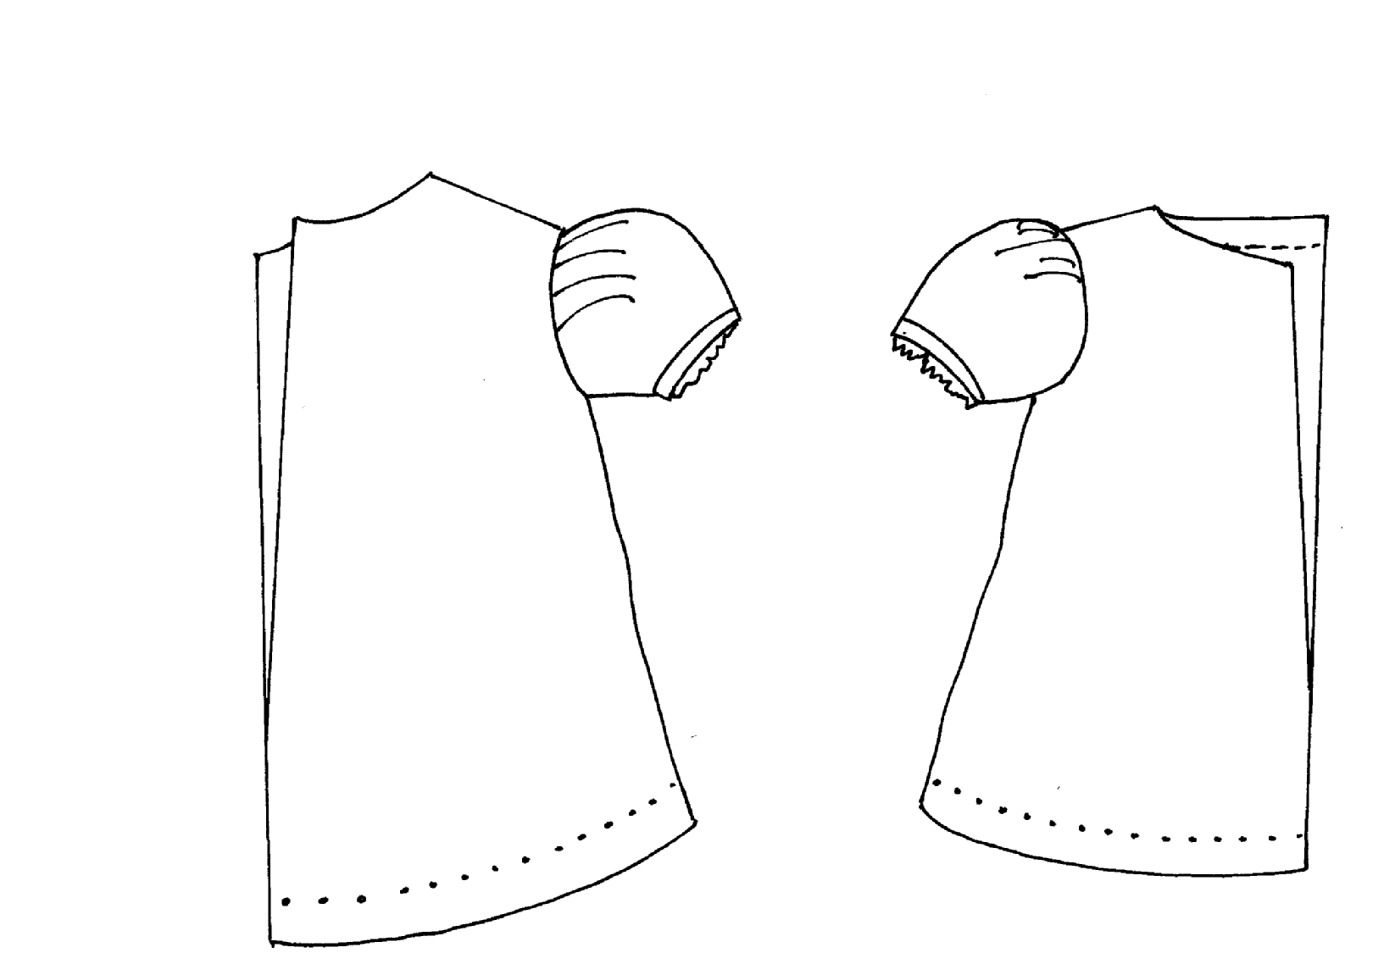
BACK VIEW FRONT VIEW

LAYOUT (NOT DRAWN TO SCALE)
