Home Science - Grade 5 Term 1 Exams 2023
QUESTIONS
HOME SCIENCE
- Write three physical changes in pre-adolescent in girls
- Name three aspect of grooming
- Write materials used making different types of shoes
- Name the needle work tools
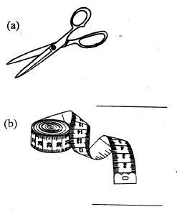
- Outline three health practices that you practise at home
- Name the best clothes to wear during cold day
- Name the food we eat
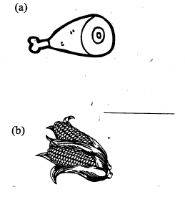
- Write two activities you can do during leisure time
PHYSICAL AND HEALTH EDUCATION
- Draw an athletic track (5mks)
- Explain what is a sprint start
- Write down safely measures to observe when improvising a baton
- Look at the picture and answer the questions below
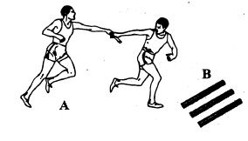
  - Write the activity played in the picture
  - Name items in picture B.
ART & CRAFT
- A still life is drawing of arrangement of (moving objects, noon moving objects)
- Name the items found in first AID kit
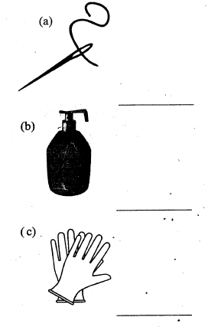
- Name the materials used when drawing a still life composition
- What is painting? (2mks)

MUSIC
- Name two things that we need to achieve good sing
- What is diction as used in music
- Write the importance of songs during national holiday?
- Draw musical instrument

- Name three colours on the national, flag

MARKING SCHEME
HOME SCIENCE

  - Enlargement of breast
  - Enlargement of hips
  - Increase of height & weight

  - personal hygiene
  - Hare a signatory cologne
  - Exfoliated

  - canvas
  - leather
  - rubbers

  - scissors
  - tape measure

  - Wash your hands
  - Drink more water
  - Exercise with a friend

  - warm clothes
  - heavy clothes
  - rubbers

  - meat
  - maize

  - reading story book
  - skipping rope
PHYSICAL EDUCATION
- Draw
- Method of gaining maximum
- Speed as quickly as possible

  - exchange of baton
  - batons
  - rubbers
ART/CRAFT
- Farming history

  - needle
  - soap
  - glove

  - pencil
  - rubber
  - drawing book
- Action or skills of using paints
MUSIC

  - Voice
  - Volume and style
- Pronunciation of your vocal expression

  - show love to ear country
  - it entertains us
- a
b

  - white
  - red
  - green

