JUNIOR SECONDARY SCHOOL
GRADE 7
NAME
GRADE
SCHOOL
ASSIGNMENT NO.
GRADE 7 EXAMIANTION
HEALTH EDUCATION
Time: 1 hour 20 minutes plus 10 minutes reading time
INSTRUCTIONS TO CANDIDATE
- Write your name. Candidate number. Class and school in the box above
- Do not open this booklet until you are told to do so
- You are given 10 minutes to read through the questions. Do not start writing until you are told to do so
- Read each question carefully
- Answer all the questions
- Write your answer in either blue or black ink, in the spaces provided in the booklet
FOR THE USE OF MARKERS ONLY
MARKS
OUT OF | 50
PERCENTAGE

- Define Health (2mks )

- Define health education (2mks )

- State three importance of health education for healthy living (3mks )
i)
ii)
iii)

- Grade 7 pupils from a certain school were asked to identify career opportunities related to health education. List 4 opportunities most likely stated (4mks )

- Name two health related activities you can do at school (2mks )

- Explain the cause of the following nutritional deficiencies and disorders
- Goiter (1mk)

- Constipation (1mk )

- Marasmus (1mk )

- The photo below shows a patient suffering from a certain nutritional disorder
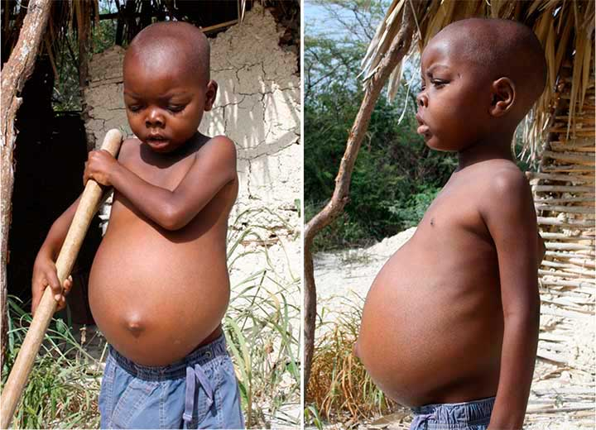

State three signs and symptoms of the above disorder (3mks)

- During health education lesson. Halima was asked by her teacher to prepare a list of meal that contain all macro-nutrients. Name the three macro nutrients found in the food she listed
(3mks )

- State three examples of non-communicable diseases and disorders (3mks )

- On her way back from school, Anita met a patient with seizure and he kept on jerking his arms and legs. The above patient wars likely suffering from (2mks)

- Explain how Anita can offer first aid to the patient in question 10. (2mks)

- Name any three common physical changes in adolescent boys and girls (2mks)

- State three factors to consider when planning a family meal (3mks)

- Study the pictures below and use them to answer the questions that follow.
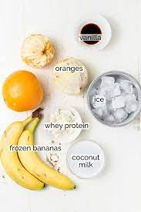
B
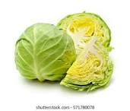
A

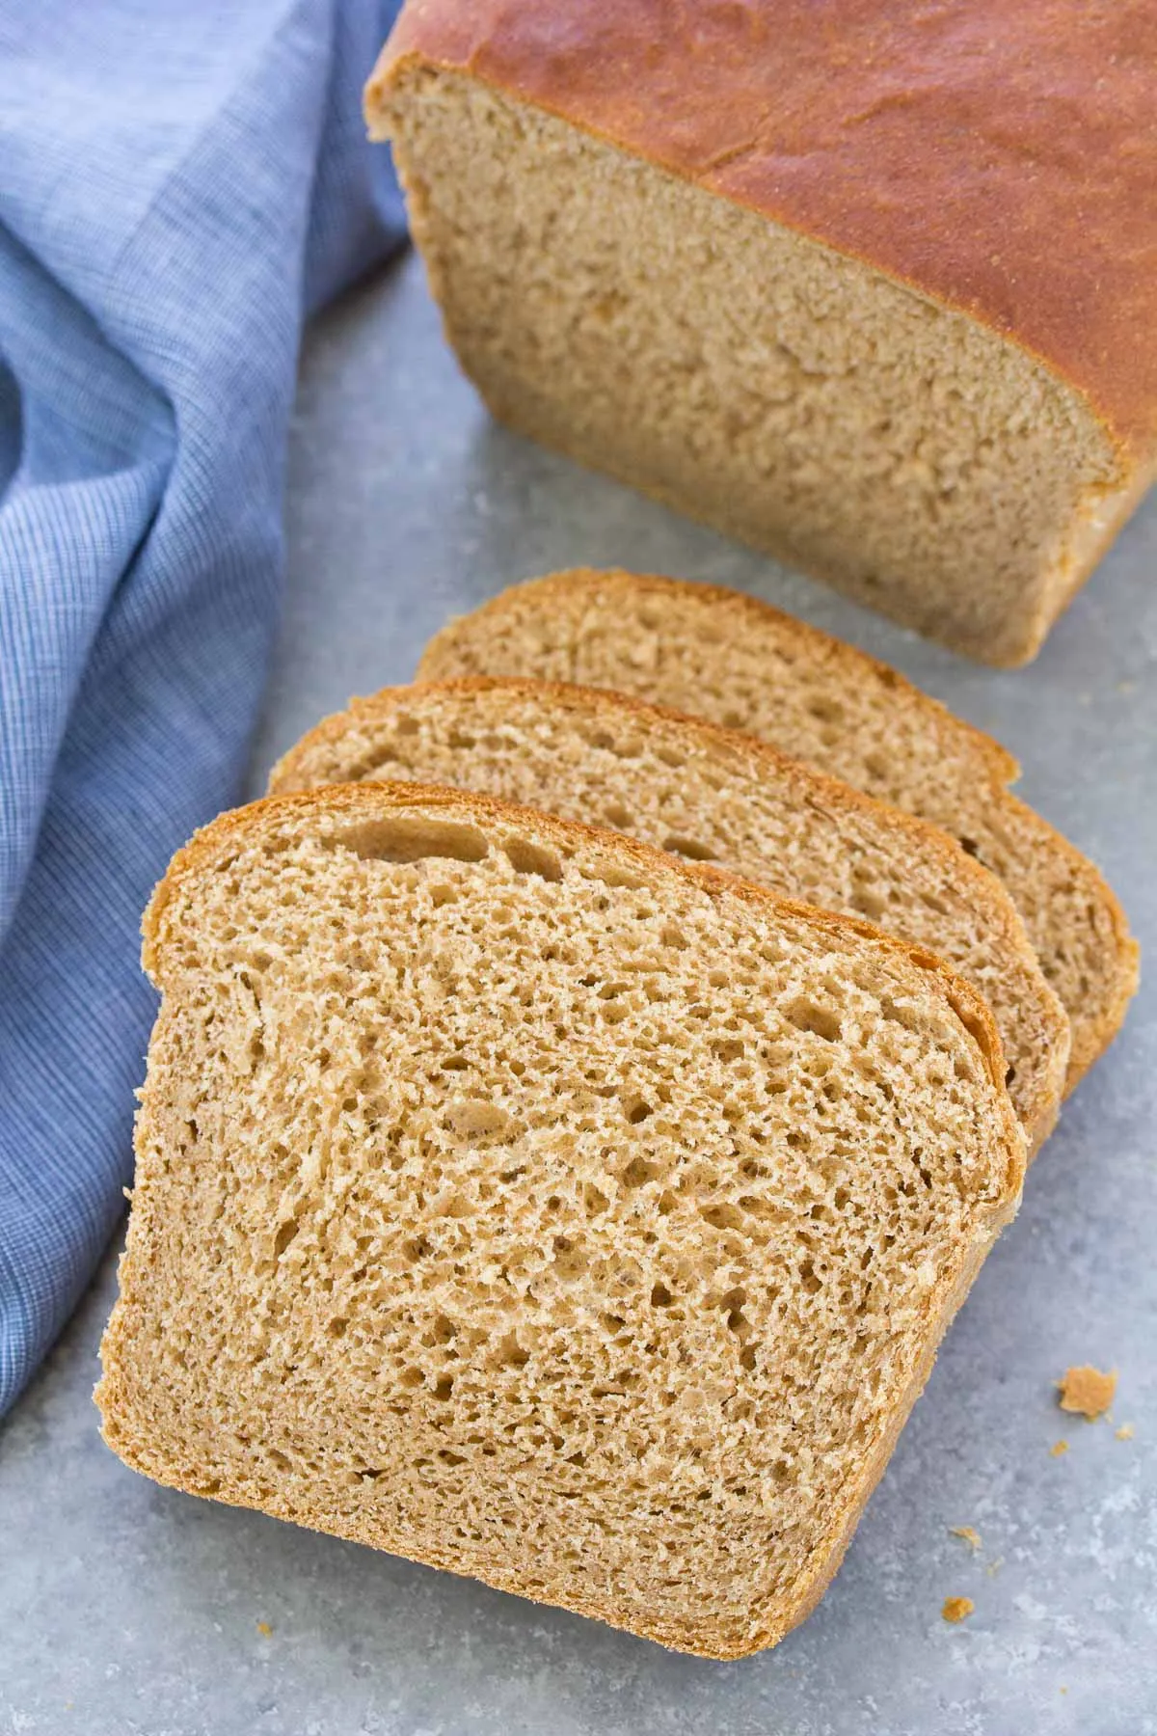
D
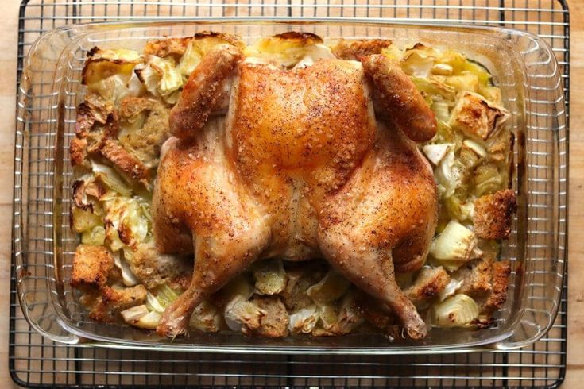
C

- Identify the food items labelled A,B,C and D (4mks)
A------

B------

C------

D------

- Which nutrients do we obtain from each of the food in the above pictures (4mks)

- Which of the foods in the pictures above provide us with macronutrients (2mks)

