HYGIENE AND NUTRITION- GRADE 3 TERM 1 2023
- We should brush our teeth ____________ times a day
- The food we eat is cooked in the ____________.
- After washing clothes we can reuse the water to ____________.
- The food we eat at lunch time is called ____________.
- A doctor who treats our teeth is called a ____________.
Draw these items found in the kitchen
- Cup

- Knife

- An orange tastes ____________
- Dirty latrines and toilets smell ____________
- An avocado has ____________seed.
- I eat breakfast in the ____________.
Name the pictures.
- 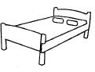___________________
- 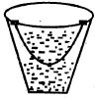
___________________
- 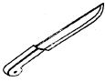
___________________
- 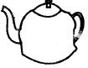
___________________
- ___________________
Name three items we use to clean the house
- ___________________
- ___________________
- ___________________
- Personal items should not be
  - ___________________

