HYGIENE AND NUTRITION GRADE 1 TERM 1 2023
- Name the foods we eat
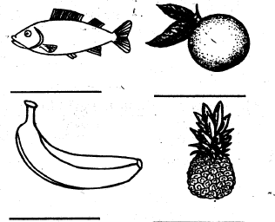
- We should take (tea, medicine) using clean water.__________________________________________
- We should wash our hands (everyday, once a day).____________________________________
- A is used to clean our nose. (towel, handkerchief).___________________________
- Name the parts of a plant
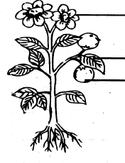
- We get tomato from _______________________(animals, plants)
- Fruits are _______________________ before eating.(cooked, washed)
- Fish, milk and meat are foods from _______________________(plant, animals)
- We should always keep medicine in a _______________________ cupboard. (closed, open)
- __________________________ cause disease(germs,clean)
- Clean toilets look________________________(good,bad)
- We use ____________________________to wash our hands.(water,soil)
- Urinals are used by _______________________(boys,girls)

