HYGIENE AND NUTRITION ACTIVITIES - CBC GRADE 2 MID TERM 1 EXAMS 2023

QUESTIONS
- Dirty mouth smells.........................................
(sweet, bad, good)
- Which food do we get from animals.........................................
(apple, pineapple, milk)
- This is a.........................................it lives in.........................................
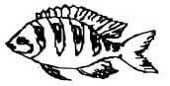
(cow, snake, fish, home, bottle, water)
- Carrots and sugarcane make our .........................................strong.
(hair, teeth)
- We wash fruits to kill .........................................
(germs, insects)
- Write 'Yes' or 'No'
It is good to share a towel .........................................
- Urinals are used by girls only.........................................
- We drink milk when we are sick.........................................
- Jim is washing his hands with soap and.........................................
(milk, soil, water)
- We buy bread from a.........................................
(farm, school, shop)
- Draw and colour any 2 fruits which you like
- A tongue is used for.........................................
(seeing, tasting)
- Which food do we eat at noon.........................................
(breakfast, lunch)
- Cate was playing while sharpening her pencil with a razor blade. She .........................................(pricked, cut) her finger.
- Name foods eaten during breakfast
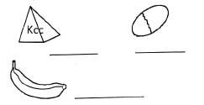

Marking Scheme
- bad
- milk
- fish,water
- teeth
- germs
- no
- no
- yes
- water
- shop
- (student draw and colors any fruit they like)
- tasting
- lunch
- cut
- milk
egg
banana

