HYGIENE AND NUTRITION ACTIVITIES - CBC GRADE 2 TERM 1 EXAM 20223
- When served with food you should say ................................ (1mk)
(sorry, thank you, please)
- We should eat with our mouth ................................(1mk)
(closed, open)
- We buy meat from a ................................ (1mk)
(butchery, shop, kitchen)
- We buy cooked food from a ................................(1mk)
- John put a lot of food in his mouth. He talked while eating. What do you think happened to John? He was................................
(chocked, cut, suffocated) (1mk)
- If you play with a knife you can easily................................ your fingers. (fall, cut, burn (1mk)
- Say places where these foods are sold (4mks)
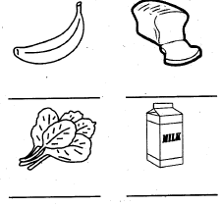
- Colour these fruits (4mks)
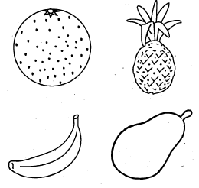
- We cut our nails short using a_____________________
- ______________are used by boys and men. (1 mk)
- We should________________the toilet after using it. (1mk)
- Name the two mains sources of food. (2mks)
a)__________________________________
b)__________________________________
- A ripe tomato is________________in colour. (1mk)
- Milk teeth are also called___ teeth. (1mk)

Fill in with the correct answer (4 marks)
- I eat food so as to stay ________________
- We eat food to get ____________ to work
- We eat food daily so as to ___________ healthy
- Eating food everyday prevents _______________
(energy, grow, healthy, illness)
- Tick good behavior during meal time(5mks)
Licking fingers | .
Serving enough food
Chew food with mouth closed
Eating food too fast
Clear the table after meals
- Name two fruits according to colour
Green
__________________
__________________
Yellow
__________________
__________________
Red
__________________
__________________

