HYGIENE AND NUTRITION - CBC GRADE 3 TERM 1 EXAMS 2023
QUESTIONS
- A________________________ is a personal item (toothpaste, towel, textbook)
- We can clean a____________________ using warm salty water. (toothbrush, hairbrush, handkerchief)
- Personal items should not be shared so that we don't spread or get___ (them, germs, clean)
- Name three healthy habits.
________________________________________
________________________________________
________________________________________
- Regular foods help one to have a good ____________ (body, name, health)
- When do we brush our teeth?
_________________________________
_________________________________
- Lack of food causes _______________in our bodies.
- When our feet are dirty and we do not wear shoes we get ____________________.
- Name two foods that can cause teeth cavities.
_________________
_________________
Match the given foods to their tastes.
- Salt sweet
- Lemon bitter
- Honey salty
- Ginger sour
- We eat the seeds of__________________________(sugarcane, cabbages, maize)
- ____________________of sukumawiki are eaten as food. (Stems, Fruits, Leaves)
- ______________________can be eaten as a snack. (Potatoes, Popcorns, Porridge)
- Eating snacks between meals makes us___________________ (weak, healthy, sleep)
- For good health, we should take___________________meals a day. (four, two, three)
- It is good to eat__________________food. (more, enough, little)
- Breakfast is the food eaten in the___ _____________________(morning, afternoon, evening)
- What table manner is this? ____________________________
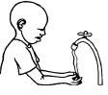
- Match these foods with what they give us.
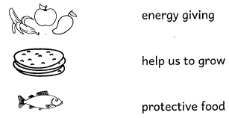
- Food from the three groups make us __________________(weak, ill, healthy)
- Write one food that you like. _____________________________
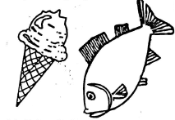
- When we eat too much, food we can__________________________ (faint, vomit, cough)
- Dental floss can be used to clean between our________________________ (eyes, teeth, ears)
- Water used for rinsing school uniform can again be used for_________________(mopping, cooking, drinking)
- A_____________is likely to be found in the bedroom. (pillow, bicycle, tree)
- Second hand smoke is dangerous because it affects our______________(lungs, teeth, mounths)
- The equipment below is likely to be found in the________________(kitchen, bedroom, bathroom)
