Term 1- 2023 OPENER EXAM
HOME SCIENCE (441/1)
FORM FOUR(4)
Time: $2\frac{1}{2}Hours$

Name: …………………………………………………………. Adm No: ……………….
School: ……………………………………………………….. Class: …………………..
Signature: …………………………………………………….. Date: …………………...

Instructions to students
- Write your name, admission number and class in the spaces provided
- Sign and write the date of the examination in the spaces provided
- This paper consists of three sections: A, B and C
- Answer all the questions in sections A and B and any two questions in section C
- Answers to all the questions must be written in the spaces provided in the paper
- This paper consists of 13 printed pages
- Students should check the question paper to ascertain that all the pages are printed as indicated and that no questions are missing
- Students should answer the questions in English

For examiner’s use only
Section | Question | Maximum Score | Student’s Score
A | - 21 | 40
B | 22 | 20
C |  | 20
 |  | 20
TOTAL SCORE |  | 100

SECTION A: (40 marks)
Answer ALL the questions in this section in the spaces provided.

- Give two reasons for covering food when cooking. (1mark)
……………………………………………………………………………………………………………………………………………………………………………………………………………………………………………………………………………………………………………………………………………………....
- Identify four groups of people who are more susceptible to tuberculosis (TB) infection. (2marks)
……………………………………………………………………………………………………………………………………………………………………………………………………………………………………………………………………………………………………………………………………………………....…………………………………………………………………………………………………………………
- Mention two qualities of a well-made machine fell seam. (2marks)
……………………………………………………………………………………………………………………………………………………………………………………………………………………………………………………………………………………………………………………………………………………....
- State two ways avoiding worm infestation. (2marks)
……………………………………………………………………………………………………………………………………………………………………………………………………………………………………………………………………………………………………………………………………………………....
- Give two ways the current drought may affect consumers. (2marks)
……………………………………………………………………………………………………………………………………………………………………………………………………………………………………………………………………………………………………………………………………………………....
- Mention four reasons for laundering clothes. (2marks)
…………………………………………………………………………………………………………………………………………………………………………………………………………………………………………………………………………………………………………………………………………………….................................................................................................................................................................

- State three qualities of children’s play clothes. (3marks)
……………………………………………………………………………………………………………………………………………………………………………………………………………………………………………………………………………………………………………………………………………………....……………………………………………………………………………………………………………………………………………………………………………………………………………………………………………………………………………………………………………………………………………………....
- Give two qualities of good firewood. (1mark)
……………………………………………………………………………………………………………………………………………………………………………………………………………………………………………………………………………………………………………………………………………………....
- Highlight two ways of reducing spread of infection when taking care of a child with chickenpox. (2marks)
…………………………………………………………………………………………………………………………………………………………………………………………………………………………………………………………………………………………………………………………………………………….................................................................................................................................................................
- Suggest three dangers of careless sex amongst young people. (3marks)
……………………………………………………………………………………………………………………………………………………………………………………………………………………………………………………………………………………………………………………………………………………....……………………………………………………………………………………………………………………………………………………………………………………………………………………………………………………………………………………………………………………………………………………....
- Mention four ways of finishing of the lower edge of a girl’s pair of shorts decoratively. (2marks)
……………………………………………………………………………………………………………………………………………………………………………………………………………………………………………………………………………………………………………………………………………………....…………………………………………………………………………………………………………………

- Highlight two precautions to observe when planning meals for vegans. (2marks)
……………………………………………………………………………………………………………………………………………………………………………………………………………………………………………………………………………………………………………………………………………………....…………………………………………………………………………………………………………………
- Give two uses of a seam ripper in sewing. (1mark)
…………………………………………………………………………………………………………………………………………………………………………………………………………………………………………………………………………………………………………………………………………………….....
- Give the meaning of the following terms in cookery. (3marks)
- Course ………………………………….….……………………………………………………………………………………………………………………………………………………………………………
- Entrée ……………………………………………………………………………………………………………………………………....……………………………………………………………………………
- Saute ……………………………………………………………………………………………………………………………………………………………………………………………………………………
- Name four pockets that can be found on a shirt/blouse. (2marks)
……………………………………………………………………………………………………………………………………………………………………………………………………………………………………………………………………………………………………………………………………………………....…………………………………………………………………………………………………………………
- Suggest two factors that can predispose a person to diabetes. (1mark)
……………………………………………………………………………………………………………………………………………………………………………………………………………………………………………………………………………………………………………………………………………………....…………………………………………………………………………………………………………………
- State two diseases that can be spread by a cook through careless handling of food. (1mark)
………………………………………………………………………………………………………………………………………………………………………………………………………………………………
- Highlight two ways of caring for a kitchen bin. (2marks)
…………………………………………………………………………………………………………………………………………………………………………………………………………………………………………………………………………………………………………………………………………………….................................................................................................................................................................
- Mention two qualities of a good food storage store. (2marks)
…………………………………………………………………………………………………………………………………………………………………………………………………………………………………………………………………………………………………………………………………………………….................................................................................................................................................................
- Give two disadvantages of clothes made from cotton. (2marks)
……………………………………………………………………………………………………………………………………………………………………………………………………………………………………………………………………………………………………………………………………………………....…………………………………………………………………………………………………………………
- Suggest two reasons for weaning a baby. (2marks)
……………………………………………………………………………………………………………………………………………………………………………………………………………………………………………………………………………………………………………………………………………………....…………………………………………………………………………………………………………………

SECTION B: (20 marks)
COMPULSORY
Answer question 22 in the spaces provided after the question

- Your elder sister is preparing for her traditional wedding ceremony.
- Describe the procedure you will follow to launder loose coloured lesso to be used to cover her on that day. (9marks)
- Outline the procedure for cleaning the calabash for use on that day. (4marks)
- Give the procedure you will follow to clean the polished three legged stool to be used for the ceremony. (7marks)

……………………………………………………………………………………………………………………………………………………………………………………………………………………………………………………………………………………………………………………………………………………....……………………………………………………………………………………………………………………………………………………………………………………………………………………………………………………………………………………………………………………………………………………....……………………………………………………………………………………………………………………………………………………………………………………………………………………………………………………………………………………………………………………………………………………....……………………………………………………………………………………………………………………………………………………………………………………………………………………………………………………………………………………………………………………………………………………....……………………………………………………………………………………………………………………………………………………………………………………………………………………………………………………………………………………………………………………………………………………....……………………………………………………………………………………………………………………………………………………………………………………………………………………………………………………………………………………………………………………………………………………....……………………………………………………………………………………………………………………………………………………………………………………………………………………………………………………………………………………………………………………………………………………....……………………………………………………………………………………………………………………………………………………………………………………………………………………………………………………………………………………………………………………………………………………....……………………………………………………………………………………………………………………………………………………………………………………………………………………………………………………………………………………………………………………………………………………....……………………………………………………………………………………………………………………………………………………………………………………………………………………………………………………………………………………………………………………………………………………....……………………………………………………………………………………………………………………………………………………………………………………………………………………………………………………………………………………………………………………………………………………....……………………………………………………………………………………………………………………………………………………………………………………………………………………………………………………………………………………………………………………………………………………....……………………………………………………………………………………………………………………………………………………………………………………………………………………………………………………………………………………………………………………………………………………....……………………………………………………………………………………………………………………………………………………………………………………………………………………………………………………………………………………………………………………………………………………....……………………………………………………………………………………………………………………………………………………………………………………………………………………………………………………………………………………………………………………………………………………....……………………………………………………………………………………………………………………………………………………………………………………………………………………………………………………………………………………………………………………………………………………....……………………………………………………………………………………………………………………………………………………………………………………………………………………………………………………………………………………………………………………………………………………....……………………………………………………………………………………………………………………………………………………………………………………………………………………………………………………………………………………………………………………………………………………....……………………………………………………………………………………………………………………………………………………………………………………………………………………………………………………………………………………………………………………………………………………....……………………………………………………………………………………………………………………………………………………………………………………………………………………………………………………………………………………………………………………………………………………....……………………………………………………………………………………………………………………………………………………………………………………………………………………………………………………………………………………………………………………………………………………....……………………………………………………………………………………………………………………………………………………………………………………………………………………………………………………………………………………………………………………………………………………....……………………………………………………………………………………………………………………………………………………………………………………………………………………………………………………………………………………………………………………………………………………....………………………………………………………………………………………………………………………………………………………………………………………………………………………………………………………………………………………………………………………………………………………
SECTION C: (40 marks)
Answer any two questions from this section in the spaces provided at the end of the section.

- Use the diagram of the skirt below to answer the questions that follow:
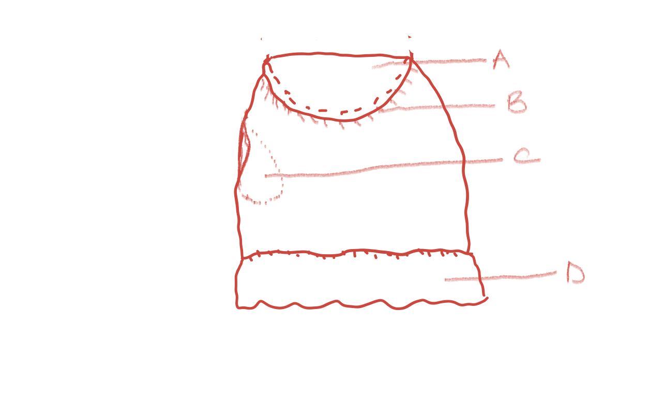
- Label the features labelled A to D. (4marks)
- Mention two possible ways of finishing the top of the skirt. (2marks)
- List three ways of finishing of the lower edge other than using feature D. (3marks)
- (i) Name the seam used in joining feature A to the skirt. (1mark)
(ii) Outline four qualities of this seam when well-made. (4marks)
- Give three rules to observe when working feature B. (3marks)
- Briefly explain three qualities of a well-made feature C. (3marks)

- Explain four qualities of a good charcoal iron. (4marks)
- Highlight five advantages of machine washing over hand washing. (5marks)
- Discuss three points to consider when buying washing equipment for laundry. (6marks)
- Outline five advantages of drying clothes on a clothes line. (5marks)

- Highlight four dangers of rising obesity in the population. (4marks)
- Discuss three qualities of a good kitchen work surface. (6marks)
- Study the baby growth chart graph below and answer the questions that follow.
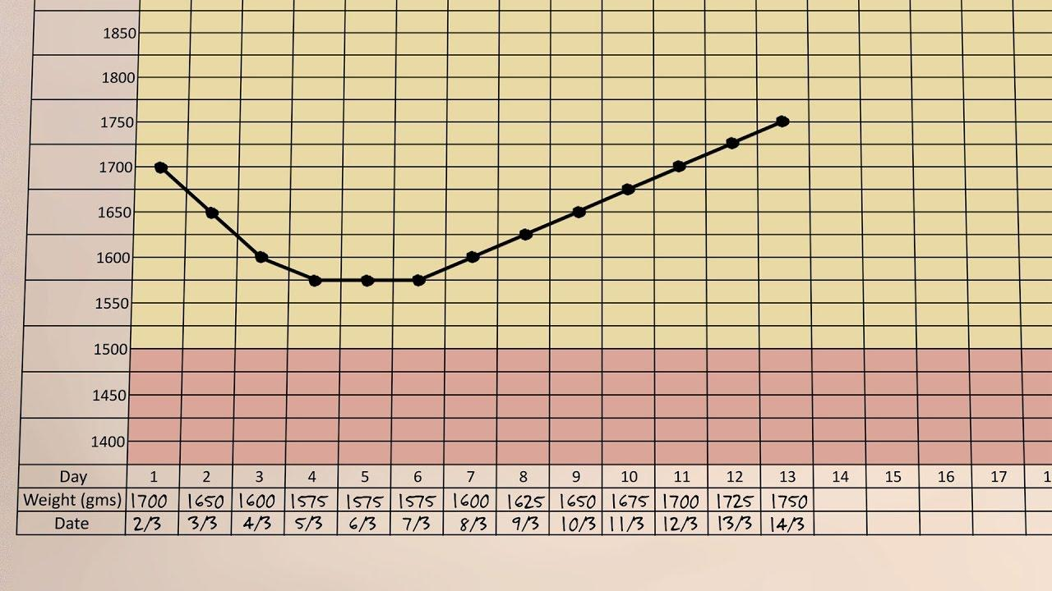

- Discuss three factors that could have led to the phenomena observed in day 1 to 4 of the baby’s life. (6marks)
- Mention four dangers of the trend between day 1 to day 4 if this was a monthly record. (4marks)

……………………………………………………………………………………………………………………………………………………………………………………………………………………………………………………………………………………………………………………………………………………....……………………………………………………………………………………………………………………………………………………………………………………………………………………………………………………………………………………………………………………………………………………....……………………………………………………………………………………………………………………………………………………………………………………………………………………………………………………………………………………………………………………………………………………....……………………………………………………………………………………………………………………………………………………………………………………………………………………………………………………………………………………………………………………………………………………....……………………………………………………………………………………………………………………………………………………………………………………………………………………………………………………………………………………………………………………………………………………....……………………………………………………………………………………………………………………………………………………………………………………………………………………………………………………………………………………………………………………………………………………....……………………………………………………………………………………………………………………………………………………………………………………………………………………………………………………………………………………………………………………………………………………....……………………………………………………………………………………………………………………………………………………………………………………………………………………………………………………………………………………………………………………………………………………....……………………………………………………………………………………………………………………………………………………………………………………………………………………………………………………………………………………………………………………………………………………....……………………………………………………………………………………………………………………………………………………………………………………………………………………………………………………………………………………………………………………………………………………....……………………………………………………………………………………………………………………………………………………………………………………………………………………………………………………………………………………………………………………………………………………....……………………………………………………………………………………………………………………………………………………………………………………………………………………………………………………………………………………………………………………………………………………....……………………………………………………………………………………………………………………………………………………………………………………………………………………………………………………………………………………………………………………………………………………....……………………………………………………………………………………………………………………………………………………………………………………………………………………………………………………………………………………………………………………………………………………....……………………………………………………………………………………………………………………………………………………………………………………………………………………………………………………………………………………………………………………………………………………....……………………………………………………………………………………………………………………………………………………………………………………………………………………………………………………………………………………………………………………………………………………....……………………………………………………………………………………………………………………………………………………………………………………………………………………………………………………………………………………………………………………………………………………....……………………………………………………………………………………………………………………………………………………………………………………………………………………………………………………………………………………………………………………………………………………....……………………………………………………………………………………………………………………………………………………………………………………………………………………………………………………………………………………………………………………………………………………....……………………………………………………………………………………………………………………………………………………………………………………………………………………………………………………………………………………………………………………………………………………....……………………………………………………………………………………………………………………………………………………………………………………………………………………………………………………………………………………………………………………………………………………....……………………………………………………………………………………………………………………………………………………………………………………………………………………………………………………………………………………………………………………………………………………....……………………………………………………………………………………………………………………………………………………………………………………………………………………………………………………………………………………………………………………………………………………....……………………………………………………………………………………………………………………………………………………………………………………………………………………………………………………………………………………………………………………………………………………....……………………………………………………………………………………………………………………………………………………………………………………………………………………………………………………………………………………………………………………………………………………....……………………………………………………………………………………………………………………………………………………………………………………………………………………………………………………………………………………………………………………………………………………....……………………………………………………………………………………………………………………………………………………………………………………………………………………………………………………………………………………………………………………………………………………....……………………………………………………………………………………………………………………………………………………………………………………………………………………………………………………………………………………………………………………………………………………....……………………………………………………………………………………………………………………………………………………………………………………………………………………………………………………………………………………………………………………………………………………....……………………………………………………………………………………………………………………………………………………………………………………………………………………………………………………………………………………………………………………………………………………....……………………………………………………………………………………………………………………………………………………………………………………………………………………………………………………………………………………………………………………………………………………....……………………………………………………………………………………………………………………………………………………………………………………………………………………………………………………………………………………………………………………………………………………....……………………………………………………………………………………………………………………………………………………………………………………………………………………………………………………………………………………………………………………………………………………....……………………………………………………………………………………………………………………………………………………………………………………………………………………………………………………………………………………………………………………………………………………....……………………………………………………………………………………………………………………………………………………………………………………………………………………………………………………………………………………………………………………………………………………....……………………………………………………………………………………………………………………………………………………………………………………………………………………………………………………………………………………………………………………………………………………....……………………………………………………………………………………………………………………………………………………………………………………………………………………………………………………………………………………………………………………………………………………....……………………………………………………………………………………………………………………………………………………………………………………………………………………………………………………………………………………………………………………………………………………....……………………………………………………………………………………………………………………………………………………………………………………………………………………………………………………………………………………………………………………………………………………....……………………………………………………………………………………………………………………………………………………………………………………………………………………………………………………………………………………………………………………………………………………....……………………………………………………………………………………………………………………………………………………………………………………………………………………………………………………………………………………………………………………………………………………....……………………………………………………………………………………………………………………………………………………………………………………………………………………………………………………………………………………………………………………………………………………....……………………………………………………………………………………………………………………………………………………………………………………………………………………………………………………………………………………………………………………………………………………....……………………………………………………………………………………………………………………………………………………………………………………………………………………………………………………………………………………………………………………………………………………....……………………………………………………………………………………………………………………………………………………………………………………………………………………………………………………………………………………………………………………………………………………....……………………………………………………………………………………………………………………………………………………………………………………………………………………………………………………………………………………………………………………………………………………....……………………………………………………………………………………………………………………………………………………………………………………………………………………………………………………………………………………………………………………………………………………....…………………………………………………………………………………………………………………………………………………………………………………………………………………………………………………………………………………………………………………………………………………….............................................................................................................................................................................................................................................................................................................................................................................................................................................................................................................................................................................................................................................................................................................................................................................................................................................................................................................................................................................

