Term 3 – 2023 OPENER EXAM
HOME SCIENCE (441/1)
FORM FOUR(4)
Time: $2\frac{1}{2}Hours$

MARKING SCHEME
SECTION A

- Reasons for covering food when cooking.
- To keep the heat in so that the food cooks faster.
- To prevent foreign objects from falling into the food.
- To save on energy.
(½ mark for each point. ½ x 2 = 1mark)
- People who are more susceptible to tuberculosis (TB) infection.
- The elderly
- Young children and babies
- Persons living with a person suffering from tuberculosis in a crowded place
- Persons living with HIV
- Persons with chronic health conditions like diabetes or cancer.
- Malnourished persons.
(½ mark for each point, ½ x 4 = 2marks)
- Qualities of a well-made machine fell seam.
- It is even in size throughout.
- The seam stitching is straight.
- Second line of stitching done very close to the fold.
- The fell is neatly tucked under with no visible raw edges.
- The fell is correct in size (6mm).
- The fell lies flat on the right and the wrong side.
- The fell is pressed toward the back.
(1 mark for each point, 1 x 2 = 2marks)
- Ways avoiding worm infestation.
- Wash hands before eating or preparing food.
- Drink treated or boiled water.
- Deworm pets regularly.
- Clean all vegetables and fruits thoroughly before eating or cooking.
- Cook meat thoroughly/avoid eating undercooked meat.
- Avoid walking barefoot on soil.
- Proper fecal disposal.
(1 mark for each point, 1 x 2 = 2marks)
- Ways the current drought may affect consumers.
- Prices of food may go up due to low supply.
- There may be scarcity of food in the market.
- It may lead to malnutrition.
- There may be more cases of insecurity.
- Price of electricity may go up due to low water in dams.
(1 mark for each point, 1 x 2 =2marks)

- Reasons for laundering clothes.
- Helps to remove microorganisms on the clothes.
- To maintain the colour of the clothes.
- To avoid a build-up of dirt that could weaken the clothes.
- To avoid attracting pests like lice.
- To avoid bad odour from sweat and build-up of perfumes.
- To look neat and presentable.
(½ mark for each point, ½ x 4 = 2marks)
- Qualities of children’s play clothes.
- They should be strong so as not tear during play.
- They should withstand frequent washing.
- They should not stain easily.
- They should be loose to allow movement.
- They should be strongly stitched.
- They should be easy to put on and remove.
- They should not be too expensive.
- They should be comfortable to wear.
(1 mark for each point, 1 x 3 = 3marks)
- Qualities of good firewood.
- Should be dry.
- It should not smoke too much.
- It should not be from a poisonous tree.
- It should not splutter.
(½ mark for each point, ½ x 2 = 1mark)
- Ways of reducing spread of infection when taking care of a child with chickenpox.
- Wash hands thoroughly with soap and water after attending to the child.
- Isolate the child especially keep them away from other children.
- Keep their room well ventilated.
- Keep the room clean.
- Disinfect their clothing during laundry.
- Wash their clothes separate from the other family wash.
- Wear protective clothing when attending to the child and remove them after.
(1 mark for each point, 1 x 2 =2marks)
- Dangers of careless sex amongst young people.
- Risk of sexually transmitted infections (STI’s).
- Risk of unplanned pregnancy in girls.
- High risk of contracting HIV.
- Poor self-image.
- Risk of dropping out of school.
(1 mark for each point, 1 x 3 = 3marks)
- Ways of finishing of the lower edge of a girl’s pair of shorts decoratively.
- Use of lace
- Using a contrasting facing on RS
- Use of a frill
- Binding using a contrasting colour.
- Using decorative stiches when working the hem such as herringbone and cross stitch.
(½ mark for each point, ½ x 4 = 2marks)
- Precautions to observe when planning meals for vegans.
- Ensure there is enough proteins in the diet.
- Use spices to flavour food to make the food tasty.
- Ensure that the oil and any additives are safe for vegans.
- Take caution to ensure that the food has minerals and vitamins that are in low amounts in plants.
(1 mark for each point, 1 x 2 = 2marks)
- Uses of a seam ripper in sewing.
- To undo/remove unwanted stitches.
- To cut buttonholes in the absence of buttonhole scissors.
(½ mark for each point, ½ x 2 = 1mark)
- Meaning of the following terms in cookery.
Course
- A single food or set of food items that are served together in a meal all at the same time and eaten in a particular order.
Entrée
- The main course of a meal comprising of a protein, carbohydrate and vegetable.
Saute
Fry quickly in a little hot fat.
(1 mark for each correct definition, 1 x 3 = 3marks)
- Types of pockets that can be found on a shirt/blouse.
- Patch pocket
- In-seam pocket
- Bound pocket
- Placket pocket
- Faux pocket
- Welt pocket
(½ mark for each point, ½ x 4 = 2marks)
- Factors that can predispose a person to diabetes.
- Being overweight.
- Have a history of diabetes in the family.
- Low physical activity.
- Pregnancy – gestational diabetes.
- Age- over 45 years of age.
(½ mark for each point, ½ x 2 = 1mark)
- Diseases that can be spread by a cook through careless handling of food.
- Cholera
- Typhoid
- Amoeba
- Dysentery
- Hepatitis A
(½ mark for each point, ½ x 2 = 1mark)
- Ways of caring for a kitchen bin.
- Empty the bin daily.
- Line the bin.
- Clean the bin daily.
- Keep the bin away from heat.
- Avoid dropping or banging the bin.
(1 mark for each point, 1 x 2 = 2marks)
- Qualities of a good food storage store.
- Should be well ventilated.
- It should have shelves.
- It should have a door.
- It should not have openings/vents that can let in rodents.
- It should be cool (not getting direct sunlight)
- It should be easy to access from the kitchen.
- It should be dry-not damp.
(1 mark for each point, 1 x 2 = 2marks)
- Disadvantages of clothes made from cotton.
- They crease easily.
- They are easily attacked by mildew if stored in a damp place.
- They shrink easily unless given shrink proof finish.
- They are highly inflammable.
- They lack lustre/ they are dull
(1 mark for each point, 1 x 2 = 2marks)
- Reasons for weaning a baby.
- New tastes and textures encourage babies to eat a wide range of foods.
- Solid foods help babies to practice lip, tongue and jaw movement.
- Breast milk is eventually not enough to satisfy baby’s hunger.
- Breast milk does not contain all the nutrients the baby needs for healthy growth after 6 months.
- To allow the mother go back to her regular routine.
(1 mark for each point, 1 x 2 = 2marks)

SECTION B

- Procedure for laundering a loose coloured lesso.
- Collect all equipment and materials needed (½).
- Wash the lesso quickly(½) by kneading and squeezing(½) in warm(½) water containing a mild detergent(½)
- Rinse thoroughly in warm(½) water to remove all dirt and detergent
- Give a final(½) cold(½) rinse containing salt(½) to fix colour and vinegar(½) to brighten the colour
- Squeeze out water and dry flat(½) in the shade(½) on a clean surface(½)
- Iron using a relatively hot(½) iron on the wrong side(½) while still damp(½)
- Air(½) to remove all moisture
- Fold(½) using the four screen fold(½) and store(½) in a clean, dry and well lined place
- Clear up the working area (½).
(½ mark for correct procedures as indicated, ½ x 18 = 9marks)
- Procedure for cleaning a calabash.
- Collect equipment and materials needed
- Clean in plain(½) warm(½) water using a sisal pad/soft pad(½) to avoid scratching the calabash
- Rinse thoroughly in clean warm(½) water
- Give a final rinse in clean cold(½) water to close the grain
- Pat with a clean dish cloth(½) to remove excess water
- Dry in an airy(½) place with the open side facing down/upside down(½)
- When completely dry store in a clean dry(½) place
- Clean and store the cleaning equipment.
(½ mark for correct procedures as indicated, ½ x 8 = 4marks)
- Procedure of cleaning a polished three legged stool.
- Protect the working surface(½)
- Collect all the equipment and materials needed
- Dust(½) the stool using a dusting cloth
- Wipe(½) the stool using a cloth wrung from warm(½) soapy(½) water
- Wipe the legs(½) and the underside(½)
- Rinse(½) by wiping(½) with a cloth wrung from clean water
- Wipe with a clean dry cloth(½) to remove water
- Leave for a while in a cool airy(½) place to dry completely
- Apply polish sparingly(½) using circular motion/use spray polish
- Leave the polish for a while to settle (½)
- Buff(½) with a dry soft cloth(½)
- Store(½) in a clean area in the house
- Clear the working surface(½)
(½ mark for correct procedures as indicated, ½ x 14 = 7marks)

SECTION C

- Diagram of a skirt used for questions a-f:
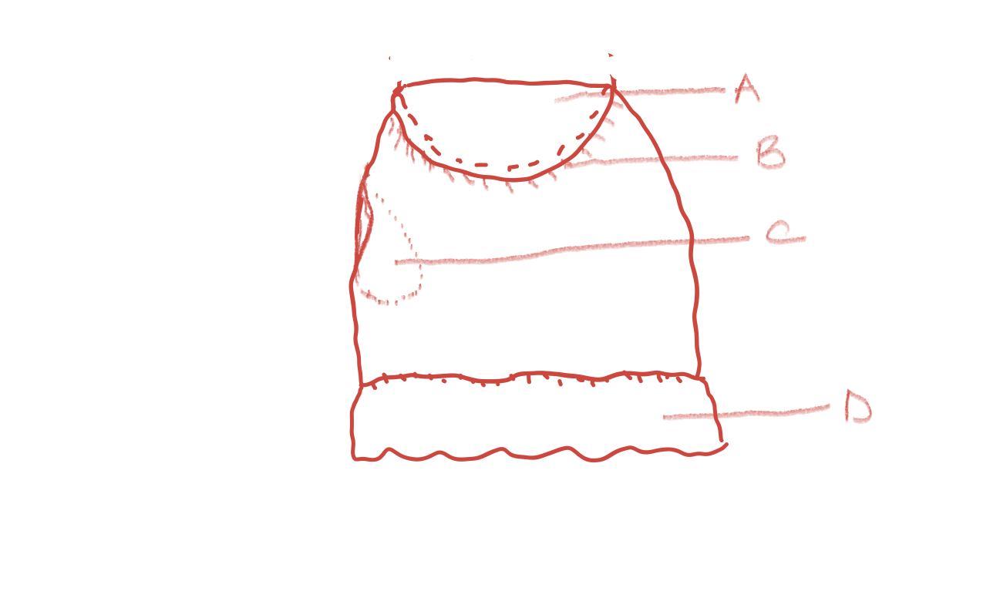
- Features labelled A to D.
- A Skirt yoke/yoke
- B Gathers
- C In-seam pocket
- D Frill
(Correct naming 1 mark each, 1 x 4 = 4marks)
- Possible ways of finishing the top of the skirt.
- Using a facing
- Use of a waistband
- Using elastic
(1 mark for each point, 1 x 2 =2marks)
- Ways of finishing of the lower edge other than using a frill.
- Using lace
- Binding
- Making a hem
- Use of a facing
(1 mark for each point, 1 x 3 = 3marks)
- (i) Name of the seam used in joining the yoke to the skirt.
- Overlaid seam
(Correct naming of seam 1 mark, 1 x 1 = 1mark)
- Qualities of a well-made overlaid seam.
- The overlay is stitched very close to the fold.
- Stitching is straight.
- The stitching is done directly over the stitching line of the underlay.
- The seam lies flat.
- The seam allowance is trimmed to 1 cm.
- The seam is well neatened.
(1 mark for each point, 1 x 4 = 4marks)
- Rules to observe when working gathers.
- Work two rows of running stitches/machine gathering stitch 6mm above and 6mm below the stitching line.
- Secure one end of the gathers by tying a knot.
- Pull the gathers and distribute them evenly.
- Secure the other end of the gathers on a pin using a letter 8 motion.
(1 mark for each point, 1 x 3 = 3marks)
- Qualities of a well-made frill.
- It should be firmly stitched to avoid undoing/coming off.
- It should be evenly stitched to maintain shape.
- It should be even in size for neatness.
- The lower edge should be correctly finished to enclose raw edges.
- Gathers should be evenly distributed for good drape.
- mark for each point, 1 x 3 = 3marks)

- Qualities of a good charcoal iron.
- It should have a well-insulated handle to avoid accidental burns.
- The lid should be well fixed to avoid opening when using.
- The locking device should be firmly fixed to avoid accidental opening during use.it should have vents on the lower and upper side to allow for proper burning of the charcoal.
- It should have an inner rack to hold charcoal so that the bottom does not get too hot.
- It should have a stand to place the hot iron and avoid burning surfaces.
- The sole should be smooth to avoid snagging thread on clothes.
(1 mark for each point, 1 x 4 = 4marks)
- Advantages of machine washing over hand washing.
- It saves on labour thus making one less tired than when hand washing.
- It washes faster than using hands to wash a large amount of clothes thus saving on time.
- It gives one room to attend to other activities when the washing is going on unlike hand washing where one has to do the work.
- One can wash heavy household articles like blankets that may be difficult to handle if hand washing.
- Most machines dry the clothes after washing so clothes can be finished straight from the machine or put out to dry very briefly. In hand washing clothes take a long time to dry.
- Clothes can easily be disinfected by boiling for cotton items since the machine can be set to heat water to boiling point.
- Depending on the size of the machine, it handles a bigger wash load than can be handled in hand washing at a go thus saving on water
(1 mark for each point, 1 x 5 = 5marks)
- Points to consider when buying washing equipment for laundry.
- The amount of washing. This helps one to buy equipment that are of good size to handle the amount of washing done.
- The design of the equipment. It should have a flat bottom to avoid toppling when washing and should not have grooves that make it difficult to clean.
- It should be wide enough at the mouth. This allows one to manipulate clothes easily.
- They should be adequate in number. This allows one to have ready water for the process of washing and rinsing without waiting to empty some of the equipment.
- Storage space available. To ensure that there is enough space to store the equipment well.
(1 mark each for statement, 1 mark for explanation, 2 x 3 = 6marks)
- Advantages of drying clothes on a clothes line.
- Clothes are raised from the ground and do not get dirt from the surface.
- They are less likely to have insects crawling on them.
- They are safe from being trampled/stepped on.
- If well secured they dry faster than when on the ground because the wind blows on them and allows water to drain.
- They can be dried straight allowing water to drip down and keep the clothes less creased.
(1 mark for each point, 1 x 5 = 5marks)

- Dangers of rising obesity in the population.
- Obesity increases risk of cardiovascular diseases.
- Obesity may also lead to higher cases of diabetes type 2.
- People with obesity are more prone to joint problems also known as osteoarthritis.
- Higher incidences of chronic illnesses means that the population is less productive.
- More money is spent by families and the government to treat chronic conditions.
- Life expectancy is reduced as chronic illness raise mortality rate.
(1 mark for each point, 1 x 4 = 4marks)
- Qualities of a good kitchen work surface.
- It should be easy to clean. This makes it easy to ensure proper hygiene of surfaces.
- It should be water resistant. This ensures that the surface is not destroyed by constant exposure to water.
- It should not stain easily. The surface is exposed to different foods and extracts that may colour and stain surfaces.
- It should be durable. This allows the surface to withstand daily use and cleaning without wearing off.
- It should be smooth. Any cracks or grooves on the surface can easily hold dirt and become a source of micro-organisms.
- The surface should be resistant to scratches and scrapes. This is because sometimes the surface can be used for food preparation that requires use of sharp items.
- It should be non-flammable. Due to use of fire in the kitchen, the surfaces should not burn easily.
- It should be of a convenient height. This reduces strain when working thus it should neither be too low or too high.
(1 mark each for statement, 1 mark for explanation, 2 x 3 = 6marks)
- Baby growth chart graph for questions that follow.
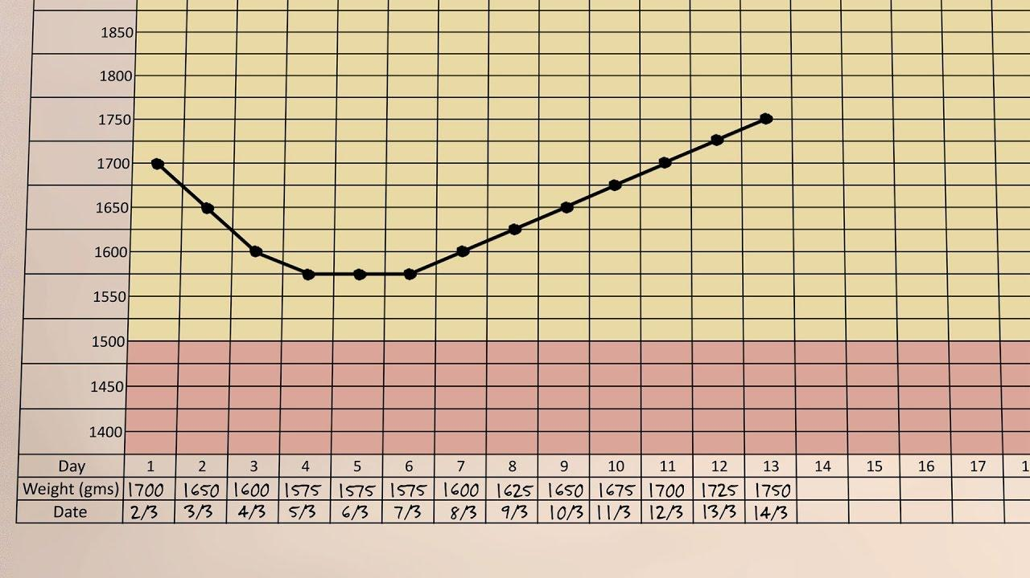

- Factors that could have led to loss of weight in the first four days of a baby’s life.
- The mother was not producing enough milk. Some mothers take a little long to produce milk and even when it comes it may be little and thus the baby does not get enough.
- The baby was premature. A premature baby may be unable to feed and thus lose weight.
- The mother had complications after delivery and could thus not take care of the baby in the first four days.
- The baby is unable to latch and thus does not get enough milk.
- The baby may be lazy and sleepy. Some babies sleep for long and not awake long enough to feed well.
(1 mark each for statement, 1 mark for explanation, 2 x 3 = 6marks)
- Dangers continuous drop in weight in an infant.
- It may lead to stunted growth.
- Babies may be slow in reaching milestones.
- The baby may become malnourished.
- The baby may die.
- The baby may have slow development of the brain.
(1 mark for each point, 1 x 4 = 4marks)

