Name: ______________________________________Index No: ________________________

School: ______________________________ Candidate’s Sign___________________

Date: ____________________________

441/2
HOMESCIENCE
Paper 2
Practical

August/September - 2022
Time: 2½ Hours

ARISE AND SHINE TRIAL 2 EXAMINATIONS
HOMESCIENCE [CLOTHING CONSTRUCTION]
Kenya Certificate of secondary Education. (KCSE)

Instructions to Candidates
- Candidates should check the question paper to ascertain that all the pages are printed.
- Candidates must use machine stitches appropriately in the construction of garments. Hand stitches used instead of machine stitches will not be marked.
- Hand stitches will only be allowed for the making of hemming, tacking and loop stitches.

Instructions.
A pattern of a girl dress is provided. You are advised to study the sketches, instructions and the layout carefully before you begin the test

MATERIAL PROVIDED:
- Pattern pieces

- Skirt front/back.
- Bodice front.
- Bodice back.
- Sleeve.
- Back neck facing.

- A plain light weight cotton fabric 60cm long and 90cm wide
- Sewing thread to match the fabric
- One large envelop.

THE TEST
Using the materials provided, lay cut out and make the LEFT HALF of a girl’s dress to show the following process:
- Cutting out (3½ marks)
- Making shoulder seam using an open seam. (8 marks)
- Joining the back neck facing to the extended front facing. Attaching the facing to finish the neckline (16 marks)
- Making the bodice side seam and underarm seam using a French seam. (11 marks)
- Preparing and attaching the sleeve to the armhole. Neaten a quarter of the armhole seam from the underarm seam using loop stitches.
Manage the sleeve hem with tacking stitches. (19 marks)
- Preparing the skirt using gathers and attaching it to the bodice. (12 marks)
- Neatening the free edge of the facings (4 marks)
- Overall presentation (6½ marks).

At the end of the examination, firmly sew onto your work on a single fabric, a label bearing your name and index number.

Remove the needle, pins and loose threads from your work. Fold your work neatly and place it in the envelope provided.

Do not put scraps of fabric in the envelope. Don’t seal the envelope.

Dress view
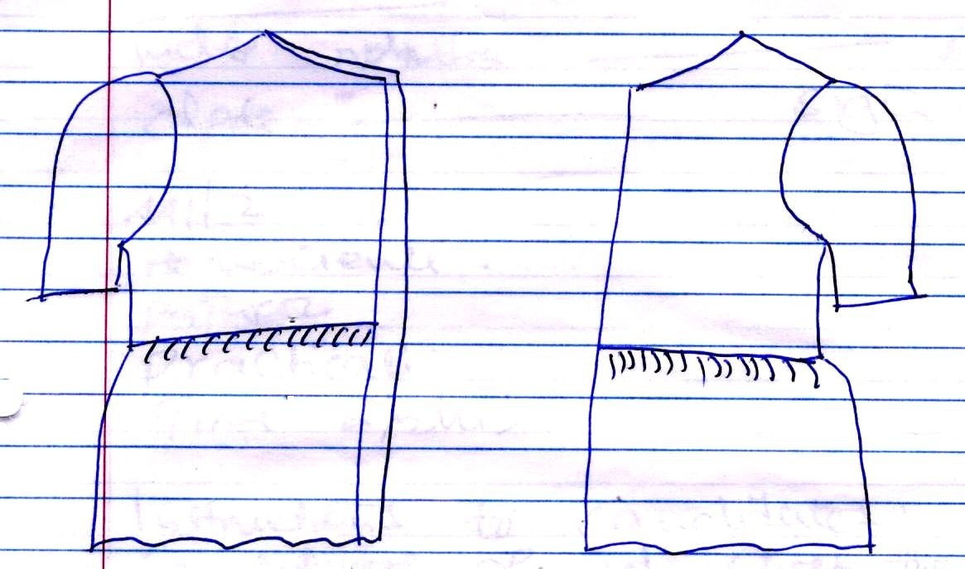
Front view Back view

LAYOUT (not drawn to scale)

