ARISE AND SHINE 2022- TERM 2 TRIAL 1-2022
441/1
HOME SCIENCE (THEORY)
PAPER 1

MARKING SCHEME
SECTION A (40 MARKS)

- Give why vitamins necessary for good eye sight. [2 marks]
- Vitamin A and C.
- State two factors to consider when buying a house. [2 marks]
- Cost
- Value of the house
- Location of the house
- Construction
- Orientation
- Family requirements
- The reliability of the seller
- Differentiate between drainage and refuse disposal. [2 marks]
- Drainage –system of getting rid of waste water from rain and sewage from house or building.
- Refuse disposal- it is getting rid of rubbish or waste matter from a house
(Give 1 mark for each well define=2 marks)
- Give two reasons why lampshades are popular. [2 marks]
- Add to interior decoration.
- They reduce the amount of light in a room i.e. The larger the shade the dimer the light
(1x2=2mks)
- State two ways of preventing cholera outbreak (2 marks)
- Wash hands before handling food or eating.
- Drink boiled water or chlorinated water.
- Clean raw food thoroughly.
- Use clean utensils.
- Dispose faecal waste in the toilet or pit latrine other household refuse appropriately.
(1x2=2mks)
- Highlight four disadvantages of preserving food. [2 marks]
- Some nutrients are lost e.g Vitamin C.
- Food can cause food poisoning if poorly preserved.
- Some chemical preservatives alter the natural taste of food
- Some changes are stopped by food preservation e.g preserved milk cannot ferment.
- Some methods of food preservation are not suitable for some groups of people.e,g sugar as a preservative is unsuitable as a preservative is unsuitable for diabetic people.
(1/2 x 4=2)
- State two factors consider when choosing pegs. [2 marks]
- They should be well fixed
- They should open and close easily
- Should be strong enough to secure heavy clothes without breaking
(1x2=2mks)
- Give two reasons why nylon is unsuitable for sportswear. [2 marks]
- It is nonabsorbent.
- Produce static electricity therefore it clings to the body.
- Does not conduct heat. Therefore it is not warm.
- Damaged by heat hence cannot be boiled to remove stains and brighten the colour
(1x2=2marks)
- State any two reasons why a child’s growth monitoring is important. [2 marks]
- Monitoring a Child’s growth by weight. For age is an immediate indicator of normal or abnormal growth
- Monitoring a |Childs growth by means of height for age helps to determine if the Child is stuffed or is getting too tall.
- If the growth is too fast or too slow for age the health clinic officers should suggest measures to correct it to avoid an obese or underdeveloped Child. (1x2=2mk)
- State three ways of providing variety in meal planning and management. [3 marks]
- Variety in colour-choose interesting colours combination
- Texture-Variety of texture e.g crispy,crinding and tenders foods
- Flavours-variety of flavours e.g, salty, sweet, plain flat or a romantic.
(1x3=3mks)
- State three main forms of advertisement. [3 marks]
- Electronic media
- Print media
- Person to person
(1x3=3mks)
- List three types of pleats used in garment construction. [3 marks]
- Box pleat
- Inverted pleat
- Knife pleat
(1x3=3mks)
- Differentiate between advancing and receding colours. [2 marks]
- Advancing colours-colours that make a room/figure appear smaller
- Receeding colours-colours that make a room or a fatigue appear larger. (1x2=2mks)
- State three precautions to be taken to prevent bed sores when taking care of sick person at home. [3 marks]
- Turn the patient more often to change positions
- Massage the hip and back muscles
- Ensure the beddings are dry at all times
- Check them for bed sores often
(1x3=3mks)
- State two factors to consider when planning lighting for various rooms in the house.[2 marks]
- Purpose of the room.
- Size of the room
- The existing colour scheme
(1x3=3mks)

- Give two methods of ventilating a room naturally. [2 marks]
- Windows
- Doors
- Chimneys
- Vents
(1x2=2mks)

- Identify three methods of attaching the collar to the neckline. [3 marks]
- Attaching collar with crossway strip
- Attaching collar by sandwiching it between the facing/Revers.
- Self-neatening method of attaching a collar

- Give two causes of anemia. [1 marks]
- Excessive bleeding due to accidents
- Heavy menstrual flow
- Parasite infestation worms
- Malfunctioning of the body

SECTION B – [20 marks]

COMPULSORY QUESTION

19. You are assisting your mother with household chores. With reasons,
(a). Explain how to launder a white towel used by your sick brother. (11 marks)
- Soak in cold (¹/₂ ) water with disinfectant (¹/₂ ) to kill the germs (¹/₂ )
- Wring out soaking water (¹/₂ )) to get rid of dirt and avoid cooling the washing water (¹/₂ )
- Wash in hot (¹/₂ )soap (¹/₂ ) water by fiction (¹/₂ )method to remove all dirt (¹/₂ )
- Rinse in hot (¹/₂) water severally to remove dirt and detergent. (¹/₂ )
- Final rinse in cold water (¹/₂) to which laundry blue has been added(¹/₂ ) to freshen and whiten the towel (¹/₂ ) (can boil to whiten or soften using a fabric conditioner.)
- Wring out as much water as possible to hasten drying(¹/₂ )
- Hang the towel straight with pegs. (¹/₂ )for support under direct sunlight(¹/₂ )to bleach and dry (¹/₂ )
- Press when it’s slightly damp (¹/₂ ) using a hot iron to remove creases.
- Air (¹/₂ )to freshen and dry completely(¹/₂ )
- Fold and store appropriately(¹/₂ )
(b). Describe how to clean a plastic plate. (4 marks)
- Clean in warm (¹/₂) soapy (¹/₂) water using a soft cloth/sponge (¹/₂ )
- Rinse (¹/₂) thoroughly in warm (¹/₂) water
- Dry (¹/₂) completely with a cloth (¹/₂) drip dry
- Buff (¹/₂ ) with a soft non-fluffy cloth

(c). Explain how to sponge your polyester tie. (5 marks)
- Shake (¹/₂) to remove loose dirt.
- Spread on a clean surface (¹/₂) clean using a folded cloth/sponge (¹/₂) wrung out (¹/₂) of an appropriate solution (¹/₂ )(specify)
- Start with W.S(¹/₂) little section at a time (¹/₂ )overlapping portions$√$ ½
- Rinse with cloth/sponge wrung out of warm clean water (¹/₂)
- Put out to dry (¹/₂) then press air and fold.

20. (a). Discuss five factors that affect normal foetal development. (10 marks)
- S.T, I.S e.g. Gonorrhea and syphilis
- HIV/AIDS-full blown/infected
- Alcohol and smoking leads to under weight babies
- Drugs-underweight babies and miscarriage
- German measles-deformity
- Trauma-miscarriage
- Nutrient deficiency retardation
Stating (1) well discussed (1) 2x5=10mks

(b). Explain five factors affecting consumer buying. (10 marks)
1. Income
This will influence what should be bought
When income is low, usually only the most basic needs are first catered for such as food, shelter and clothing
A reduction or increased income will reduce or improve the purchasing power of a household.
2. Price fluctuation
Depending on the time of the year, prices of certainties, for example, fruits and vegetables will vary. This will affect the allocation of income.
3. Substitute products
These are products that have the same use as others available in the market. For example margarine and butter are both used on bread: butter is more expensive hence consumer can choose the affordable product.
4. Complementary products
These are products that one needs to use together with other products such as sugar and tea.
The need for one product creates the need for the other, such that one cannot be used without the other,
5. Time and energy
Any limitation in time and energy will affect the shopping, since there may be inadequate time to compare prices and get the best value for one’s money.
6. Family set-up (the stage in the family life cycle)
A family with babies or young children has different needs for young ones and grown up children. This difference will therefore the type of items bought and amount of money spend on them.
7. Rural/urban set-ups
Different set-ups affect the needs of families and individuals, depending on what is a available in the specific areas. For examples fruits and vegetables may be cheaper in rural areas.

8. Inflation (reduced purchasing power due to price increase, but income remain the same).
Prices increase, but income remains the same. The rise in price reduces the purchasing power of a person. This is known as inflation.
9. Customs and traditions
These involve the expenditure of money during occasion such as feasts, graduation, Christmas and burials..
10. Need to define a certain self-image
The desire to live above one’s means in order to portray a certain status may influence one to spend above their means.

21. a). Explain five points on the care of ironing board. (10 marks)
- Do not leave a hot iron on the padded surface to avoid burning the board
- The cover of the board should be kept clean to avoid staining the garment being ironed
- Avoid placing objects on the board which can cause breakage
- It should be placed on flat steady ground when in use to avoid falling, thus weakening its joints.
- It should be folded when not in use so that it does not become an obstacle to the home maker
- The frame and the legs should be cleaned occasionally according to the type of material to keep it neat.
(2x5=10mks)
(b). Explain five desirable qualities of laundry brush. (5 marks)
- Strong materials to last long
- Bristles should be firmly fixed to avoid falling
- Bristles should not be stiff to avoid damaging clothes
- The material used for the bristles handle and head should be water resistant to avoid getting damaged easily.
- Should have a handle to facilitate easy drip for the user
- The head or handle should be smoothly finished to avoid damaging clothes
(Any 5 well explained pointsx1=5marks)
(c). Give five reasons why laundered articles must be dried completely before storage. (5 marks)
- Prevent them from developing bad odour
- Prevent them from developing stain/mildew
- Stop pest attack
- Avoid damaging fibres
- To prevent damaging storage facility with excess moisture
- To prevent excess humidity in the storage room
- To stop loosely coloured ones from staining other clothes (Any5 well started reasonsx1)

22. a). Explain five points to observe when using a sewing machine. (5 marks)
- Ensure that there is good light to avoid straining the eyes
- Ensure that machine is correctly threaded for efficiency in stitch formation
- Ensure that the correct stitches are set or the right stich length and tension
- Ensure that the appropriate needle is used for the fabric
- The machine should be tested before the actual stitching
- Dust the machine to avoid soiling the work (Any 5 well explained pointsx1=5mks

(b). Discuss five points to consider when choosing the type of pocket/or a garment. (5 marks)
- The type of garment where the pocket is to be attached
- The type of fabric used
- The desired effect
- The position in the garment
- The size of the pocket/Design of the pocket
(c). With the help of the diagrams, describe how to prepare a shirt collar ready for attaching.
(10 marks)
- Place the interfacing on the wrong side leaving the seam allowance (1 mark)
- Place the upper and under collar together right sides facing. (1 mark)
- Pin and tack along the fitting lines, leave the lower edge free (1 mark)
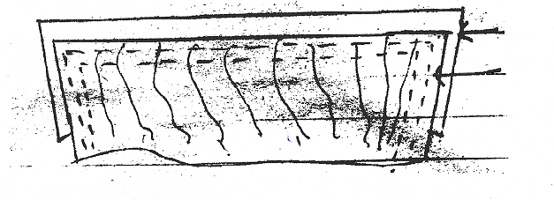
1mark
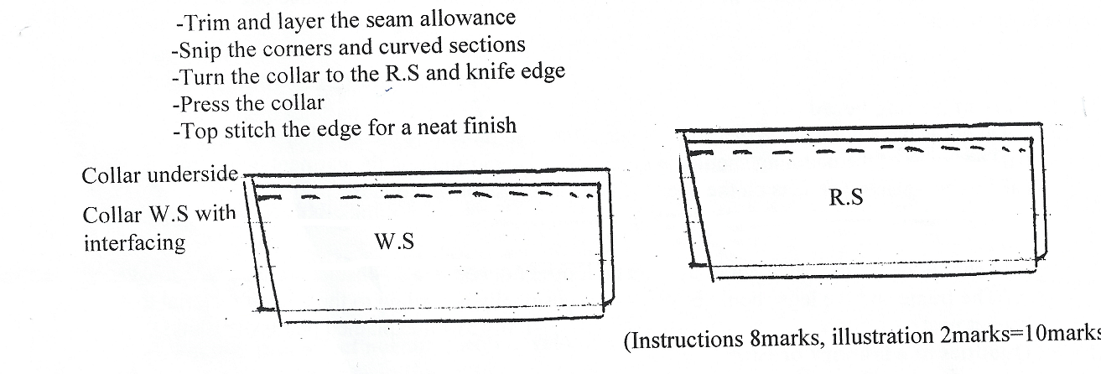
- Trim and layer the sea allowance - 1 mark
- Snip the corners and curved section - 1 mark
- Turn the collar to the R.S and knife edge - 1 mark
- Press the collar - 1 mark
- Top stitch the edge for a neat finish -1 mark
        - W.S – ½ mark
        - R.S – ½ mark

