441/2
HOMESCIENCE
Paper 2
CLOTHING AND TEXTILE

CATHOLIC DIOCESE OF KAKAMEGA EVALUATION TEST
AUG/SEPT EXAM 2022
Kenya Certificate of Secondary Education (K.C.S.E)

HOME SCIENCE
(CLOTHING CONSTRUCTION)
PAPER 2 – PRACTICAL
TIME: 2 ½ HOURS

A pattern of an Apron is provided. You are advised to study the sketches, the question paper
and the layout carefully before you begin the test.

MATERIALS PROVIDED:

1. Pattern pieces.
A Apron skirt
B Bib
C Waistband
D Frill
E Pocket

2. Plain light weight cotton fabric 80cm long by 114cm wide.
3. Sewing thread to match the fabric.

THE TEST:

Using the materials provided, cut out and make the apron to show the following.

- The preparation of the bib.
- The attachment of the bib to the waistband.
- The preparation of the pleats on the frill.
- Attaching the frill onto the skirt using an overlaid seam.
- Starting from the right hand edge, neaten 8cm of the overlaid seam
using loop stitches.
(f) Machine hemming the right hand edge of the skirt.
(g) Preparation of the pocket and attaching it on the skirt of apron.
(h) Working of gathers on the skirt.
(i) Machining the skirt onto the overlap of the waistband.
(j) Holding the under lap onto the skirt using long and short tacking stitches.
Do not hem.
(k) Working of buttonhole.

.

At the end of the examination, firmly sew onto your work, on a single fabric a label
bearing your name and index number. Remove the needle and pins from your work,
then fold your work neatly and place it in the envelope provided. Do not put scraps
of fabric in the envelope.

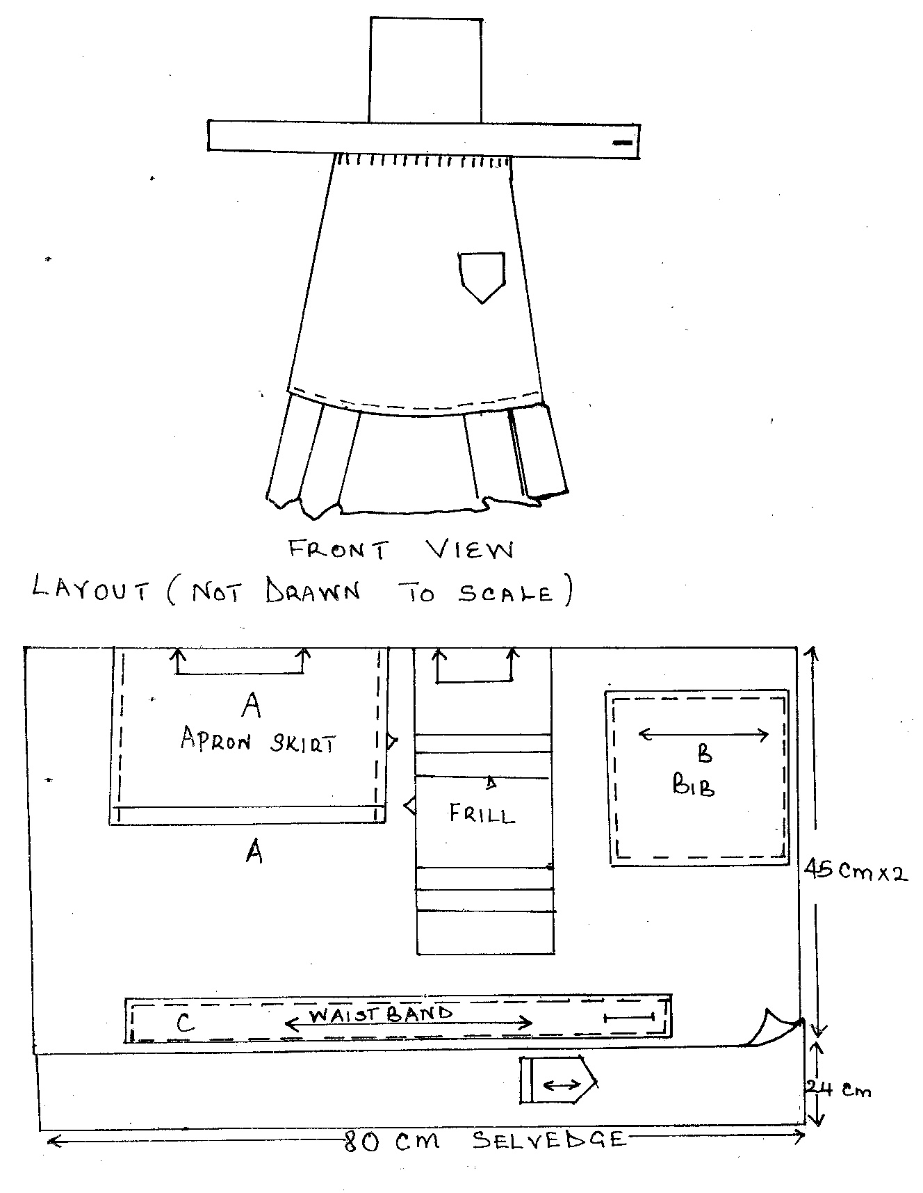

KAKAMEGA DIOCESAN JOINT EXAMINATION

