HOME SCIENCE GRADE FIVE TERM 1 2023
- A person going through puberty is referred to as?
Answer as per the instructions provided.
- Match the picture with the type of nutrients
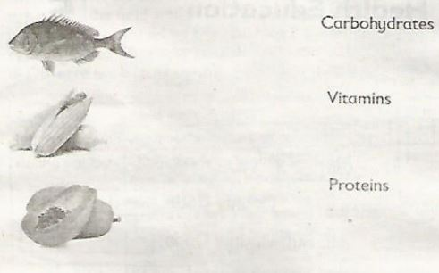
- Leonida was asked by her parents to make a menu for their dinner.
Which was the best menu?
  - Ugali, fish and cabbage
  - Meat, rice and potatoes
  - Chapati, chips and chicken
- State three nutritional deficiency diseases.

- The picture below shows a child suffering from a certain nutritional deficiency disease. Which one is it?_________________________________
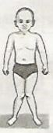
- What is the cause of goitre?____________________________________________
- Name two pulses we get from plants_______________________________________________
- Draw two tools found in the kitchen

- State two improvised cleaning materials_________________________________________________________
- Cleaning kitchen tools made of melamine
Materials needed: melamine plate or cup, warm water, soap, soft cloth or sponge. Follow the right steps to clean your tool of choice.
- Making a menu for dinner.
Make a balanced menu for dinner that can be used at home on a weekend. Use food that have a variety of nutrients.
- Name four good grooming habits.
- You were asked to advice fellow students on physical exercises. State three physical exercises for an adolescent.
- State three importance of physical exercise.
- Fill the table below by naming three examples in each case.
Body building foods | Protective foods
- It's important to wash hands regularly. State three instances when one must wash hands?

