HEALTH EDUCATION - GRADE 7 EXAMS TERM 1 2023

QUESTIONS
- What is health? (1mark)
- What is the meaning of nutrition? (1mark)
- State two activities that can be carried out to observe health either at home or in. school. (2marks)
- Describe what health education is. (1mark)
- Give two examples of plants that are sources of foods. (2marks)
- State four food items we can get from animals. (4marks)
- Outline three common nutrient deficiency diseases. (3marks)
- What causes kwashiorkor? (1mark)
The diagram below shows a health activity. Use it to answer questions 9 and 10.
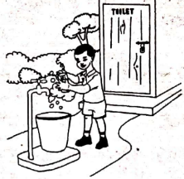
- Which activity is taking place in the picture? (1mark)
- What is the importance of the activity taking place in the above picture? (2marks)
- To which health education related profession would you refer a person with a stomachache? (1mark)
- Outline two health concerns in your community. (2marks)
- Name two measures that can be used to prevent common illnesses in your community? (2marks)
- State the importance of a healthy diet? (1mark)
- Name two types of nutrients. (2marks)
- Name two component of a varied diet?
- Differentiate macronutrients from micronutrients. (2marks)
- What are the sources of macronutrients? (2marks)
Study the pictures below and use them to answers questions 19-21,
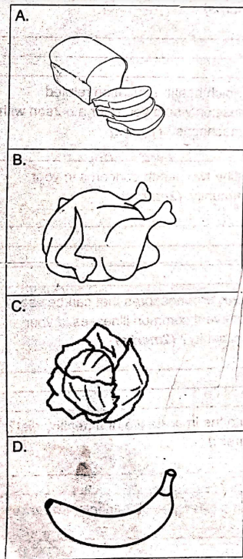
- Identify the food items labeled A, B, C and (2marks)
- Which nutrients do we obtain from each of the foods in the above pictures? (4marks)
- Which of the foods in the pictures provide us with macronutrients? (2marks)
- Outline the importance of health education. (1mark)
- List three career opportunities that need knowledge in health education. (3marks)
- What are the roles of the following career people involved in health;
  - nutritionist (1mark)
  - nurses (1mark)
  - doctors (1mark)
- Which condition is prevented by intake of water and fibre? (1mark)

MARKING SCHEME
- Il refers to the general condition of ones body. It could be physical, mental or social
- is the process of providing or obtaining the food necessary for a healthy growth

  - Eating healthy, well cleaned and properly cooked food
  - Cleaning the environment around school or at home
- It is learning about a habit, interaction and decision related to healthy behavior living and planning for the future
- Maize plant, Banana plant
- Milk, meat, eggs, mutton
- Kwashiorkor, marasmus, rickels, poltre, anaemia
- It is caused by lack of or insufficient intake of proteins
- Washing of hands
- It helps to keep away germs that may cause illness through contamination
- A doctor
- Assess
- Assess
- A healthy diet ensures one has a healthy body to be able to carry out their daily activities
- Micronutrients, Macronutrients
- Carbohydrates, minerals, proteins, vitamins
- Macronutrients are need in large amounts in the body while micronutrients are need in small amount in the body
- Carbohydrates, proteins, fats and oils

  - A-bread
  - B- chicken
  - C- cabbage
  - D. banana

  - A - carbohydrates
  - B - Proteins
  - C - Vitamins
  - D - Minerals and vitamins

  - A - bread
  - B - chicken

  - Chronic disease awareness and prevention
  - Injury and violence prevention
  - Maternal and infant health
  - Mental and behavioral health
  - Nutrition , exercise and obesity prevention
  - Tobacco use and substance abuse
- Nutritionists, Psychologists, Physical education trainer, health commmunity workers, doctors, nurses.

  - provides information on healthy mating habits
  - take care of patients admitted in gospitals mas they undergo treatment
  - Trained for diagnosis and treat diseases.
- Constipation

