Student Name…………………………………………Adm No…………………………………………..
School………………………………………………Class………………………Date……………………

312/2
GEOGRAPY
PAPER 2
TERM ONE 2022
TIME: 2 ¾ Hours
CEKENAS END OF TERM ONE EXAM-2022 FORM FOUR
Kenya Certificate of Secondary Education. (K.C.S.E)

312/2
GEOGRAPY
PAPER 2
TERM ONE 2022

INSTRUCTION

a.) Write your name and index number
b.) Sign and write the date of examination in the space provided above
c.) This paper consists of two section A and B
d.) Answer all section in the section A
e.) Answer question 6 and any other two questions from section B
f.) Answers must be written in the spaces provided the end of question 10
g.) This paper consists of 12 pages
h.) Candidates must check all the Questions to ascertain that all pages are printed as indicated and no question is missing
(i) Candidates should answer all questions in English

SECTION | QUESTION | MAXIMUM SCORE | CANDIDATE SCORE
A | 1-5 | 25
B | 6 | 25
 |  | 25
 |  | 25
 |  | TOTAL SCORE

SECTION A
ANSWER ALL QUESTIONS IN THIS SECTION
1. a) Define the term human geography (2mks)
b.) Give three subdivision of human Geography (3 mks)
2 a.) Name two counties in Kenya in Eastern highlands where tea is grown (2mks)
b.) State three economic problems experienced by small scale tea famers in Kenya (3mks)
3. a) What is mixed farming (2mks)
b.) Give three physical condition that favors wheat cultivation in Kenya (3mks)
4. a) Name the river along which Bunyala swamp is found in Kenya (1mk)
b.) State four physical problem facing irrigation farming in Kenya (4mks)
5. a) What is energy crisis (2mks)
b.) Give three limitations of using solar energy (3mks)
ANSWER QUESTION 6 AND ANY OTHER TWO QUESTIONS FROM THIS SECTION

6.a) The table below shows beef producftion in varies counties in Kenya in metric tonnes(000) between 2018 and 2020. Use it to answer the questions that follows.
County | 2018 | 2019 | 2020
Baringo | 320 | 340 | 340
Marsabit | 360 | 360 | 380
Kajiado | 340 | 320 | 360
Tana river | 380 | 380 | 400

i) Identify the counties that had the highest beef production within the period (1mk)
ii.) Name type of cattle breed reared by pastoralists in Kenya (2mks)
b.i) Using the scale of 1 cm representing 100,000 metric. Draw a comparative bar graph to represent the above data (7mks)
ii.) Explain three measures that have been taken by the government of Kenya to improve beef farming (6mks)
iii.) Outlines three ways in which the market of animals is done by the nomadic pastoralists in Kenya (3mks)
c.) Explain three environmental conditions that favor commercial beef farming in Argentina (6mks)
7.) a) Name two types of placer mining (2mks)
ii.) Describe the processing of gold in South Africa (6mks)
iii.) Give any three uses of gold in South Africa (3mks)
b.) Explain how the following factors influence exploitation of minerals
i.) Value of the mineral (2mks)
ii.) Quality of the ore (2mks)
iii.) Mining method (2mks)
c.) Explain four effects of open cast mining on the environment (8mks)
8. a.i) Distinguish between domestic and international tourism (2mks)
ii.) State three effects of human encroachment in to wildlife habitats (3mks)
b.) Study the map of East Africa provided and use to answer the questions that follows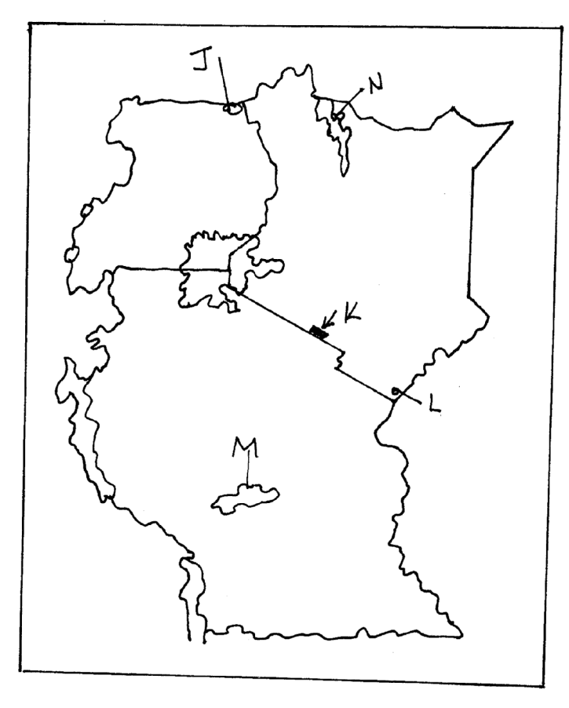
Name
(i) The national parks labeled J,K and N (3mks)
J –
K –
N –
ii) The game reserve named L (1mk)
L –
c.) Give four measures that Kenyans should take in order to attract more tourism (4mks)
d.) Explain four factors why Switzerland receives more tourists than Kenya (8mks)
e. (i.) Students of Narok high school intend to visit Maasai Mara game reserve
(i) Outline two objectives for their study (2mks)

ii) Give any two unique human activities they are likely to come across which is not in national park (2mks)
9. a.i) Define the term fisheries (2mks)

ii.) Give two factors that favors the growth of planktons (2mks)

(b) The map below shows the North-West Atlantic fishing grounds. Study it and answer questions that follow.
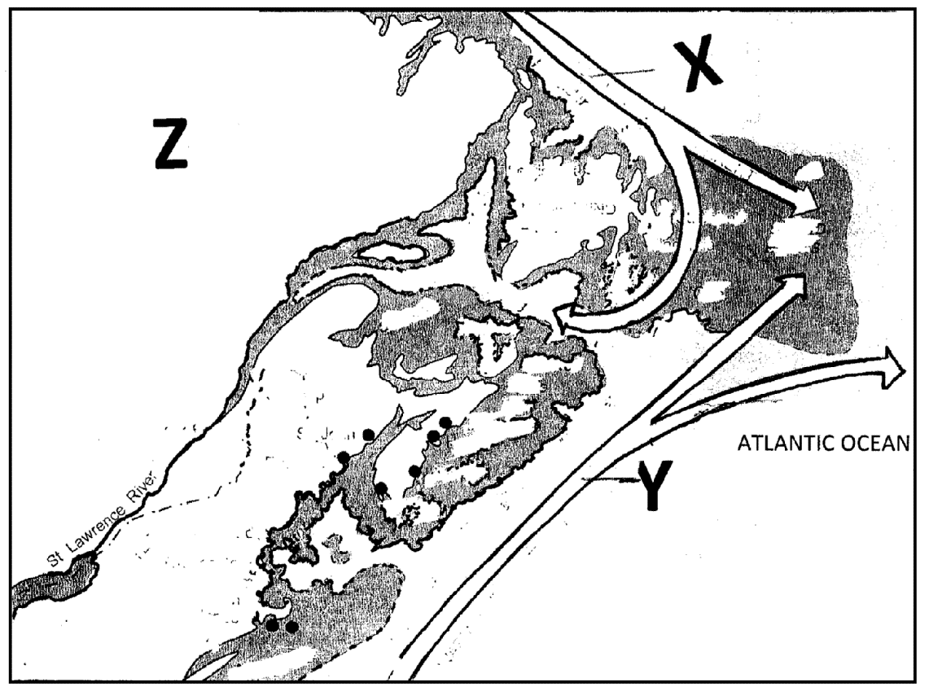
Name ocean current named X and Y (2mks)
X –
Y –
ii) Explain the way in which convergence of ocean current marked X and Y favors fishing in the North – West Atlantic (4mks)

(iii) Name the country marked Z (1mks)
(iv) Name two examples of fish caught in the North-West Atlantic fishing (2mks)

c.) Explain four reason that discouraged East Africa from being a major producer of fish and fish products in the world (8mks)

(d) State four measures that Kenyan Government has undertaken to conserve fisheries (4mks)

10. (a) Differentiate between forestry and forest (2mks)

(i) Give two softwood tree spices which grow in the forest in Kenya (2mks)

(ii) Give characteristics of planted forest in Kenya (3mks)

b.) Compare fishery in Kenya and in Canada under the following subheading
(i) Harvesting of trees (2mks)

(ii) Marketing of trees products (2mks)
c.) Explain four measures taken by Kenyan government to control human encroachment on forested areas (2mks)

d.) The students of Mugoiri girls are planning too carry out a field study in forestry on the slope of Mt. Kenya
(i) Give three reasons why it would be necessary to sample part of the forest for the study (3mks)

(ii) State two ways in which their findings would be useful to the community living near the forest (2mks)

………………………………………………………………………………………………………………………………………………………………………………………………………………………………………………………………………………………………………………………………………………………………………………………………………………………………………………………………………………………………………………………………………………………………………………………………………………………………………………………………………………………………………………………………………………………………………………………………………………………………………………………………………………………………………………………………………………………………………………………………………………………………………………………………………………………………………………………………………………………………………………………………………………………………………………………………………………………………………………………………………………………………………………………………………………………………………………………………………………………………………………………………………………………………………………………………………………………………………………………………………………………………………………………………………………………………………………………………………………………………………………………………………………………………………………………………………………………………………………………………………………………………………………………………………………………………………………………………………………………………………………………………………………………………………………………………………………………………………………………………………………………………………………………………………………………………………………………………………………………………………………………………………………………………………………………………………………………………………………………………………………………………………………………………………………………………………………………………………………………………………………………………………………………………………………………………………………………………………………………………………………………………………………………………………………………………………………………………………………………………………………………………………………………………………………………………………………………………………………………………………………………………………………………………………………………………………………………………………………………………………………………………………………………………………………………………………………………………………………………………………………………………………………………………………………………………………………………………………………………………………………………………………………………………………………………………………………………………………………………………………………………………………………………………………………………………………………………………………………………………………………………………………………………………………………………………………………………………………………………………………………………………………………………………………………………………………………………………………………………………………………………………………………………………………………………………………………………………………………………………………………………………………………………………………………………………………………………………………………………………………………………………………………………………………………………………………………………………………………………………………………………………………………………………………………………………………………………………………………………………………………………………………………………………………………………………………………………………………………………………………………………………………………………………………………………………………………………………………………………………………………………………………………………………………………………………………………………………………………………………………………………………………………………………………………………………………………………………………………………………………………………………………………………………………………………………………………………………………………………………………………………………………………………………………………………………………………………………………………………………………………………………………………………………………………………………………………………………………………………………………………………………………………………………………………………………………………………………………………………………………………………………………………………………………………………………………………………………………………………………………………………………………………………………………………………………………………………………………………………………………………………………………………………………………………………………………………………………………………………………………………………………………………………………………………………………………………………………………………………………………………………………………………………………………………………………………………………………………………………………………………………………………………………………………………………………………………………………………………………………………………………………………………………………………………………………………………………………………………………………………………………………………………………………………………………………………………………………………………………………………………………………………………………………………………………………………………………………………………………………………………………………………………………………………………………………………………………………………………………………………………………………………………………………………………………………………………………………………………………………………………………………………………………………………………………………………………………………………………………………………………………………………………………………………………………………………………………………………………………………………………………………………………………………………………………………………………………………………………………………………………………………………………………………………………………………………………………………………………………………………………………………………………………………………………………………………………………………………………………………………………………………………………………………………………………………………………………………………………………………………………………………………………………………………………………………………………………………………………………………………………………………………………………………………………………………………………………………………………………………………………………………………………………………………………………………………………………………………………………………………………………………………………………………………………………………………………………………………………………………………………………………………………………………………………………………………………………………………………………………………………………………………………………………………………………………………………………………………………………………………………………………………………………………………………………………………………………………………………………………………………………………………………………………………………………………………………………………………………………………………………………………………………………………………………………………………………………………………………………………………………………………………………………………………………………………………………………………………………………………………………………………………………………………………………………………………………………………………………………………………………………………………………………………………………………………………………………………………………………………………………………………………………………………………………………………………………………………………………………………………………………………………………………………………………………………………………………………………………………………………………………………………………………………………………………………………………………………………………………………………………………………………………………………………………………………………………………………………………………………………………………………………………………………………………………………………………………………………………………………………………………………………………………………………………………………………………………………………………………………………………………………………………………………………………………………………………………………………………………………………………………………………………………………………………………………………………………………………………………………………………………………………………………………………………………………………………………………………………………………………………………………………………………………………………………………………………………………………………………………………………………………………………………………………………………………………………………………………………………………………………………………………………………………………………………………………………………………………………………………………………………………………………………………………………………………………………………………………………………………………………………………………………………………………………………………………………………………………………………………………………………………………………………………………………………………………………………………………………………………………………………………………………………………………………………………………………………………………………………………………………………………………………………………………………………………………………………………………………………………………………………………………………………………………………………………………………………………………………………………………………………………………………………………………………………………………………………………………………………………………………………………………………………………………………………………………………………………………………………………………………………………………………………………………………………………………………………………………………………………………………………………………………………………………………………………………………………………………………………………………………………………………………………………………………………………………………………………………………………………………………………………………………………………………………………………………………………………………………………………………………………………………………………………………………………………………………………………………………………………………………………………………………………………………………………………………………………………………………………………………………………………………………………………………………………………………………………………………………………………………………………………………………………………………………………………………………………………………………………………………………………………………………………………………………………………………………………………………………………………………………………………………………………………………………………………………………………………………………………………………………………………………………………………………………………………………………………………………………………………………………………………………………………………………………………………………………………………………………………………………………………………………………………………………………………………………………………………………………………………………………………………………………………………………………………………………………………………………………………………………………………………………………………………………………………………………………………………………………………………………………………………………………………………………………………………………………………………………………………………………………………………………………………………………………………………………………………………………………………………………………………………………………………………………………………………………………………………………………………………………………………………………………………………………………………………………………………………………………………………………………………………………………………………………………………………………………………………………………………………………………………………………………………………………………………………………………………………………………………………………………………………………………………………………………………………………………………………………………………………………………………………………………………………………………………………………………………………………………………………………………………………………………………………………………………………………………………………………………………………………………………………………………………………………………………………………………………………………………………………………………………………………………………………………………………………………………………………………………………………………………………………………………………………………………………………………………………………………………………………………………………………………………………………………………………………………………………………………………………………………………………………………………………………………………………………………………………………………………………………………………………………………………………………………………………………………………………………………………………………………………………………………………………………………………………………………………………………………………………………………………………………………………………………………………………………………………………………………………………………………………………………………………………………………………………………………………………………………………………………………………………………………………………………………………………………………………………………………………………………………………………………………………………………………………………………………………………………………………………………………………………………………………………………………………………………………………………………………………………………………………………………………………………………………………………………………………………………………………………………………………………………………………………………………………………………………………………………………………………………………………………………………………………………………………………………………………………………………………………………………………………………………………………………………………………………………………………………………………………………………………………………………………………………………………………………………………………………………………………………………………………………………………………………………………………………………………………………………………………………………………………………………………………………………………………………………………………………………………………………………………………………………………………………………………………………………………………………………………………………………………………………………………………………………………………………………………………………………………………………………………………………………………………………………………………………………………………………………………………………………………………………………………………………………………………………………………………………………………………………………………………………………………………………………………………………………………………………………………………………………………………………………………………………………………………………………………………………………………………………………………………………………………………………………………………………………………………………………………………………………………………………………………………………………………………………………………………………………………………………………………………………………………………………………………………………………………………………………………………………………………………………………………………………………………………………………………………………………………………………………………………………………………………………………………………………………………………………………………………………………………………………………………………………………………………………………………………………………………………………………………………………………………………………………………………………………………………………………………………………………………………………………………………………………………………………………………………………………………………………………………………………………………………………………………………………………………………………………………………………………………………………………………………………………………………………………………………………………………………………………………………………………………………………………………………………………………
………………………………………………………………………………………………………………………………………………………………………………………………………………………………………………………………………………………………………………………………………………………………………………………………………………………………………………………………………………………………………………………………………………………………………………………………………………………………………………………………………………………………………………………………………………………………………………………………………………………………………………………………………………………………………………………………………………………………………………………………………………………………………………………………………………………………………………………………………………………………………………………………………………………………………………………………………………………………………………………………………………………………………………………………………………………………………………………………………………………………………………………………………………………………………………………………………………………………………………………………………………………………………………………………………………………………………………………………………………………………………………………………………………………………………………………………………………………………………………………………………………………………………………………………………………………………………………………………………………………………………………………………………………………………………………………………………………………………………………………………………………………………………………………………………………………………………………………………………………………………………………………………………………………………………………………………………………………………………………………………………………………………………………………………………………………………………………………………………………………………………………………………………………………………………………………………………………………………………………………………………………………………………………………………………………………………………………………………………………………………………………………………………………………………………………………………………………………………………………………………………………………………………………………………………………………………………………………………………………………………………………………………………………………………………………………………………………………………………………………………………………………………………………………………………………………………………………………………………………………………………………………………………………………………………………………………………………………………………………………………………………………………………………………………………………
………………………………………………………………………………………………………………………………………………………………………………………………………………………………………………………………………………………………………………………………………………………………………………………………………………………………………………………………………………………………………………………………………………………………………………………………………………………………………………………………………………………………………………………………………………………………………………………………………………………………………………………………………………………………………………………………………………………………………………………………………………………………………………………………………………………………………………………………………………………………………………………………………………………………………………………………………………………………………………………………………………………………………………………………………………………………………………………………………………………………………………………………………………………………………………………………………………………………………………………………………………………………………………………………………………………………………………………………………………………………………………………………………………………………………………………………………………………………………………………………………………………………………………………………………………………………………………………………………………………………………………………………………………………………………………………………………………………………………………………………………………………………………………………………………………………………………………………………………………………………………………………………………………………………………………………………………………………………………………………………………………………………………………………………………………………………………………………………………………………………………………………………………………………………………………………………………………………………………………………………………………………………………………………………………………………………………………………………………………………………………………………………………………………………………………………………………………………………………………………………………………………………………………………………………………………………………………………………………………………………………………………………………………………………………………………………………………………………………………………………………………………………………………………………………………………………………………………………………………………………………………………………………………………………………………………………………………………………………………………………………………………………………………………………………………………………………………………………………………………………………………………………………………………………………………………………………………………………………………………………………………………………………………………………………………………………………………………………………………………………………………………………………………………………………………………………………………………………………………………………………………………………………………………………………………………………………………………………………………………………………………………………………………………………………………………………………………………………………………………………………………
THIS IS THE LAST PRINTED PAGE!

