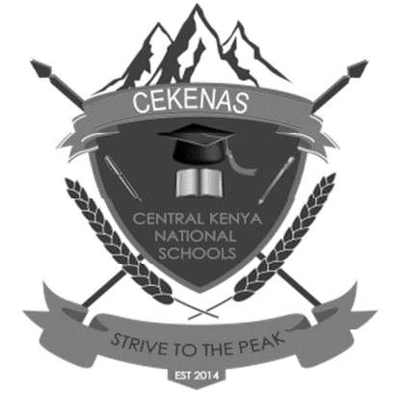
CEKENAS END OF TERM TWO EXAM-2022
FORM FOUR EXAM
Kenya Certificate of Secondary Education. (K.C.S.E)
Geography paper 1
312/1
Confidential

You are provided with a map of Nyeri 1: 50,000 9120/4)

