NAME…………………………………………….………..INDEX NO………….….....................…
SCHOOL………………………………………………..CANDIDATES SIGN…………....................….
DATE…………………......................………
312/1
GEOGRAPHY
PAPER 1
TIME: 2³/₄ HOURS
AUGUST-2022
CEKENAS END OF TERM TWO EXAM-2022
FORM FOUR EXAM
Kenya Certificate of Secondary Education. (K.C.S.E)
Geography paper 1
312/1

INSTRUCTIONS TO CANDIDATES
- Write your name and index number in the spaces provided above
- Sign and write date of examination in the space provided.
- This paper consists of TWO sections A and B
- Answer ALL questions in Section A. In section B answer QUESTION 6 and any other TWO.
- All answers MUST be written in the spaces provided at the end of question 10.
- Answer all questions in English.
For Examiners Use Only
Section | Questions | Maximum Score | Candidates Score
A | 1 – 5 | 25
B | 6 | 25
 |  | 25
 |  | 25
 | TOTAL SCORE | 100

SECTION A (25 MARKS)
1. (a) Give two evidences supporting the Nebula Cloud theory on the origin of the earth. (2marks)
(b) The diagram below represents the revolution of the earth.
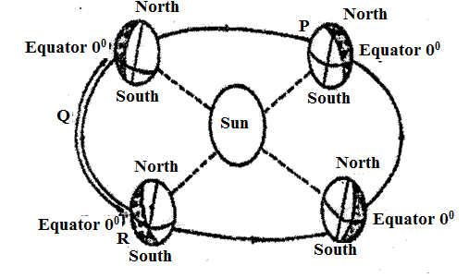
Give three climatic conditions in Europe when the earth is in position R. (3marks)
2. (a) Give two forces that may cause faulting process. (2marks)
(b) Describe how a block mountain is formed through compressional forces. (3 marks)
3. (a) What is natural vegetation? (2 marks)
(b) Identify the temperate grassland in the following countries
- Argentina (1mark)
- South Africa (1 mark)
- Australia (1 mark)
4. (a) Name two types of tides. (2marks)
(b) State three conditions necessary for formation of a beach. (3marks)

5. (a) Study the diagram below and answer the questions that follow.
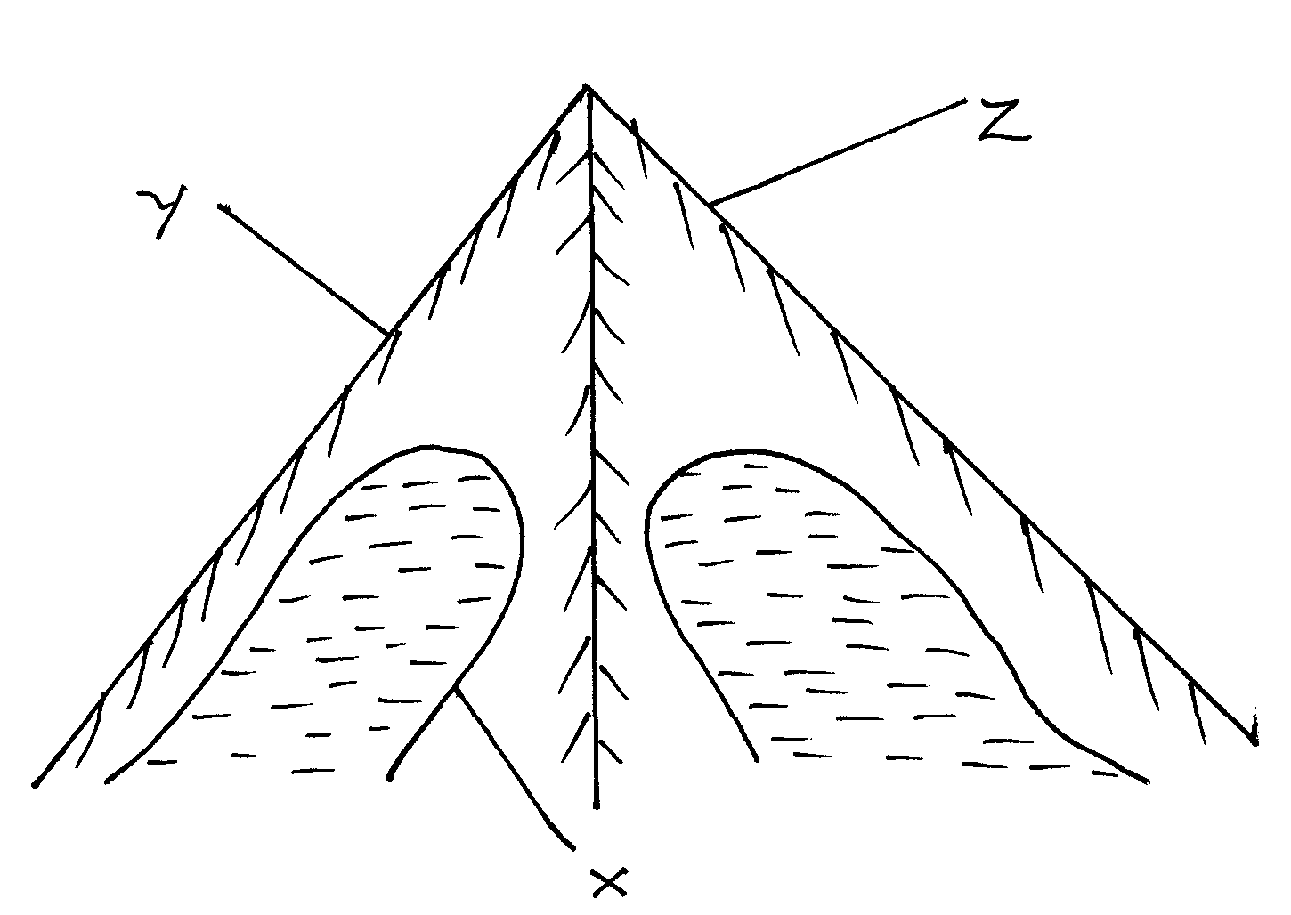
(i) Name the features marked
X (1 Mark)
Y (1 Mark)
Z (1 Mark)
(ii) Identify two processes through which the feature marked X is formed. (2 marks)
SECTION B
Answer question 6 and any other two questions from this section.
6. Study the map of Nyeri 1: 50 000 (sheet 120/4) provided and answer the following questions.
a (i) Identify the sheet number of the map provided (1mark)
(ii) Convert the scale of map into a statement scale. (2marks)
(iii) What is the bearing of the trigonometrical station 1906 in grid square 6860 from the trigonometrical station 1865 in grid square 6957. (2 marks)
b (i) Identify three physical features found in grid square 6259. (2 marks)
(ii) Give the latitudinal extent of the area covered by the map. (2 marks)
(iii) Identify two districts in the area covered by the map. (2 marks)
c (i) Using a scale of 1 cm represents 20m, draw a cross section from Easting 68 to Easting 74 along Northing 64 . (4 marks)
On it mark and name
- A hill top (1mark)
- A stream/river (1 mark)
- All weather road loose surface (1mark)
(ii) Calculate the vertical exaggeration of the cross-section. (2 marks)
d) Citing evidence from the map, identify two social services offered in Mweiga Township. (4 marks)

7. (a) What is climate (2 marks)
(b) (i) Explain two effects of climate change on the physical environment. (4 marks)
(ii) State four characteristics of the hot desert climate. (4 marks)
(c) Using a well-labelled diagram, explain the formation of anabatic winds. (5 marks)
(d) (i) Define micro climate. (2 marks)
(ii) Explain four human activities that can lead to aridity and desertification. (8 marks)

8. (a) Identify two types of earthquake waves. (2 marks)
(b) (i) Describe two ways in which the strength of an earthquake is measured. (4 marks)
(ii) State three human causes of earthquakes. (3 marks)
(c) Explain four effects of earthquakes on physical environment. (8 marks)
(d) Students from Karatina School carried out a field study of an area affected by earthquake.
(i) Identify three effects they noticed on human environment. (3 marks)
(ii) State three advantages of collecting information in the area using photographs? (3 marks)
(iii) Give two problems they are likely to experience (2 marks)

9. a) i) Distinguish between the river system and river interfluves (2 marks)
ii) Give three types of river erosion. (3 marks)
b) i) What is a waterfall? (2 marks)
ii) Give four types of waterfalls. (4 marks)
c) Describe each of the following drainage patterns.
i) Dendritic pattern (4 marks)
ii) Trellis pattern (4 marks)
d) Your class is required to carry out a field study on the lower course of a river.
i) Give three advantages of dividing the class into groups. (3marks)
ii) List three features the students would identify. (3marks)

10. a) i) Define the term ‘leaching’. (2 marks)
(ii) State two factors that contribute to the leaching of soils. (2 marks)
b) (i) Explain how laterization (ferrallization) occur. (6 marks)
(ii) State three types of soils degeneration. (3 marks)
c (i) Explain four ways in which vegetation protects the soils and prevents soil erosion. (8 marks)
(ii) State four advantages of mulching soil using organic matter. (4 marks)
……………………………………………………………………………………………………………….
……………………………………………………………………………………………………………….
……………………………………………………………………………………………………………….
……………………………………………………………………………………………………………….
……………………………………………………………………………………………………………….
……………………………………………………………………………………………………………….
……………………………………………………………………………………………………………….
……………………………………………………………………………………………………………….
……………………………………………………………………………………………………………….
……………………………………………………………………………………………………………….
……………………………………………………………………………………………………………….
……………………………………………………………………………………………………………….
……………………………………………………………………………………………………………….
……………………………………………………………………………………………………………….
……………………………………………………………………………………………………………….
……………………………………………………………………………………………………………….
……………………………………………………………………………………………………………….
……………………………………………………………………………………………………………….
……………………………………………………………………………………………………………….
……………………………………………………………………………………………………………….
……………………………………………………………………………………………………………….
……………………………………………………………………………………………………………….
……………………………………………………………………………………………………………….
……………………………………………………………………………………………………………….
……………………………………………………………………………………………………………….
……………………………………………………………………………………………………………….
……………………………………………………………………………………………………………….
……………………………………………………………………………………………………………….
……………………………………………………………………………………………………………….
……………………………………………………………………………………………………………….
……………………………………………………………………………………………………………….
……………………………………………………………………………………………………………….
……………………………………………………………………………………………………………….
……………………………………………………………………………………………………………….
……………………………………………………………………………………………………………….
……………………………………………………………………………………………………………….
……………………………………………………………………………………………………………….
……………………………………………………………………………………………………………….
……………………………………………………………………………………………………………….
……………………………………………………………………………………………………………….
……………………………………………………………………………………………………………….
……………………………………………………………………………………………………………….
……………………………………………………………………………………………………………….
……………………………………………………………………………………………………………….
……………………………………………………………………………………………………………….
……………………………………………………………………………………………………………….
……………………………………………………………………………………………………………….
……………………………………………………………………………………………………………….
……………………………………………………………………………………………………………….
……………………………………………………………………………………………………………….
……………………………………………………………………………………………………………….
……………………………………………………………………………………………………………….
……………………………………………………………………………………………………………….
……………………………………………………………………………………………………………….
……………………………………………………………………………………………………………….
……………………………………………………………………………………………………………….
……………………………………………………………………………………………………………….
……………………………………………………………………………………………………………….
……………………………………………………………………………………………………………….
……………………………………………………………………………………………………………….
……………………………………………………………………………………………………………….
……………………………………………………………………………………………………………….
……………………………………………………………………………………………………………….
……………………………………………………………………………………………………………….
……………………………………………………………………………………………………………….
……………………………………………………………………………………………………………….
……………………………………………………………………………………………………………….
……………………………………………………………………………………………………………….
……………………………………………………………………………………………………………….
……………………………………………………………………………………………………………….
……………………………………………………………………………………………………………….
……………………………………………………………………………………………………………….
……………………………………………………………………………………………………………….
……………………………………………………………………………………………………………….
……………………………………………………………………………………………………………….
……………………………………………………………………………………………………………….
……………………………………………………………………………………………………………….
……………………………………………………………………………………………………………….
……………………………………………………………………………………………………………….
……………………………………………………………………………………………………………….
……………………………………………………………………………………………………………….
……………………………………………………………………………………………………………….
……………………………………………………………………………………………………………….
……………………………………………………………………………………………………………….
……………………………………………………………………………………………………………….
……………………………………………………………………………………………………………….
……………………………………………………………………………………………………………….
……………………………………………………………………………………………………………….
……………………………………………………………………………………………………………….
……………………………………………………………………………………………………………….
……………………………………………………………………………………………………………….
……………………………………………………………………………………………………………….
……………………………………………………………………………………………………………….
……………………………………………………………………………………………………………….
……………………………………………………………………………………………………………….
……………………………………………………………………………………………………………….
……………………………………………………………………………………………………………….
……………………………………………………………………………………………………………….
……………………………………………………………………………………………………………….
……………………………………………………………………………………………………………….
……………………………………………………………………………………………………………….
……………………………………………………………………………………………………………….
……………………………………………………………………………………………………………….
……………………………………………………………………………………………………………….
……………………………………………………………………………………………………………….
……………………………………………………………………………………………………………….
……………………………………………………………………………………………………………….
……………………………………………………………………………………………………………….
……………………………………………………………………………………………………………….
……………………………………………………………………………………………………………….
……………………………………………………………………………………………………………….
……………………………………………………………………………………………………………….
……………………………………………………………………………………………………………….
……………………………………………………………………………………………………………….
……………………………………………………………………………………………………………….
……………………………………………………………………………………………………………….
……………………………………………………………………………………………………………….
……………………………………………………………………………………………………………….
……………………………………………………………………………………………………………….
……………………………………………………………………………………………………………….
……………………………………………………………………………………………………………….
……………………………………………………………………………………………………………….
……………………………………………………………………………………………………………….
……………………………………………………………………………………………………………….
……………………………………………………………………………………………………………….
……………………………………………………………………………………………………………….
……………………………………………………………………………………………………………….
……………………………………………………………………………………………………………….
……………………………………………………………………………………………………………….
……………………………………………………………………………………………………………….
……………………………………………………………………………………………………………….
……………………………………………………………………………………………………………….
……………………………………………………………………………………………………………….
……………………………………………………………………………………………………………….
……………………………………………………………………………………………………………….
……………………………………………………………………………………………………………….
……………………………………………………………………………………………………………….
……………………………………………………………………………………………………………….
……………………………………………………………………………………………………………….
……………………………………………………………………………………………………………….
……………………………………………………………………………………………………………….
……………………………………………………………………………………………………………….
……………………………………………………………………………………………………………….
……………………………………………………………………………………………………………….
……………………………………………………………………………………………………………….
……………………………………………………………………………………………………………….
……………………………………………………………………………………………………………….
……………………………………………………………………………………………………………….
……………………………………………………………………………………………………………….
……………………………………………………………………………………………………………….
……………………………………………………………………………………………………………….
……………………………………………………………………………………………………………….
……………………………………………………………………………………………………………….
……………………………………………………………………………………………………………….
……………………………………………………………………………………………………………….
……………………………………………………………………………………………………………….
……………………………………………………………………………………………………………….
……………………………………………………………………………………………………………….
……………………………………………………………………………………………………………….
……………………………………………………………………………………………………………….
……………………………………………………………………………………………………………….
……………………………………………………………………………………………………………….
……………………………………………………………………………………………………………….
……………………………………………………………………………………………………………….
……………………………………………………………………………………………………………….
……………………………………………………………………………………………………………….
……………………………………………………………………………………………………………….
……………………………………………………………………………………………………………….
……………………………………………………………………………………………………………….
……………………………………………………………………………………………………………….
……………………………………………………………………………………………………………….
……………………………………………………………………………………………………………….
……………………………………………………………………………………………………………….
……………………………………………………………………………………………………………….
……………………………………………………………………………………………………………….
……………………………………………………………………………………………………………….
……………………………………………………………………………………………………………….
……………………………………………………………………………………………………………….
……………………………………………………………………………………………………………….
……………………………………………………………………………………………………………….
……………………………………………………………………………………………………………….
……………………………………………………………………………………………………………….
……………………………………………………………………………………………………………….
……………………………………………………………………………………………………………….
……………………………………………………………………………………………………………….
……………………………………………………………………………………………………………….
……………………………………………………………………………………………………………….
……………………………………………………………………………………………………………….
……………………………………………………………………………………………………………….
……………………………………………………………………………………………………………….
……………………………………………………………………………………………………………….
……………………………………………………………………………………………………………….
……………………………………………………………………………………………………………….
……………………………………………………………………………………………………………….
……………………………………………………………………………………………………………….
……………………………………………………………………………………………………………….
……………………………………………………………………………………………………………….
……………………………………………………………………………………………………………….
……………………………………………………………………………………………………………….
……………………………………………………………………………………………………………….
……………………………………………………………………………………………………………….
……………………………………………………………………………………………………………….
……………………………………………………………………………………………………………….
……………………………………………………………………………………………………………….
……………………………………………………………………………………………………………….
……………………………………………………………………………………………………………….
……………………………………………………………………………………………………………….
……………………………………………………………………………………………………………….
……………………………………………………………………………………………………………….
……………………………………………………………………………………………………………….
……………………………………………………………………………………………………………….
……………………………………………………………………………………………………………….
……………………………………………………………………………………………………………….
……………………………………………………………………………………………………………….
……………………………………………………………………………………………………………….
……………………………………………………………………………………………………………….
……………………………………………………………………………………………………………….
……………………………………………………………………………………………………………….
……………………………………………………………………………………………………………….
……………………………………………………………………………………………………………….
……………………………………………………………………………………………………………….
……………………………………………………………………………………………………………….
……………………………………………………………………………………………………………….
……………………………………………………………………………………………………………….
……………………………………………………………………………………………………………….
……………………………………………………………………………………………………………….
……………………………………………………………………………………………………………….
……………………………………………………………………………………………………………….
……………………………………………………………………………………………………………….
……………………………………………………………………………………………………………….
……………………………………………………………………………………………………………….
……………………………………………………………………………………………………………….
……………………………………………………………………………………………………………….
……………………………………………………………………………………………………………….
……………………………………………………………………………………………………………….
……………………………………………………………………………………………………………….
……………………………………………………………………………………………………………….
……………………………………………………………………………………………………………….
……………………………………………………………………………………………………………….
……………………………………………………………………………………………………………….
……………………………………………………………………………………………………………….
……………………………………………………………………………………………………………….
……………………………………………………………………………………………………………….
……………………………………………………………………………………………………………….
……………………………………………………………………………………………………………….
……………………………………………………………………………………………………………….
……………………………………………………………………………………………………………….
……………………………………………………………………………………………………………….
……………………………………………………………………………………………………………….
……………………………………………………………………………………………………………….
……………………………………………………………………………………………………………….
……………………………………………………………………………………………………………….
……………………………………………………………………………………………………………….
……………………………………………………………………………………………………………….
……………………………………………………………………………………………………………….
……………………………………………………………………………………………………………….
……………………………………………………………………………………………………………….
……………………………………………………………………………………………………………….
……………………………………………………………………………………………………………….
……………………………………………………………………………………………………………….
……………………………………………………………………………………………………………….
……………………………………………………………………………………………………………….
……………………………………………………………………………………………………………….
……………………………………………………………………………………………………………….
……………………………………………………………………………………………………………….
……………………………………………………………………………………………………………….
……………………………………………………………………………………………………………….
……………………………………………………………………………………………………………….
……………………………………………………………………………………………………………….
THIS IS THE LAST PRINTED PAGE!

