CEKENAS END OF TERM TWO EXAM-2022
FORM FOUR EXAM
Kenya Certificate of Secondary Education. (K.C.S.E)
Geography paper 1
312/1
MARKING SCHEME
- (a)Give two evidences supporting the Nebula Cloud theory on the origin of the earth.
  - All planets undergo rotation and revolution.
  - Temperatures of the planets increases with the increase in depth.
  - - Material making up the Nebula were hot hence planets nearer the centre of the solar system have higher temperature than those far away. (2x1 = 2mks)
- The diagram below represents the revolution of the earth.
- 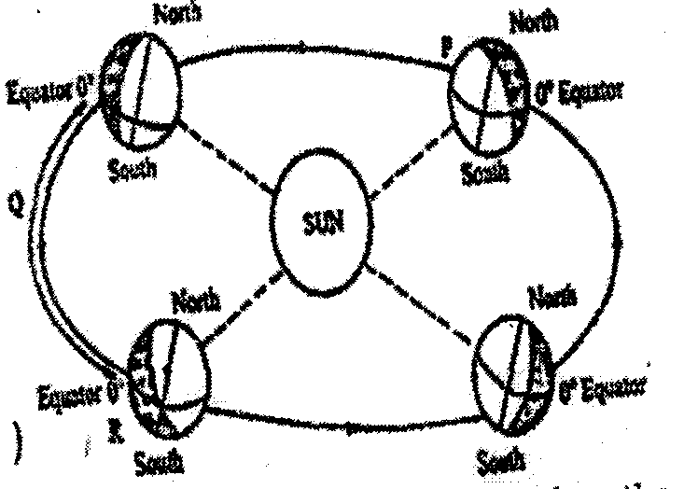
(i) Give three climatic conditions in Europe when the earth is in position A.
- High temperatures
- High rainfall
- Convergence of winds
- Low atmospheric pressure
- High humidity
- It is cloudy (3x1 = 3mks)
- (a) Give two forces that may cause faulting process.
- Tensional forces
- Compressional forces
- Vertical forces (2x1 = 2mks)
(b) Describe how a block mountain is formed through compressional forces.
- Earth crustal rock are subjected to compressional forces developing reversed faults.
- Continued subjection to compressional forces on crustal rocks triggers off vertical forces.
- Vertical forces pushes the middle block up at higher level while the side block remains at the original positions.
- The raised middle block that is above the surrounding sides blocks forms block mountains.
(3x1 = 3mks)
- (a) What is natural vegetation?
- It is the plant cover that grows wildly on the earth’s surface without interference from man and his animals. (2x1 = 2mks)
(b) Identify the temperature grassland in the following countries
- Argentina - Pampas
- South Africa - Veldts
- Australia – Downs
(3x1 = 3mk)
- (a) Name two types of tides.
- Spring tides
- Neap tides
- Apogean tides
- Perigean tides
(2x1 = 2mks)
(b) State three conditions necessary for formation of a beach.
- Presence of abundant supply of material to be deposited.
- Presence of a shallow shore/ continental shelf
- A relatively weak long shore current
- Gently sloping land at the sea shore
- A weak backwash/ constructive wave.
(3x1 = 3mks)
- (a) Study the diagram below and answer the questions that follow.
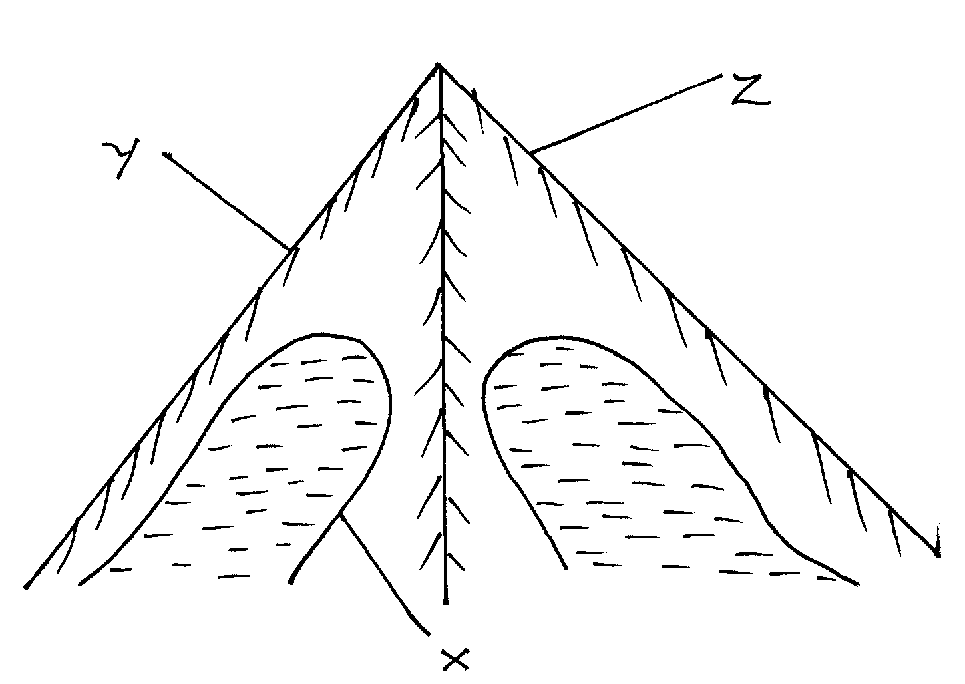
- Name the features marked
X – Corrie/ cirque (1 Mark)
Y - Arete (1 Mark)
Z – Pyramidal peak (1 Mark)
- Identify two processes through which the feature marked X is formed.
- Abrasion
- Plucking
(2x1 = 2mks)
SECTION B
Answer question 6 and any other two questions from this section.
- Study the map of Nyeri 1: 50 000 (sheet 120/4) provided and answer the following questions.
- (i) Identify the sheet number of the map provided (1mk)
- 120/4
(ii) Convert the scale of map into a statement scale. (2mks)
Therefore 1 cm rep 0.5km or 1 cm rep
- What is the bearing of the trigonometrical station 1906 in grid square 6860 from the trigonometrical station 1865 in grid square 6957. (2 marks)
or N22W
- (i) Identify two physical features found in grid square 6259. (2mks)
- Stream/river
- River/valley
- Scrub vegetation
- Woodland vegetation
(ii) Give the latitudinal extent of the area covered by the map. (2mks)
Latitudinal extent =
(iii) Identify two districts in the area covered by the map. (2mks)
- Nyeri district
- Laikipia district
- (i)Using a scale of 1 cm represents 20m, draw a cross section from Easting 68 to Easting 74 along Northing 64. (4mks)
On it mark and name
- A hill top (1mk)
- A stream/river (1mk)
- All weather road loose surface (1mk)
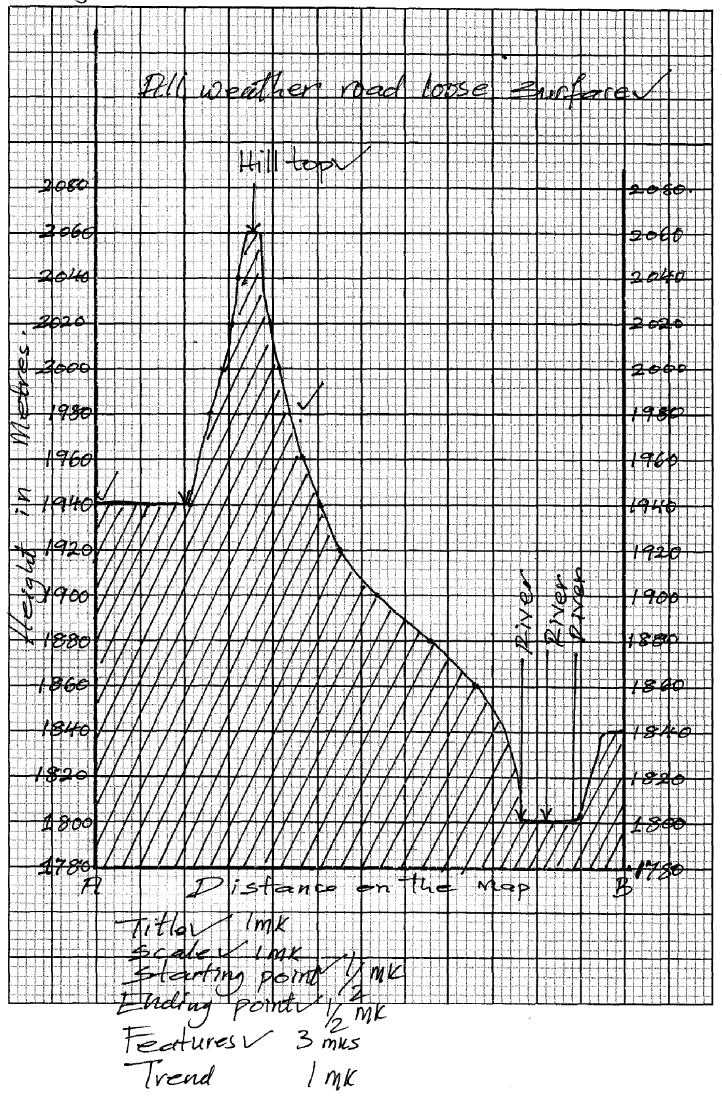
(ii) Calculate the vertical exaggeration of the cross-section. (2mks)
(d) Citing evidence from the map identify two social services offered in Mweiga township.
- Recreation services as evidenced by presence of youth club
- Education as evidenced by presence of school
- Medical/ Health as evidenced by presence of dispensary
- Administration as evidence by the chief’s office
- Security as evidenced by presence of police station.
(2x2 = 4mks)
- (a) What is climate
- Climate is the average weather conditions of a place over a long period of time.
(2x1 = 2mks)
(b) (i) Explain two effects of climate change on the physical environment.
  - Global warming and increase in temperatures.
  - Increased temperature may lead to melting of ice caps and ice sheets leading to rising sea level.
  - Increase in temperatures may result to high evaporation leading to drought.
  - May cause changes in rainfall patterns in different parts of the world.
(2x2 = 4mks)
(ii) State four characteristics of the hot dessert climate.
  - High temperatures during the day and low temperatures during the night due to high terrestrial radiation.
  - High diurnal range of temperature
  - Clear and cloudless skies
  - Receives less than 250mm of rainfall annually
  - Receive short and torrential rains which cause flash floods
  - Humidity is low and evaporation rate is high
  - Sandstorms are very common
  - High wind velocity due to the frictional force.
(4x1 = 4mks)
- Using a well-labelled diagram, explain the formation of anabatic winds.
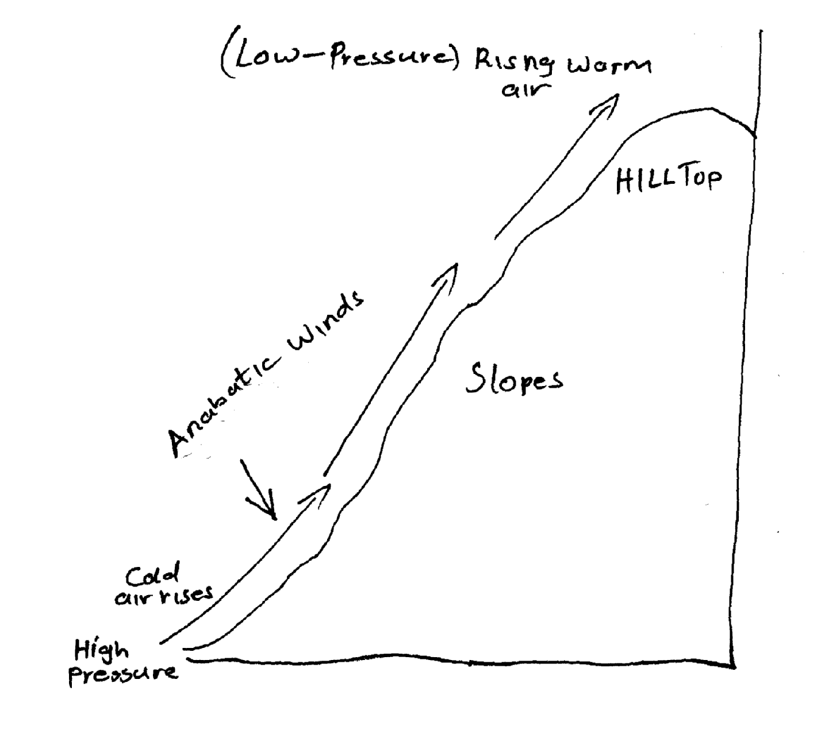
- During the day, mountain slopes are heated and warm faster than in the valley bottoms.
- Low pressure develops on mountain slopes than at the valley bottoms
- The air on the mountain slopes expands and rises by convection.
- The cool air from the valley bottom rises as anabatic wind to take its place
(5x1 = 5mks)
(d) (i) Define micro climate.
- Climate experienced within a small or restricted area which is different from general climate in the region.
(1x2= 2mks)
(ii) Explain four human activities that can lead to aridity and desertification.
- Clearing of vegetation for settlement and agriculture interfering with the water cycle causing drying up.
- Overstocking that leads to overgrazing leaving the land bear exposing to soil erosion.
- Poor agricultural practices such as over- cultivating, monoculture, slashing and burning leading to soil erosion.
- Poor irrigation methods leading to evaporation and salts brought from below to the surface and deposited on the top soil making soils salty and unable to support plants.
- Industrial release of greenhouse gasses like CO₂ to the atmosphere which absorb heat rising earth’s temperatures.
(4x2 = 8mks)
8. (a) Identify the types of earthquake waves.
- Primary waves
- Secondary waves
- Longitudinal waves/L waves
(1x2 = 2mks)
(b) (i) Describe two ways in which the strength of an earthquake is measured.
- The strength of an earthquake is measured by its intensity.
- Intensity measures how strong and hard an earthquake shakes the ground
- It is measured on the Mercalli scale or Rossi Farrell scale
- The strength is measured by its magnitude
- Magnitude measures the amount of energy released by an earthquake.
- It is measured on the Ritcher scale
(2x2 = 4mks)
(ii) Human causes
- Use of explosives
- Underground nuclear tests
- Construction of large reservoirs
- Movement of trains
(3x1 = 3mks)
(c) Explain four effects of earthquakes on physical environment.
- It causes landslides/slumps
- It causes raising or lowering of land
- It causes faulting of the crust
- It causes lateral or vertical displacement of rocks
- It causes rising and lowering of the sea level.
(4x2 = 8mks)
(d) Students from Karatina School carried out a field study of an area affected by earthquake.
(i) Identify three effects they noticed on human environment.
- Cracks in buildings
- Landslides covering crops etc.
- Collapse of weak buildings
- Panic and fear amongst people
- Death and destruction of properties due to falling objects
(3x1 = 3mks)
(ii) What are the advantages of collecting information in the area using photographs?
- They are easy to take
- Cheap to produce
- Can be stored for future references
- Easy to extract information of well-labelled
- Features portrayed are realistic
(3x1 = 3mks)
(iii) Give two problems that they are likely to experience
- Inaccessibility of the area due to massive destruction
- The rubble may obscure the evidence
- Lack of informers because people may have evacuated
(3x1 = 3mks)
9. a) i) Distinguish between the river system and river interfluves
- River system is the main river and its tributaries while river interfluves is the high areas in between the tributaries.
(1x2 = 2mks)
ii) Give three types of river erosion.
- Head ward erosion
- Vertical erosion
- Lateral erosion
(3x1 = 3mks)
b) i) What is a waterfall?
- A waterfall is the sharp break in the river channel over which the river falls
(1x2 = 2mks)
ii) Give four types of waterfalls.
- Waterfalls formed where a river channel passes over underlying hard rock
- Waterfall formed where there is vertical hard work along the river channel.
- Waterfall formed where the river course flows over a fault scarp.
- Waterfall formed where a river enters a coastal plain from a plateau
- Waterfall as a result of river rejuvenation
- Waterfall formed where a river channel flows over underlying volcanic dykes, lava dorms or plugs
- Waterfall formed where a river enters the sea through a cliff.
- Waterfall formed in a glaciated upland where a river flows from a hanging valley and plunges into a u-shaped valley.
Any (4x1 = 4mks)
c) Describe each of the following drainage patterns.
i) Dendritic pattern
- The pattern develops in areas where rocks have uniform structure.
- The direction of flow is influenced by the slope of the land
- The tributaries join the main river at acute angles.
- The tributaries join the main river forming a shape like that of a tree and its branches.
- Rivers join the main river from many directions.
Any (4x1 = 4mks)
ii) Trellis pattern
- The pattern develops where soft and hard rocks alternate vertically.
- The tributaries join the main river at right angles.
- The consequent streams are parallel to the main river.
- Some consequent streams flow to the opposite direction of the main river.
- The main river and its tributaries form a rectilinear pattern.
Any (4x1 = 4mks)
d) Your class is required to carry out a field study on the lower course of a river.
i) Give three advantages of dividing the class into groups.
- The class would be able to study the entire course of the river.
- It will enable them to obtain detailed information on the river.
- It will enable the field study to be carried in an orderly way.
- It will encourage participation of all the members of the class
- It will facilitate more interaction among the group members.
Any (3x1 = 3mks)
ii) List three features the students would identify.
- Alluvial fan
- Meanders
- Oxbow lakes
- Natural levees
- Deferred tributaries
- Braided channels
- Flood plains
- Delta
- Distributaries
Any (4x1 = 4mks)
10. a) i) Define the term ‘leaching’.
- It is the removal by rainwater on soluble mineral matter in solution from the upper horizon or the soils (horizon A) to the lower horizons of the soils.
(1x2 = 2mks)
(ii) State two factors that contribute to the leaching of soils.
- Nature of the soils especially its texture and solubility or its minerals
- High rainfall in the rain season alternating with a dry season
- Topography
Any (2x1 = 2mks)
b) (i) Explain how laterization (ferrallization) occur. (6mks)
- It occurs in areas which experience alternating wet and dry seasons especially the warm hot humid tropical regions.
- During the wet season mineral salts in the A- horizon dissolve in percolating rain water.
- The dissolved minerals percolate from A – horizon downwards i.e. leached out.
- The soil solution also cause removal or silica in a process called desilication.
- The dissolved minerals are deposited in the lower layer in a process known as precipitation.
- Insoluble minerals such as iron and aluminum oxides accumulate in A – horizon to form a crust known as laterite.
- -There is rapid circulation or bases between the soil and the vegetation because or abundance of leaf litter and its rapid decay.
(ii) State three types of soils degeneration.
- Physical degeneration
- Chemical degeneration
- Biological degeneration
(3x1 = 3mks)
c (i) Explain four ways in which vegetation protects the soils and prevents soil erosion.
- The leaf cover helps to reduce the force or rain drops which would otherwise loosen and remove soil particles if their force was not checked.
- vegetation cover increases the rate or infiltration or rainwater and thus reduces surface run-off
- Plant roots which penetrate the soil create space through which water percolates deep into the ground.
- A wide – spreading and deeply penetrating root system is very effective in binding the soil particles together.
- Plant cover breaks the force of wind at ground and reduces evaporation which would otherwise dry and loosen the soil.
- Decayed vegetable matter provides humus which binds the soil particles together.
Any (4x2 = 8mks)
(ii) State four advantages of mulching soil using organic matter.
- It reduces the rate of evaporation of water from the soil
- It protects the soil from erosion
- It increases the humus content of the soil when they disintegrate
- Increases the rate of infiltration of water into the soil
- The mulch provide suitable habitat for borrowing animals which churn the soil and improve its texture and capacity.
Any (4x1 = 4mks)

