GEOGRAPHY PP2 MARKING SCHEME

1. Name three patterns of human settlements
- Dispersed
- Nucleared
- Linear
2. i) List any two products from Jua kali industry in Kenya exported to other countries. (2mks)
- Jikos
- Ciondos
- Wheel barrows
- Basket / mats
ii) Name two renewable sources of energy used in Kenyan industries .
- Wind
- Wood
- Solar
- Geothermal / underground steam
3. a) Name three surfaces that are reclaimed in Kenya
- Deserts
- Swamps
- Tsetse infested valleys
- Flood prone plains
b) Identify the method of reclamation used in each surface mentioned in 3.(a) (3mks)
- Deserts irrigation
- Swamps – Draining
- Tsetse – Chemical / Biological
- Floods- Earth dams
- Drainage ditch
- Dykes
4. Explain how the following practices help in soil conservation
i) Mulching
- Protects the soil from erosion
- Reduces evaporation
- Adds humus
- Increases micro organism
ii) Terracing – Reduces erosion (2mks)
- Allows water rentention and inflitration ( more moisture)
5. a) Describe how deep shaft mining takes place.
- Shaft dug / hole dug to reach the ore
- Horizontal tunnels penetrate the ore areas
- Props support the tunnels roof
- Laying the light railway for transportation of ore
- Explosives blast / digging out of the ore
- Ore is brought to the base of the shaft and loaded into cages
- The lift system left the ore to the surface for processing.
b) Name three products from an oil refinery other than petrol.
- Asphalt/ Tar
- Grease
- Gas
- Kerosene

SECTION B
6. A divided circle showing milk yield in Denmark per cow in kg (1mk)
= Total yield(kg) = 5243 +6693 +7398 +7610 +7792 +7946 =42,682=360⁰
(Each calculate ½ mk)
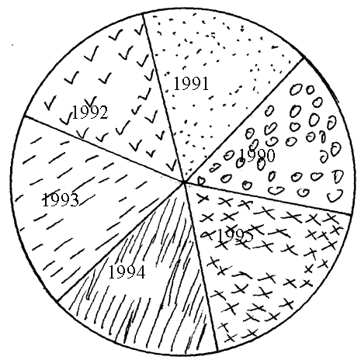 -Each segment well done ½ mk
-Title 1mk
-Key (or impleed)1mk
(ii) Two advantages of using a divided circle
- Attractive / good visual impression
- Good for comparison
- Easy to read / Interprete
- Easy to draw / construct
(iii) Two other methods other than a divided circle
- Simple bar graph
- Divided rectangle
(b) (i) Factors favouring dairy farming in Denmark
- The low lying and relatively flat landscape makes it ideal for dairy farming
.The average height of the land is about 30M above sea level.
- The average monthly temperature in Denmark is about 7-9ºc.The warm
sunny summers are suitable for out door grazing.
- The soil, derived from boulder clay are fertile for growth of pasture.
- High rainfall of 500 -1500 MM p.a suitable for livestock and pasture
provides also water for livestock. (Any 3x2=6mks)
(ii) Problems facing dairy farmers in Kenya
- Insufficient feeds
- Poor management of dairy co-operative societies
- High cost of production. Especially cattle feeds, drugs and veterinary
services.
- Poor infrastructure
- Shortage of proper milk storage facilities
- Attack by pests and diseases eg ECF. Ticks.
- Inadequate / veterinary services
- Inadequate veterinary training to fairly farmers
- Collapse of the diseases control system ie cattle dips in most parts of
Kenya. (Any 3x1=3mks)
(c) Why beef farming is more developed in Argentina than in Kenya.
- Enough pasture and adequate water for livestock in Argentina due to moderate
rainfall of 1000MM than in Kenya.
- Moderate temperature of 24⁰C during summers and above 10⁰C in winter ensures
continuous growth of pasture Argentina than in Kenya.
- Fertile soils give rise to healthy natural pastures for livestock in Agentina than in
Kenya.
- High quality exotic cattle breeds from Europe.
- Well developed infrastructures eg railway network for beef transportation.
- Large scale ranches which are well managed and mechanized.
- Availability of adequate capital
- Availability of both local and foreign markets. (Any 2x2=4mks)

7 (a) (i) Forms of which minerals occurs
- Veins and lodes
- Beds and seams
- Weathering products
- Alluvial / placer deposits
(ii) Three places where limestone is mined in Kenya
- Bamburi
- Athi River
- Sultan Hamud
- Homa bay
- Koru
- Kerio –valley
- Kariandusi
(b) Factors explained
(i) Market
- Ready market will lead to mining of a mineral
- Uncertain market reduces / minimizes mining
(ii) The quality of ore
- Higher the grade / ores are economical to extract as they yield a large
amount income.
- Low quality ores are rarely extracted as their metal content is very low.
- Important minerals eg uranium are mined despite their low quality.
(iii) Technology
- Exploitation of any mineral depends on the level of development of a
country since it requires advanced technology.
(c) (i) Two provinces in south Africa where gold is mined.
- Orange Free State
- Lyden bury
- Witwatersland
- Ogendaolvos
(ii) Three problems facing gold mining in south Africa (explaining)
- Deepening of mines of gold bearing rocks which lie deeply underground
hence experiencing to mine
- Low Gold content in the ore because of exhaustion
- Poor quality of the ore as the mines get deeper
- Labour shortage is due to competition of labour from other sectors and the
increasing demands by laborers like wages married staff quarters.
- Inadequate water supply on the surface areas as gold requires large amounts
of water for purification.
- Exhaustion of mines eg the old rand mines. (3x2=6mks)
(d) Description of diamond processing in S.Africa
(i) There is blasting o frocks ore from the underground
(ii) The rock is then crushed into small pieces
(iii) It is then washed using water to remove dirt
(iv) The remaining rock pieces that contain diamonds is passed over a rotating table
that is covered with grease.
(v) Water is then passed over the rotating table to remove the dirt and unwanted rock
material.
(vi) Diamond is then removed
(viii) The process is replaced several times (6mks)
Sequence must be followed

8 (a) (i) Two sources of non-renewable sources of energy.
- Coal
- Nuclear energy
- Natural gas
(1×2 = 2mks)
(ii) Advantages of solar Energy.
- It’s free
- Found anywhere
- Its renewable
- It’s clean
(1×3=3 mks)
(b) Four problems involved in mineral exploitation in keya.
- Local communities are rarely involved hence tend to oppose mining.
- Compensation of the displaced is very expensive and not transparent.
- The local community hardly want to move from their ancestral lands.
- Some areas of mineral potential are unlinked – roads, rail to other parts of the country / poor transport / roads.
- Scarcity of capital for Government to invest in mineral prospecting.
- Minerals are of relatively small quantities to qualify mining hence fetch little capital
- Most minerals are of low value hence fetch low prices.
(2 ×4 = 8 mks)
(c) Effects of over-reliance on oil as a source of energy.
- A lot of foreign exchange reserve is used in oil importation. This affects other sectors of the economy.
- When prices of oil increase, non-oil producing states, economy is affected.
- May lead to increase of prices of goods resulting from inflation.
- May affect agricultural production resulting to scarcity of food / raw materials.
- May result to increase of fares that is passed on to passengers.
(2×4=8 mks)
(f) Four methods Government uses to conserve her energy resources.
- Power rationing / water rationing
- Afforestation / Reforestation programmes
- Encouraging passengers to use public transport as much as possible.
- Encouraging people to use renewable forms of energy e.g. biogas, HEP, wind other than oil.
- Use of more efficient energy saving devices to reduce the amount of oil/energy used.
- By smoothening road surfaces to avoid delays that may lead to more use of fuel.

9 a) i) Define the term forestry. (1 mark)
i) It is the science of developing and managing forest or
ii) It is the practice of managing and using trees, forests and their associated resources for human benefits or
- It is the art of planting, tending, managing and extracting forest products.
2 marks
ii) Give three differences between natural forest and planted forests.(3marks)
- Natural forests comprise of indigenious trees while planted forests are mainly composed of exotic trees
- Trees in natural forests are of mixed species while in planted forests trees are of one species
- Trees in natural forests grow haphazardly while in man-made forest trees are planted in rows
- Forests of the natural type spread from lowland to highland while planted forests are found in the highlands
- Thick undergrowth in natural forests but less undergrowth in planted forests
- Natural forest have canopy while man-made has none
- Natural forests have trees that yield hardwood while in planted forests trees yield softwoods
Any 3 x 1 mark=3 marks

b) Explain FOUR causes of forest depletion in Kenya today.(8 marks)
i) Fire outbreaks like the one that happened on Mount Kenya recently destroy large tracts of forests
ii) Pests and diseases also kill trees leading to forest depletion
iii) Population explosion has raised demand for wood which has resulted into overexploitation of the forests
- Forest encroachment by man has reduced area under forests
- Industrialization –setting up of industries that use timber as their raw materials has
led to deforestation
- Adverse climatic conditions e.g prolonged drought make trees to die
- Illegal felling of trees hence their depletion
Any 4 x 2 mark=8 marks

c) i) From the map below, give the names of the forests marked A, B ad C
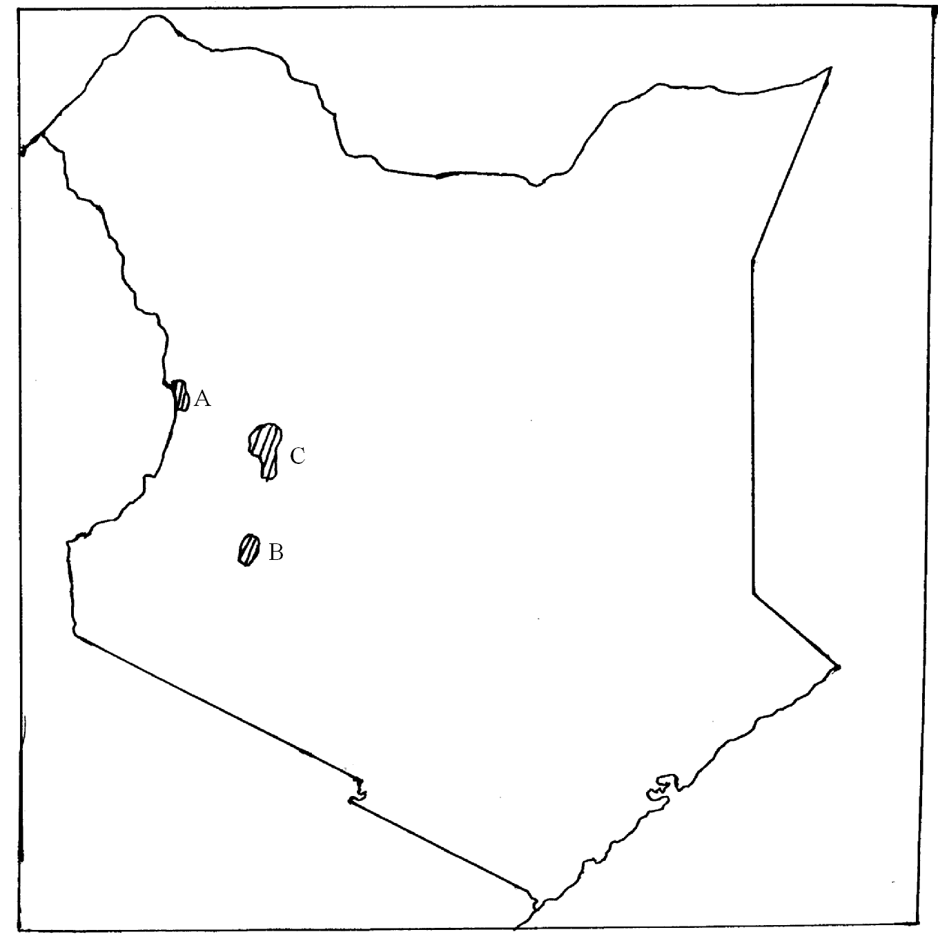
A – Mt. Elgon forest
B - Kakamega forest
C – Cherangani hills forest
Any 3 x 1 mark=3 marks

ii) State FOUR measures that are being undertaken by the Kenya Government to conserve forests. (4 marks)
- Enforcing afforestation and re-aforestation programs
- Involving the local communities in forest conservation
- Scientific management of trees e.g spraying against diseases and pests, pruning, thinning, carrying out research
- Creating awareness through education about the need to conserve forests
- Creation of buffer zones to eradicate forest encroachment
- Increasing forest guards to reduce illegal felling of trees
- Imposing stiff penalties through legislation on illegal loggers
- Use of alternative sources of energy particularly the renewable like solar, electricity to reduce reliance on forest for energy.
- Perimeter fencing of National parks to stop wild animals invading forests
- Reduction of wastage e.g use of economic jikos
Any 4 x 1 mark=4 marks
d) Explain THREE factors favouring the exploitation of softwoods in Canada. (6marks)
i) The many rivers in Canada provide adequate hydro-electric power for the pulp and prayer as well as other related industries
ii) The mild winters with ice-free waters in British Columbia make it possible to transport logs all year round using rivers
iii) The many rivers provide plenty of water needed in pulp and paper industries
- Excellent transport system ensures fast ferrying of logs to the factories and the finished products to the market
- High domestic as well as international market enhances continuous exploitation
- Proximity of adequate capital necessary in forest management as well as establishment of related industries.

