MARANDA HIGH SCHOOL
Kenya Certificate of Secondary Education
MOCK EXAMINATIONS 2022

GEOGRAPHY 312/2
AUGUST 2022 – TIME: 2 ¾Hours
MARKING SCHEME

- (a) Define economic geography
Deals with the location and distribution of natural resources, their uses, exploitation and problems encountered in their use
(1×2)
(b) State three reasons why it is important to study human geography
- Acquire awareness on the management and conservation of the environment and the need to use resources sustainably.
- Geography enhances national unity.
- Geography is a career subject i.e. it is a prerequisite requirement for admission in certain courses such as geology, engineering, surveying, remote sensing, meteorology and teaching hence improving people’s living standards
- Geography enhances international awareness, interactions, and co-operation and teaches interdependence among people.
- Helps learners acquire positive attitudes and values which enable them to become useful members of the society thus a tool for better citizenship.
- Learn and understand about location, features and characteristics of both the physical and human environments on earth. (3×1)

2. (a) Name two towns where motor vehicle assembly plants are located in Kenya
- Mombasa
- Thika
- Nairobi (2×1)
(b) State three ways in which proximity to Nairobi has favoured development of Thika Town
- Nairobi provides some inputs required by the industries in Thika
- Nairobi provides a ready/large market for the manufactured goods from Thika
- The short rail and road connection between Nairobi and Thika provided cheaper movement of goods and services for the industries in Thika.
- There is industrial interdepent among the industries in Nairobi and Thika
3. (a) The diagram below represents the functional zones of an urban center.
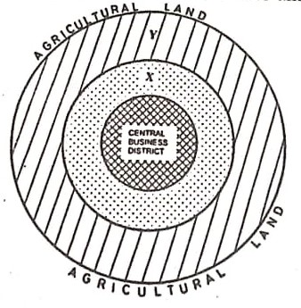
Name the zones marked X and Y
X industrial zone
Y-Suburb area (2×1)
(b)Give three Functions of the Central Business District
- Trading
- Administration
- Recreation
- Commerce/Banking/Insurance
- Offices
- Location of light industries
3×1)
4. (a) Name two forest reserves found in the coastal region of Kenya (2 marks)
- Shimba hills forest
- Arabuko Sokoke forest reserve
- Boni/Dodori forest
- Mangrove forest
- Kaya Forest
(2×1)
(b) State three physical factors that favour the growth of natural forests in the coastal region of Kenya ` (3 marks)
- Coastal areas have moderate to high temperatures that allow for the growth of tress.
- Coastal areas have deep/wee drained soils that allow roots to penetrate deep into the ground.
- Coastal areas receive moderate rainfall which encourages the growth of trees. (3×1)
5. (a) Differentiate between emigration and immigration .
- Emigration involves movement from your country to another while immigration is the movement from other countries into a country (1×2)

(b) Sate three causes of urban to rural migration
- Job transfers from urban to rural
- search for employment due to decentralization of industries,
- retirement,
- retrenchment. ( 3×1)

SECTION B
6. (a) The table below passenger traffic in millions that used different modes of transport in Kenya between the year 2017 to 2020
MODE OF TRANSPORT | 2017 | 2018 | 2019 | 2020
SGR | 699,055 | 1,576,289 | 1,626,505 | 1,688,752
BUSES | 1,568,366 | 1,268,366 | 986,082 | 800,868
AIR | 578,686 | 686,753 | 787,519 | 486,522
- Using a scale of 1cm represent 200,000 people, draw a comparative bar graph to represent data in the table above. (8 marks)

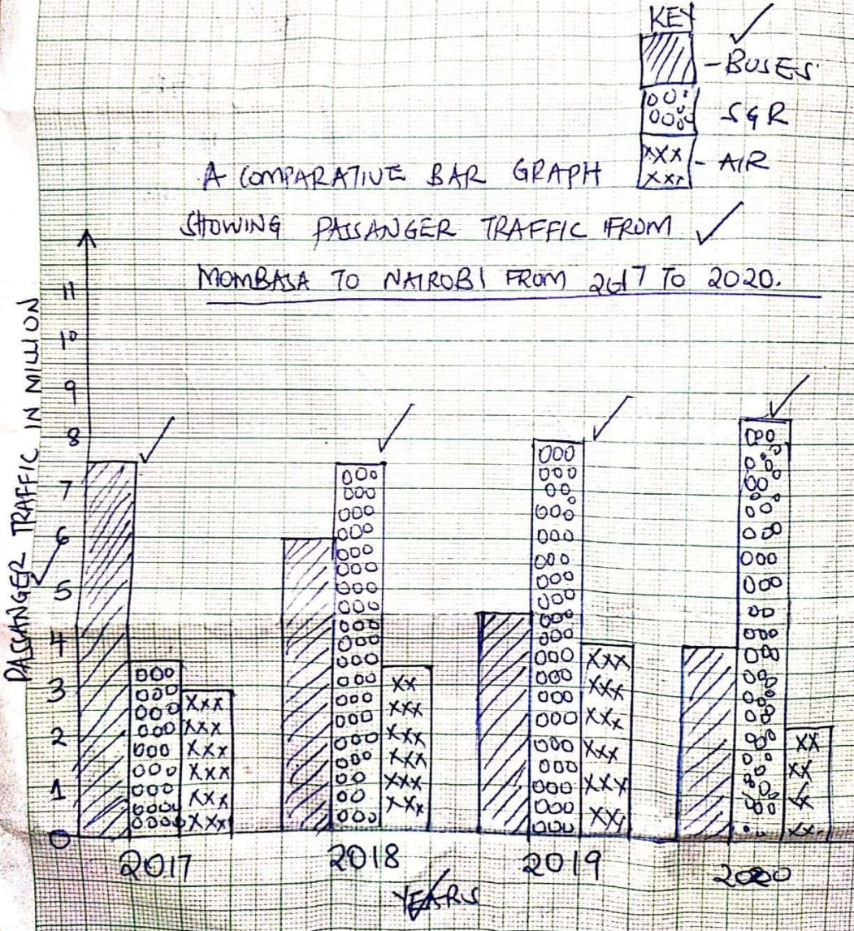

- State two disadvantages of using a comparative bar graph to represent the above data.
- It is difficult to follow the trend of any particular variable through the period.
- Total contribution of the values of a group cannot be given at a glance
(2×1)
(b) Give four reasons why there is limited use of river transport in Africa (4 marks)
  - Some of the rivers contain huge rocks/boulders/rock outcrops on their courses that reduce the navigable distance
  - Presence of waterfalls and rapids along the courses of some of the rivers do not favour development of river transport as they have increased velocity of river water/very steep
  - High siltation in the lower courses of some rivers make their channels shallow to suffice river transportation
  - Most rivers have short and shallow navigable stretches thus discouraging development of transport in them
  - Some rivers flow in areas of low economic value/sparsely populated areas that have limited human activities

(c) Explain how the following factors have negatively affected development of transport and communication in Africa
Rugged Terrain (2 marks)
- Most African countries experience rugged relief with several steep slopes due to volcanic mountains and the rift valley. This makes it difficult and expensive to establish transport routes and communication lines across such terrain hindering transport and communication.
Civil wars (2 marks)
- Some African countries have experienced continued civil wars. During such wars, transport and communication lines are always targeted for vandalism.

(d) State four benefits of the Standard Gauge Railway to the Economy of Kenya(4 marks)
- Led to job oppoturnities, hence improving living standards
- Reduces cost of transporting cargo from Mombasa to hinterlands
- It has enabled passengers to enjoy a faster and cheaper journey this helps to reduce wear and tear on highways this also attract tourist who bring in foreign exchange that can be used improve other sectors of the economy
- The Standard gauge railway will speed up industrialization through cheaper transport and the establishment of new industries to service the new railway
- Urbanization along its route – several towns have mushroomed along the transport route thereby enhancing trade. (4×1)
(e) Identify any three activities involved in the development of St. Lawrence Seaway project (3 marks)
- Construction of bypass canals like St. Marie Canal by-pass the Marie Rapids and Rudeau Canal connecting River Ottawa and Lake Ontario.
- Dredging of the thousand islands section of the river near Lake Ontario.
- Dredging of stretches of River St. Lawrence which had rocky Shoals (rocks were removed by blasting).
- Drowning of rapids and numerous shallow waterfalls like Long, Lachine and St. Marie by creating Dams.
- Introduction of icebreakers during winter (between December and April) to enable use of the route throughout the year.
- Construction of several hydro-electric power dams like Iroquois and Beauharnais.

7. (a) (i) Define the term Fisheries (2 marks)
Fisheries are water bodies or areas where fish and other aquatic resources are reared or caught in large numbers. (1×2)
(ii) Give four measures the Government has taken to conserve fresh water fisheries in Kenya (4 marks)
    - The government comes up with stringent measures against dumping of waste into fresh water fisheries.
- Encouraging fish farming to supplement the fish caught in natural fishing grounds/reduce overdependence on natural fisheries.
- Control of foreign fishermen by monitoring their expeditions through KWS patrols and licensing their entry into the Kenyan waters especially Indian Ocean.
- Restricting disposal of untreated waste into the water bodies to ensure the water remains ideal for survival of fish/industries to treat their wastes before disposing to water bodies.
- Improving transport system through construction of roads connecting the major fishing grounds and the markets to reduce overexploitation.
- Restocking the over fished areas using hatcheries and fingerlings obtained from Lake Basin Development Authority or overstocked grounds. /pisciculture
- The law of the sea that restricts fishing in the exclusive zones ensures the protection of marine fisheries from external exploitation.
      - The government and local institution make funds available for fishermen and women to assist them to purchase fishing equipment
      - Efforts are being made by the local communities and the government to remove the weeds from the lakes.
      - Research is carried out of expand and improve fisheries.
(4×1)
(b) (i) Explain ways in which each of the following factors affect fishing in Kenya;
Technology (2 marks)
- Kenya has low level of technology limiting the fishermen from conducting deep sea fishing, this reduces the number of fish caught in a given area. (1×2)
Fish eating culture
Kenyans have poor eating culture especially for marine water fish, this has reduced the market for fish round Indian ocean. (1×2)
- Describe how trawling method is used in catching Fish (4 marks)
- A trawnet attached to a trawler ship is immersed in a waterbody.
- The upper part of the net is kept open by floaters attached to it.
- The lower parts of the net is kept down by weights attached to it,
- The net is dragged by the trawler ship over the water to collect fish,when theres is sufficient catch ,the net is hauled into the trawler. (4×1)
(c) Study the Map below and use it to answer question 7 (c) (i) to (iii)
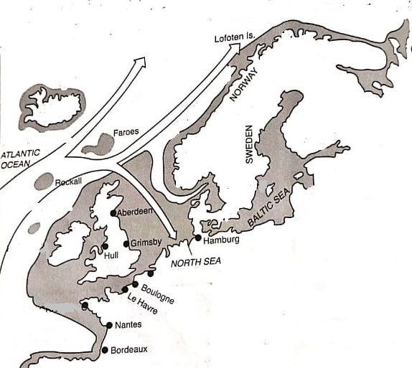
- Give two fish species caught in the above fishing ground(2 marks)
Salmon Herring,Halibut,Hake ,Cod Alaska Pollack and Flounder (2×1)
- Name the ocean current marked B (1 mark)
Warm North Atlantic Drift (1×1)
- Explain how the above ocean current influences fishing in the above fishing ground (2 marks)
The ocean current raises the temperatures and therefore making fishing in the area possible throughout the year,makes the place ice free.(1×2)
(d) Explain the significance of fishing in Japan (6 marks)
- It has provided employment to many Japanese, earning them income thus raising the living standards
- It has promoted industrial growth by providing raw materials in the following industries: ship making industries
- Earns foreign exchange -through exports of fish and fish products the country used in the development of other sectors of the economy.
- Saving of forein exchange/import expences by being available locally. The savings are then used to finance other developments.

8. (a) Define the term balance of trade (2 marks)
- refers to the difference in value between a country’s visible exports and imports. This could be favorable or adverse depending on the value of exports relative to imports. (1×2)
(ii) Name two major imports to Kenya from European Union ( 2 marks)
Motor vehicles, electronics, Pharmaciticals
(b) State four factors that inhibit trade between Kenya and her neighbours ( 4 marks)
- Most of her neighbours produce similar goods ,mainly agricultural based
- Kenya’s pattern of trade still follows the line of flow established by her former colonizer developed countries provide the manufactured goods that Kenya requires so they can form better trading partners
- Transport and communication networks between Kenya and her neighbours is underdeveloped which hinders inter-territorial trade.
- Some of her neighbours also control trade through allocation of quotas and through tariffs.
(c) Explain how the following factors influence trade in Kenya.
    - Security (2 marks)
- places with relative peace enjoy greater trading opportunities since traders are sure of their security and of their goods, they thence invest more (1×2)

    - Transport
Places that are accessible make it possible for trades to transport their goods to the market/Where there are efficient means of transport, traders transport their goods to the market in good time (1×2)
(d) (i) Name two member states of ECOWAS. ( 2 marks )
- Benin
- Bukina Faso
- Liberia
- Mali
- Cape Verde
- Cote D’Ivoire
- Niger
- Nigeria
- Ghana
- Guinea
- Senegal
(ii) Give three roles played by SADC in the economies of her member states (3 marks
- It has led to an increase in employment opportunities through the promotion of free movement of labour which has widened the labour market.
- Through joint ventures it has promoted the development and transfer of technology among member states.
- The creation of a common market has led to the expansion of markets for goods from member state hence industrial and agricultural growth.
- Financing member state leading to economic development. (3×1)
(iii) Explain the measures the government of Kenya has taken to reduce her unfavourable balance of trade ( 8 marks)
- The government imposes tariffs on imported goods so as to discourage importation of non essential and luxury goods.
- Kenya has established the Export Processing Zone and encouraged foreign investors to set up industries,this will increase the volume of goods for export besides production of goods of a higher value.
- Kenya signed the international trade agreement on COMESA, which will increase her trade,she is assured of a wider market for her goods.
- The government has made great efforts in establishing internal roads and road links with her neighbours.
- The government has created the ministry of Trade and industry to oversee mattersrelating to trade in the country.
- The government organizes trade fairs to enable the business community advertise their products,this helps to widen the market for the goods,it also facilitates promotion of tourism in the countries of major tourist origin.
- The government encourages production of high quality goods which are competitive in the world market. This is ascertained by the Kenya Bureau of standards (4×2)
9.(a)(i) Differentiate between domestic dairy farming and commercial dairy farming (2 marks)
Domestic dairy farming is the practice of rearing animals for milk and milk products for subsistence use while commercial dairy animals is the practice of rearing animals for Milk and milk products for sale (1×2)
(ii) Name two breeds of dairy cattle reared in Kenya (2 marks)
Fresian,Ayrshire,Guernsey,Jersey,andSahiwal (2×1)
(b) (i) Give four characteristics of dairy cattle breeds in Kenya (4 marks)
  - Their udders are well developed and firm
  - Their milk has a high protein and butter content
  - They have wide hindquarters,big stomachs and small chests
  - They are very fertile which enables them to calve regularly.
  - They have big milk veins
  - Their legs are short and well set to support their heavy bodies. (4×1)
(ii) State three physical factors favouring dairy farming reared in Kenya (3 marks)
- Low temperatures (150 C-180 C)/cool conditions are ideal for survival of high quality exotic breeds, which have low tolerance to high temperatures.
- Heavy rainfall throughout the year ensuring availability of pasture all year round
- Fertile volcanic soils that ensure constant growth of pasture and high quality nutritious grass
- Permanent water sources from rivers and lakes due to heavy and reliable rainfall (3×1)
- Name three counties where dairy farming is practiced in large scale in Kenya (3 marks)
Nakuru, Laikipia, Uasin Gishu, Kericho, Nandi, Bomet, Kiambu, Kakamega, Meru, Kisii, Nyamira, Migori, Kirinyaga, Nyeri, Murang’a Vihiga, Bungoma, Machakos, Makueni (3×1)
(c) Give reasons why Kenya;s dairy sector fails to meet it’s domestic demand (5 marks)
- Inadequate animal feeds during dry season
- Stiff competition from imported milk and milk products and from alternative land uses e.g. horticulture, tea and coffee
- High incidences of pests and diseases e.g. ticks, foot and mouth, rinderpest that reduce the quality of dairy cattle thus low milk yield
- High costs of farm inputs has limited and minimized the mechanization of the dairy farms
- Poor management of dairy cooperatives results to misappropriation of funds leading to delayed payments that lowers the farmers’ initiatives
- Prolonged and abrupt droughts that lower the quality/quantity of pasture resulting to low yields vi. Poor roads that is impassable during the rainy season. This leads to delays in delivery of milk to the creameries (5×1)

(d) State three differences between dairy farming in Kenya and Denmark (6 marks)
In Denmark, the practice is carried out throughout the country while in Kenya; it is restricted to the cool areas especially the highlands.
ii. In Denmark, the cattle depend on fodder crops and commercial feeds while in Kenya they depend on natural grass with limited use of fodder and commercial feeds.
iii. In Denmark, mechanization is widely used while in Kenya, it is limited especially on small-scale farms. iv. In Denmark, dairy farmers are highly specialized while in Kenya farmers practice mixed farming.
v. In Denmark, all farmers have access to Artificial Insemination, in Kenya; Artificial Insemination is limited to most farms.
vi. In Denmark, high yields are achieved throughout the year because animals are kept indoors and fed on fodder in winter while in Kenya dairy yields are affected by climate changes and drought.
vii. In Denmark, dairy products are mainly for export while in Kenya; dairy products are consumed locally. viii. In Denmark, the cooperatives are highly developed and have enough funds, in Kenya; dairy cooperatives are young and lack adequate funds to advance to farmers.
ix. In Denmark, cattle are kept indoors in winter and autumn while in Kenya;cattle are grazed outdoor throughout the year
10 (a) Give three ways in which mineral occur ( 3marks)
- Veins and lodes
- Seams and beds
- Alluvial deposits
- Weathering products
(ii) Name two minerals that occur as alluvial deposits ( 2 marks)
Gold Diamond
(b) Explain three factors that influence the mining of trona in Lake Magadi
- Trona occurs as alluvial deposits in Lake Magadi which can easily exploited through dredging method
- Large deposits of salts available making the extraction sustainable
- Availability of labour (skilled and semi-skilled) required in the mining
- Availability of market both local and foreign promoting the extraction of the trona
- Good transport network- road and railway facilitating movement of minerals and people.
(c) Study the diagram below and use it to answer question c (i) and (ii)
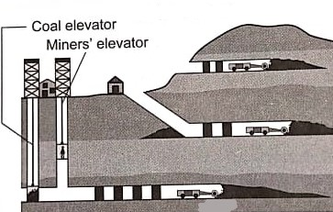
- Identify the mining method shown on the diagram above ( 1 mark)
Deep shaft mining (1×1)
- Describe how the method is used used to extract minerals ( 5 marks
- Vertical shaft is sunk into the Earth’s crust to reach the layer of miners.
- Horizontal tunnels (galleries) are dug from the vertical shaft until the vein/lode/seam of the mineral bearing rock is reached.
- The tunnel is kept well ventilated by pumping fresh air while poisonous gases are pumped out.
- They are also kept clear of flooding.
- The tunnels are supported by steel beams or pit props to prevent them from collapsing.
- Light railway tracts/conveyor systems are laid down to bring the mineral ore to the foot of the shaft.
- The ore is then blasted using explosives/dug out/drilled.
- The ore is then loaded onto trolleys and transported along the tunnels to the vertical shaft by conveyor system/rail.
- The ore is then hauled to the surface by a lift (or cage) and transported for processing.

- State three problems facing gold mining in South Africa ( 3 marks)
- The costs of production have greatly increased due to the deepening of the mines leading to reduced profits
- Exhaustion of the gold bearing reef as the mineral is non-renewable
- Collapse of mines due pressure bursts as a result of heavy weights above as the mines become deeper leading to loss of miners
- Shortage of labour as the workers are sourced from the neighboring southern African countries who demand higher wages and provision of social amenities
- Decline in gold-grade quality. This decline is related to increase in depth of mines (3×1)

- Explain three effects of mining on the environment ( 3 marks)
- Land that abandoned after the mining process. is agriculturally unproductive and water may accumulate in it hence breeding sites for disease causing organisms/makes the land look ugly (loses land’s aesthetic value) and is a health and accident hazard.
- During mining, poisonous gases may be emitted from the mines leading to atmospheric pollution./ Water may also wash some toxic wastes from mines to water bodies causing water pollution./ Heavy machinery and explosives used in mineral extraction also leads to noise pollution
- During mining, extensive areas of vegetation may be cleared to give way for mineral exploitation leading to loss of plant life. Also habitat for various wild animals are destroyed
- Mining loosens the soil structure making it susceptible to wind and water erosion. Also poisonous gases emitted from heavy machinery/chemicals used in mining and pumped out mines may change soil composition thus reducing its fertility and makes it agriculturally unproductive
- Heavy machinery and explosives used in mining may cause tremors/shake the crustal rocks and trigger sudden/gradual movement of weathered material down slope due to gravity. These may bury settlements and destroy property (3×1)

(d) Maranda high school students carried out a field study on the processing of trona on lake Magadi
(i) Identify two methods they will use in recording data ( 2 marks)
- Filling in questionnaires
- Taking photos/ photographing
- Writing notes
- Taking videos (2×1)
(ii) Give two follow up activities they may have carried out ( 2 marks)
    - Displaying charts and photographs
    - Playing audio/visual tapes
    - Displaying filled in questionnaires
    - Drawing charts and graphs
    - Giving a talk/lecture
    - Writing and displaying reports
    - Drawing sketch maps and diagrams (2×1)

