GEOGRAPHY pp2
Form 4 marking scheme

1. State five reasons of studying Geography
prepares one for career opportunities
promotes awareness about the country
Promotes international understanding
Promotes development of skills and critical thinking
provides knowledge about the immediate environment and wider envirtwment and makes us understand the earth which we live in (Any 5xl= 5 marks)
2. a) Two biological factors influencing agriculture
Weeds and parasitic plants.
Pests/fungi/diseases. (Any 2 x 1 =2)
b) Three use of sugars in Kenya.
Used as sweetener for a whole range of foods and beverage.
Used in the manufacture of sweets, chocolates. Spirits, soft drinks and juices.
Used as a sweetener of syrup in the food canning industry.
Brown course sugar and molasses are used in the manufacture of local brews.
Molasses used as a sweetener for livestock feeds.
Molasses used in the manufacture of ethanol acetone and ethyl acetate.
Filter cake from filtration process during manufacture of sugar is used as manure in
The fields near the factory. (Any 3 x I = 3mks)

3a) Name three main mining methods. (3mks)
- surface mining
- Underground mining
- Alluvial mining
- Submarine method Any 3 x 1 = 3 mks

b) Name two places where Gold is mined in Tanzania. (2mks)
- Mpanda
- Musoma
- Lupa
- Mwanza Any 2 x 1 = 2mks)

4a) Outline three characteristics of coniferous forests. (3mks)
- trees are conical in shape
- occurs in pure stands
- trees grow tall and straight
- trees have needle-like leaves
- trees are evergreen
- trees ahve thick barks
- trees have shallow fibrous root system Any 3 x 1 = 3mks

b) Identify two fibre crops found in the tropical forests. (2mks)
- flax
- Jute
- Palm Any 2 x 1 = 2mks)

5. (a) Name two tourist attraction found in Kenyan Rift Valley.
- Lakes e.g Nakuru, Baringo, Naivasha, Elementaita.
- Flamingoes / birds.
- People’s culture.
- Mining sites e.g Kariandusi.
- Nakuru National park.
- Hot springs / geysers / fumaroles / geothermal.
- Menengai crater.
- Water falls – Thomson falls.
- Wildlife.
- Pre-historic sites e.g Kapenguria.
- Sport tourism e.g sport fishing, marathon.
(b) State three factors that hinder domestic tourism in Kenya.
- Negative attitude towards local tourism by the citizens.
- High cost of accommodation in the lodges and hotels discourages many people.
- Poor transport and communication network of roads leading to the parks and other attractive sites.
- Preferential treatment gives to the foreign tourists discourage locals.
- Inadequate knowledge on the tourist attractive sites.

6 The table below shows the prices of sugar in Kenya shillings per ton in some countries in Africa.

Use it to answer questions (a)
YEAR | KENYA | SOUTH AFRICA | TANZANIA | ZAMBIA
2014 | 95,400 | 61,927 | 68,702 | 84,447
2015 | 111,713 | 67,462 | 66,985 | 93,798
2016 | 110,878 | 65,173 | 90,649 | 86,832

a)(i) Draw a divided rectangle 16cm long to represent the prices of sugar in the year 2016 (8marks)

110,878 + 65,173 + 90,649 + 86,832 = 353,532 (1mark)
Length of bars
Kenya = x 16 = 5.01cm = 5cm ⁽¹/₂mark)

South Africa = x 16 = 2.95 cm = 3cm (¹/₂mark)

Tanzania = x 16 = 4.10cm = 4cm (¹/₂ mark)

Zambia = x 16 = 3.93cm = 4cm (¹/₂ mark)

Divided rectangle showing prices of sugar in 2016

KENYA | + + + + +  TANZANIA  + + + + + + | O OOOO  ZAMBIA  O OOOO | / / / / / SOUTH AFRICA / / / /  / / / / / /

Title (1mark)

Segments = mark each (4marks)
Calculations = ½ mark each = (2 marks)
Rectangle (1mark)
Total (8marks)
(ii) State two advantages of using compound bar graph to present
statistical data (2marks)
It gives a clear visual impression
It allows for comparison
Easy to read and interpret
Can be used to present a wide range of data.
(2 x 1 = 2marks)

(b) State three physical conditions that favours cocoa farming in Ghana (3marks)
- Well distributed rainfall throughout the year to enhance growth of cocoa.
- High rainfall / 1300 – 1500 mm per year to enhance growth of cocoa
- High temperature 24-30c to enhance the growth of cocoa
- Deep soils for proper anchorage
- Well drained soils for high production
-High humidity 70 -80% to enhance availability of moisture in the soil
- Undulating low lands 0-70m above sea level
-sunshine for ripening of cocoa pods
-Shade from strong sun rays for the seedlings
- Shelter from strong winds for protection
(Any 3 x 1 = 3marks)
(c)Describe the stages involved in processing of cocoa from harvesting to market(8marks)
- Pods are cut using sharp knives
-the pods are collected and pilled at a central place
-the pods are split open using a sharp knife
-the beans are scooped by hand
-the cocoa beans are heaped on mats and covered with banana leaves to ferment for 5-6 days as the pulp drains away.
-The fermented beans are washed and cleaned
- The beans are spread on tables covered with mats to dry in hot sun
-the beans are turned frequently until they turn brown
-the dry beans are packed in bags
- transported to the buying centers
-the beans weighed, graded ready for export.
(Any 8 x 1 = 8marks)
(d) A part from making oil, give four other uses of oil palm (4marks)
- the leaves are used for roofing
-the shells / fibers are used for fuel
-the leaves are used for making baskets / hats/ mats/brooms
- the stems are used as building poles.
- the sap is used for making wine / alcoholic drinks
-crushed nuts are used for animal feeds / fertilizer
(Any 4 x 1 = 4marks)

6(a)(i)Name the substances (3mks)

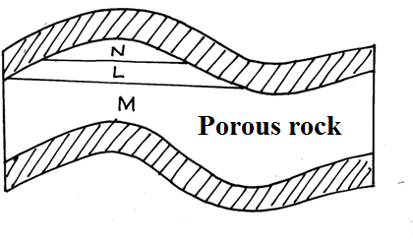

L-Oil
M-Underground water
N-Natural gas
(ii)Give three by-products obtained when crude oil is refined (3mks)
Bi lumen
Wax
Lubricants such as grease
Petrochemicals
(b State five effects of mining on the environment (5mks)
Mining causes
Dereliction of land
Pollution of water and land
Disruption /lowering of the water table
Instability of basement rock
Destruction of bio diversity
Soil erosion
Wastage of agricultural land

(c )(i)Describe the stages involved in the processing of trona from lake magadi (6mks)
On reaching the factory ,trona is separated from water by being put on large sieve –like trays
The water from the trona is directed back into the lake
The trona is then washed to remove impurities such as mud and salt.It is heaped on the ground to dry
After drying ,it is heated in huge cylinders called desiccators .The heating separates sodium carbonate (soda ash) from sodium bi -carbonate .
When heating is complete, the soda ash is allowed to cool.
Soda ash is then ground into poweder and sieved
The powder is packed in paper or jute bags, ready for transportation to the market.
(ii) Ways in which Kenya has been profited from the mining of trona on lake magadi (8mks)
Through exporting trona ,the country erans foreign exchange which is used to important essential items like machinery
The mining of trona has created employment to many Kenyans improving their living standards it has led to establishment of industries by providing raw materials e.g glass industries
It has led to provision of social amenities e.g hospitals, schools hence improving living standards.
Mining of trona has stimulated the development of transport lines e.g it has led to the growth of Magadi town.
The company that runs the mining of trona has improved the living standards of the local people by providing free water for domestic and livestock use
The government earns revenue through taxation of the earnings from the sale of soda ash.

8.(a) i. Define the term land reclamation 1mk
Is the process by which less useful land is converted into more useful land.
ii. State four benefits that resulted from the Reclamation of Yala swamp 4mks
- It has led to the control of floods in the area
- It has stimulated development of infrastructure
- It has increased the amount of agricultural land thus increasing crop production/output
- It has created employment opportunities thus improving the living standards
- It has controlled mosquitoes
- It has increased food production
(4×1=4mks)
(b)The diagram below shows the distribution of irrigation schemes in Kenya. Use it to answer the questions that follow
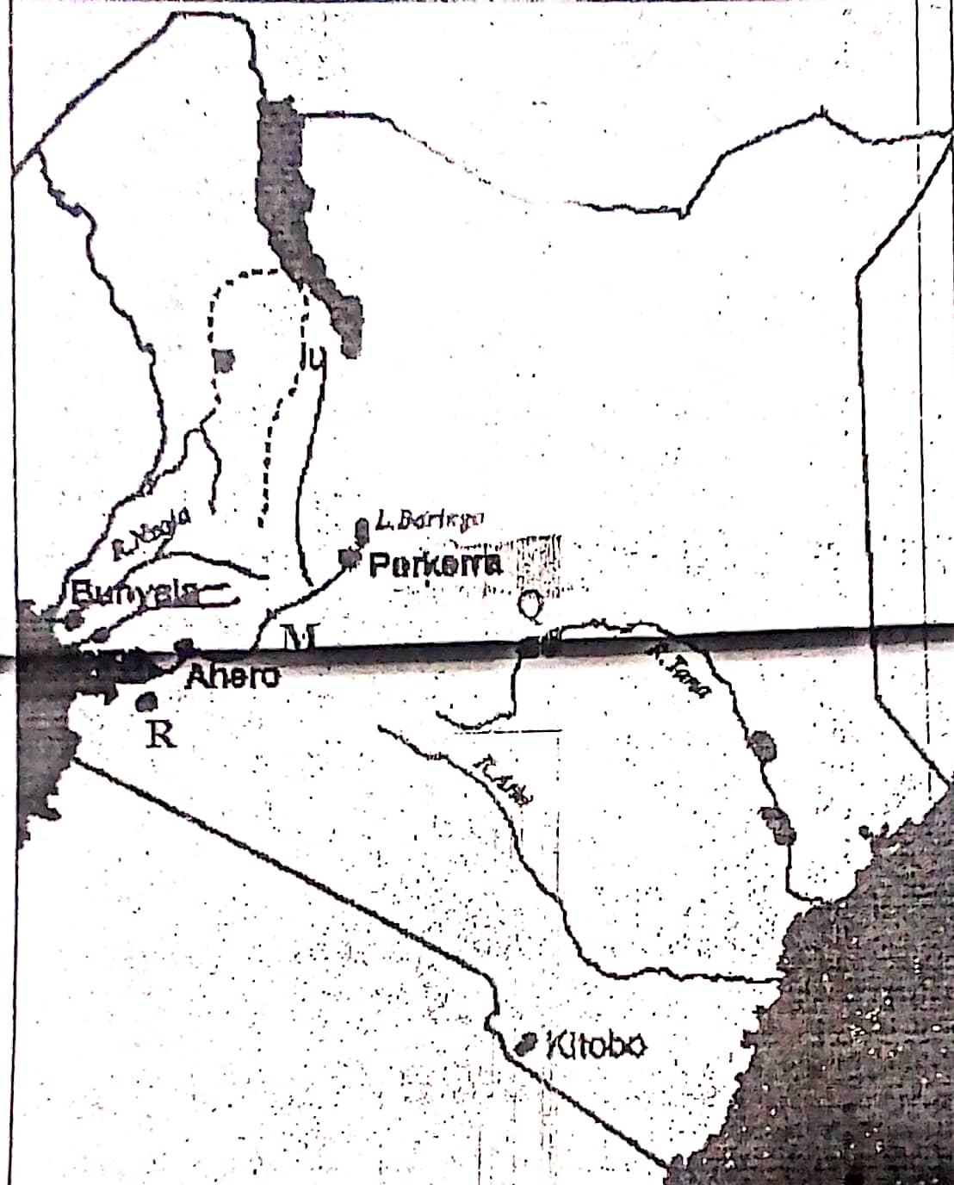
- Name the irrigation schemes labelled Q and R 2mks
- Q- Mwea Tebere
- R- West Kano
- Name the river marked M 1mk
River Nyando
- Explain four factors that favoured the establishment of perkerra irrigation scheme 8mks
- Presence of river perkerra which supplies abundant water for irrigation all year round
- Gently sloping land that allows for natural flow/ by gravity of water and mechanization of the farms
- Presence of fertile loam soils that allows cultivation of various crops
- Unreliable rainfall/ semi-arid conditions of the area necessitated irrigation farming for crop production
- Availability of extensive land due to sparse population thus allowing extensive/expansion of farms
(c)State four problems facing irrigation farming in Kenya 4mks
-stagnant waters in the plots and canals encourage the breeding of snails and mosquitoes that spread diseases( Bilharzia and Malaria) that weaken the farmers hence causing low output leading to low productivity.
-some irrigation schemes are located in sparsely populated areas/ far from urban centers where there is ready market e.g. perkerra, Hola, Katilyu etc.
- some irrigation schemes e.g Hola and Bunyala are affected by floods during the rainy season that destroy the crops grown and infrastructure
- crops planted in the schemes are often attacked by pests and diseases e.g. Quelea birds, root rot etc which destroy the crops in the field s thus lowering their quality
-Siltation of the canals requires frequent dredging whuich is expensive and reduces the capacities of the dams
-inadequate capital to hire labour for planting/weeding and harvesting/ purchase of equipment/ meet operation costs
- shortage of water for some schemes e.g perkerra

(d) i. What is a polder? 1mk
A polder is alow lying area/ land reclaimed from the sea in the Netherlands
ii. Give two differences between land reclamation in Kenya and Netherlands
KENYA | NETHERLANDS
- Land reclamation is done in small scale | Land Reclamation is done on large scale
- Reclaimed land may not have been necessarily covered by water( dry land) | Land mainly reclaimed from the sea? Below the sea
- Land reclamation methods( drainage of swamps,irrigationof dry lands, clearing of bushes, afforestation) | Mainly polderisation/draining of rivers and marshlands, upgrading sandy and barren areas through fertilizer application  (2×2=4mks)

9.(a) i. Differentiate between pelagic and demersal fish 2mks
Pelagic fish Are fish that swim close to the surface while demersal are fish that are found at the bottom of deep water bodies where the water is cool

ii. Name two examples of demersal fish
- Cod
- Haddock
- Pollack
- Hake
- Flounder
- Halibut
(b) The map below shows major world fishing grounds. Use it to answer the questions that follow
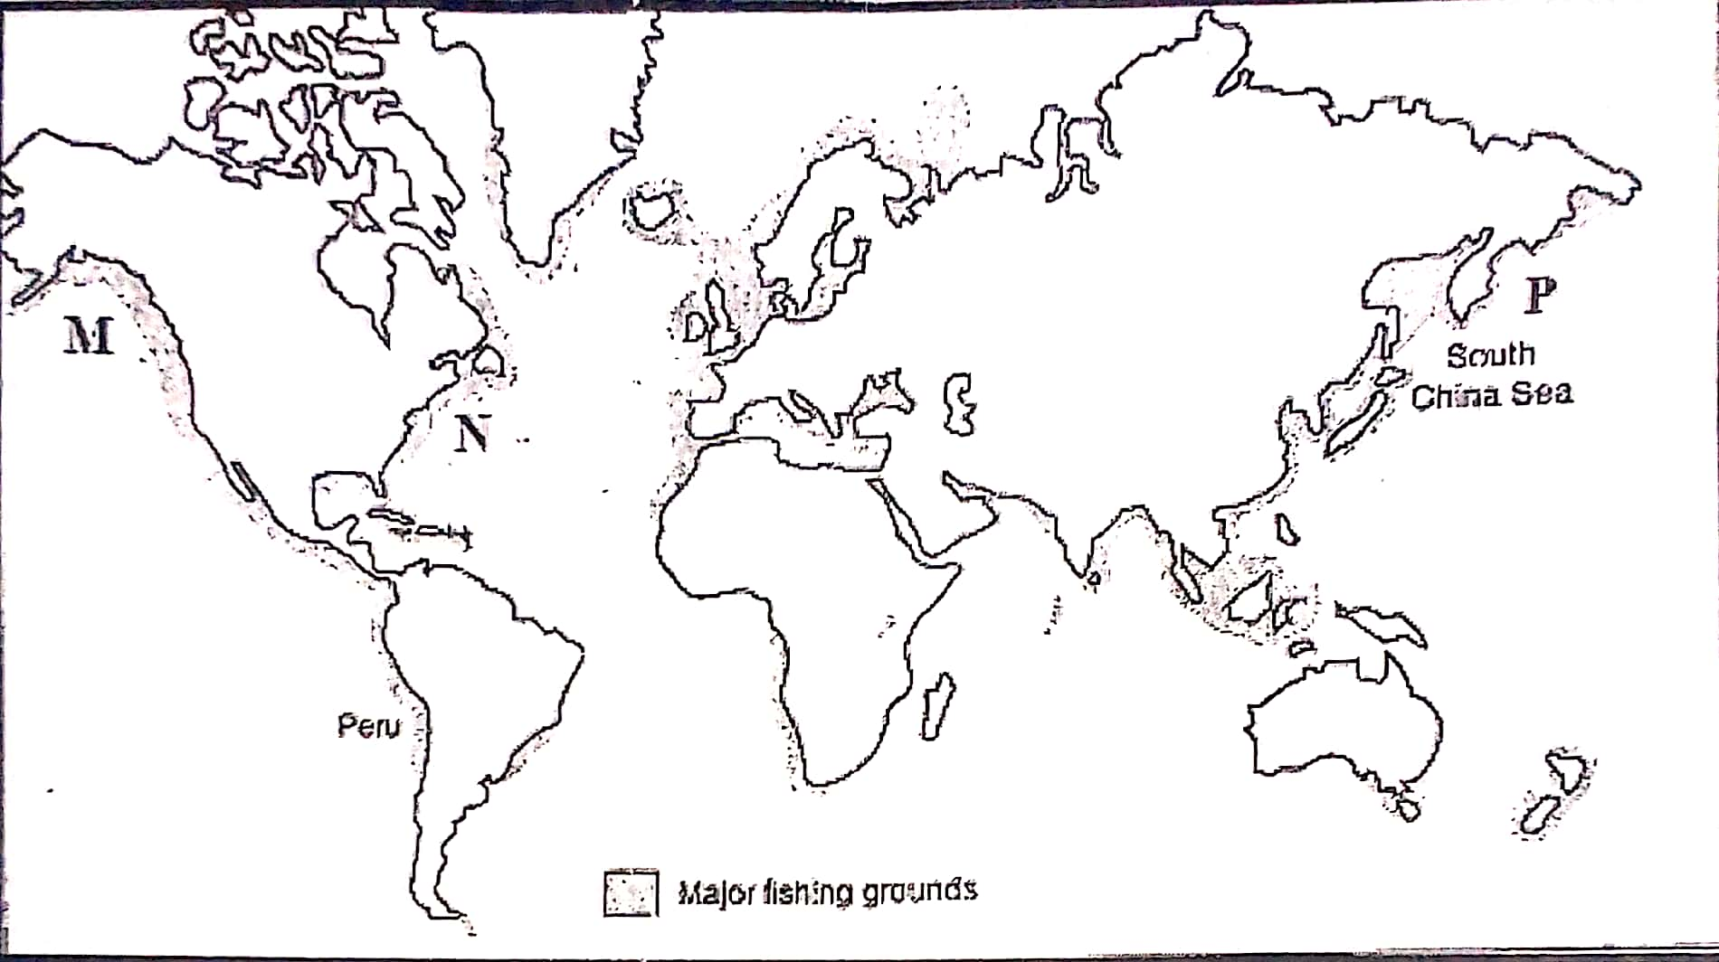
- Identify the fishing grounds marked M, N and P 3mks
- M- North East Pacific
- N- North West Atlantic
- P- North West Pacific
- Explain three human factors favouring fishing in the ground marked P 6mks
- Availability of capital to be able to purchase fishing equipment/ gears
- There is ready market in the densely populated countries of China, Japan and Taiwan
- Advanced technology in the area especially in Japan has encouraged the development of the fishing industry. Besides being a world leading ship builder, japan is also leading in electronic technology as well as in the fish farming industry
- Advanced methods of catching pearls has had a land mark effect on the development of world fisheries
(c)Give reasons why Fresh water fishing is more developed in East Africa compared to
Marine fishing 4mks
- There are more inland fishing grounds than marine fishing grounds in East Africa
- The East African countries have inadequate capital to buy modern equipment for marine fishing
- There is a low demand for marine fishing among the East African population
- The East Africa has a narrow continental shelf that limits plankton growth that is essential for the development of marine fisheries
- The East African coastline is regular, this means that there are no proper areas for fish breeding due to inadequate sea inlets
(d)Explain FOUR measures used in management of fisheries in Kenya
- Banning of fishing; gives time to young fish to mature and breed e.g on lakes Naivasha and Victoria
- Licensing of fishermen; this helps in operating in specific grounds. It regulates the number of fishermen and control their activities
- Ban on indiscriminate fishing; the government agrees on the size of the nets to be used for fishing.
Consequently, only fish of a certain size is caught while the young ones are preserved to mature for harvesting later
- Introduction of new species; Efforts have been made to restock some fishing grounds with fast breeding and maturing fish species
- Research; international research in fisheries is being conducted on activities such as fish species, habits, food requirements and habitats, life expectancy and migratory behavior
- International agreement on fisheries; countries should enforce the law on Exclusive Economic Zones(EEZ)
This a UN conventional law on the sea that allows the coastal states and their citizens the exclusive right to exploit marine resources within 320km off coasts
It reduces the competition for fish especially from the developed countries. In Kenya there are regular patrols from the KWS personnel who arrest those who stray into territorial waters

10.( a) i. Define the term Tourism 1mk
Tourism is the visiting of places of interests for recreational purposes
ii)Name two tourist attractions found in the Rift valley region of Kenya 2mks
- The varied relief features/ sceneries/Great Rift Valley
- Wild animals
- Birds/ Flamingos
- Hot springs/ geysers/fumaroles/geothermal
- Vegetation/ peoples culture/pre historic sites/mining sites
- Sport tourism e.g. fishing
(b)Explain four factors which hinders development of domestic tourism in Kenya
- The roads leading to tourist sites are poorly maintained. Discourages people from visiting such sites
- Inadequate local campaign and advertisement of tourist attractions/ special packages lead to low public awareness.
- Familiarity with the tourist attraction among the local people makes them fail to appreciate their beauty and value
- Negative attitude towards local tourism limits the number of people who engage in tourism
- Insecurity from gangsters/ poachers in national parks and game reserves scare people away from visiting them
- The high cost of accommodation in the game lodges discourages local tourism/ the high cost of hiring tourist vehicles discourages people from touring/ low income

(c)Explain three problems experienced by Kenyan government in its effort to conserve wildlife 6mks
- Illegal hunting/poaching of wild game threatens the conservation efforts. Leads to extinction of some species of animals
- Overstocking of some wild animals leads to destruction of natural environment through overgrazing
- Frequent drought experienced in some of the national parks and reserves leads to loss of animals through starvation and death
- Straying wild animals from the parks to settlement leads to destruction of crops/animals/people, hence high compensation by the government/ high cost of fencing
- Inadequate capital limits government conservation efforts/ overreliance on foreign donor
- Rapid human population growth leads to the encroachment of game parks and reserves
- Pollution of the environment leads to death of animals
- Fire outbreaks destroy wildlife
(d) Explain four factors which have made Switzerland a major tourist
attraction in Europe 8mks
- Favorable climate with warm sunny summers which allow swimming and sun bathing and cold winters which encourage winter sports such as skiing
- The varied scenery consisting of snowcapped mountains, cascading waterfalls and glaciated landscapes provides varied tourist attraction which are lacking in other parts of Europe make the country easily accessible from other European countries
- Political neutrality of Switzerland removes any travel restrictions to the country as tourist destination
- Diversity of languages spoken in Switzerland makes it possible for tourists to communicate and move around the area
- Well-developed transport network to tourist sites provide easy accessibility
- Advanced training in tourism industry enables Switzerland ti provide the necessary services to tourists thus attracting more to the country/ package tour services offered e.g hotels
- Inherent hospitality of swiss people encourage tourists to visit Switzerland
- Well-developed financial institutions(banks) have promoted easy transaction, hence encouraging tourists to Switzerland
- Switzerland is a HQ of several international agencies: this has led to the influx of delegates to the country who later turn to tourists

