BUNAMFAN CLUSTER EXAMINATION - 2022

Kenya Certificate of Secondary Education
312/2 – GEOGRAPHY – Paper 2

June 2022 - 2 ¾ hours
Name…………………………………Adm No……

Class…………… Date……………………………

.
Instructions to Candidates

- Answer all questions in section A.
- In section B, Answer question 6 and any other two questions from the remaining questions.
- Answer all questions using the answer booklet provided.
- Candidate should check that all pages are printed and no questions are missing.

For Examination use only.

 | Maximum Score | Candidate Score
Section A. | 25
Question 6 | 25
Question 7 | 25
Question 8 | 25
Question 9 | 25
Question 10 | 25
TOTAL | 100%

SECTION A
Answer all questions in this Section
- State three reasons for studying Geography. (3marks)
b.Name two branches of geography (2marks)
- (a) Name two biological factors influencing agriculture. (2marks)
(b) State three uses of sugar in Kenya. (3marks)
- a) Name three main mining methods. (3marks)
b) Name two places where Gold is mined in Tanzania. (2marks)
- a) Outline three characteristics of coniferous forests. (3marks)
b) Identify two fibre crops found in the tropical forests. (2marks)
- (a) Name two tourist attractions found in Kenya Rift valley. (2 marks)
(b) State three factors that hinder domestic tourism in Kenya (3 marks)
SECTION B
Answer question 6 and any other questions from this section.
- The table below shows the prices of sugar in Kenya Shillings per ton in some countries in Africa.
Use it to answer question a.(i)
YEAR | KENYA | SOUTH AFRICA | TANZANIA | ZAMBIA
2014 | 95,400 | 61,927 | 68,702 | 84,447
2015 | 111,713 | 67,462 | 66,985 | 93,798
2016 | 110,878 | 65,173 | 90,649 | 86,832

- (i) Draw a divided rectangle 16cm long to represent the prices of sugar in the year 2016.
(8 marks)
(ii) State two advantages of using divided rectangle to present statistical data. (2marks)
(b) State three physical conditions that favours cocoa farming in Ghana. (3 marks)
(c)Describe stages involved in processing of cocoa from harvesting to marketing. (8 marks)
(d)Apart from making oil give four other uses of oil palm. (4 marks)

- (a)The diagram below shows the occurence of petroleum in the earth’s crust.Use it to answer question a i)

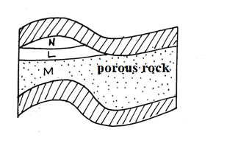

- (i)Name the substance in the areas labelled L,M and N (3marks)
L……………………………………………………………………………………………
M……………………………………………………………………………………………
N……………………………………………………………………………………………
(ii)Give three by –products obtained when crude oil is refined (3marks
(b)State five effects of mining on the environment (5marks)
(c) (i)Describe the stages involved in the processing of trona from lake Magadi. (6marks)

(ii)Explain four ways in which Kenya has benefited from the mining of trona on lake Magadi (8mks)
8.(a) i. Define the term land reclamation (2mks)
ii. State four benefits that resulted from the Reclamation of Yala swamp (4mks)

(b)The diagram below shows the distribution of irrigation schemes in Kenya. Use it to answer the questions that follow
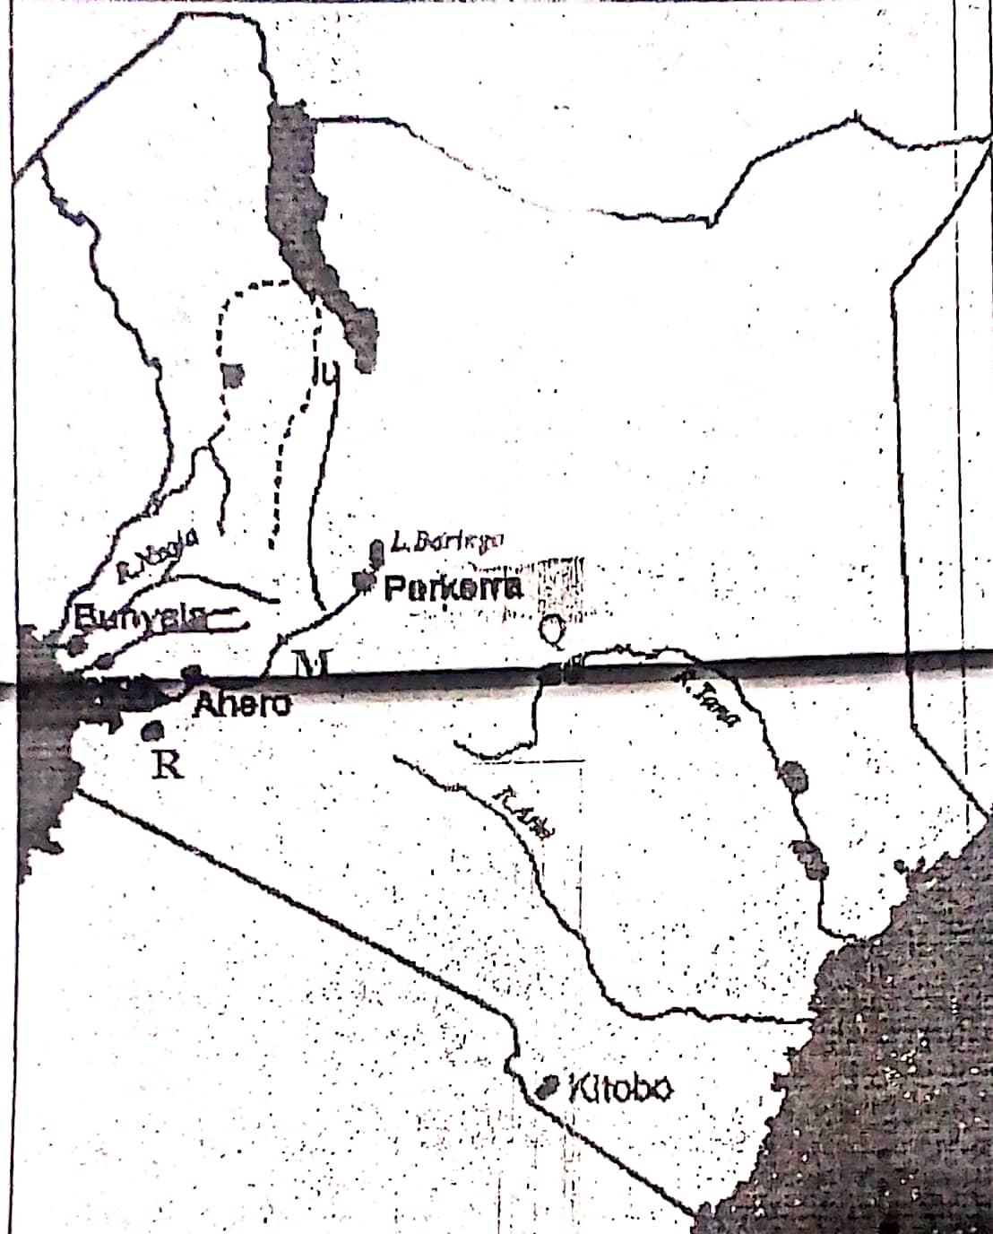
- Name the irrigation schemes labelled Q and R 2mks
- Name the river marked M 1mk
- Explain four factors that favoured the establishment of perkerra
irrigation scheme 8mks
(c)State four problems facing irrigation farming in Kenya 4mks
(d) i. What is a polder? 2mk
ii. Give two differences between land reclamation in Kenya and Netherlands 2mks
9.(a) i. Differentiate between pelagic and demersal fish 2mks
ii. Name two examples of demersal fish 2mks

(b) The map below shows major world fishing grounds. Use it to answer the questions
that follow
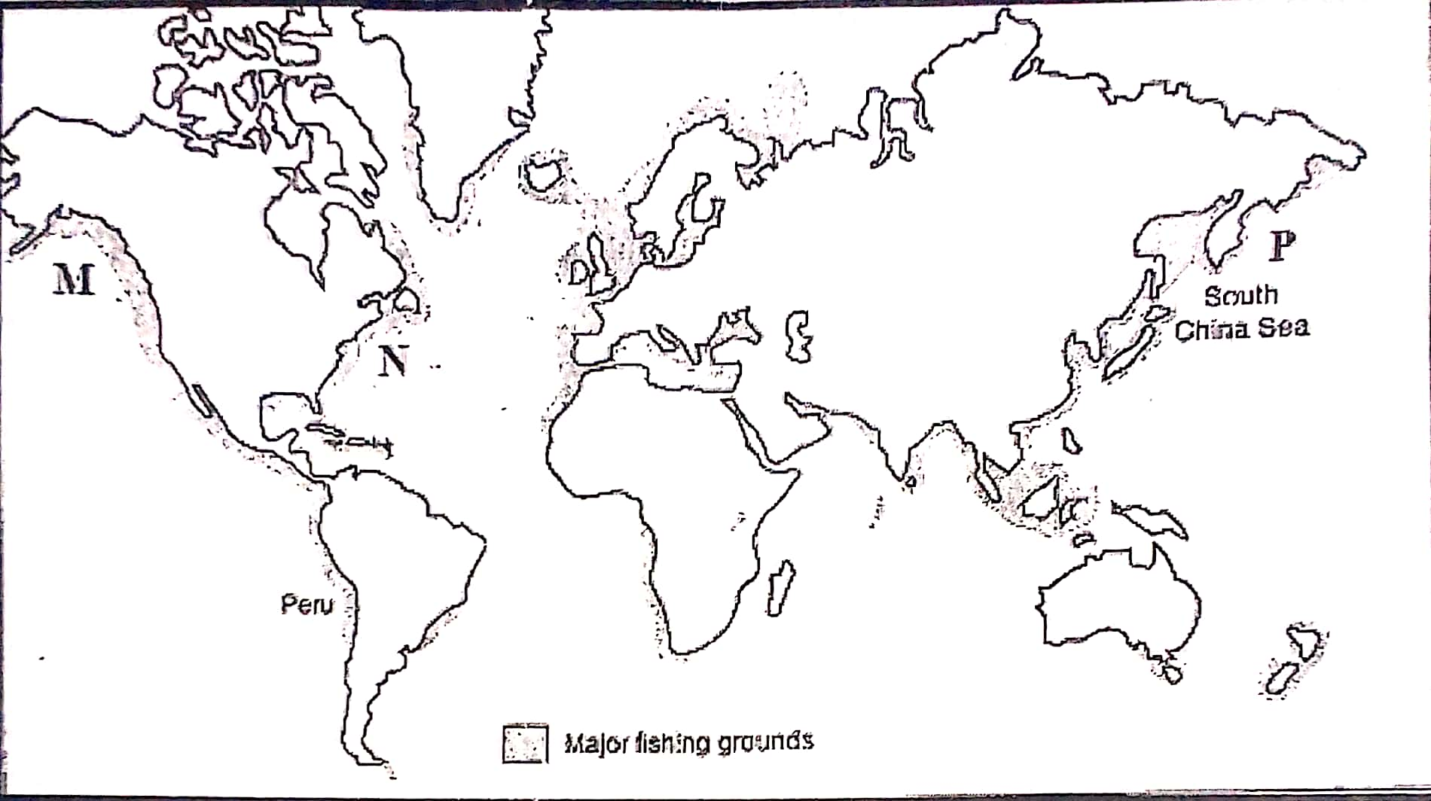
- Identify the fishing grounds marked M, N and P 3mks
- Explain three human factors favouring fishing in the ground marked P 6mks
(c)Give reasons why Fresh water fishing is more developed in East Africa compared to
Marine fishing 4mks
(d)Explain FOUR measures used in management of fisheries in Kenya 8mks
10.( a) i. Define the term Tourism 1mk
ii)Name two tourist attractions found in the coastal region of Kenya 2mks
(b)Explain four problems associated with tourism in Kenya 8mks
(c)Explain three problems experienced by Kenyan government in its effort to
conserve wildlife 6mks
(d) Explain four factors which have made Switzerland a major tourist
attraction in Europe 8mks

THIS IS THE LAST PRINTED PAGE

