TERM 1 2023

SOCIAL STUDIES GRADE 4
- An instrument used to show direction is called (2mrks)

- The sun sets in the (1mk)

- A high flat land is called a (2mrks)

Study the diagram below and answer the questions (10marks)

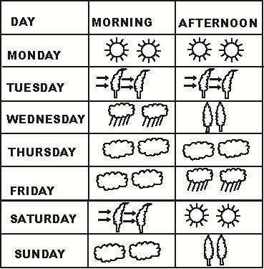

- The above diagram is called a

- Which day did the pupils wear gumboots in the morning?

6 The weather on Thursday was

- Which day was sunny throughout?

- The best day for winnowing was

- A representation of a large area on a small flat surface is called (1mark)

- Name two social insects (4marks)

- Identify and name any three physical features (6marks)

- Your social studies teacher has asked you to draw a map. Name any three important elements that are supposed to be in your map (6marks)

_________________________________________

- Kenya is made up 47 counties. Name any 3 counties you know (6marks)

- The head of a given country is called a (1mk)

- I live in county (1mk)

- The green color found in the national flag represents (1mk)

- People who kill our wild animals are called (1mk) 18.Draw a compass direction and show the 4 main cardinal points (8marks)

