GRADE THREE
COMPETENCE BASED CURRICULUM MATHEMATICAL ACTIVITIES

TERM 1 EXAMS 2023

NAME
SCHOOL
GRADE

Count in 3’s forward

1. 3, 6, 9,12, ,

2. 42, 45, 48, ,

3. 101, 104, 107, ,

Write the short form of the position of numbers

- Third

- First

- Second

Name the shapes

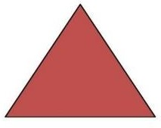

7.

8. ________________________

9.

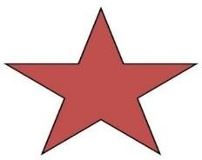

10.

11. 299 + 11 =

12. 766 + 414 =

13. 1425+396=

Write is the place value of 4 in

14. 417

15. 8043

16. 274

Write the following numbers in words

17. 302

18. 311

19. 44 20. 446 21 .Shade a half of the group

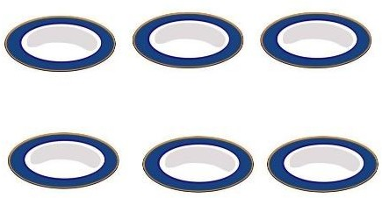

22. How many quarters are there in ¼ ?

23. ¼ of 16 =

24. ½ of 20 =

- Shade ¼

- A class has 50 pupils. 13 of them were absent. How many pupils were present?

- What is a quarter of 28? 28. 5 x7 =
29.9 x 5 =

30.3 x 4=

31.2+2+2+2= x =

32.4+4+4= x - =

- Maina had 99 cows. He bought one more cow. How many cows did he have altogether?

- 1 hour = minutes

- 6 cows have got legs

- Mary was sent to buy 13 eggs .4 eggs broke. How many eggs was she left with?

Write the following numbers in figures

- Three hundred and one

- Nine hundred and sixty

- Thirty nine -

- Divide 20 by 4 =

- What is the difference of 89 and 40=

- What is the time?

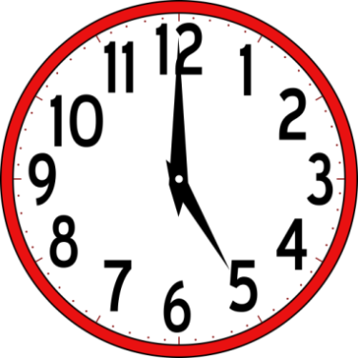

- .Which number comes before 350?

44. 29 days = _weeks and Days

45. 100

-56

46. 250

-46

47. 1027

-678

Write, ‘less than’ or ‘more than’

- 5litres is 8 litres.

- 6litres is 3 litres.

- 2litres is 2 litres.

