GRADE THREE
COMPETENCE BASED CURRICULUM ENVIRONMENTAL ACTIVITIES TERM 1 EXAMS 2023
NAME
SCHOOL
GRADE

- I am a small animal. I spread malaria. Who am I?
(was p ,mosquito , butterfly.)
- The sun rises from which direction (ea st ,south, west)
- When light is blocked by an object a is formed.(Object ,image, shadow)
- In our national flag, which colour represents the people of Kenya?
( green , black, red)
- Animals that live in the forest are called
animals. (tame, domestic, wild).

Name 4 domestic animals

6.
7.

8.

9.

- Stella was seen carrying an umbrella as shown below. Which was the weather
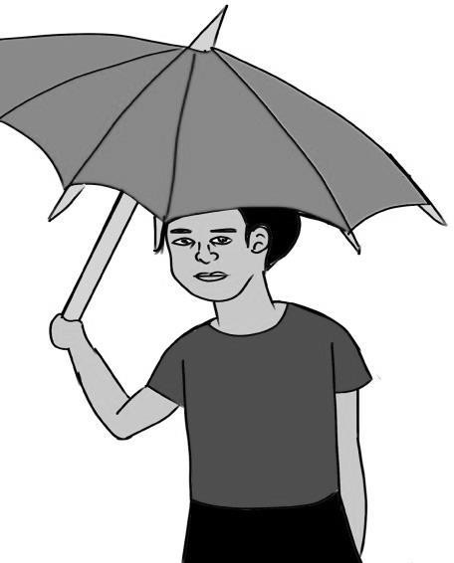
(sunn y, windy, rainy)

- Animals that give us meat are called animals ( Dairy ,beef, food)
- An elephant is a
animal (wild
, domestic , home )

- People coming from other countries to see world animals are called
(poachers, visitors, tourists) 14.
pr ovides us with wool and manure. (goat, sheep, cow)
15. A lot of rainfall causes
(floods, drought , clouds)
16.

Write 5 things that are used to store water at home
19.

20.

21.

Name 3 children rights

22.

24.

25.

soil feels rough.(loam, clay, sand)
- To show respect during flag raising we should all stand

(at ease, on one leg, attention)
- Grains are stored in the

(church , granary, store)

