CEKENAS END OF TERM TWO EXAM-2022
Kenya Certificate of Secondary Education. (K.C.S.E)
MARKING SCHEME

SECTION A
1. a) Define mining (2marks)
-Mining is the extraction of valuable minerals from the earth’s crust
b) Give three ways in which minerals occurs (3mks)
- beds and seams
- As weathering products
- As alluvial deposits
- Veins and lodes
2a) Apart from tropical hardwood forest name two other types of natural forest (2mks)
- Coniferous forest
- Temperature hardwood
- Mangrove forest
- Mixed forests
- Mountain forest

b) State three characteristics of tropical hardwood forests that make it difficult to exploit (3mks)
- Trees occur in mixed stand
- Trees have lianias/buttress roots
- Trees are usually heavy
- Trees have huge trunks
- Trees takes long to mature
- Trees grows close to each other / thick forests

3a.) Name two breeds of dairy cattle reared in Kenya (2mks)
- Frieshian / Holstein
- Jersey
- Guernsey
- Ayrshire
- Alderney
- Swiss brown

b) State three human factors that favour dairy farming in Denmark (3mks)
- Availability of markets
- Availability of extension services
- Well-developed transport/communication network
- Plenty of fodder
- Advanced technology / skills
- Well-developed co-operative movement/ availability of capital
4. (a) Differentiate between fishing and fishery (2mks)
- Fishing refers to catching aquatic resources while a fishery is a water body from which aquatic resources are got
b.) State measures used by the government to conserve marine fisheries (3mks)
- Restocking overfished areas
- Licensing fishermen to reduce their number
- Enacting laws against water pollution
- Standardizing size of net
- Banning fishing in certain seasons/ part of the sea
- Enforcing international agreements
5a.) State three physical factors which influences the location of statements (3mks)
- Water supply
- Availability of land
- Gently sloping land
- Absence of pests/ diseases
- Fertile soils
- Suitability of climate
- Good drainage
b.) Identify two functional zones of ideal urban Centre (3mks)
- Central business district(CBD)
- Transitional zone
- Industrial zone
- Residential zone
- Sub-urban zone

SECTION B: ANSWER QUESTION 6 AND ANY OTHER TWO
6.) The table below shows tonnage of trade world in 2005 and 2006. Use it to answer question (a) and (b)
Place of origin | Tonnage per year
 | 2005 | 2006
Europe | 942000 |  | 985000
Africa | 120000 |  | 154000
Asia | 97000 |  | 128000
North America | 94000 |  | 103000
Australia and New Zealand | 19000 |  | 24000
All other countries | 29000 |  | 41000
TOTAL | 1301000 |  | 1435000

a.i) which continent had the highest increase in tonnage of trade item in Kenya between 2005 and 2006 (1mk)
- Europe
ii.) Calculate the percentage increase trade tonnage from Australia and New Zealand between 2005 and 2006 (2mks)
2006 = 24000
2002 = 1900
Difference = 5000
=$\frac{5000}{1900} x 100\%$
= 26.3% or 26 $\frac{6}{19}$ %
Or 26%
.iii) Draw a divided rectangle 15cm long to represent the tonnage of trade items in Kenya in 2006 (8mks)
Europe = $\frac{985000}{1435000} x 15$ cm = 10.30cm
African = $\frac{154000}{143500} x 15$cm =1.6cm
Asia = $\frac{128000}{1435000} x 15$cm =1.34cm
North America = $\frac{103000}{1435000} x 15cm$ =1.10cm
Australia and New zea land$\frac{24000}{1435000} x 15cm$ =0.25cm
All other countries =$\frac{41000}{1435000} x 15cm$ = 0.43cm

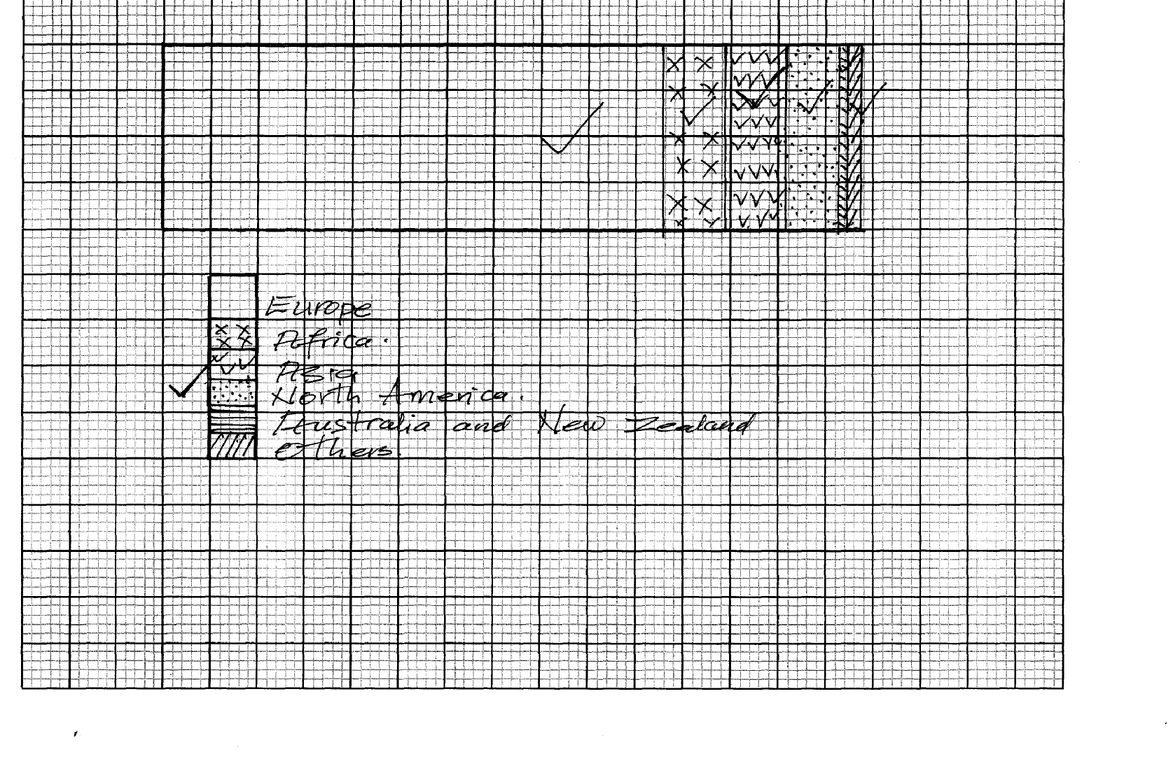
bi.) State two advantages of using divided, rectangles to represent geographical data (2mks)
- Divided rectangles are easy to interpret
- They can be used to represent a wide range of data
- Easy to draw
- They give a clear visual impression
- They allow for comparison
ii.) State four reasons why in 2005 and 2006 there was higher tonnage for trade items from Europe compared to that from Africa continent (4mks)
- Low level of technology Africa limits production of proceed goods
- Different political ideologies among member countries in African restrict trade
- Insufficient transport facilities between Kenya and other different countries in Africa limits volume of trade
- Political instability / civil war in some part of Africa limit trade
- Trade in Kenya still follow pattern i.e. Kenya was colonized by Britain (Europe) hence established trade / political pattern
- Ignorance of what is produced in member countries of Africa.
- Most of the countries in Africa produce similar goods to that of Kenya hence low volume of trade
c.) Explain four ways through which the Kenyan government is promoting external trade (8mks)
- Signing international trade agreements with other countries like in COMESA to increase volume of export
- Establishing the export processing zones (EPZ ) to produce more goods for export
- Reducing import duty on raw materials to attract more industrial for products export
- Encourages foreign investors to establish industries to increase export of goods
- Introduced export compensation scheme on raw materials for producing export goods
- Participating in trade fairs and international exhibitions to display export items so as to have a wider market
- Improving transport and communication for easy flow of raw materials to the industries /commodities to the market
- Looking for new markets especially in the far East to expand export market
- Licensing investors willing to engage in export trade
- Encouraging industries/ farmers to produce quality goods for export
7a(i) State three physical conditions that favour sugarcane farming in Kenya (3mks)
- High temperature (20-27º C)
- Gently sloping land/undulating land
- High rainfall (1200-1500mm) well distributed throughout the year
- Sunny condition for sugar concentration
- Deep well drained day/black cotton soils
ii) Apart from Bungoma name two counties where sugarcane is grown on large scale (2mks)
- Kakamega
- Kisumu
- Siaya
- Busia
- Migori
- Kwale
bi.) Describe the cultivation of sugarcane in Kenya (6mks)
- Land is cleared of vegetation and ploughed
- Harrowing is done to loosen the large lumps of soils
- Shallow furrows are dug 1.2 – 1.8m apart cutting are planted in the furrows
- Top dressing fertilizers are applied
- Weeding is done regularly/ herbicides are applied
- After 18month the cane is ready for harvesting
- The cane is cut using pangas
- The cut cane is loaded into lorries for transportation to the factory
ii.) Explain four problems facing sugarcane farming in Kenya (8mks)
- Pests e.g. termites, white grub/ diseases e.g. ratoon stunting and smut attack the crop and lowers the yields lowering /farmers income.
- Prolonged drought often destroys the crops leading to low yields
- Poor feeder road in some areas leads to delay in delivery of the cane to the factory lowering the quality / profit to the farmers
- High cost of farm inputs reduces the farmers profit margins
- Accidental fire/ fire set by arsonists destroy the cane resulting in heavy loses to the farmers
- Delay in harvesting reduces the quality / tonnage of the cane reducing the farmers earnings
- Flooding of the market by cheap imported sugar causes unfair competition thus lowering demand for locally produced sugar and payment to farmers
- Closures of some factories has deprived farmers of their sources of income
- Mismanagement of industries leads to low and delayed payments discouraging the farmers
- Low / delayed payments demoralizes the farmers
c (i) Give three by-products from sugarcane (3mks)
- Bagasse
- Molasses
- Jaggery
- Filter cake/ mud
- Cane juice
ii.) Give three uses of sugar (3mks)
- As a sweetener
- It is used in baking/ confectionary
- Used in soft drinks
- Used to make sweets/ ice cream
- Is used in production of drugs

8 a i.) State two farming methods that assists in soil rehabilitation (2mks)
- Soil terracing
- Ploughing along the contour
- Controlling / Regulating grazing
- Planting cover crops
- Mixed cropping
- Crop rotation
- Adding manure/fertilizers
- Mulching
- Agroforestry
ii.) Give two methods that are used to drain swamps in Kenya (2mks)
- Constructing drainage pipes
- Digging open ditches / canals
- Pumping out the water

b(i) Name two river that supply water to Mwea Tebere irrigation scheme (2mks)
- Thika
- Nyamindi
- Murubara

ii.) Give the method of irrigation used in Mwea Tebere irrigation scheme (1mks)
- Basin / flood
c) Explain how the following factors influenced the establishment of Mwea Tebere irrigation scheme
- Soil (2mks)
- Presence of black cotton soil which is suitable for cultivation of rice/ retains water for along time
- Government policy (2mks)
- There was need to keep political detainees busy this made the colonial government to set up the scheme where there was large detention camp
d (i) Describe the process of land reclamation in Mwea Tebere irrigation scheme (4mks)
- Canals are constructed to direct water from rivers Thiba/Nyamindi/Murubara
- The land is divided in rectangular portions surrounded by ridges/ bunds
- Water is directed into canals then into the paddy fields
- The plots is are ploughed/rotavated
- The plants remained are buried in the mud to facilitate their decomposition
- Leveling of the fields is done ready for planting
ii.) State four characteristics of three the polders of Netherlands (4mks)
- The soils are highly desalinated
- They are protected by the dykes against gales/sea encroachments
- They are surrounded by ring canals to facilitate drainage
- They are divided into specific land use activities/rectangular portions
- The land is intensively utilized
- Horticulture is the predominant agricultural activity
- The largely lie below sea level
- They are large in size/area/ a crease
- They are gently sloping
e.) Your class intend to carry out a field study in Mwea Tebere irrigation scheme
i) Name two crops that you are likely to identify in the scheme (2mks)
- Rice
- Beans
- Maize
- Tomatoes
- Vegetables
ii.) State two reasons for the need of sampling the area of the study (2mks)
- To reduce the cost of study
- To minimize biasness during the study
- To save time during the study
- Enables detailed study
iii.) Give two after study activities you are likely to engage in (2mks)
- Displaying the photographs taken during the field study
- Writing a report about the study
- Discussing the findings in groups
- Reading further on the topic of study
- Analyzing the data collected
- Presenting the findings
9 (a)(i) What is industrialization? (2mks)
- Is the process and pace a country sets to establish industries
ii) Name a town in Kenya where each one of the following industries is located
oil refining (1mk)
- Mombasa
Paper manufacturing (1mk)
- Webuye
Motor vehicle assembly (1mk)
- Nairobi, Mombasa,Thika
Textile industry (1mk)
- Thika, Nairobi,Mombasa,Eldoret,Kisumu,Nakuru, kitui
b i) Give five reasons why the development of Jua kali industry is encouraged in Kenya (5mks)
- Mainly produces for local market thus saving foreign exchange
- It produces relatively cheap products that are affordable to many improving living standards
- It facilitates decentralization of industries thus curbing rural-urban migration
- It uses locally available/scrap metals/ recycled raw materials thus reducing cost of imports/conservers environment
- Has promoted development of technical skills/innovations useful in other sectors of the economy
- It creates employment raising living standards
- It requires less capital to establish
ii.) Explain four factors that led to the development of iron and steel industry in the Ruhr region of Germany
(8 mks)
- Presences of navigable rivers e.g. Rhine/canals which provide cheap transport for bulky raw materials and finished products
- Availability of raw materials iron ore /limestone/coal from the rhine valley for use in the industries
- Presences of coal in rhine valley / imported petroleum which provided power
- Availability of water from River Rhine//Lippe for various industries uses
- The dense and affluent population in Germany/ Europe provided a large and ready large market for iron and steel
- Highly skilled labour from within the region to work in industries
- Availability of capital from rich families/merchants for stabilizing industries
c.) Explain three causes of the decline in the textile industry in Kenya (6mks)
- Large scale importation of second hand clothes has reduced demand for locally produced textile/ second hand clothes are cheaper than locally produced new textile
- These has been declined in the production of cotton which has led to limited supply of raw materials for the textile industry
- Liberalization of the economy has encouraged business people to import textile from other countries instead of selling locally provided ones
- Mismanagement of textile factories has led to closure of some industries
- Belief that imported garments are superior to locally produced once has reduced demand for local garments
- Decline in the economy has discouraged investors who would set up textile industries in Kenya
10. (a) Give three reasons why road transport is better developed than air transport is east Africa (3mks)
- Most vehicles are cheaper to buy and maintain than air crafts
- Roads transport is more flexible than air transport
- Construction of roads is cheaper than that of airports
- Fare / freight charges on roads are lower than that of air transport
- Motor vehicles require less skills to operate than aircraft

ii.) Name two international airport in Kenya (3mks)
- Jomo Kenyatta international airport / Nairobi
- Isiolo international airport
- Kisumu international airport
- Eldoret international airport
- Moi international airport /Mombasa
b.) Explain four factors that have hindered the development of river transport in Africa (8mks)
- Many river passes through different climatic regions causing fluctuations in river water
- Presences of rapids/waterfalls which hinders navigation
- \Many rivers are short or shallow making it difficult for movement of water vessels
- Presence of floating vegetation/sudd hinders navigation
- Silting at river mouths hinder port development
- Many rivers pass across political boundaries which hinder river transport development
- Low levels of technology hinder process of developing rivers transport
c.) The diagram below shows the great lakes St Laurence seaway. Use it to answer question C, ii) and (iii)
Name
i.) the part marked N and P (2mks)
- N – Quebec
- P - Chicago
ii.) the lake marked L (2mks)
- Superior
iii,) Waterfall marked M
M- Niagara
iii.) Explain the benefit of the Great lakes St. Laurence’s seaway to the economies of Canada and USA (8mks)
- Dams/reservoirs found along the route provide HEP for domestic/ industrial use
- The sea way /Niagara fall attract tourists who bring in foreign exchange used to develop other sector of the economy
- Has created employment opportunities in the transport sector of the economy raising the standard of living of the people in the area
- Provide cheap means of transport for both imports and export thus encouraging trade
- It has led to the growth of towns/ ports which have become focal points for economic activities
- There has been extensive industrial development in the area / growth of Pittsburg industrial conurbation due to accessibility to the raw materials
- The countries earn revenue from tariffs charged on ships which is used to develop other sectors of the economy

