Student Name…………………………………………………………Adm No ……………..
School…………………………………………………Class……………Date……………………
GEOGRAPHY
PAPER ONE
312/1
2022
TIME: 2 ¾ Hours

CATHOLIC DIOCESE OF KAKAMEGA EVALUATION TEST
AUG/SEPT EXAM 2022
Kenya Certificate of Secondary Education (K.C.S.E)
312/1 GEOGRAPHY PAPER ONE
TIME: 2 ¾ Hours
INSTRUCTION
a.) Write your name and index number
b.) Sign and write the date of examination in the space provided above
c.) This paper consists of two section A and B
d.) Answer all section in the section A
e.) Answer question 6 and any other two questions from section B
f.) Answers must be written in the spaces provided at the end of question 5
g.) This paper consists of 8 pages
h.) Candidates must check all the Questions to ascertain that all pages are printed as indicated and no question is missing
(i) Candidates should answer all questions in English
SECTION | QUESTION | MAXIMUM SCORE | CANDIDATE SCORE
A | 1-5 | 25
B | 6 | 25
 | 7 | 25
 | 8 | 25
 | 9
 | 10

SECTION A
ANSWER ALL QUESTIONS IN THIS SECTION
1. a) Define the term Geography (2mks)
b) What is the relationship between Geography and Biology (2mks)
2. a) Use the diagram below to answer the following questions
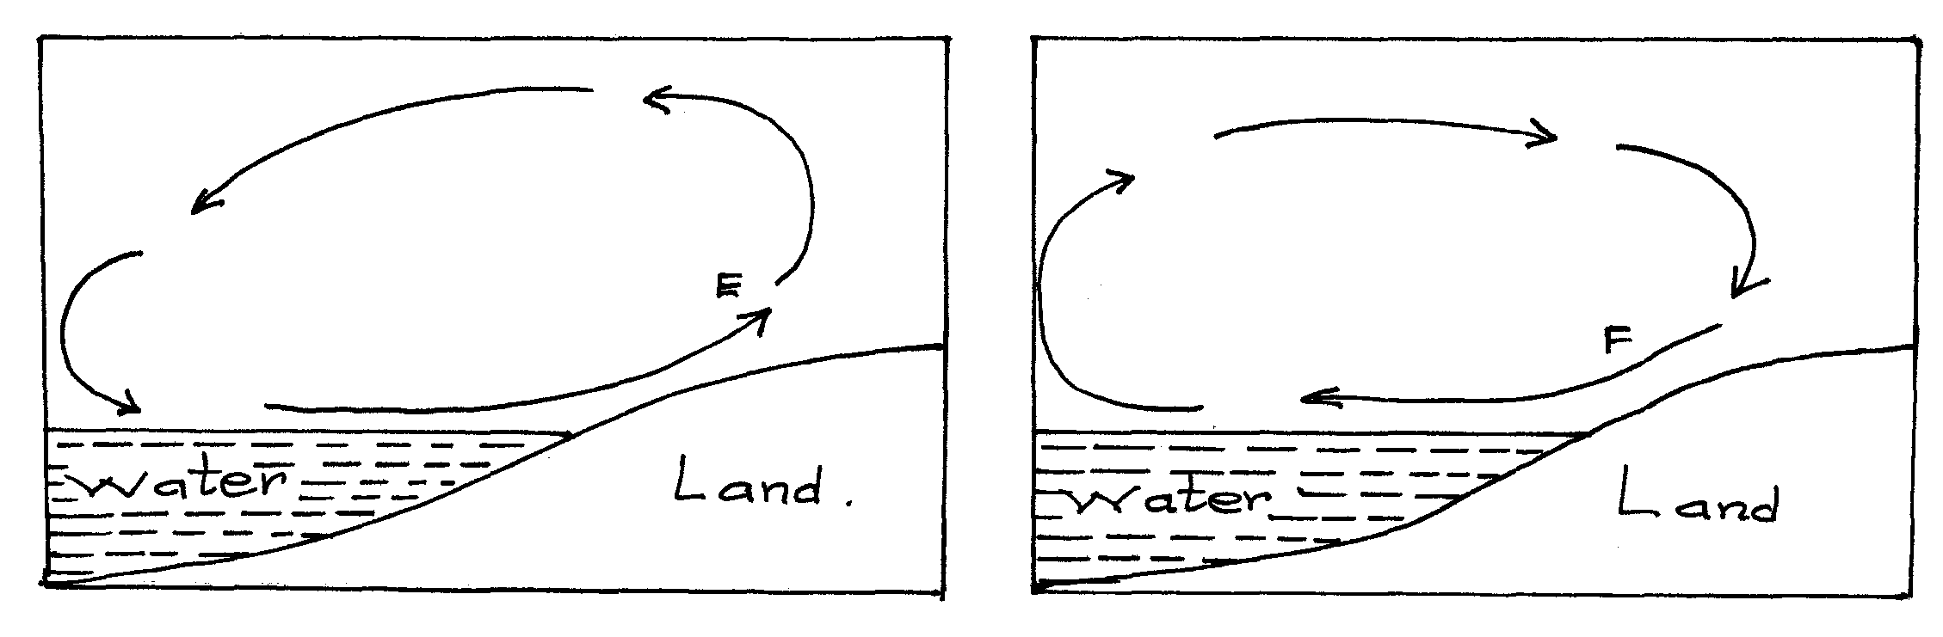
i) Name the air currents marked E. (1mk)
ii) Why does the air current marked F flow at night. (3mks)
b) Give reason why air cools as it rises. (2mks)
3. (a) Define folding. (2mks)
b) List four types of folds. (4mks)
4.) The diagram below illustrates a mass wasting process. Use it to answer question (a) and (b)
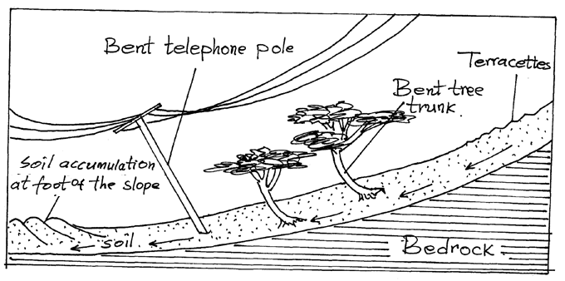
a.) Identify the process. (1mk)
b.) Explain how the process occurs . (3mks)
5. a.) What is a river profile? (2mks)
b.) Name the three stages of a river profile. (3mks)

SECTION B
ANSWER QUESTION 6 AND OTHER TWO QUESTION FROM THIS SECTION
6. Study the map of Nyeri 1:50,000 (Kenya). Use it to answer the questions that follow.
a) i) Give the latitudinal and the longitudinal position of the south west corner of the map extract (2mks)
ii) Calculate the magnetic declination of the map extract (2mks)
b) i) Which adjoining sheet is to the S.E of the area covered by the map? (1mk)
ii) What is the general flow of river Chanya (2mks)
iii) Give three social function of Nyeri town (3mks)
c.) Calculate the area of Nyeri Forest to the East of Easting 69 and North of Northing 56. (Give your answer in Kilometre squared(Km²⁾ (2mks)
d.) Citing evidence from the map. Give
i.)Two reasons why the area covered by the map is suitable for coffee growing (4mks)
ii.) Two factor that favor saw milling in the area covered by the map (4mks)
e) Describe drainage of the area covered by the map (5mks)
7. a) i) Define the term rock (2mks)
ii.)Give two ways of classifying rocks (2mks)
b) Describe the following characteristic of minerals (6mks)
- Lustre
- Colour
- Hardness
ii.) Give the changes that occur on sedimentary rocks when subjected to intense heat and pressure (4mks)
c. i) State the condition necessary for the growth of coral (3mks)
ii.) Describe how coral rocks are formed (4mks)
d.)You are planning to carry out a field study on rocks
i.) List two methods of recording data you are likely to use (2mks)
ii.)Give two follow up activities of your study (2mks)
8. a.) What is Vulcanicity (2mks)
b.) i) Apart from Sill name other intrusive Volcanic features (3mks)
ii.) Describe how the following features are formed
- A sill. (5mks)
- Hotspring. (5mks)
iii) Differentiate between lava and magma. (2mks)
iv.) Explain four negative effects of vulcanicity. (8mks)
9.) a.) i) What is the process through which wave transport the eroded materials along the coast. (1mk)
ii.) Give three factors that influence wave deposition. (3mks)
b i.) Name two types of submerged coast. (2mks)
ii.) State three characteristic of emerged highland coast. (3mks)
c.) By the use of well labeled diagrams, describe the formation of a spit. (7mks)
d.) Student from Moi secondary school are planning to conduct a field study on wave erosional features to areas along the coast.
i.)Give three activities they will undertake while in the field. (3mks)
ii.) Name three erosional features they are likely to identify. (3mks)
iii.) Outline three problems they are likely to face while in the field. (3mks)
10.(a )(i) Identify two processes in which ice erodes (2mks)
ii.) Name four types of glacial moraine (4mks)
b.) Give three ways in which ice moves (3mks)
c.) i) Apart from Aretes, identify three other ice erosional features in highland areas (3mks)
ii.)Describe how an Aretes is formed (5mks)
d) Explain the significance of upland glaciated features to human activities (8mks)

THIS IS THE LAST PRINTED PAGE!

