NAME: ……………………………… INDEX NUMBER: ………….…………………….. SCHOOL…………………….. SIGNATURE:…………................. DATE:……………….

312/1
GEOGRAPHY
PAPER 1
FORM 4
TIME: (2 ¾ HOURS)

DECEMBER EXAM 2021
KENYA CERTIFICATE OF SECONDARY EDUCATION
GEOGRAPHY
PAPER I

Instructions to Candidates
- This paper consists of two sections A and B. Answer all questions in Section A
- In section B answer question 6 and any other two questions.
QUESTION | MAXIMUM SCORE | CANDIDATE’S SCORE
1-5
6
7
8
9
10
TOTAL SCORE

SECTION A (25marks)
Instructions: answer all questions in this section.
1. (a) What is a habitat. (2mks)
(b) Name disciplines related with the following areas of study.
(i) Geomorphology (1mk)
(ii) Biogeography (1mk)
2. (a) State three characteristics of summer solstice. (3mks)
(b) Give two ways in which sea breezes influences the adjacent lands. (2mks)
3. The diagram below shows a breaking wave
(a) Name the parts labelled A, B, C (3mks)
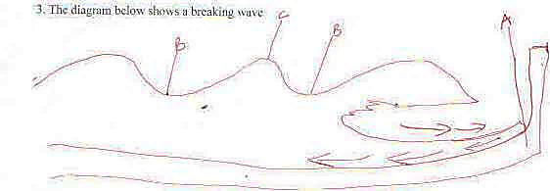

(b) Give three conditions for the formation of a beach. (3mks)
4(a) Outline three reasons why some lakes have fresh water. (3mks)
(b) Name two lakes formed as a result of crustal warping. (2mks)
5(a) What is soil catena? (2mks)
(b) Outline three characteristics of halmorphic soils. (3mks)
SECTION B (All questions carry equal marks)
Answer question 6 and any other two from this section.
6. (a) Study the map of Kijabe 1:50,000 sheet 134/3 provided and answer the following questions.
(i) Give the six – figure grid reference of the water tank at Bathi near the cattle dip. (2mks)
(ii) Measure the distance of the regional boundary North West of the area covered by the map. (2mks)
(iii) What is the longitudinal extend of the area covered by the map. (2mks)
(b) Describe the relief of the area covered by the map. (5mks)
(c) Explain three factors that have influenced the distribution of settlement in the area covered by the map. (6mks)
(d) Students of St. Monica secondary school went for a field study in the area covered by the map.
(i) Name three social functions they may have identified. (3mks)
(ii) Giving evidence, show any one agricultural activity they identified. (2mks)
(iii) Give three problems they are likely to experience during the study. (3mks)
7 (a)(i) Define folding (2mks)
(ii) Draw a diagram to show a simple fold. On it mark and name the following;
A syncline A limb Compressional forces (3mks)
(b) (i) Describe how Fold Mountains are formed.
By geosyncline theory. (7mks)
(ii) A part from Fold Mountains, name any other three features resulting from folding.
(3mks)
(c) Name two fold mountains in Africa. (2mks)
(d) Explain four negative effects of folding to human activities. (8mks)
8(a)(i) Define desertification. (2mks)
(ii) Name three major deserts in Africa. (3mks)
(b) Describe three processes of wind erosion. (6mks)
(c) Describe how the following desert features are formed.
(i) Yardang’s (4mks)
(ii) Seif dunes (4mks)
(d) Explain any three positive effects of desert features to human environment. (6mks)
9.(a) (i) Differentiate between a valley glacier and an ice sheet. (2mks)
(ii) Explain two processes of glacial movement (4mks)
(b) (i) State three causes of glacial deposition. (3mks)
(ii) List four erosional features of glacier in the highland areas. (4mks)
(c) (i) Describe how a drumlin is formed. (4mks)
(d) You are supposed to carry a field study of a glaciated low land.
(i) Give three reasons why you need a map of the area of study. (3mks)
(ii) Give two methods you will use to collect data. (2mks)
(iii) List three problems that you are likely to experience during the field study. (3mks)

10. The diagram represents underground features in a limestone area. Use it to answer question (a)
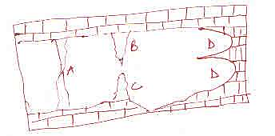

(a) (i) Name the features marked B, C, and D. (3mks)
(ii) Describe how the feature marked A is formed. (6mks)
(b) What are the ideal conditions for the formation of artesian basin? (4mks)
(c) Explain how the following factors influence the existence of underground water.
(i) Precipitation. (2mks)
(ii) Nature of rocks (2mks)
(iii) Vegetation cover. (2mks)
(d) Explain three significance of Karst scenery to human activities. (6mks)

