312/2
Geography
Paper 2.
August/ September 2022.
Time:2$\frac{3}{4}$ hours
MOKASA 2 JOINT EXAMINATION
Kenya Certificate of Secondary Education.
312/2
Paper 2.
Geography
INSTRUCTIONS TO THE CANDIDATES.
- This paper has two sections A and B.
- Answer ALL questions in section A. in section B answer question 6 and any other TWO questions.

OR EXAMINERS’ USE ONLY
SECTION | CANDIDATE’S SCORE
SECTION A
QUESTION 6
QUESTION 7
QUESTION 8
QUESTION 9
QUESTION 10
TOTAL

SECTION A
Answer all questions in this section.
- (a) State three importance of studying geography. (3 marks)
(b) Explain the relationship between geography and demography. (2 marks)
- Study the mining method shown below and answer the following questions
(a) Identify the mining method (1 mark)
(b) State the negative effects of the above method to the environment. (4 marks)
- (a) Define industrialization. (2 marks)
(b) Give three characteristics of Jua kalI industries in Kenya. (3 marks)
- (a) Define international trade. (2 marks)
(b) Name three imports from Europe to Kenya. (3 marks)
- (a) Name two rivers in the lowlands of western rift valley causing flooding.
(2 marks)
(b) State three methods used to control floods in Kenya. (3 marks)
SECTION B
Answer question 6 and any other TWO questions in this section.
- The table below shows Kenya’s leading imports by value. Use it to answer question (a). value in ‘000’ million shillings.
Year | 2013 | 2014 | 2015
Machinery | 80 | 75 | 60
Petroleum | 50 | 70 | 40
Fertilizers | 30 | 40 | 45
Others. | 45 | 30 | 25

- i) What was Kenya’s total value of imports in the year 2015. (1 mark)
ii) Describe the trend of Kenya’s imports between 2013 to 2015. (3 marks)
iii) Give three reasons why Kenya imports some agricultural produce yet she is a producer of the same commodities. (3 marks)
iv) Draw a comparative bar graph to show Kenya’s import by value between 2013 and 2015. (7 marks)
(b) i) Name two counties to the East of Rift Valley where tea is grown. (2 marks)
ii) State three physical conditions that influence the growing of tea in Kenya. (3 marks)
- Describe the stages involved in the cultivation of tea from land preparation to harvesting. (6 marks)
- (a) i) Define the term forestry. (2 marks)
ii) Name two types of forests found in Kenya. (2 marks)
iii) Give two examples of forest reserves in Kenya. (2 marks)
(b) Explain three physical factors favoring the development of soft wood forests in Kenya. (6 marks).
(c) Compare soft wood forests in Kenya and Canada under the following.
- Growth. (2 marks)
- Logging. (2 marks)
- Forests products. (2 marks)
(d) A Mokasa Geography class intended to carry out a field study in Mau forest in the Rift Valley.
- Name the methods they would use to record data during the study. (4 marks)
- State three problems they are likely to face during the study. (3 marks)
- (a) i. Define fisheries (2 marks)
ii). State four ways in which marine fisheries in Kenya can be conserved.
(4 marks)
- i) What is fish farming. (2 marks)
ii) State three ways in which fish farming contribute to the economy of Kenya. (3 marks)

(c). Use the map below to answer the following questions.
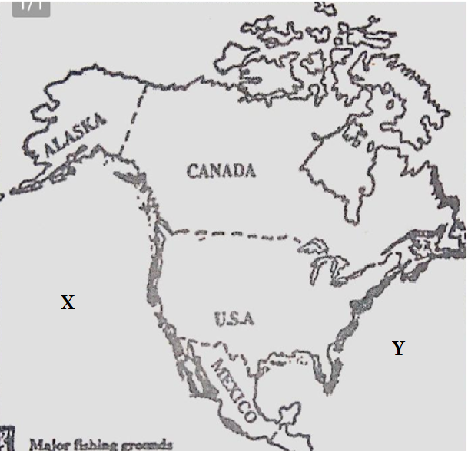
- Identify the following grounds marked X and Y (2 marks)
- Name four fish species caught along the fishing ground marked Y.
(4 marks)
- Explain four physical factors favoring fishing in the region marked Y. (8 marks)
- (a) i) Differentiate between transport and communication. (2 marks)
ii) Name three means used on land transport. (3 marks)
iii) Explain the following factors how they influence development of transport and communication.
- Technology (2 marks)
- Urbanization. (2 marks)

(b).The diagram below shows the major ports around Lake Victoria, use it to answer questions that follows.

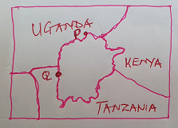
- Name the ports labelled P and Q. (2 marks)
- State four advantages of using containers at the port of Kisumu. (4 marks)
(c).i) Identify three canals along the St Lawrence and Great Lakes sea way in USA and Canada. (3 marks)
ii) Name four products transported along the sea way route. (4 marks)
iii) Explain how the following problems faced at the st Lawrence sea route were improved.
- Siltation. (2 marks)
- Freezing of water. (2 marks)
- a) i) Define the term settlement. (2 marks)
ii) Give any two types of rural settlement patterns. (2 marks)
iii) Explain how the following factors influencing settlement.
- Drainage (2 marks)
- Vegetation. (2 marks)
b) Apart from central business district, name three other functional zones of urban Centre. (3 marks)
c) State any three negative effects of urbanization. (3 marks)
d) Explain four factors that led to the growth of Eldoret town. (8 marks)
e) State three factors that contribute to the emergence of slums in urban centers.
(3 marks)

