GEOGRAPHY PAPER 2 MARKING SCHEME
DECEMBER EXAM 2021
SECTION A
- (a) What is eco – tourism? (2mks)
- Is a form of tourism in which tourists travel to an area of interest with an aim of conserving the environment.
(b) State any two benefits of eco-tourism to the government. (2mks)
- Source of revenue
- Protects threatened wildlife
- increase area under forests.
- Creates job opportunities to the locals in remote areas.
- (a) State two challenges of rail transport in Kenya. (2mks)
- Competition from other forms of transport i.e. roads or pipeline which are faster, flexible & cheaper.
- High cost of rail network maintenance and expansion.
- Inadequate servicing of rail equipment.
- Mismanagement of rail services leading to poor services.
(b) State why road transport is used more than air transport in East Africa.(3mks)
- It is cheaper than air transport/cheaper to construct.
- It is flexible.
- Provides door to door services.
- Readily available in many areas.
- Faster over short distances.
- (a) Name any three towns where motor vehicles assembly takes place in Kenya. (3mks)
- Mombasa
- Thika
- Nairobi
(b) State any three factors that led to the development of iron and steel industry in Ruhr region. (3mks)
- Availability of large iron deposits.
- Availability of water from River Rhine & Rhone which provides water for the industries.
- Availability of abundant source of power/coal
- Availability of raw material / limestone/ iron ore
- Developed transport – network/navigable rivers/canals.
- Traditional industries provided skilled labour.
- Availability of capital/rich population/companies/gloup family
- Large market in central and western Europe/large population.
- (a)Name any three environmental hazards. (3mks)
- Lightning
- Windstorms
- Pests and diseases.
- Seismic disturbances/earthquakes/ Tsunamis
- Volcanic eruptions.
- Drought/desertification.
- Forest & bushfires.
(b) Give two ways in which water is polluted. (2mks)
- Chemicals/fertilisers from farms.
- Oil spills from factories, garages over land/tankers.
- Industrial & domestic wastes.
- Washing of garbage/surface run off.
- (a) State two characteristics of market gardening in Kenya. (2mks)
- Practiced near urban centres.
- Farms are small.
- Intensive cultivation of land.
- Application of manual labour.
- Scientific management e.g. use of fertilisers and insecticides.
- Application of irrigation to facilitate production.
- Products for local market
2x1 = 1
(b) Give three factors favouring horticultural farming in Kenya. (3mks)
- High demand both local and abroad.
- Investment by large companies e.g. Delmonte, Oserian, homegrown etc.
- Wet and hot conditions.
- Availability of good transport network like Nakuru – Nairobi highway/ airports
- Technical assistance by foreign countries e.g. Israel, Netherlands
- Organised marketing of crops coordinated by Horticultural crops development authority.
3 x 1 = 3
SECTION B
- The table below shows four main mineral exporters in Africa in 2007. Use it to answer questions.
South Africa – 300,000
Libya – 350,000
DRC – 140,000
Tanzania – 60,000
(a)(i) Draw a divided rectangle 15cm long to represent the data. (8mks)
South Africa – 300,000
Libya – 350,000
DRC – 140,000
Tanzania – 60,000
Total - 850,000

Libya = $\frac{350,000}{850,000}×15=6.18cm≈6.2$
$$S. Africa\frac{300,000}{850,000}×15=5.29cm≈5.3$$
DRC = $\frac{140,000}{850,000}×15=2.47cm≈2.5$

Tanzania = $\frac{60,000}{850,000}×15=1.06cm≈1.2cm$
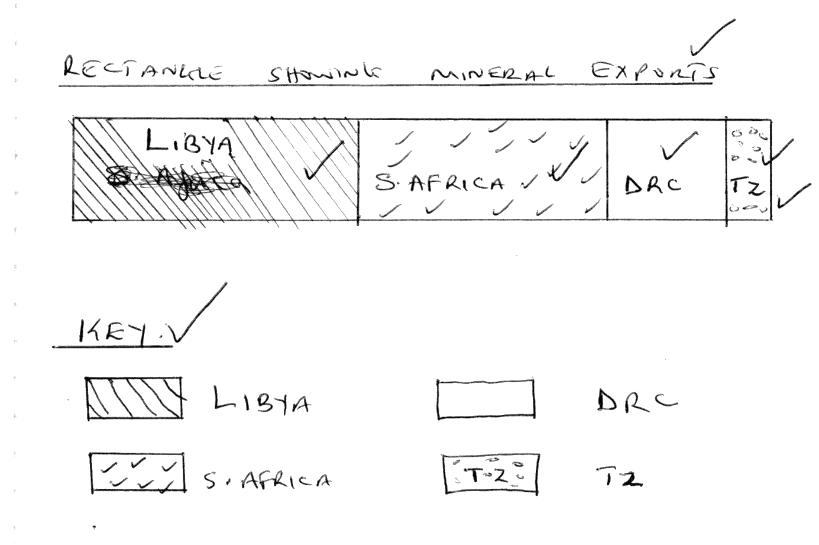

(ii) State two disadvantages of using divided rectangles to represent data.
- It is difficult to determine values of individual components at a glance.
- It consumes time because of calculations involved.
- Limited to few variables
(iii) Name two major minerals exported by South Africa. (2mks)
- Diamond
- Gold
(b)(i) State three processes which influence the occurrence of minerals. (3mks)
- Vulcanicity
- Metamorphism
- Weathering
- Erosion and sedimentation.
- Evaporation.
(ii) Explain how solution method of mining is done. (6mks)
- Is used to mine minerals that are soluble e.g. Sulphur, potash.
- Pipes with super heated water or steam are sunk down to the deposits.
- Minerals dissolve into the water which is then pumped to the surface.
- At the surface water is evaporated and the mineral extracted. (6mks)
(c) State four effects of open cast mining on the environment (4mks)
- Causes mass wasting
- Leads to destruction of bio diversity
- Leaves heaps of soil lowering aesthetic values
- Causes pollution
- Lead to land dereliction
- Define the following terms.
(a) (i)Fertility. (2mks)
- It’s the number of live births a woman has during her reproductive age.
(ii) Census (2mks)
- It is the enumeration of entire human population of an area.
(b) State three reasons why Kenya carries out census. (3mks)
- In order for government to obtain information on the composition of its population in terms of gender, age and regional distribution.
- To establish the population trends and level of mortality and fertility.
- Helps the government to plan for the provision of social amenities such as hospitals, schools etc.
- Avail employment opportunities.
- Make decisions on the divisions of new administrative areas.
- To plan for provision of servises
(c) Explain four problems that result from high population growth in E. African Countries. (8mks)
- High dependency ratio resulting into little savings by the working population/low investments/low living standards.
- High importation to meet local demands hence depleting foreign exchange.
- High unemployment rate since job opportunities may not increase at rate that can cope with the number of job seekers/may increase rate of crime.
- Increase in demand for social amenities leading to congestion in schools/hospitals/housing and transport facilities.
- Increase in demand of food which may lead to food shortage.
- Increase in demand of agricultural land causing land fragmentation/landlessness/destruction of forests.
- Decrease in revenue that would be used for development of income generating projects hence slow economic growth.
(d) State any four factors leading to slow population growth rate. (4mks)
- Tradition – Cultural practices such as period between two children.
- Wars leading to death.
- Calamities/epidemics leading to death of people.
- Education which results in late marriage reducing child bearing period.
- Use of contraceptives which regulates/reduces chances of conception.
- Creation of awareness about the benefits of small families/change of altitude.
- Modern careers especially for women leading to long separation periods between couple.
- Emigration of people leading to reduced numbers in the area of outgoer.
(e) Explain three ways in which the population of Kenya is different from that of Sweden. (6mks)
- Dependency ratio in Kenya is high and low in Sweden.
- Majority of the Kenyan population is in rural areas while Sweden’s majority are in urban centres.
- Kenyan population has a large number of young people aged below 20 years while Sweden has an aging population.
- Kenyan population has a lower life expectancy while Sweden has a higher life expectancy.
- Birth rate is high in Kenya but low in Sweden.
- Fertility rate is high in Kenya but low in Sweden.
- Population structure in Kenya has a broad base and narrows with increasing age while that of Sweden is narrow at the bottom, bulges out in the middle and arbit wide at the top.
- In Kenya death rate is high and low in Sweden.
- (a) What is the difference between pelagic fish and demersal. (2mks)
- Pelagic fish – fish communities that live near the surface or at the shallow sea depth.
- Demersal fish – Fish that live close or the bottom of the sea.
(b)(i) On the outline map of the world provided name the fishing grounds marked ABC.
A – N.E Pacific
B – N.W Atlantic
C – N.W Pacific
(ii) Explain four factors that make the area marked C an important fishing grounds. (8mks)
- Cold Kamchatka and warm kurosiwo current converge on this grounds thereby creating a conducive condition for development of planktons.
- Rugged landscape discourage other forms of economic activities.
- Densely populated countries of China, Japan and Taiwan provide a ready market for the fish.
- Advanced technology in the area especially in Japan has encouraged the development of the fishing industry.
- The many islands in the North Asian Coast form good shelter for the breeding of fish.
- Extensive and shallow continental shelf favours the thriving of several types of plankton.
(c)(i) List four ways in which fish from Lake Victoria is preserved. (4mks)
- Sun – drying
- Frying
- Smoking
- Salting
- Refrigeration.
(ii) Explain four reasons why tropical waters are not rich fishing grounds. (8mks)
- Water is too warm for plankton growth.
- High temperature discourage fish preservation in absence of refrigeration.
- The coast of Africa & America are straight/ lacking inlets/bays which discourage fish breeding and for fishing ports.
- Tropical coasts have narrow continental shelves.
(d) State to reasons why marine fishing is less developed in Kenya. (3mks)
- Regular coastline
- Warm tropical waters discourage breeding
- Territorial conflicts in the ocean
- Many fresh water fisheries
- Low market for marine fish
- (a)(i) State the difference between land rehabilitation and land reclamation. (4mks)
- Reclamation – is a process of making waste lands (deserts & swamps ) suitable for farming and settlement.
- Rehabilitation – is the process of restoring waste land to its former good conditions for human activities.
(ii) Name any three irrigation blocks that are part of the Mwea irrigation schemes. (3mks)
- Mwea
- Karaba
- Tebere
- Thiba
- Wamumu 3x1=3
(b)Explain any four factors that influenced the establishment of Perkerra irrigation schemes.
- Presence of river perkerra which provides water for irrigation.
- The area slopes gently allowing flow of water to the fields by gravity.
- Availability of soils rich in minerals enables a variety of crops to be grown.
- Availability of extensive land which makes large scale cultivation of crops possible.
- The area had sparse population hence making it easy to resettle it.
- The area is semi-arid therefore there was need for irrigation farming.
(c)(i) What is a polder?
- This is a low lying land in the Netherlands reclaimed from the sea.

(ii) Explain any three benefits of the Zuyder Zee project. (6mks)
- Creation of large fresh water lake in the middle of the country for domestic & industrial use – Lake Yssel.
- Polders have attracted towns which have led to improvement of transport routes & social amenities.
- The great dyke has shortened the coastline distance by a great deal/320 km
- The fresh water of Lake Yssel has helped in reducing the salt content of the neighbouring regions. Availing more land for grazing and farming.
- Tidal flooding on the coastal areas has been completely reduced after the construction of protective dykes.
- Reclaimed land is fertile – production of wheat, beet root etc.
- Reclaimed areas have been used for settlement, recreation industries and establishment of social amenities.
(iii) Apart from irrigation and polders list two other ways of reclaiming land. (2mks)
- Draining swamps.
- Tsetse fly control
- (a) State three physical conditions that favour coffee growing in the central highlands of Kenya. (3mks)
- Experience high rainfall 1000 – 1500mm, well distributed rainfall per year which in ideal for coffee.
- The soils are deep, volcanic type, well drained.
- The area experience cool to warm condition/14 – 24ºC throughout the year.
- The land has gentle slopes/undulating landscape that allow good drainage.
(b) Name three coffee growing counties in the western region of Kenya. (2mks)
- Bungoma
- Busia
- Vihiga
- Nyamira
- Kisii
- Trans-Nzoia
(c) Describe the stages involved in coffee cultivation. (8mks)
- Land is cleared
- Land is ploughed.
- Seedlings are raised in a nursery – where they are watered and shaded as they germinate & stay for six month.
- Holes are dug in the field with a space of 3 metres, apart . manure is added and watered regularly.
- Seedlings are then transplanted in the holes in the field.
- Seedlings are sheltered from strong sunlight by trees artificial shades.
- The seedlings are also mulched to conserve moisture.
- The plant is pruned, weeded, sprayed and manured regularly.
- The coffee matures at about 5 years.
- Coffee berries are picked by hand.
(d)(i) Compare coffee growing in Kenya and Brazil under the following sub-heading.
Coffee Growing areas.
- In Brazil coffee is grown at lower altitudes upto 900m/ on gently rolling Brazilian plateaus while in Kenya is mainly grown in the highlands.
Soil
- In Brazil it is grown in deep porous/tera rossa soils while in Kenya in deep volcanic soils.
Labour
- In Kenya work is done by family members while in Brazil it is done by tenants.
3x2 = 6
e (i) State any three problems facing coffee farmers in Kenya. (3mks)
- Pests and diseases such as black coffee thrip, red spider mites, weevils and beetles.
- Hailstone which lower the quality and the quantity of the berries.
- Fluctuation of world market prices.
- Inadequate rainfall in times of prolonged drought.
- Labour shortage.
- Soil exhaustion
(ii) Name the two coffee varieties in Kenya.
- Arabica
- Robusta
- Ruiru II

