312/2.
GEOGRAPHY.
Paper Two.
August/September 2022.
Time 2^{3/4} Hours.
MOKASA TWO JOINT EXAMINATION 2022.
(MARKING SCHEME)
SECTION A: Answer all questions in this section.
- (a) State three importance of studying Geography. (3marks)
- Prepare one for career opportunities.
- Promote development of critical thinking.
- Promote environmental awareness.
- Promote development of pratical skills.
- Helps students to manage time.
(b) Explain the relationship between Geography and Demography.
- Geography when studying population uses the knowledge of demography to explain factors influencing population distribution and changes on the earths surface.
- Study the mining method shows below and answer the following questions.

- Identify the mining method (1mark)
- State four negative effects of the above method to the environment.
- Open quarries make the environment ugly.
- Heaps of waste causes land pollution.
- Dust products during mining causes air pollution
- Open quarries may collect rain water creating ponds which are habitats for mosquitoes causing malaria.
- Mining causes vegetation destruction /loss of biodiversity.

- (a) Define industrialization. (2marks)
- The process through which a country sets up and develops manufacturing industries.
(b) Give three characteristics of Jua Kali Industries. (3marks)
- Request less capital to start.
- Depends on locally available raw materials/ recycled materials
- Requires low technical skills/ simple skills /basic skills.
- Requires use of simple equipment.
- Operated mostly in the open / sheds.
- They are wide spread.
- (a) International trade. (2marks)
- The exchange of goods and services between different countries.
(b) Name three imports from Europe to Kenya. (3marks)
- Machinery
- Capital equipment
- Fertilizers
- Automobiles
- Medicine / pharmaceutical products
- Clothes
- (a) Name two rivers in the low lands of western Rift valley causing seasonal flooding. (2marks)
- River Nyando
- River Nzoia
- River Yala
- River Kuja / Gucha
(b) State three methods used to control floods in Kenya. (3 marks)
- Construction of check/ earth dams across rivers.
- Construction of dykes / artificial levees along river banks
- Construction of diversion channels / canals
- Construction of drainage channels / ditches / furrows
- Dredging to deepen / widen river channel
- Planting trees in the catchment areas.

SECTION B: Answer question 6 and any other two from the remaining.
- The table below shows Kenya’s leading imports by value. Use it to answer questions (a)value in “000” million shillings.

Year | 2013 | 2014 | 2015
Machinery | 80 | 75 | 60
Petroleum | 50 | 70 | 40
Fertilizers | 30 | 40 | 45
Others | 45 | 30 | 25

- (i) What was Kenya’s total value of imports in the year 2015. (1mark)
60+40+45+25= Ksh. 170million
(ii)Describe the trend of Kenya’s imports between 2013 to 2015
- The importation of machinery dropped significantly from 80 million shillings.
- The importation of petroleum dropped significantly from 50 million shillings to 45 million shillings.
- Importation of fertilizers steadily from 30 million shillings to 45 million shillings.
- The importation of other items dropped significantly from 45 million to 25 million shillings.
- Give three reasons why Kenya imports some agricultural produce yet she is a producer to 25 million shillings.
- Kenya is unable to produce enough to cater for the high population.
- The commodities produced in Kenya are sold at higher prices compared with imported products.
- Crop failure due to drought diseases /pests leads to shortage hence importation to supplement locally produce products.
- High cost of farm inputs leads to low production hence need import.
- Liberalization of trade encourages importation of the commodities.
- Delayed payments / low prices of the products discourage small scale farmers thus reducing production.
- Illegal exports/ smuggling of these commodities create shortages leading to importation.
- Mismanagement of the sugar and maize industries leading to their collapse hence importation to supplements local supplies.

- Draw a comparative bar graph to show Kenya’s imports by value between 2013 and 2015. (7marks)
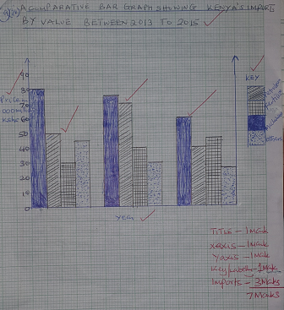
(b)(i) Name two countries to the East of Rift valley where tea is grown. (2marks)
- Kiambu
- Nyeri
- Kirinyaga
(ii)State three physical conditions that influence the growing of tea in Kenya. (3marks)
- High rainfall / 1000mm to 2000mm
- Well distributed rainfall throughout the year
- Deep soils
- Gentle slopping and undulating landscape
- Well drained soils
- Moderate to high temperature / 15ºc– 30ºc/warm to hot climate.
- (i) A comparative bar graph showing Kenya’s import by value between 2013 to 2015

(iv) Describe the stages involved in the cultivation of tea form land preparation to harvesting. (6marks)
- The land is cleared of vegetation
- Land is ploughed.
- Seedlings / cutting are planted in a nursery and allowed to grow to 20cm – 30cm.
- Seedlings are then transplanted on to the cleared land at the beginning of the rainy season in rows which are about 1.5 meters apart.
- The plants are weeded and manure mulching applied regularly.
- Once the plants start growing the tips of the branches are pruned / pegging regularly to encourage the plant to form more branches.
- After 2-4 years the crop is ready for harvesting
- The crop is harvested every two weeks once it attains maturity.
- After harvesting, the green leaves are transported to the collecting center within 24 hours.
- (a)(i) Define forestry. (2marks)
- The science of developing and maintaining forests are forest products including cultivating them.
(ii)Name two types of forests found in Kenya. (3marks)
- Natural forests
- Planted / artificial forests
- Exotic forests
- Indigenous forests
(iii)Give two examples of forests reserves in Kenya (2marks)
- Shimba hills
- Arabuko sokoke
- Mt. Kenya
- Kakamega
- Abardare
- Mau
- Explain three physical factors favouring the development of softwood forests in Kenya. (6marks)
- Cool climate which enables the trees to flourish all year round.
- High and reliable rainfall supporting the growth of forests.
- Tugged and steep highland which discourage human settlements and agriculture learning forests to flourish.

- Differentiate soft wood in Kenya and Canada under the following Sub-headings
- Growth (3marks)
In Kenya, trees grow faster which in Canada trees grows slowly.
- Logging (2marks)
In Kenya workers are transported to logging site while in Canada logging involve seeking up settlement in the forest.
In Kenya trees is cut using simple power saw while in Canada, trees are cut using mechanized / pororfuel power saws.
- Forest products (2marks)
- In Kenya, forest products are sold locally and while in Canada products are sold locally and others exported in European countries.
- Tape recording / videoing
- Tallying
- Photographing / taking photographs.
(ii) State three problems they are likely to face during the study. (3marks)
- Heavy rainfall
- Inaccessibility
- Occurance of injuries
- Attack by wild animals.

8. (a) (i) Define fisheries (2marks)
The water bodies where aquatic organism / fish are found or reared and exploited for food or commercial purposes.
(ii) State three ways in which fish farming contributes to the economy of Kenya. (3marks)
- Fish sold for income raising standards of living.
- Fish farming activities creates employment.
- Fish products are raw materials to some industries promoting industrialization.
- Some fish products are exported earning foreign exchange.
- Helps in diversify the economy.

(c) Use the map below to answer the following questions.
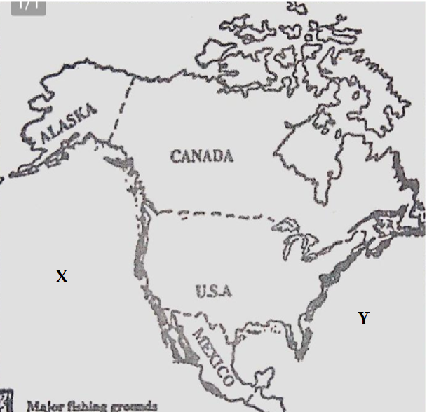
- Identify the following ground marked X and Y (2marks)
X – NE Pacific fishing ground.
Y – NW Atlantic fishing ground.
- Name four fish species caught along the fishing ground marked Y.
- Mackerel
- Sardines
- Flounder
- Haddock
- Tuna
- Herring
- Halibut
- Pilchard
- Hapke
- Menhaden
(iii) Explain four physical factors favoring fishing in the region marked Y. (8marks)
Broad and shallow continental sheif ideal for the growth of plenty of plantations attracting many fish species.
Cool waters / low temperature favorable for the survival of variety of fish species.
Irregular / in dental coastline providing ideal condition for fish breeding / several bays for setting up ports / riellages.
Convergence of cold Labrador and warm Gulf Stream ocean currents raising water temperature making the region the free encouraging fishing throughout the year.
Presence of many rivers and melting ice bring land derived minerals into the ocean for the growth of plauklous attracting fish species.
Rugged landscape / cold climates limiting agricultural activities hence fishing is the alternative source of food.
9(a)(i) Differentiate between transport and communication (2marks)
- Transport is the movement of goods and people from one place to another while communication is the transmission of ideas from one person to another.
(ii) Name three means used on land transport. (3marks)
- Animal transport
- Road transport
- Railway transport
- Pipelines
(iii)Explain the following factors how they influence development of transport and communication. (4marks)
Technology
- Developed countries have modern skills and technology of transport and communication. (4marks)
- Developing countries have poorly developed network due to insufficient technology.
Urbanization
- Large urban centers attract construction of good transport and communication networks in and out of town. E.g Thika super highway.

(b)The diagram below shows the major ports ground Lake Victoria. Use it to answer questions that follow.
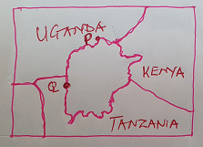
(i)Name the ports labeled P and Q (2marks)
P – Jinja
Q – Bukoba
(ii) State four advantages of using containers at the port of Kisumu. (4marks)
- Containers guard against goods destruction
- Containers use loading and offloading easly and faster using cranes.
- Containers occupy less space as they are even shape.
- Containers guard against theft of goods
- Containers safe on time when leading and offloading using cranes.
C(i) identify three canals along the St. Lawrance and the great lakes sea way in USA and Canada. (3marks)
- Soo canal
- Well and canal
- New york stape barge canal
- Rideau canal
(ii)Name four products transported along the sea route. (3marks)
- Iron ore
- Goal
- Forest products / timber
- Barley/ wheat/ corn
- Manufactured goods
- Oil products

(iii)Explain how the following problems faced at the Lawrence sea rote were improved.
- Situation: (2marks)
- Dredging the channels to remove the silts and deepen them for easy navigation of vessels.
- Freezing of water:
- Introduction of ice breakers to melt water away along the route in winter for use by ships throughout the year.
10.(a)(i) Define the term settlement. (2marks)
- Settlement is a place with housing units where a group of people live together.
(ii)Give two types of rural settlements patterns (2marks)
- Nucleated settlement pattern
- Dispersed settlement pattern
- Explain how the following factors influence settlement.
- Drainage (2marks)
- River and springs having clean water capture more settlements.
- River and lakes attract more / dense settlements.
- Sways discourage settlements due to presence of pets / snail causing diseases.
- Vegetation (2marks)
- Thick vegetation / dense forests discourage human settlements.
- Thick of vegetation an habitats of tsetse flies causing sleeping sickness / nagana /diseases
(b) A part from Central Business name three other functional zones of urban center (3marks)
- Residential
- Industrial
- Commuter
(c)State three negative effects of urbanization. (3marks)
- Environmental degradation
- Rise in crime activities
- Inadequate housing
- Shortage of public utilities.
- Emergence of sheet families.

- Explain four factors that lead to the growth of Eldoret town. (8marks)
- The town is easily accessible by both road, and railway and air transport.
- Availability of social amenities has led to rapid population growth.
- Establishment of service industries such as banking, and influence coupled with communication network.
- High population from the surrounding areas provided labour for industries ready market for manufactured goods.
- Plenty of land for expansion of the town and industries.
(d)State four factors that contribute to the emergence of slums in urban centers.
- Low income due to unemployment / underemployment
- Shortage of proper houses
- Inadequate financial ability
- High cost of land / houses
- Poor urban planning
- High rate of migration into urban centers

